Btree examples

For degree=1 (nodes btw 1 and 2 keys).

Insert 1-7.



For degree=2 (nodes btw 2 and 4 keys).

Insert 1-10.



insert 5:

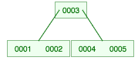

After insert 8:

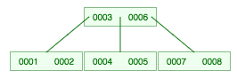

**Deletion example:**

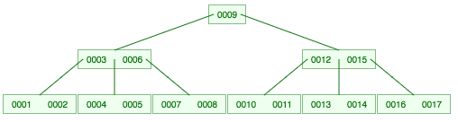

Delete 9:

Replace 9 with 8, then delete 9 in the leaf.

7 is now all alone. can’t rotate.

Merge with left sibling (4, 5), and sep (6) to form 4 5 6 7.

But now 3 is too small.

Can’t rotate.

Merge 3 with sibling (12 15) and parent (8) to form 3 8 12 15.

