Chapter 7 – Functions

7.1

* A function f from a set X to a set Y, denoted f : X -> Y, is a procedure that assigns each element in X a corresponding element in Y.
  + Every element in X must be assigned an element in Y.
  + No element in X can be assigned more than one element in Y.
  + It is possible for some elements in Y to have multiple elements in X assigned to them, or have no elements in X assigned to them.
  + Sometimes called a map or mapping
  + Given some element x in X, if x is assigned to element y in B, then we say:
    - f sends x to y
    - f maps x to y
    - or f of x equals y
    - f(x) = y
    - the value of f at x is y
  + X is called the domain
  + Y is called the co-domain.
  + the range of f is the subset of Y that has things mapped to it.
    - = {y in Y | y = f(x) for some x in X}
* For the purposes of this class, we use f(x) to mean the value of f at x, and f by itself to mean the whole function.
* Arrow diagrams
  + Draw X ={a,b,c} with 3 elements and Y ={1,2,3,4} with 4 – make sure one thing in B gets hit twice.
  + An arrow diagram for a function always has exactly one arrow coming out of every element in A.
  + **[functions can use any sets you want]** Draw arrow diagram for f : X->Y with X = sanders, Kirlin, welsh, larkins, and Y = 0,1,2,3,4
    - Draw an arrow diagram where f represents how many CS courses they’re teaching this semester.
  + Find domain, codomain, f(sanders), f(Kirlin), range
* Images and inverse images (preimages)
  + If f(x) = y, we will sometimes call y the image of x under f.
    - Visual—think of a function like an Instagram filter.
    - y=f(x). x is the “real world” thing we are photographing, and f is the filter, and y is the IMAGE you get out of the filter.
  + Sometimes we want to talk about the **set** of all things that get mapped to by a **subset** of X.
  + Assume function f : X -> Y.
  + If A subseteq X, then the image of A under f is the set
    - { y in Y | exists x in A y = f(x) } = f(A)  
      Procedural definition: y in f(A) <-> exists x in A y = f(x)
    - Notice that the image of a set is always a subset of the co-domain
    - The set that we take the image of must be a subset of the domain
    - therefore range of f = f(X).
  + Sometimes we are also interested in the set of all things that map to things in a subset of Y.
  + If C subseteq Y, then the inverse image of C under f is the set
    - { x in X | f(x) in C } = f^-1(C)
    - Procedural def: x in f^-1(C) <-> f(x) in C.
    - The inverse image of a set is always a subset of the domain
    - The set that we take the preimage of is always a subset of the co-domain
  + DRAW ARROW DIAG FOR EXAMPLE:
    - Class example: X = 1,2,3,4 Y = a,b,c,d,e
    - f(1)=b f(2)=a f(3)=d f(4)=b
    - Define S = {1,4}; T={a,b}; V = {c,e}.
  + Ask: What is f(S)? {b}
  + Ask: What is f(X)? {a,b,d}
  + Ask: What is f^-1(T)? {1,2,4}
  + Ask: What is f^-1(V)? empty set
* Defining a function with an equation
  + Define f: R -> R by f(x) = x^2 for all x in X.
  + what is the domain, codomain?
  + Range = R>=0
  + Image of [-1, 1] is [0, 1]
  + Inverse image of {1} = {-1, 1}
  + What if we said f: R to R+ by f(x) = x^2. Now this function is not well-defined. (because when x=0, f(x) is undef)
    - Not well-defined if there’s more than one value, or no value in Y for some x.
* Identity function is a special function that always maps elements in the domain to the same element in the co-domain:
  + Define I_X : X->X by I_X(x) = x for all x in X.
* Functions defined on a powerset
  + Let X = {a,b,c}
  + Define N: P(X) -> Z>=0 by N(X) = |X|
  + Draw arrow diagram.
* Functions defined on a Cartesian product.
  + Define M: RxR -> R as M(a, b) = ab
  + Define L: RxR -> RxR as L(a,b) = (-a, b)
* Proof with functions
  + Let X,Y be sets, and let f be a function from X to Y, and let A,B be subsets of X.   
    Prove f(A union B) subseteq f(A) union f(B)
  + Suppose y is an arb element in f(A union B)
  + We know exists an x in A union B such that y = f(x).
  + X is in A or x is in B.
    - Case 1 – x is in A:
    - Therefore y is in f(A)
    - Therefore y is in f(A) or y is in f(B)
    - Therefore y is in f(A) union f(B)
    - Case 2 x is in B.

7.2 1-1 and onto

* Some functions when given two different values of the domain, always yield different values of the co-domain. No element in the co-domain has more than one arrow pointing to it.
* Draw arrow diagram.
  + Hand-wavy example: f(x) = 2x from Z to Z has this property.
  + G(x) = x^2 from Z to Z does not have this property.
* 1-1
  + Def: A function f from X to Y is one-to-one or injective if
  + For all x1 x2 in X, f(x1) = f(x2) -> x1 = x2.
* Not 1-1:
  + Def: exists x1 x2 in X f(x1) = f(x2) and x1 neq x2.
* Proving something is 1-1
  + HOW TO PROVE IT:
    - “Suppose x1 and x2 are arbitrary members of *domain*. Assume f(x1)=f(x2). Work with equation until you get x1 = x2.”
  + **Prove that f:R->R f(x) = 4x-1 is 1-1.**
* Proving something is not 1-1.
  + HOW TO PROVE IT: On scratch area, find two numbers x1 and x2 that are different that map to the same element in the co-domain.
  + FOR THE PROOF: Define x1 and x2 and show how they map to the same elt in the co-domain.
  + **Prove that g:R->R g(x) = x^2 is not 1-1.**
* Some functions have the property that the range is equal to the co-domain. That is, every element in the co-domain has an arrow pointing to it.  
  CALLED ONTO or surjective
* Def of onto:
  + For all y in Y, exists x in X such that f(x) = y.
* Def of not onto:
  + Exists y in Y, for all x in X f(x) neq y.
* Proving something is onto:
  + HOW TO PROVE IT: Suppose y is an arbitrary in the co-domain. Define an element x in the domain and show f(x) = y. You will generally use y to define your x (think of an inverse function).
  + Scratch work on the side to find inverse.
  + **Prove that f:R->R f(x) = 4x-1.**
* Proving something is not onto
  + HOW TO PROVE IT: Do by contradiction. Assume f is onto and show a y that makes the equation impossible.
  + SCRATCH WORK: find the y in Y that breaks it.
  + **Prove g:R->R g(x) = x^2 is not onto.**
* If a function is 1-1 and onto, it is called a 1-1 correspondence or bijection.
* Every bijection has an inverse function:
  + If f is a bijection, then f^-1: Y->X is a function defined by f^-1(y) = the unique element x in X such that f(x) = y.
* What goes wrong when you try to prove x^2 is 1-1?
* **Prove f(x) = 2x from Z to EVEN is onto.**

NEW:

* If a function is 1-1 and onto, it is called a 1-1 correspondence or bijection.
* Every bijection has an inverse function:
  + If f is a bijection, then f^-1: Y->X is a function defined by f^-1(y) = the unique element x in X such that f(x) = y.

MONDAY NOV 14 2016

* Put up defs of 1-1, onto, bijection/1-1 correspondence
  + 1-1: For all x1 x2 in X, f(x1)=f(x2) 🡪 x1=x2
  + onto: For all y in Y, Exists x in X such that f(x)=y.
* Show four functions between a set X=1,2,3 and Y=a,b,c.
  + F1 is 1-1 and onto
  + F2 is 1-1 but not onto.
  + F3 is not 1-1, but onto.
  + F4 is neither.
* Suppose we wanted to reverse a function. We have the concept of an inverse image.
  + Which one of these could I reverse all the arrows and still have a function?
* If a func is 1-1 and onto, it has an inverse function.
  + f^-1: Y->X is a function defined by f^-1(y) = the unique element x in X such that f(x) = y.
  + Inverses are only defined for bijections, because what could go wrong if we take the inverse of something that is NOT 1-1? Not onto?

7.3 composition

* Let f:X->Y and g:Y->Z be functions. The composition of g with f, denoted g circle f X->Z, is  
  (g circ f)(x) = g(f(x)) for all x in X.
  + Draw sample arrow diagram
  + X = {1,2,3} Y = {a,b,c,d} Z = {I, j, k}
  + Make f 1-1. g cannot be 1-1, but make the bad 1-1ness involve the left over element in Y.
    - So g(f(x)) is still 1-1.
  + Ask is f 1-1? YES
  + Is g 1-1? NO
  + Is g circ f 1-1? YES.
  + Draw updated diagram with only X and Z.
* Order of composition matters
  + Let f(x) = x + 1 and g(x) = x^2. (both R to R)
  + (f circ g)(x) = f(g(x)) = x^2 + 1
  + (g circ f)(x) = g(f(x)) = (x+1)^2
* Make up arrow diagram composition
  + What is range of g circ f?
* Identity function
  + Composition with the identity function never changes
* Composing with its inverse yields identity

REVIEW GENERAL STRATEGIES FOR PROVING 1-1 and ONTO.

1-1:

Pick two arbitrary elements of the domain.

Assume that the values of the function, when applied to those two elements, are equal.

Prove that the elements themselves must be equal.

ONTO:

Pick an arbitrary element in the co-domain.

Do some scratch work to show how to define an element x in the co-domain such that f(x)=y.

* **1-1 compositions yield 1-1: prove this**
* **onto compositions yield onto: prove**

7.4 Cardinality

* Cardinality refers to the size of a set.
* Start with ideas of size of set:
  + Suppose |X|>|Y|. [Make X much bigger?]
    - Can you draw a 1-1 function? (No)
    - Can you draw an onto function? (Yes)
  + Suppose |X|<|Y|. [Make Y much bigger]
    - Can you draw a 1-1 function? (Yes).
    - Can you draw an onto function? (No).
  + Suppose equal.
    - Can you draw 1-1? Yes
    - Can you draw onto? Yes
* Conclusions:
  + If a func is 1-1, then |X| <= |Y|
  + If a func is onto, then |X| >= |Y|.
  + If a func is 1-1 and onto, then |X|=|Y|.
* F is 1-1 means that |A| <= |B|
* F is onto means that |A| >= |B|
* Two sets have the same cardinality iff there is a 1-1 correspondence between them.
* Prove that Z has the same cardinality as EVEN.
* Countability
  + A set is countably infinite iff it has the same cardinality as Z+.
  + A set is countable if it is finite or countably infinite.
* Show Z is countable.
  + F(x) = x/2 if x is even
  + F(x) = (1-x)/2 if x is odd.
* Show EVEN is countable.
  + Do using transitive property of cardinality.
* Show Q+ is countable.
  + 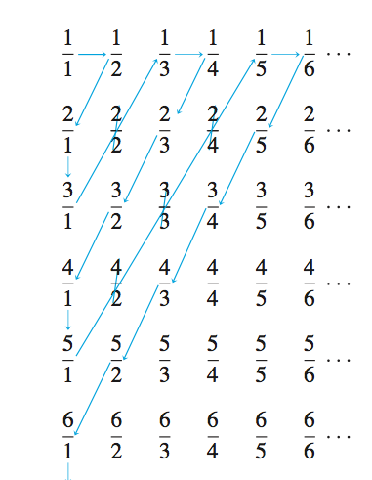
* 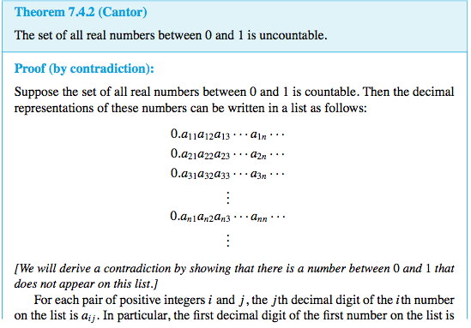
* 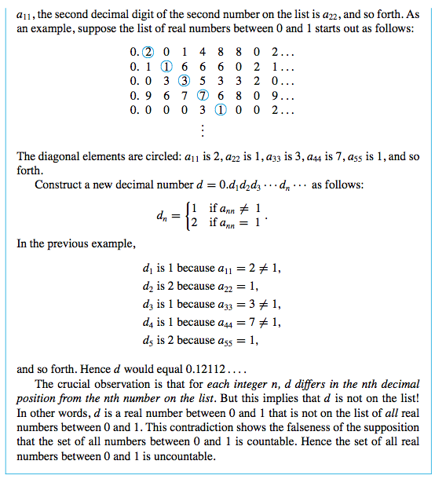
* Any subset of a countable set is countable.
  + If A subseteq B and B is countable, then A is countable.
* Any set with an uncountable subset is uncountable.
  + If A subseteq B and A is uncountable, then B is uncountable.
* Prove the set of all computer programs in Python is countable.
* Prove the set of all functions from Z+ to {0,1,2,3.4.5.6.7.8.9} is uncountable.

Let *T* be the set of all functions from the positive integers to the set {0,1,2,3,4, 5, 6, 7, 8, 9}. Show that *T* is uncountable.

b. Derive the consequence that there are noncomputable functions. Specifically, show that for any computer language there must be a function *F* from **Z**+ to {0, 1, 2, 3, 4, 5, 6, 7, 8, 9} with the property that no computer program can be written in the language to take arbitrary values as input and output the corresponding function values.

Solution

a. Let *S* be the set of all real numbers between 0 and 1. As noted before, any number in *S* can be represented in the form

0.*a*1*a*2*a*3 ...*an* ...,

* where each *ai* is an integer from 0 to 9. This representation is unique if decimals that end in all 9’s are omitted.

Define a function *F* from *S* to a subset of *T* (the set of all functions from **Z**+ to

{0,1,2,3,4,5,6,7,8,9}) as follows: *F*(0.*a*1*a*2*a*3 . . . *an* . . .) = the function that sends each

positive integer *n* to *an*.

* Choose the co-domain of *F* to be exactly that subset of *T* that makes *F* onto. That is, define the co-domain of *F* to equal the image of *F*. Note that *F* is one-to-one because if *F*(*x*1) = *F*(*x*2), then each decimal digit of *x*1 equals the corresponding decimal digit of *x*2, and so *x*1 = *x*2. Thus *F* is a one-to-one correspondence from *S* to a subset of *T* . But *S* is uncountable by Theorem 7.4.2. Hence *T* has an uncountable subset, and so, by Corollary 7.4.4, *T* is uncountable.