**UGANDA CHRISTIAN UNIVERSITY**

**FACULTY OF SCIENCE AND TECHNOLOGY**

**QUESTION 1**

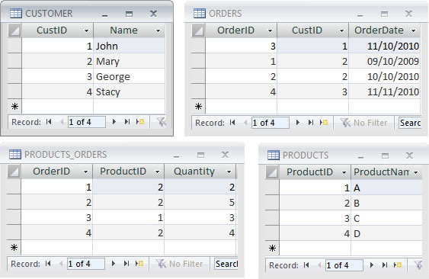

Consider the diagram above and and answer the following questions:

1. State possible field types for fields(attributes) of the tables displayed above (4 marks)
2. Define the following terms and identify these terms in the tables above:( 2 marks@)
   * 1. Primary key
     2. Foreign key
     3. Tuple
     4. Attribute
3. Identify the possible relationships between the tables and brief explain how you would go about creating one of the relationships you have identified.( 5 marks)
4. Briefly explain why storing information structured in tables like shown above would be better than storing that same information in a spreadsheet or word document.( 4 marks)
5. Describe the steps one would take to create a query to output customer Name and the Product-Name associated with each customer. ( 4 marks)
6. Describe the steps one would take to create a report to output products ordered grouped by customer who ordered them. ( 8 marks)

**Question 2**

|  |  |  |  |  |  |  |  |  |  |  |  |  |  |  |  |  |  |
| --- | --- | --- | --- | --- | --- | --- | --- | --- | --- | --- | --- | --- | --- | --- | --- | --- | --- |
|  | **A** | | **B** | | **C** | | **D** | | **E** | | **F** | | **G** | | **H** | | **I** |
| **1** | **XYZ COMPANY SALES PERFORMANCE** | | | | | | | | | | | | | | | |  |
| **2** |  |  | |  | |  | |  | |  | |  | |  | |  | |
| **3** |  |  | |  | |  | |  | |  | |  | |  | |  | |
| **4** | **SALESPERSON** | **ANNUAL TARGET** | | **QTR1** | | **QTR2** | | **QTR3** | | **QTR4** | | **TOTAL SALES** | | **AVERAGE SALES** | | **COMMISSION** | |
| **5** |  |  | |  | |  | |  | |  | |  | |  | |  | |
| **6** | ALBERT | 750 | | 148 | | 256 | | 133 | | 154 | | X | |  | |  | |
| **7** | MICHAEL | 650 | | 187 | | 143 | | 258 | | 143 | | X | |  | |  | |
| **8** | CARL | 800 | | 233 | | 200 | | 216 | | 152 | | X | |  | |  | |
| **9** | GEORGE | 700 | | 256 | | 145 | | 136 | | 259 | | X | |  | |  | |
| **10** | LUCY | 1,000 | | 249 | | 212 | | 215 | | 124 | | X | |  | |  | |
| **11** |  |  | |  | |  | |  | |  | |  | |  | |  | |
| **12** | TOTAL | X | | X | | X | | X | | X | | X | |  | |  | |
| **13** |  |  | |  | |  | |  | |  | |  | |  | |  | |
| **14** | COMMISSION | 6% | |  | |  | |  | |  | |  | |  | |  | |
| **15** |  |  | |  | |  | |  | |  | |  | |  | |  | |

* 1. Given the table above, write formulas or describe how you would calculate the Total Sales in column G and Row 12.
  2. How would you calculate the Average Sales? Write the formula as it should appear in Excel and show the method of duplicating it to the other cells.
  3. How would you calculate the Commission? Write the formula as it would appear in Excel and explain the method of duplicating it to the other cells.
  4. How would you calculate the Commission give that every sale above the sales person annual target a sales person is given 30% commission?Write the formula as it would appear in Excel and explain the method of duplicating it to the other cells.
  5. What does this sign (# # # ) mean when seen in cell(s)? What should you do when you see this sign?
  6. You are asked to compare QTR1 and QTR3 sales for all salespersons in the above table using a chart:
     1. What range of cells do you need to select and how would you select it?
     2. What type of graph would you use?
  7. How can you edit a chart once it is created, lets say, to change the series from columns to rows, to change the legend, etc?