BIT class Exercise

To be submitted to: [pkisambira@ucu.ac.ug](mailto:pkisambira@ucu.ac.ug)

A company has budgeted up to $8000 per week for local advertisement. The money is to be allocated among four promotional media: TV spots, newspaper ads, and two types of radio advertisements. The company goal is to reach the largest possible high-potential audience through the various media. The following table presents the number of potential customers reached by making use of advertisement in each of the four media. It also provides the cost per advertisement placed and the maximum number of ads than can be purchased per week.

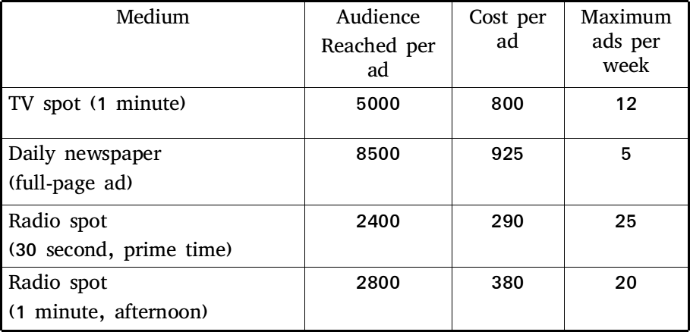

The company arrangements require that at least five radio spots be placed each week. To ensure a board-scoped promotional campaign, management also insists that no more than $1800 be spent on radio advertising every week

Formulate a linear programming model for this problem, to determine how many ads of each medium tin order to maximize the total audience reached per week.

|  |  |  |  |  |  |  |
| --- | --- | --- | --- | --- | --- | --- |
|  | **A** | **B** | **C** | **D** | **E** | **F** |
| **1** | **TOWN / DAY** | **Mon** | **Tue** | **Wed** | **Thur** | **Fri** |
| **2** | Mombasa | 30 | 29.5 | 31 | 28.5 | 32 |
| **3** | Kisumu | 31 | 33 | 30 | 30 | 32 |
| **4** | Nakuru |  |  |  |  |  |
| **5** | Nairobi | 24 | 23.5 | 22 | 23 | 24.5 |
| **6** |  |  |  |  |  |  |
| **7** |  |  |  |  |  |  |
| **8** | **TOWN / DAY** | **Mon** | **Tue** | **Wed** | **Thur** | **Fri** |
| **9** | Mombasa |  |  |  |  |  |
| **10** | Kisumu |  |  |  |  |  |
| **11** | Nakuru |  |  |  |  |  |
| **12** | Nairobi |  |  |  |  |  |

1. Use a formula to calculate the temperature for Nakuru, given that the temperature for Nakuru is ¾ that of Mombasa.
2. Create two blank rows below Row 1.
3. Type “**Temp. in degrees Celsius**” in Cell A2 and “**Temp. in degrees Fahrenheit**” in Cell A9.
4. Calculate the temperature in F using the conversion factor given as F=(C+19)*9/5.
5. Calculate the temperature for Kericho in both versions given that it is 4/5 that of Kisumu.
6. Type “**Average Temp. (C)**” in Cell G3 and “**Average Temp. (F)**” in Cell G11 respectively. Calculate the average temperatures for all the towns.
7. Format all cells containing the temp. values to zero decimal places with no commas.
8. Use the Average values (C) in column G to create a 3-D Exploded Pie Chart to show distribution of temperature for the towns.

The title should be “**Average Temp. (C)”.** Use the text in column A as the legend. In the data labels, select **Show Value**.

1. Save the worksheet as **Weather**.

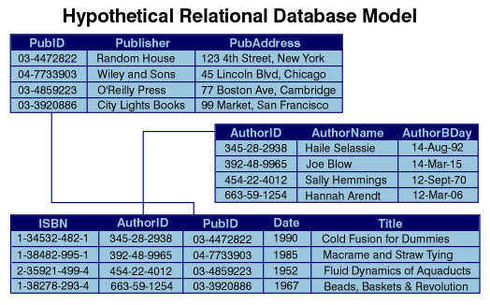

Create the database above named Library with the topmost table named Publisher with PubID as the primary key,the second Table called Author with AuthorID as the primary key and the lower most table called Book with ISBN as the primary key.

Use appropriate field type for the fields above

Create the relationships as indicted by the arrows

Create queries of your own choosing: 2 queries involving one, 2 queries involving two of the tables and 2 queries involving the three tables

Create 2 reports :

* 1. Report showing Publisher, AurthorName and Title and Date. This report is grouped by Publisher
  2. Report showing AuthorName and Title and Date. This report is grouped by AuthorName.