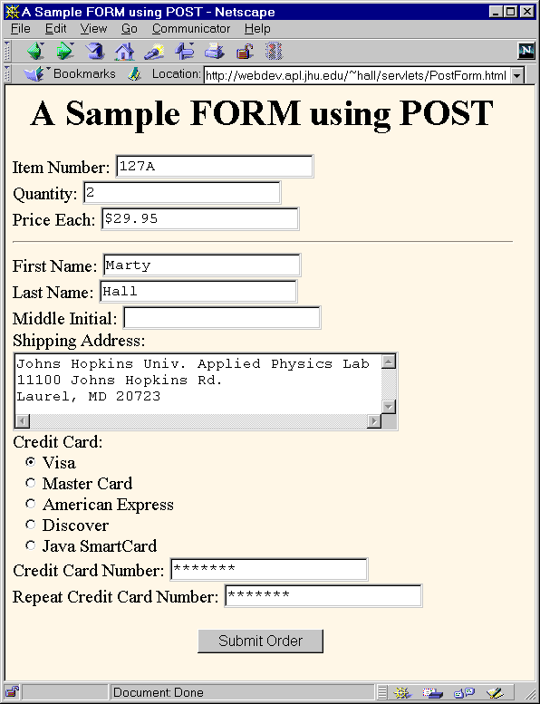Create the form below and a database to store the information below: the design of the database is up to you.

Create a PHP script to insert the data below into the tables of your database.