- Industry 4.0

  - About Industry 4.0

Industry 4.0 is signaling a change in the traditional manufacturing landscape. Also known as the Fourth Industrial Revolution, Industry 4.0 encompasses three technological trends driving this transformation: connectivity, intelligence and flexible automation. Industry 4.0 converges ITinformation technolgy and OT(Operational Technology), to create a cyber-physical environment. This convergence has been made possible thanks to the emergence of digital solutions and advanced technologies, which are often associated with Industry 4.0.^{[1]}
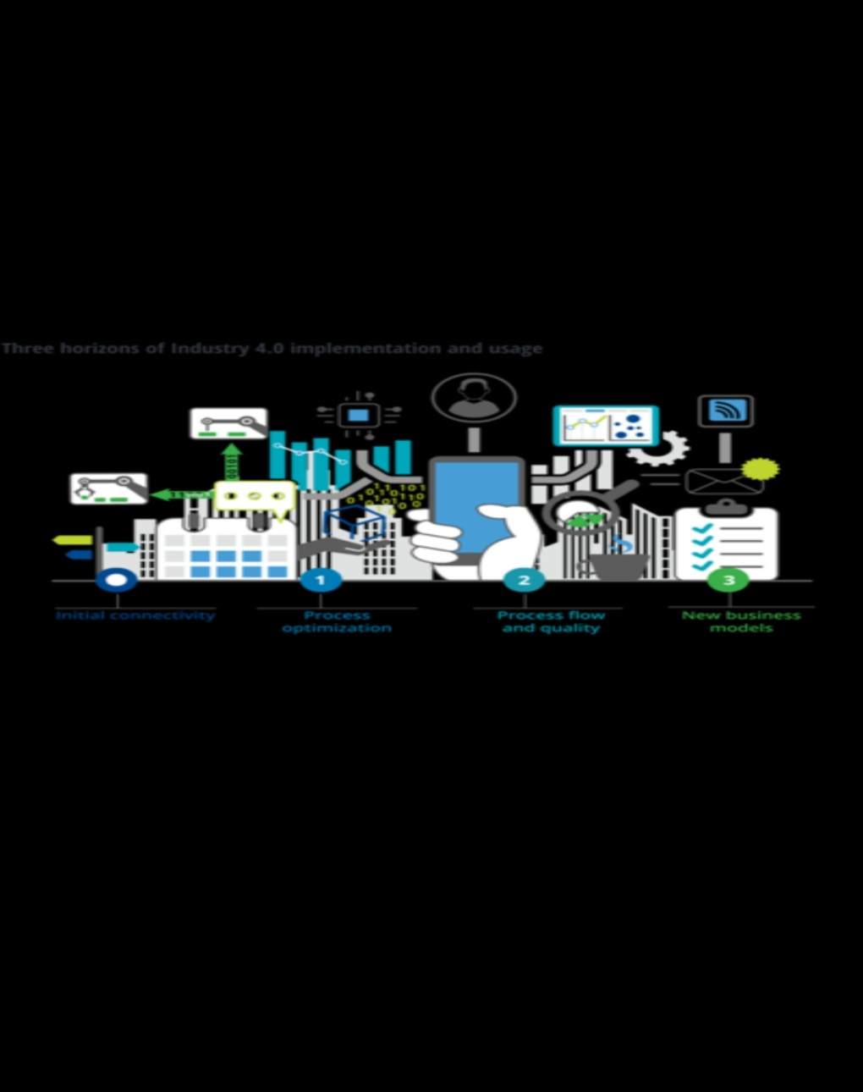

Figure 1. Industry 4.0

Industry 4.0 type
Industry 4.0 is the future of global manufacturing. It is the era of automation, of the digitalized factory and
digitalized products – the fourth phase of industrial revolution, or Industry 4.0. Nevertheless, the academics field is
still unable to define the approach as the Industry 4.0 is the basic term referring to the fourth industrial revolution.
This causes difficulty to distinguish its components. There are 9 characteristics for industry as shown in Figure 2
below.

  - Cyber physical System (CPS)

Industry 4.0 can be played as a Cyber-Physical System study where the advances and speed of development in
communication and calculation form the Cyber-Physical System and Industry 4.0. Each production system of CPS
has sensors installed in the entire physical aspects in order to connect the physical things with virtual models. Due to
Cyber-Physical System to be more common in society and occurs during interaction with humans, it must be
ensured that CPS behave stably and has a certain bearing when utilized with artificial intelligence (AI) (Mosterman
& Zender, 2015).CPS is also the foundation to create the Internet of Things (IoT) which can be combined to become
the Internet of Services (IoS).Hence, businesses will find it easier to establish global networks which joins the
warehousing systems, machinery and production facilities of CPS in the future

Internet of things (ITI)

Industry 4.0 is the new phrase for the combination of the present Internet of Things (IoT) technology and the
manufacturing industry. Industry 4.0 was initiated as a result of the combination of the Internet of Things (IoT) and
the Internet of Services (IoS) in the manufacturing process (Kagermann, Wahlster & Johannes (2013). Generally,
IoT can provide advanced connectivity of systems, services, physical objects, enables object-to-object
communication and data sharing. IoT can be achieved through the control and automation of aspects like heating,
lighting, machining and remote monitoring in various industries (Zhong et al., 2017).

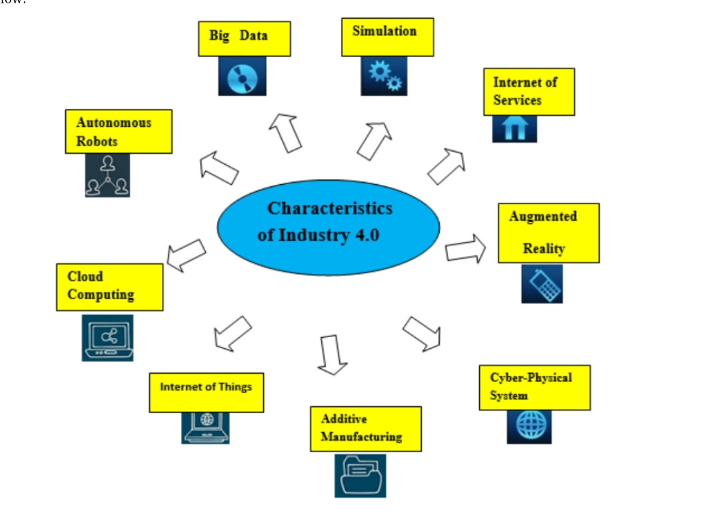

Internet of service (IOS)

Internet of Services acts as important components in the automotive industry. Activities are triggered through
data transfers in the information technology to make daily mobility safer, easier and pleasant. The Internet of
Services (IoS) acts as “service vendors” to provide services through the internet according to the types of
digitalization services. These services are available and on demand around business models, partners and any setup
for services. The suppliers provide and aggregate the services into additional value services as communication
among consumers can be received and accessed by them through various channels( Buxmann, Hess, & Ruggaber (2009)

- Component of industry 4.0

Industry 4.0 can be classified into three components. The first is horizontal integration. It brings the concept of a
new type of worldwide value chain networks. The second is vertical integration. The concept is to achieve
hierarchical subsystems at the production line to produce an easy to configure and high flexibility production line.
The last component is engineering integration along the whole value chain from the beginning to the end to assist in
the customization of products. The horizontal integration is described as one where a corporation should both
cooperate and compete with corporations that have similar characteristics to create an efficient production system.
Material, financial control and knowledge can be connected in all these companies easily. Therefore, new control
systems and models for business may appear (Wang et al., 2016). Vertical integration delivers the idea of a factory
that has various informational and physical subsystems, for example like production management, actuator and
sensor, value and corporate planning. It is important for the vertical integration of sensor and actuator signals along
various stages of the enterprise resource planning (ERP) level to ensure high flexibility and ease to configure
production lines. From this integration, the highly intelligent machines create an automated controlled system that is
able to be automatically reconfigured according to the various types of products. The large amounts of data collected
and processed enables the manufacturing system to be transparent(Wang et al., 2016). Lastly, End-To-End
engineering integration in a chain of activities throughout the product-centric value creation process involves aspects
such as customer requirement expression, product development and design, recycling, production engineering,
production services, production planning and maintenance. From end-to-end integration, every stage can be reused
for the same product model. Product design effects on services and production can be predicted by utilizing a
software tool in the chain to make sure the products are customizable (Wang et al., 2016)
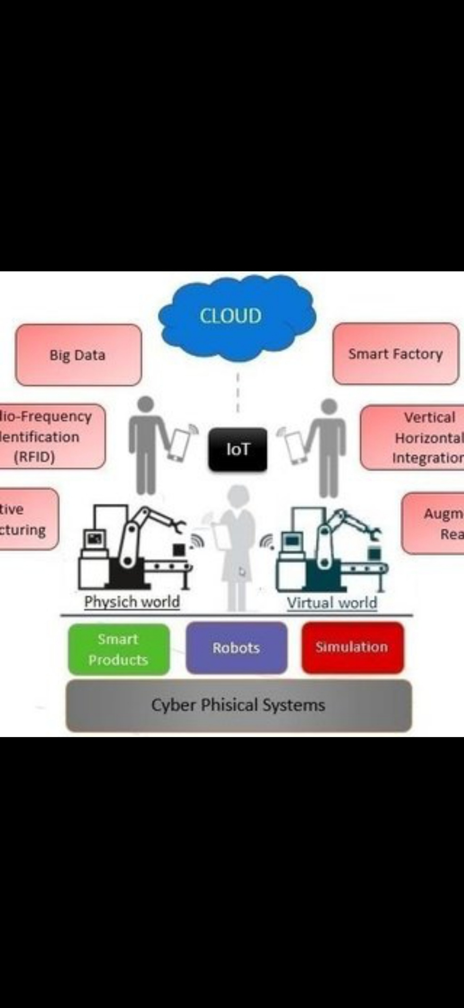
Conclusion
In a nutshell, Industry 4.0 is the future of global manufacturing which aggregates existing ideas to a new value
chain which plays a crucial role to transform whole value chains of life cycle of goods while developing innovative
services and products in the manufacturing industry which involves the connection of systems to things that creates
self-organizing and dynamic control within an organization. Industry 4.0 describes a future scenario of industrial
production that is characterized by the aspects of a new level of controlling, organizing and transforming the entire
value chain with the life cycle of products,resulting in higher productivity and flexibility through three types of
effective integration which are horizontal, vertical and end-to-end engineering integration. Hence, these can predict
product performance degradation and autonomously manage and optimize product service needs and consumption
of resources which lead to optimization and reduction of costs. Next, the creation of dynamic, real-time optimized
and self-organizing cross-company value networks through the Cyber-Physical Systems(CPS), Internet of Things

References
1Buxmann P., Hess T. and Rugabber R. Internet of Services. Business & Information Systems Engineering 5
(2) (2009).
[2] China. State Council – SC. Made in China 2025: report. Beijing: State Council, 2015.
[3] Conseil national de l’ industrie. The New Face of Industry in France. Paris: French National Industry
Council, 2013.
[4] Dilberoglu, U. M., Gharehpapagh, B., Yaman, U. and Dolen, M.. The role of additive manufacturing in the
era of Industry 4 . 0. Procedia Manufacturing 11 (2) (2017) 545–554.
[5] European Factories of the Future Research Association – EFFRA. Factories of the future: multi-annual
roadmap for the contractual PPP under Horizon2020: report. Brussels: EFFRA, 2013.
[6] Foresight. The Future of Manufacturing: A New Era of Opportunity and Challenge for the UK. London:
UK Government Office for Science, 2013.
[7] Gorecky, D., Schmitt, M., Loskyll, M. and Zühlke, D. Human-Machine-Interaction in the Industry 4.0 Era.
12th IEEE International Conference on Industrial Infomatic, 2014, 289–294.
[8] He, K.F. Cyber-Physical System for Maintenance in Industry 4.0. Jonkoping University: Master’s Thesis,
2016.
[9] Kagermann, H., Wahlster.W. and Johannes, H. Recommendations for Implementing the Strategic Initiative
INDUSTRIE 4.0. Forschungsunion, 2013.
[10] Liao, Y., Deschamps, F., Freitas, E.D. and Loures, R. Past, present and future of Industry 4.0 - a systematic
literature review and research agenda proposal. International Journal of Production Research 55 (12),
(2017) 3609–3629.
[11] Marcos, M., Suárez, S., Marcos, M., Fernández-miranda, S. S., Marcos, M., Peralta, M. E. and Aguayo, F.
The challenge of integrating Industry in the degree of Mechanical Engineering. Procedia Manufacturing 13
(1) (2017) 1229–1236.
[12] Masoni, R., Ferrise, F., Bordegoni, M., Gattullo, M., Uva, E., Fiorentino, M., Carrabba,E. and Donato,M.,.
Supporting remote maintenance in industry 4.0 through augmented reality. Procedia Manufacturing 11 (6)
(2017) 1296–1302.
[13] Ministry of Trade Industry and Energy of South Korea – MOTIE. Manufacturing innovation 3.0 strategy
for the creation of economy. Sejong City, 2014.
[14] Mosterman, P. and Zender, J. Industry 4.0 as a Cyber-Physical System study Industry 4.0 as a Cyber-
Physical System study. Software & Systems Modeling 12 (2) (2015) 1-14.
[15] Mrugalska, B. and Wyrwicka, M.K. Towards Lean Production in Industry 4.0. Procedia Engineering 182
(2017) 466–473.
[16] National Research Fountation Research, Innovation and Enterprise 2020 (RIE2020). Retrieved
from : http://www.nrf.gov.sg/rie2020, 2016.
[17] President’s Council of Advisors on Science and Technology – PCAST. Report to the president accelerating
U.S. advanced manufacturing. Washington: Executive Office of PCAST, 2014.
[18] Qin, J., Liu, Y. and Grosvenor, R. A Categorical Framework of Manufacturing for Industry 4.0 and Beyond.
Procedia CIRP, 2016, 173–178.
[19] Rodič, B. Industry 4.0 and the New Simulation Modelling Paradigm, Organizacija 50 (3) (2017) 193–207.
[20] Sangeetha, A. Malaysia’s Industry 4.0 initiative slow on uptake.The Edge Financial Daily. Retrieved
from http://www.theedgemarkets.com/article/malaysias-industry-40-initiative-slow-uptake, 2017.
[21] Schumacher, A., Erol, S. and Sihn, W. A maturity model for assessing Industry 4 . 0 readiness and maturity
of manufacturing enterprises. Procedia CIRP 52 (2016) 161–166.
[22] Schwab, K. The Fourth Industrial Revolution, what it means and how to respond. Retrieved
from https://www.weforum.org/agenda/2016/01/the-fourth-industrial-revolution-what-it-means-and-how-

