- BLUE – RAY DISC

  - Blu – Ray disc

The Blu-ray Disc (BD), often known simply as Blu-ray, is a digital optical disc storage format. It is designed to supersede the DVD format, and capable of storing several hours of high-definition video (HDTV 720p and 1080p). The main application of Blu-ray is as a medium for video material such as feature films and for the physical distribution of video games for the PlayStation 3, PlayStation 4, PlayStation 5, Xbox One, and Xbox Series X. The name "Blu-ray" refers to the blue laser (which is actually a violet laser) used to read the disc, which allows information to be stored at a greater density than is possible with the longer-wavelength red laser used for DVDs.
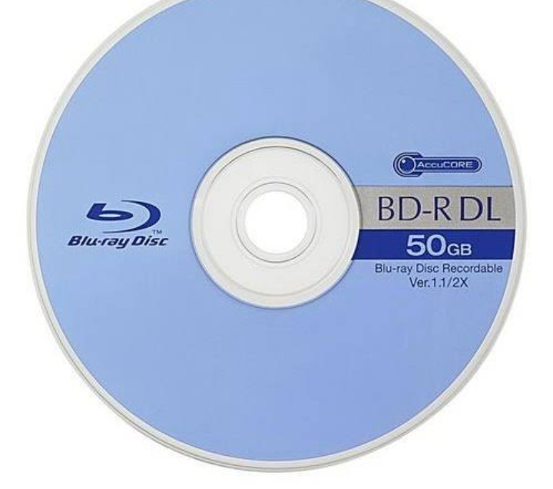
Media type | High-density optical disc
Encoding | Data encoding: CLV or Zoned CAV pits-and-lands with interleaved error correction code  BDMV Video encoding: H.262/MPEG-2 Part 2  H.264/MPEG-4 AVC  VC-1  H.265/HEVC (only Ultra HD Blu-ray)
Capacity | 25 GB (single-layer), 50 GB (dual-layer)  100, 128 GB (BDXL)  Up to four layers are possible in a standard form BD.
Block size | 2 KB sector,[1] 64 KB ECC-block[2]
Read mechanism | 405 nm diode laser, 36 Mbit/s
Write mechanism | 405 nm diode laser with a focused beam using more power than for reading
Developed by | Sony  Blu-ray Disc Association[3]
Dimensions | 12 cm (4.7 in) diameter  1.2 mm thickness[4][note 1]
Usage | Data storage  High-definition video  High-resolution audio  Stereoscopic 3D  PlayStation 3 games  PlayStation 4 games  PlayStation 5 games  Xbox One games  Xbox Series X games
Extended from | DVD
Extended to | Ultra HD Blu-ray  Archival Disc
Released | June 20, 2006; 15 years ago

The plastic disc is 120 millimetres (4.7 in) in diameter and 1.2 millimetres (0.047 in) thick, the same size as DVDs and CDs.[5] Conventional or pre-BD-XL Blu-ray Discs contain 25 GB per layer, with dual-layer discs (50 GB) being the industry standard for feature-length video discs. Triple-layer discs (100 GB) and quadruple-layer discs (128 GB) are available for BD-XL re-writer drives.[6]
High-definition (HD) video may be stored on Blu-ray Discs with up to 1920×1080 pixel resolution, at 24 progressive or 50/60 interlaced frames per second. DVD-Video discs were limited to a maximum resolution of 480i (NTSC, 720×480 pixels) or 576i (PAL, 720×576 pixels).[7] Besides these hardware specifications, Blu-ray is associated with a set of multimedia formats.
The BD format was developed by the Blu-ray Disc Association, a group representing makers of consumer electronics, computer hardware, and motion pictures. Sony unveiled the first Blu-ray Disc prototypes in October 2000, and the first prototype player was released in Japan in April 2003. Afterward, it continued to be developed until its official worldwide release on June 20, 2006, beginning the high-definition optical disc format war, where Blu-ray Disc competed with the HD DVD format. Toshiba, the main company supporting HD DVD, conceded in February 2008,[8] and later released its own Blu-ray Disc player in late 2009.[9] According to Media Research, high-definition software sales in the United States were slower in the first two years than DVD software sales.[10] Blu-ray faces competition from video on demand (VOD) and the continued sale of DVDs.[11] In January 2016, 44% of U.S. broadband households had a Blu-ray player.[12] For playback of 4K content, the BDA introduced a variant of Blu-ray called Ultra HD Blu-ray.

THANK YOU

- Third Main Heading
Write Content from here
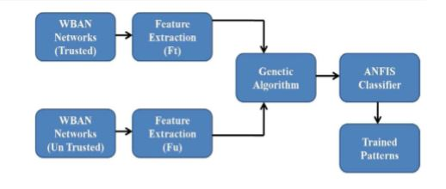
Figure 2: Insert Diagrams here

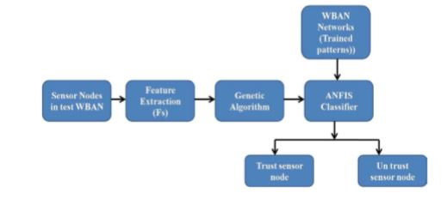

Figure 3: Testing Mode [15]

- Fourth Main Heading
Write content from here
4.1 Sub Heading
4.2 Sub Heading
4.3 Sub Heading
Write your content
4.4 Sub Heading
Write your content

6. Summary and Future Work
Write your content here

References

- Jing, L., Ming, L., Bin, Y., Wenlong, L., A Novel Energy Efficient MAC Protocol for Wireless Body Area Network. China communication, Feb. 2015.
- Negra, R., Jemili, I., Belghith, A.: Wireless Body Area Networks: Applications and Technologies. Procedia Computer Science 83, 1274 – 1281 ( 2016 )
- Yuce, M.R.: Implementation of wireless body area networks for healthcare systems. In: Sensors and Actuators A: Physical, Vol 162, Issue 1, Pages 116-129. Elsevier B.V (2010)
- Dabhi, K., Mahet, A.: Internet of Nano Things-The Next Big Thing. In: International Journal of Engineering Science and Computing, vol 7 Issue No.4 (2017)
- Negra, R., Jemili, I., Belghith, A.: Wireless Body Area Networks: Applications and Technologies. Procedia Computer Science 83, 1274 – 1281 ( 2016 )
- Yuan, X., Li, C., Ye, Q., Zhan, K., Cheng, N., Zhan, N., Shen, X.: Performance Analysis of IEEE 802.15.6-Based Coexisting Mobile WBANs with Prioritized Trafﬁc and Dynamic Interference. In: IEEE Transactions on Wireless Communications (Volume: 17, Issue: 8, Aug. 2018)
- Adhikary S., Chattopadhyay S., Choudhury S.: A Novel Bio-inspired Algorithm for Increasing Throughput in Wireless Body Area Network (WBAN) by Mitigating Inter-WBAN Interference. In: Chaki R., Cortesi A., Saeed K., Chaki N. (eds) Advanced Computing and Systems for Security. Advances in Intelligent Systems and Computing, vol 667. Springer, Singapore (2018)
- Peng, H., Tian, Y., Kurths, J., Li, L., Yang, Y., Wang, D.: Secure and energy-efﬁcient data transmission system based on chaotic compressive sensing in body-to-body networks. IEEE Trans. Biomed. Circ. Syst. 11(3), 558–573 (2017)
- Samanta, A., Misra, S.: Energy-efﬁcient and distributed network management cost minimization in opportunistic wireless body area networks. IEEE Trans. Mobile Comput. 17, 376–389 (2017)
- Ahmad, S.S., Razzaque, M.A., Inmaculada T.R., Hussain, N.: IEEE 802.15.6 Standard in Wireless Body Area Networks From a Healthcare Point of View. The 22nd Asia-Pacific Conference on Communications (APCC2016)
- Yi, C., Wang, L., Li, Y.: Energy efﬁcient transmission approach for WBAN based on threshold distance. IEEE Sensors J. 15(9), 5133–5141 (2015)
- Misra, S., Moulik, S., Chao, H.-C.: A cooperative bargaining solution for priority-based data-rate tuning in a wireless body area network. IEEE Trans. Wirel. Commun. 14(5), 2769–2777 (2015)
- Walsh, M.J., Hayes, M.J.: Throughput rate control for an 802.15.4 wireless body area network using static and low order anti-windup techniques. In: Proc. Mediterranean Conf. Control Autom, pp.1–6 (2007)
- Eberhart, R., Kennedy, J.: A New Optimizer Using Particle Swarm Theory. Sixth International Symposium on Micro Machine and Human Science, 0-7803-2676-8/95
- Kalaiselvi, K., Suresh, G.R. & Ravi, V.: Genetic algorithm based sensor node classiﬁcations in wireless body area networks (WBAN). Cluster Comput (2018)
- Nadeem, Q., Javaid, N., Mohammad, S.N., Khan, M.Y., Gull, M.: SIMPLE: Stable Increased-throughput Multi-hop Protocol for Link Efﬁciency in Wireless Body Area Networks. 26, Jul. 2013.

