- Lifi Technology
LiFi technology will allow us to connect to the internet using light from lamps, streetlights or LED televisions. In addition to being cheaper, safer and faster than wifi, it does not need a router. All you need to do is point your mobile or tablet towards a light bulb to surf the web.



Figure 1: LIFI technology

  - What is LIFI technology

LiFi (light fidelity) is a bidirectional wireless system that transmits data via LED or infrared light. It was first unveiled in 2011 and, unlike wifi, which uses radio frequency, LiFi technology only needs a light source with a chip to transmit an internet signal through light waves.
This is an extraordinary advance over today's wireless networks. LiFi multiplies the speed and bandwidth of wifi, 3G and 4G. The latter have a limited capacity and become saturated when the number of users surfing increases, causing them to crash, reducing speeds and even interrupting the connection.
1.2.1
LiFi technology emerged thanks to the German physicist Harald Haas, a professor and director of the LiFi Research and Development Centre at the University of Edinburgh, and it could reach our homes in just a few years. It is currently being tested with LED luminaires in offices around the world and the aeronautical industry is already working on solutions to integrate it into commercial aircraft.
Airports, hospitals and city streets are other spaces where LiFi technology could become popular. The boom in mobile devices and the growing demand for higher bandwidth systems are expected to drive the development of this social technology in the next decade, as noted in the Global Market for LiFi Technology Analysis and Forecast 2018-2028.
This report estimates that the global market will reach a value of nearly $36 billion in 2028,and that over the next 10 years the compound annual growth rate will rise to 71.2%. The Asia-Pacific region will lead the global growth in LiFi technology up to 2028, overtaking Europe, which remained at the forefront in 2017.

LIFI VS. WIFI: WHO GETS TO WEAR THE WIRELESS NETWORKS CROWN?
LiFi technology is faster, cheaper and even more secure than wifi. Its main advantages include:
Faster: the current speed of wifi oscillates between 11 and 300 Mbit/s, while that of LiFi is also highly variable according to the last studies carried out. The most widely accepted speed is 10 Gbit/s, but it has been proven that it could reach 224 Gbit/s and that a 1.5 Gbit film could be downloaded in thousandths of a second.
Cheaper and more sustainable: it is up to 10 times cheaper than wifi, requires fewer components and uses less energy. All you have to do is turn on a light!

- More secure: light does not pass through walls like radio waves do, and this prevents intruders from intercepting LiFi communications through a wireless network.
- More bandwidth: the light spectrum is 10,000 times wider than the radio spectrum, which increases the volume of data it can carry and transmit per second.
- More reliable: LiFi transmits its signal without interruptions, making communication more stable than with wifi.
- No interference: electronic light does not interfere with radio communications, interact with other systems or compromise transmissions from aircraft, ships, etc
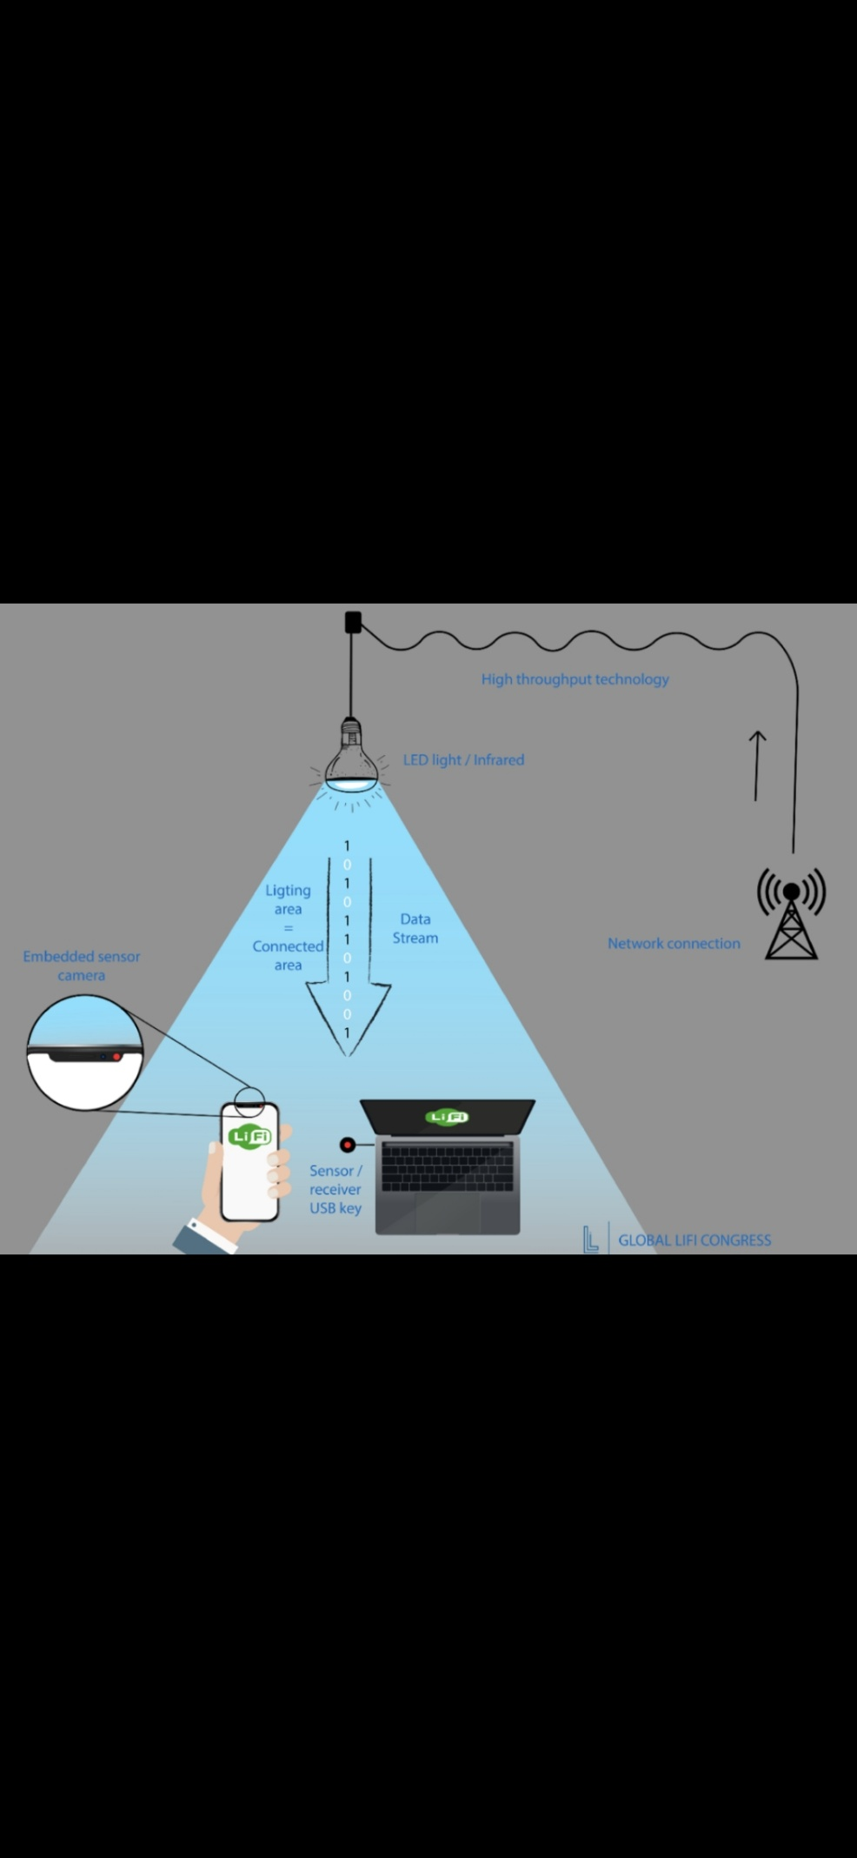
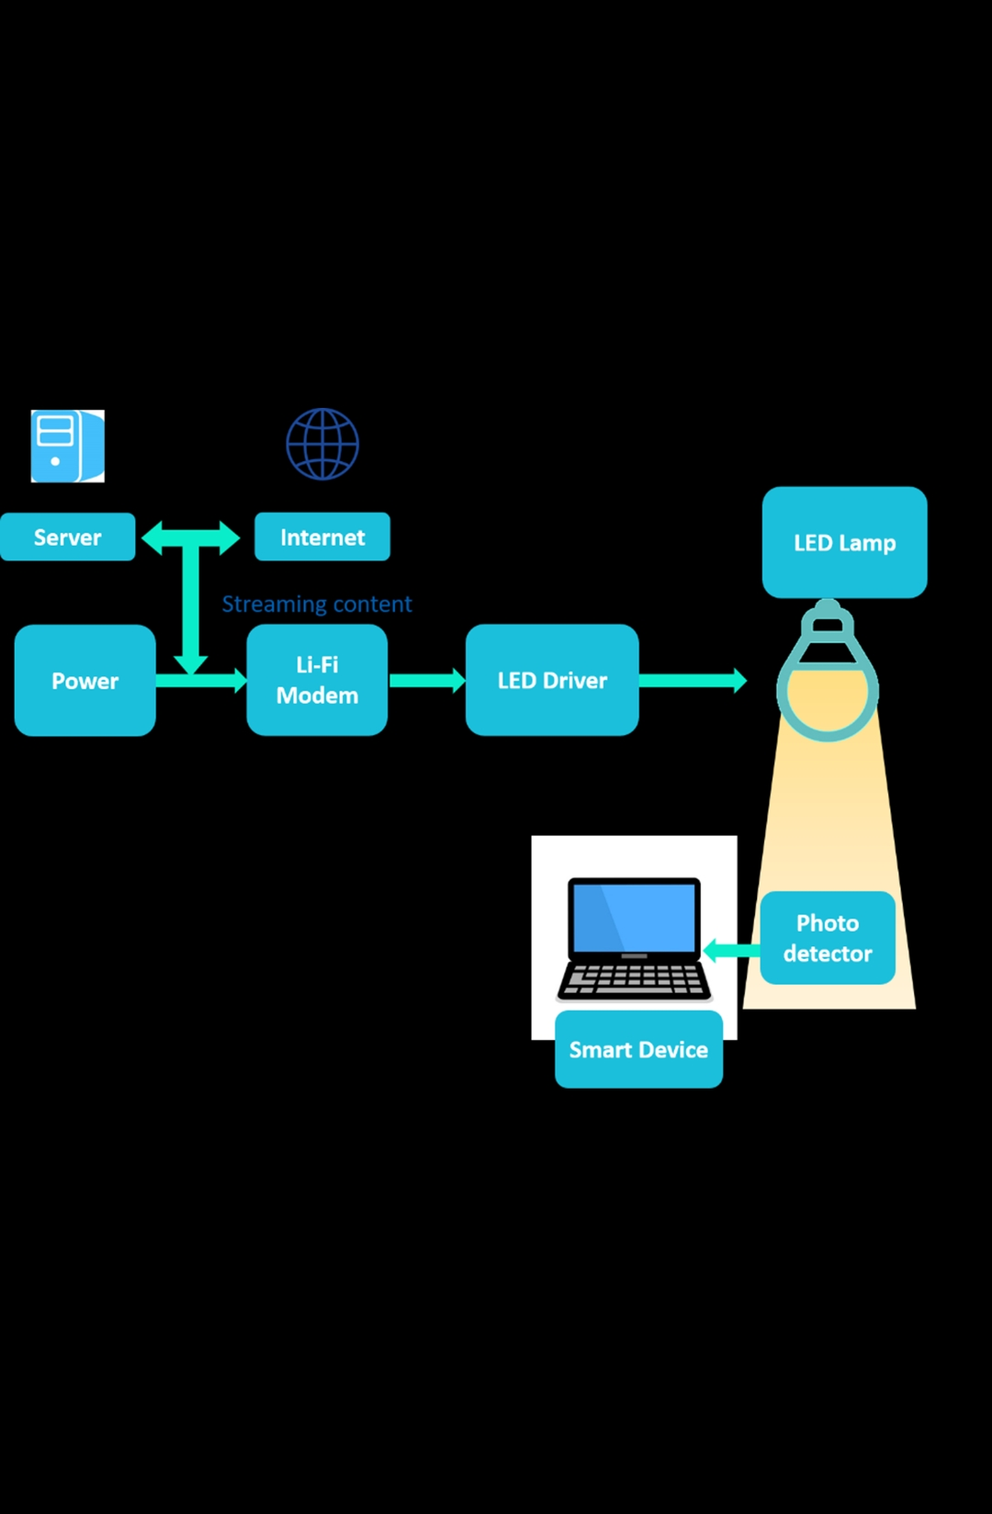

- Example of LIFI technology

For example, in corridors, waiting rooms, patient rooms and operating theatres, Li-Fi technology will allow a light communication network, which will remove electromagnetic interference issues from smartphones and the use of Wi-Fi in hospitals.

6.Conclusion
The Li-Fi technology is now developed into a ubiquitous system technology with innovative networking capabilities for universal application to The Li-Fi technology is now developed into a ubiquitous system technology with innovative networking capabilities for universal application to provide a variety of device platforms for high-speed internet communications

