3D Animation

3D animation is a graphic technique that utilizes motion in order to bring characters, objects, props, and more to life. Though 3D animation has primarily been used in the creation of video games, films, and TV shows, its usages have grown alongside its popularity.
Example: Pixar (Toy Story, Frozen, The Incredibles) Dreamworks (Shrek, How to Train Your Dragon) Feature Film CGI (the dinosaurs in Jurassic Park, the robots in Transformers, pretty much everything in Avatarj
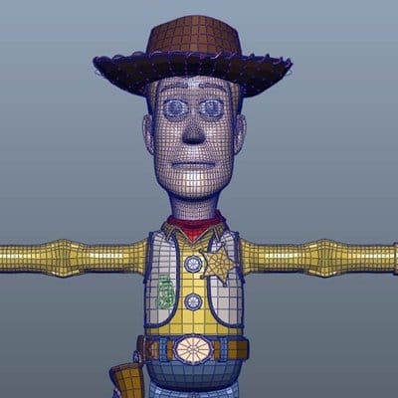

Types of 3D Animation
3D Video and Film. Among the types of 3D animation, 3D video and film is the most common. ...
Interactive 3D. This is a 3D animation production that features purely digital realm and created using a 3D computer software. ...
Virtual Reality 3D. ...
Inverse Kinematics. ...
Fluid Simulation. ...
3D Skeletal Animation.

: Forms of Animation
Traditional Animation
2D Animation.
- Traditional Animation
Traditional animation is an animation technique in which each frame is drawn by hand. The technique was the dominant form of animation in cinema until the advent of computer animation.

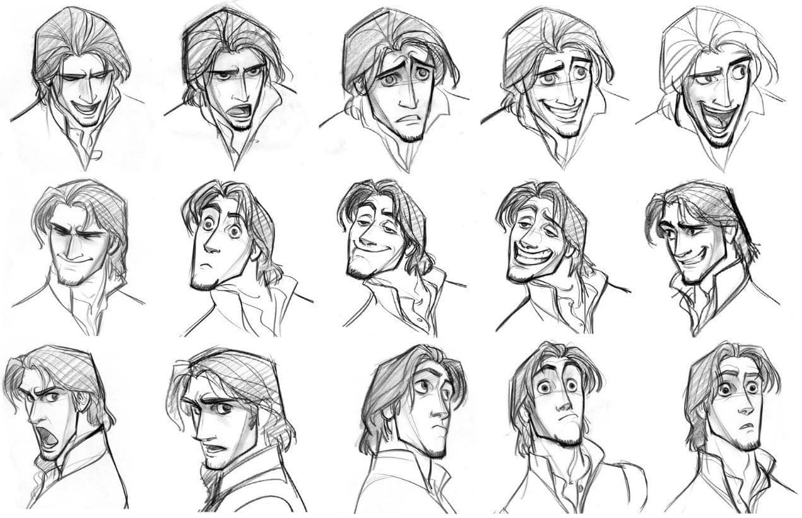
- 2D Animation
two-dimensional animation: animation, or a product of animation, created when two-dimensional images are rapidly sequenced to create the illusion of lifelike motion, as in traditional drawn animation, cel animation, or computer-generated vector graphics.

