Social Media Networks

A Project Report Submitted
for

Information Technology
By
SANJANA SHARMA
(Roll no.27)
Under the guidance of
Mr. Praveen Kumar Joshi



EVER GREEN SENIOR SECONDARY SCHOOL
(GOVERNED BY EDUCATIONAL WELFARE SOCIETY)
TULARAMPUR - 223139, DISTRICT-NAINITAL
UTTARAKHAND, INDIA

OCTOBER, 2021

CERTIFICATE

This is to certify that the project entitled “Social media networks ” being submitted to Evergeen Senior Secondary School, Haldwani for the project work of INFORMATION TECHNOLOGY is a record of the work carried by SANJANA SHARMA under my guidance and supervision.

Date: Supervisor
MR. PRAVEENJOSHI
TGT Computer
Ever Green Sr. Sec. School, Haldwani
Forwarded By:
MR. M.S. PARWAL
Principal
Ever Green Sr. Sec. School, Haldwani

ABSTRACT
Social media is a very important factor in analysing modern society as a whole, their values, norms and behaviour as being apart of our daily life . This study is oriented towards analysing social media in order to allow users to create their own preference to follow analyse a specific social media source. The web application has been developed to follow a user to follow specific Facebook accounts and categories the Facebook post on those accounts based on the user defined taxonomies. Result of this study are various reports generated from the Facebook post and their statistics that are clustered based on the user-defined taxonomic. The benefit of this project is that any user can track in real time when people are talking about some topics and it enables anyone to have better insight about society as a whole their values norms but they find interesting and many other things this tool is also useful for different companies to track the user feedback on social networks for their product.
Social networking site is a java-based project which allows people to communicate ,share ideas, activities, events with in the network. This system focuses on online communication. This system allows the user to promote social responsibilities like traffic rules, public hygiene, aversion ect.

ACKNOWLEDGEMENTS
I would like to express my most sincere heartfelt gratitude and respect to my supervisor MR. PRAVEEN JOSHI, for suggesting the topic for my project work and for his excellent guidance, valuable suggestions and endless support throughout for preparing the report. I am greatly indebted to him for his constructive suggestions and criticism from time to time during the course of progress of my work.
I would like to express my gratitude and sincere thanks to Mr. M.S. Parwal, Principal of School, and entire faculty who has imparted considerable knowledge to me.
Finally, I express my deepest gratitude to my parents for their continuous encouragement, understanding and support.

(SANJANA SHARMA)

TABLE OF CONTENTS

Chapter | Topic | Page No.
 | CERTIFICATE
 | ACKNOWLEDGEMENT
 | LIST OF FIGURES
 | ABSTRACT
1. | INTRODUCTION
1.1 | What is social? | 1
1.2 | What is media? | 1
1.2.1 | Types of media | 2
1.2.2 | What is social media? | 3-4
1.2.3 | Understanding Social media | 5
2. | Types of social media | 5
3. | Benefits of social media | 6
4. | Advantage of social media | 6
4.1 | Disadvantage of social media | 6
4.2 | What is networks ? | 7
4.3 | Types of networks | 7
4.4 | What is social networking? | 8
5. | How social networking works? | 9
6. | SUMMARY AND FUTURE WORK | 16
 | REFERENCES | 17-18

LIST OF FIGURES

S.No. | Name | Page No.
1. | Media | 2
2. | Social media | 4
3. | Social networking sites | 5
4. | Networks | 8
5. | L.A.N(local are networks) | 9
6. | W.A.N(wide area network) | 9
7. | Thank you image | 10

According to my topic let first of all we have to know no that what is social? , what is media? And what is network? So let us start with social.
We can define social as many types are as follow.
- Enjoying other people- sociable social person.
- Relating to interaction with other people specially for pleasure a busy social life.
If you are social, you like to be around people… the word social comes from the Latin Socius meaning “friend” . When you're being social, Your everyone's friend. Go to social, or mixer , and you might makes a lot of new friends.
The definition of social is someone or something that enjoys being with others or has to do with people living or gathering in groups.
Or
Of or having to do with human beings living together as a group in a situation in which they are dealing with one another affect their common welfare.
An example of social is people forming a community health clinic , children laughing and playing together is also a social example.
- Now discuss about what is media?
The term media, which is the plural of medium refers to the communication channels through which are disseminate news, music, movies, education, promotional massages and other data. It includes physical and online newspaper and magazines, telephone, the internet , fax and billiboards.
It describes the various ways through which we communicate in society. Because it refers to all means of communication, everything ranging from telephone call to the evening news on television can be call media.
When talking about reaching a very large number of people we say mass media. Local media refers to, for example , your local newspaper, or local / regional T/V radio channels.
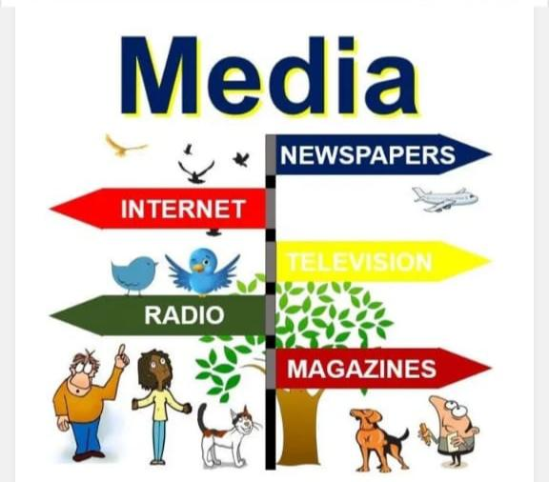
We used to get all our news and entertainment via TV, Radio Newspapers and magazines. Today the internet is gradually taking over. Print newspapers are struggling as hundreds of millions of people each year switch to news sources online.
- Different types of media
Media can be broken down into two main categories broadcast and print. The internet has also emerged as a major player, as a rapidly growing number of people globally get their news,movies etc. Online.
Print media includes all types of Publications including newspaper,journals magazines ,books and reports. It is the oldest type and despite suffering since the emergence of the internet , is still used by a major proportion.
Broadcast media refers to radio and T.V ,which came onto the scene at the beginning and metal of 20 century respectively. Most people still get their news from TV and radio broadcasts – however, experts predict that it will not be long before online sources take over.
Over the past twenty years , cable news has grown in importance.
The internet – specifically website and blogs – are rapidly emerging as viable and major channels of communication as more and more people seek news, entertainment online. Virtually every part of the internet has become a medium of communication- most free email services have little boxes that display ads and other massages.
The internet as we know it today did not really take off until the 1990. In 1995 just 1% of the world population was online compared to over 49% today list of the notion of the internet started in the 1960 in the USA during the cold war former when the military and scientist where was it about missile atack which could knock out the telephone system.
Stephen Hawking, British theoretical physicist, cosmologists, author and director of research at the centre for Theoretical cosmology within the university of Cambridge, once said : “The media need Superhouses in science just as in every sphere of life, but there is really a continuous range of abilities with no clear dividing line.”
Now we merge the word social and media and makes a new term social media. Now it is the question that.
- What is social media ?
Social media is a computer- based technology that facilitates the sharing of ideas ,thoughts and information through the building of virtual networks and communities . By design , social media internet based and gives users quick electronic communication of content.
Content includes personal information, documents, videos and photos .users engage with social media via a computer tablet or smartphone via web-based software or applications.
While social media is ubiquitous in America and Europe, Asian countries like Indonesia lead the list of social media usage . More than 3.8 billion people use social media.
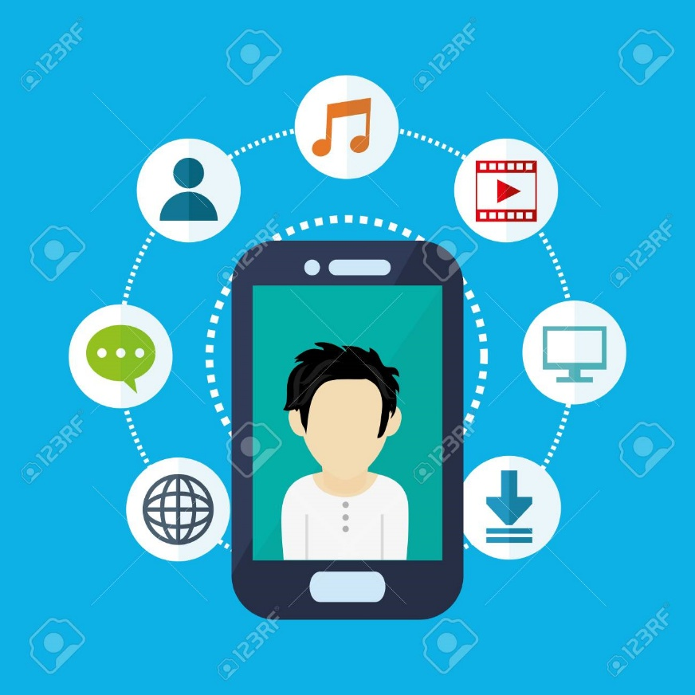
KEY TAKEWAYS
- Social media is a Computer Based technology that facilities the sharing of ideas thought and information through the building of virtual networks and communities.
- The largest social media networks include Facebook Instagram Twitter and YouTube.
- Social media type Italy feature user generated content and personalised profile.
- By 2023 the number of social media users in the United State is fore caste to increase to approximately 3257 million.
- Understanding Social Media
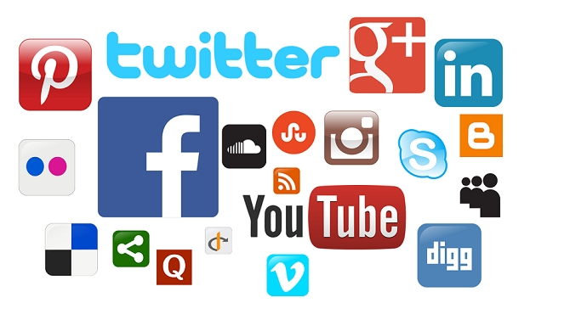
Social media originated as a way to interact with friends and family but was later adopted by businesses that wanted to take advantage of a popular new communication method to reach out to customers. The power of social media is the ability to connect and share information with anyone on earth ,or with many people simultaneously.
Globally, there are more than 3.8 billion social media users. Social media is an ever -changing and ever- Evolving field , with new apps such as clubhouse coming out seemingly every year , joining the ranks of established social networks like Facebook, YouTube Twitter and Instagram. By 2023 the number of social media users in the united state is forecast to increase to approximately 257 million.
According to the pew Research Centre social media users tend to be younger. Nearly 90% of people between the age of 18 and 29 use at least one form of social media. Further these users tend to be better educated and relatively wealthy , or earning over $75,000 per year.
Types of social media
Social media may take the form of variety of teach-enable activities. These activities include photo sharing, blogging , social gaming , social network, video sharing , business network, virtual world reviews and much more. even governments and politicians utilise social media to engage with constituent and voters.
For individual , social media is used to keep in touch with friends and extended family .Some people will use various social media applications to network career opportunities, find people across the floor with like minded interest, and sharing their thoughts , feelings , insights and emotions those who engage in these activities are part of virtual social network.
For businesses , social media is an indispensable tool. Companies use the platform to find and engage with customers and drive sales through advertising and promotion , gauge consumer trends and offering Customer services or support.
Social media role in helping businesses is significant. It facilitates communication with customers, enabling the melting of social interaction on E-Commerce sites. Its ability to collect information help focus on marketing efforts and market research. It helps in promoting products and services as it enables the distribution of targeted timely and exclusive sales and coupons to would-be customers Further , social media can help in building customer relationship through loyalty programs linked to social media.
Example of social media- Facebook is the largest social media platform in the world with a clear advantage over other social media through it has similar audiences to others like Twitter and Instagram for list of the figures for the most popular social media websites as of January 2021 are as follows.
- Facebook (2.74 billion users)
- YouTube (2.29 billion users)
- WhatsApp (2 billion users)
- Facebook messenger (1.3 billion)
- Instagram (1.22 billion user)
Facebook, YouTube, WhatsApp are the world largest social media networks.
BENEFITS OF SOCIAL MEDIA
Social media has changed the way that we all interact with each other online. It given us the ability to discover what happening in the world in their time to connect with each other and stay in touch with long distance friends and in order to have access to Endless amounts of information at your fingertips. In many senses social media has helped many individual find common ground with others online , making the world seem more approachable.
Advantage of social media
- You reach large audiences.
- You have a direct connection with your audience.
- You can create organic content.
- You have access to paid advertising services.
- You build your brand.
- You drive traffic to your website.
- You can evaluate your performance.
- You can join social media networks for free.
- You can create viral content.
- You can uncover valuable insights.
Disadvantages of social media.
- You can receive negative feedback.
- You open up the potential for embarrassment.
- You must spend a lot of time on your campaigns.
- You have to wait to see results. Etc.
Now ,
- What is a Network ?
A network consists of two or more computers that are linked in order to share resources (such as printers and CDs) , exchange files ,or allow electronic communications. The computers on a network may be linked through cables , telephone lines , radio waves , satellites, or infrared light beams.

Two very common types of networks include:
- Local area network (LAN)
- Wide area network (WAN)
You may also see references to a metropolitan area networks (MAN),a wireless LAN(WLAN),or a wireless WAN(WWAN).
- Local area network

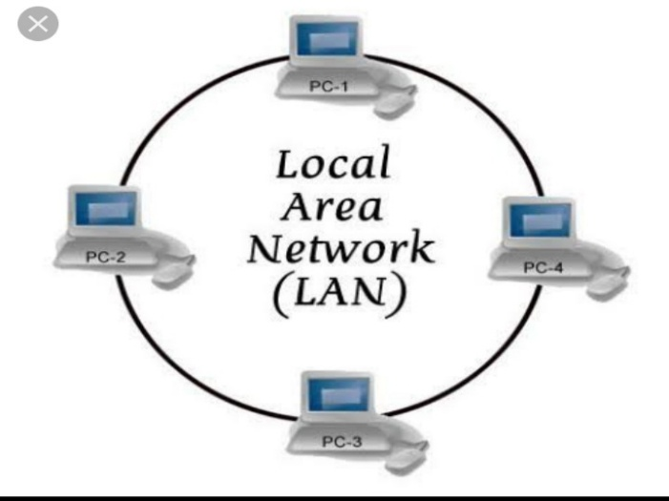
A local area network (LAN) is a network that is confined to a relatively small area. It is generally limited to a geographic area such as writing lab, school or building computers connected to a network are broadly categorized as servers or workstations.
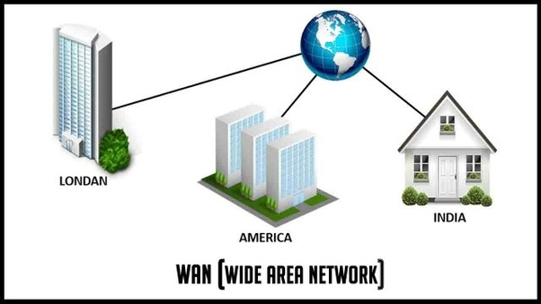
- Wide area network (WAN)

Wide area network (WAN) connect networks in a large geographic areas, such as floride, the united states , or the world .Dedicated transoceanic cabling or satellite uplinks may be used to connect this type of global networks.
- Social Networks – people use these networks to connect with one another and share information thought and ideas. The focus of these network is usually on the user. User profile help participants identify other users with common interest or concerns. Facebook and LinkedIn are good examples.
- What is social networking?
Social networking is the use of internet based social media sites to stay connected with friends,family, colleagues ,customers or clients .
Social networking can have a social purpose a business purpose,or both ,through sites like Facebook, Twitter , LinkedIn , and Instagram . Social networking has become a significant base for marketers seeking to engage customers.
social network, in technology parlance, is a website or other application where people, often of similar interests, come together to communicate with each other and share information including photos, videos, audio and written messages.
How social networking works?
Social networking involve the development and maintenance of personal and business relationship using Technology. This is done through the use of social networking sites such as Facebook Twitter and Instagram. These sites are allow people and corporations to connect with one another so they can develop relationship and so they can share information ideas and messages.

So this is my project ...

