Robotics

A Project Report Submitted
for

Information Technology
By
Divya bora
(Roll no. 12)

Under the guidance of
Mr. Praveen Kumar Joshi



EVER GREEN SENIOR SECONDARY SCHOOL
(GOVERNED BY EDUCATIONAL WELFARE SOCIETY)
TULARAMPUR - 263139, DISTRICT-NAINITAL
UTTARAKHAND, INDIA

OCTOBER, 2021

CERTIFICATE

This is to certify that the project entitled “Robotics” being submitted to Evergeen Senior Secondary School, Haldwani for the project work of INFORMATION TECHNOLOGY is a record of the work carried by MR. PRAVEEN KUMAR JOSHI under his guidance and supervision.

Date: 09/10/2021 Supervisor
MR. PRAVEENJOSHI
TGT Computer
Ever Green Sr. Sec. School, Haldwani
Forwarded By:
MR. M.S. PARWAL
Principal
Ever Green Sr. Sec. School, Haldwani

ACKNOWLEDGEMENTS
I would like to express my most sincere heartfelt gratitude and respect to my supervisor MR. PRAVEEN JOSHI, for suggesting the topic for my project work and for his excellent guidance, valuable suggestions and endless support throughout for preparing the report. I am greatly indebted to him for his constructive suggestions and criticism from time to time during the course of progress of my work.
I would like to express my gratitude and sincere thanks to Mr. M.S. Parwal, Principal of School, and entire faculty who has imparted considerable knowledge to me.
Finally, I express my deepest gratitude to my parents for their continuous encouragement, understanding and support.

(Divya Bora)

Abstract

The 21st century is a century for robotics. Robots have long borne the potential to bridge the gap between the cybernetic world (the internet of things) and the physical world. As the most promising candidate to theme the next major industrial revolution succeeding the present third (digital) industrial revolution, robotics is set to play an ever increasingly important role in society for its influence in every aspect of life in Hong Kong, including medicine and healthcare, building service, manufacturing, food production, logistics and transportation.

Table of Contents
Chapter | Topic | Page No.
1 | Introduction | 6
2 | History | 6-7
3 | Laws of Robotics by Asimov | 7
4 | Robotics Aspects | 7-9
4.1 | Mechanical construction | 7
4.2 | Electrical Aspect | 8
4.3 | A level of Programming | 8-9
5 | Types of Robots | 9-13
5.1 | Humanoid Robots | 10
5.2 | Drone Technology | 11
5.3 | Robotics in Educational field | 11
5.4 | Exoskeleton | 11-12
5.5 | Self-driving Cars | 12
6 | Robotics and AI | 13-14
6.1 | Assembly | 13
6.2 | Packaging | 14
6.3 | Customer Service | 14
6.4 | Open-source robotics | 14
7 | Advantages of Robotics | 14-15
8 | Future Work | 15-16
9 | Summary | 16
10 | References | 16

List of Figures
S. no. | Name | Page No.
1. | Unimate | 6
2. | Mechanical Aspects | 8
3. | Electrical components | 8
4. | Programming | 9
5. | Ocean One | 10
6. | Exoskeleton | 12
7. | Tesla car | 12
8. | Robots and AI | 13

1. Introduction
The word Robot comes from the Slavic word “Robota” which means Slave or Servant. Robotics is an interdisciplinary field that integrates computer science & engineering. Robotics involves design, construction, operation, and use of robots. The goal of robotics is to design machines that can help and assist humans. Robotics integrates fields of mechanical engineering, and electrical engineering, information engineering, bioengineering, software engineering, among others.

2. History
In 1948, Norbert Wiener formulated the principles of cybernetics the basis of practical robotics.
The first digitally operated and programmable robot, the Unimate, was installed in 1961 to lift hot pieces of metal from a die casing machine and stack them.
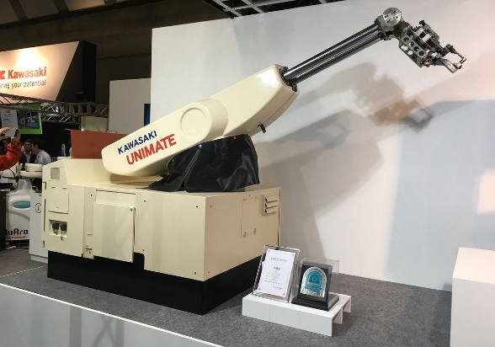
Fig 1. Unimate
Year | Development
Mid 1700s | Human Sized mechanical dolls that play music.
1801 | Jacquard Loom, a programmable machine for weaving threads.
1959 | First commercial robot introduced by planet corporation. It was controlled by switches and cams.
1960 | First Unimate Robot by Unimation.
1978 | PUMA (Programmable Universal Machine for Assembly) robot introduced by Unimation.
1979 | Development of SCARA robot at Yamanashi University in Japan.
2000 | Micro and Nano robots, Unmanned Ariel Vehicles and Under water robots.
2016 | Sofia, humanoid robot developed by Hanson Robotics.

3. Laws of Robotics by Asimov
  - A robot may not injure a human being or through inaction, allow a human to be harmed.
  - A robot must obey orders given by humans except when that conflicts with the first Law.
  - A robot must protect its own existence unless that conflicts with the First or Second Laws.

4. Robotic Aspects
There are many types of robots; they are used in many different environments and for many different uses. Although being very diverse in application and form, they all share three basic similarities when it comes to their construction:
4.1 Mechanical Construction: Robots all have some kind of Mechanical construction, a frame form or shape designed to achieve a particular task. For example, A robot designed to travel across heavy dirt or mud, might use caterpillar tracks. The mechanical aspects are mostly in the creator’s solution to completing the assigned task.

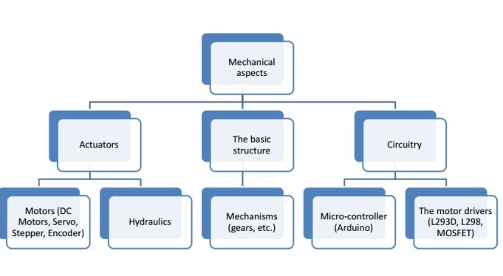
Fig 2. Mechanical Aspects
4.2 Electrical Aspects: Robots have electrical components that power and control the machinery. For example, the robot with caterpillar tracks would need some kind of power to move the tracker treads. That power comes in the form of electricity, which will have to travel through a wire and originate form a battery, a basic electrical circuit.
The electrical aspects of robots are used for movement (through motors), sensing (where electrical signal are used to measure things like heat, sound, position and energy status) and operations.
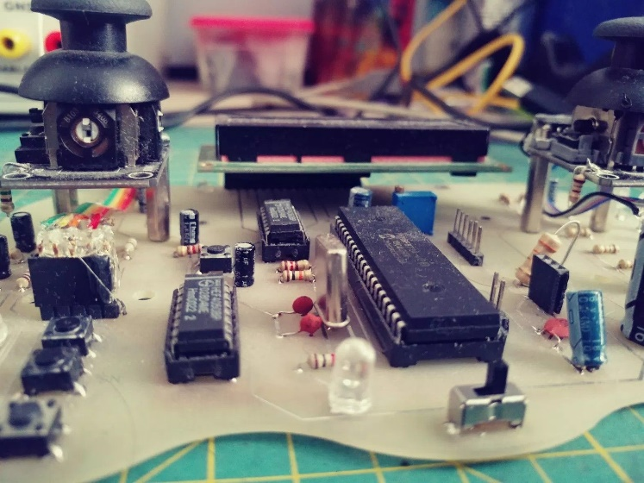
Fig 3. Electrical Components
4.3 A level of Programming: All robots contain some level of computer programming code. With the help of program robot decides when or how to do something. For example, in a caterpillar track, a robot that needs to move across a muddy road may have a correct mechanical construction or have a powerful battery but it would not go anywhere without program telling it to move.

There are 3 different types of robotics programs:
- Remote Control
- Artificial Intelligence
- Hybrid
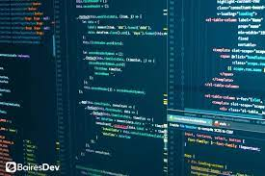
Fig 4. Programming
4.3.1 Remote Control: A robot with remote control programming has a pre-existing set of commands that it will perform if it receives a signal from a control source.

4.3.2 Artificial Intelligence: Robots that use artificial intelligence does not need any control source. The interact with their environment on their own.

4.3.3 Hybrid: Hybrid is a form of programming that incorporates both AI and RC functions in them.

5. Types of Robots
- Humanoids
- Drones
- Education
- Exoskeleton
- Self-driving car
- Disaster Response
- Entertainment
5.1 Humanoid robot: A humanoid robot is a robot with its body shape built to resemble the human body. In general, humanoid robots have a torso, a head, two arms, and two legs, though same humanoid robot may replicate only part of the body, for example, from the waist up. Some humanoid robots also have head designed to replicate human facial features such as eyes and mouths.
Some examples of humanoid robots:
5.1.1 Ocean one: A bimanual underwater humanoid robot created by the Stanford Robotics Lab to explore coral reefs, ocean one can reach depth that most human being cannot. Its design features two multi-directional thrusters and stereoscopic vision.
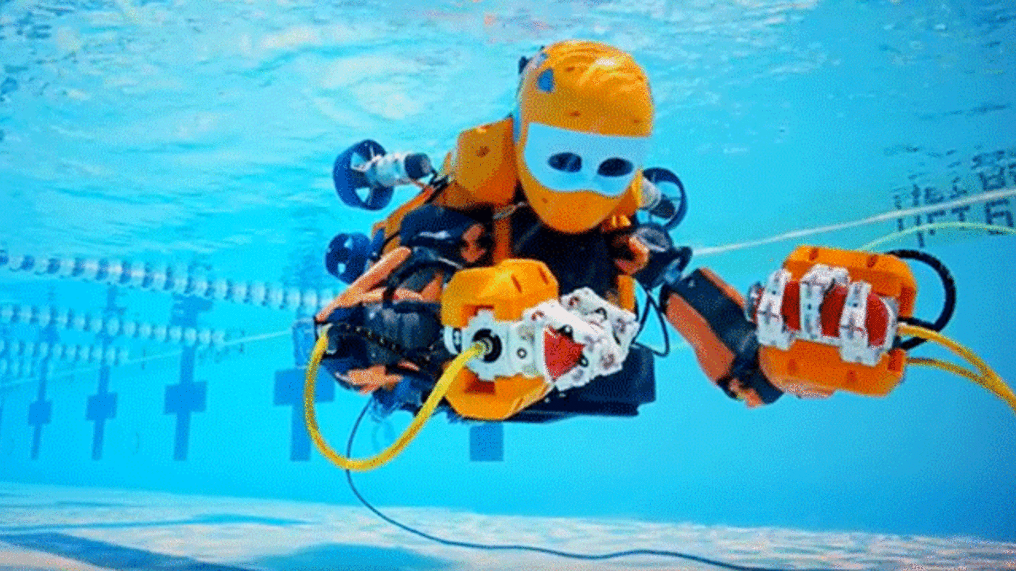
Fig 5. Ocean One
5.1.2 Atlas: Describe as “the world’s most dynamic humanoid” by its creators, ATLAS was unveiled in 2013. It was built to carry out search and rescue missions and was developed by Boston Dynamics with funding and supervision from the United States Defense Advanced Research Projects Agency (DARPA).
It can navigate its way through tough terrain and obstacles in its path using its range sensing, stereo vision, and other sensors.
5.1.3 Sophia: Sophia was developed by roboticist David Hanson and his company Hanson Robotics. She is a humanoid robot was activated in April 2015 and came to international renown in October 2017 after that she was granted citizenship by the Kingdom of Saudi Arabia.
Sophia was given ‘legs’ in January 2018 and can move now. From appearing on shows like The Tonight Show Starring Jimmy Fallon and Good Morning Britain, to delivering talks at institutions like IIT Bombay, Sophia has grown to be a sensation.
Before being known for receiving a one-of-a-kind citizenship.

5.2 Drone Technology: The term “Drone” usually refers to any unpiloted aircraft. Sometimes, referred to as “Unmanned Aerial Vehicles” (UAVs), These craft can carry out an impressive range of tasks, ranging from military operation to package delivery. Drones can be as large as an air craft or as small as the palm of your hand.

5.3 Robotics in Educational field: Robots are increasingly being used to teach students in the classroom for a number of subjects across science, math and language. But research shows that while students enjoying learning robots, teachers are slightly reluctant to use them in the classroom.
They preferred the robot not to have full autonomy and instead take on restricted roles in the classroom, the teachers also wanted full control over the robot. We observed that the teacher was in general unaware of robots and hence there was a technological bias associated with their opinion.

5.4 Exoskeleton: The field of exoskeleton systems is continuously evolving and re-inventing itself, so it is still difficult to create a singular definition. In general:
- Exoskeletons are wearable devices that work in tandem with the user. The opposite of an exoskeleton device would be an autonomous robot that works instead of the operator.
- Exoskeletons are placed on the user’s body and act as amplifiers that augment, reinforce or restore human performance. The opposite would be a mechanical prosthetic, such as a robotic arm or leg that replaces the original body part.
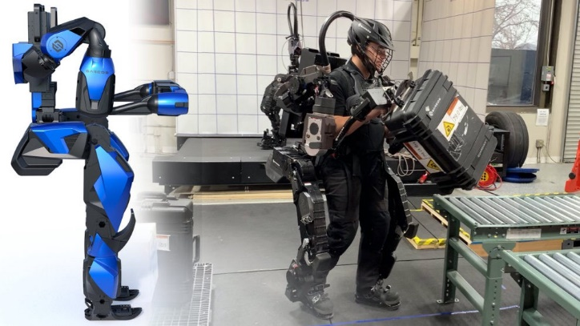
Fig 6. Exoskeleton
- Exoskeletons can be made out of rigid materials such as metal or carbon fibre, or they can be made entirely out of soft and elastic parts.
- Exoskeletons can be powered and equipped with sensors and actuators, or they can be entirely passive.
- Exoskeletons can be mobile or fixed/suspended (usually for rehabilitation or teleoperation).
- Exoskeletons can cover the entire body, just the upper or lower extremities, or even a specific body segment such as the ankle or the hip.
5.5 Self-driving cars: An autonomous car is a vehicle capable of sensing its environment and operating without human involvement. A human passenger is not required to take control of the vehicle at any time, nor is a human passenger required to be present in the vehicle at all. An autonomous car can go anywhere a traditional car goes and do everything that an experienced human driver does.
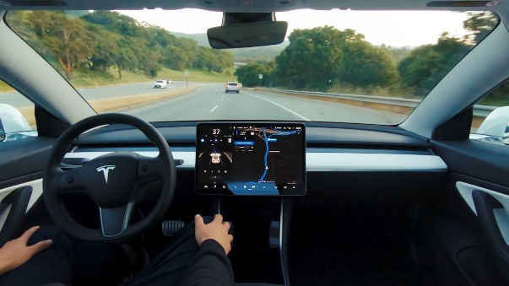
Fig 7. Tesla car

6. Robotics And AI
Artificial intelligence (AI) and robotics are a powerful combination for automating tasks inside and outside of the factory setting. In recent years, AI has become an increasingly common presence in robotic solutions, introducing flexibility and learning capabilities in previously rigid applications.
While AI is still in its nascent stages, it’s been a transformative technology for some applications in the manufacturing sector, although there are many that have yet to feel the impact.
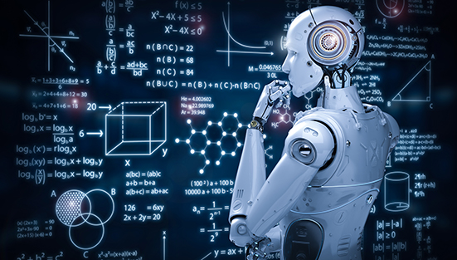
Fig 8. Robots and AI
Robotic Applications that Use Artificial Intelligence
In today’s global manufacturing sector, there are a few main ways in which AI is deployed.
  - Assembly
AI is a highly useful tool in robotic assembly applications. When combined with advanced vision systems, AI can help with real-time course correction, which is particularly useful in complex manufacturing sectors like aerospace. AI can also be used to help a robot learn on its own which paths are best for certain processes while it’s in operation.
  - Packaging
Robotic packaging uses forms of AI frequently for quicker, lower cost and more accurate packaging. AI helps save certain motions a robotic system makes, while constantly refining them, which makes installing and moving robotic systems easy enough for anybody to do.
  - Customer Service
Robots are now being used in a customer service capacity in retail stores and hotels around the world. Most of these robots leverage AI natural language processing abilities to interact with customers in a more human way. Often, the more these systems can interact with humans, the more they learn.
6.4 Open-Source Robotics
A handful of robotic systems are now being sold as open-source systems with AI capability. This way, users can teach their robots to do custom tasks based on their specific application, such as small-scale agriculture. The convergence of open-source robotics and AI could be a huge trend in the future of AI robots.
When working together, robots are smarter, more accurate and more profitable. AI has yet to come close to reaching its full potential, but as it advances, so will robotics.

7. Advantages of robotics
7.1 Safety: Safety is the most obvious advantage of utilizing robotics. Heavy machinery, machinery that runs at hot temperature, and sharp objects can easily injure a human being. By delegating dangerous tasks to a robot, you’re more likely to look at a repair bill than a serious medical bill or a lawsuit. Employees who work dangerous jobs will be thankful that robots can remove some of the risks.

7.2 Speed: A robot will never feel stressed out and start running slower. They also don’t need to be invited to employee meetings or training session. Robots can work all the time, and these speeds up production.

7.3 Consistency: Robots never need to divide their attention between a multitude of things. Their work is never contingent on the work of other people. They won’t have unexpected emergencies, and they won’t need to be relocated to complete a different time sensitive task. They’re always there, and they’re doing what they’re supposed to do. Automation is typically far more reliable than human labour.

7.4 Perfection: Robots will always deliver quality. Since they’re programmed for precise, repetitive motion, they’re less likely to make mistakes. In some ways, robots are simultaneously an employee and a quality control system. A lack of quirks and preferences, combined with the eliminated possibility of human error, will create a predictably perfect product every time.

7.5 Happier Employees: Since robots are often assigned to perform tasks that people don’t particularly enjoy, like menial work, repetitive motion, or dangerous jobs, your employees are more likely to be happy. They’ll be focusing on more engaging work that’s less likely to grind down their nerves. They might want to take advantage of additional educational opportunities, utilize your employee wellness program, or participate in an innovative workplace project. They’ll be happy to let the robots do the work that leaves them feeling burned out.

7.6 Job Creation: Robots don’t take jobs away. They merely change the jobs that exist. Robots need people for monitoring and supervision. The more robots we need, the more people we’ll need to build those robots. By training your employees to work with robots, you’re giving them a reason to stay motivated in their position with your company. They’ll be there for the advancements and they’ll have the unique opportunity to develop a new set of techs or engineering related skills.

7.7 Productivity: Robots can’t do everything. Some jobs absolutely need to be completed by a human. If your human employees aren’t caught up doing the things that could have easily been left for robots, they’ll be available and productive.

8. Future Work

In future, Robots will be used for such works or tasks which are repetitive, boring and dangerous. Autonomous and AI powered robots will be placed in hospitals, mining, industries, manufacturing, schools, homes, offices and etc. So, most of the works will be replaced by the robots. So, this may lead to the loss of jobs of humans. But absolutely new jobs will also be created for controlling and managing the robots. So, people will need to learn the emerging technologies accordingly.

Summary

Robotics is an interdisciplinary field which includes mechanical engineering, electrical engineering, computer science, biotechnology, CAD modelling, etc. Nowadays, Robots are being used in many places. Mostly, the largest number of robots in India are Industrial robots in car manufacturing industries. And the scope of robotics is very high. It’s true that Robots make our work easier and till now they are doing their job perfectly. But in future, it may become dangerous for humans.

References

- https://en.m.wikipedia.org/wiki/Robotics
- Industrial Robotics: Technology, Programming and Applications by Mikell P Groover, Mitchel Weiss, Roger N Nagel, Nicholas G Odrey and Ashish Dutta
- https://theconversation.com/robots-likely-to-be-used-in-classrooms-as-learning-tools-not-teachers-6
- https://exoskeletonreport.com/what-is-an-exoskeleton/
- https://www.synopsys.com/automotive/what-is-autonomous-car.html
- https://www.roboticstomorrow.com/story/2018/08/7-advantages-of-robots-in-the-workplace/12342/
- https://robots.ieee.org/robots/?t=type
- https://builtin.com/robotics

