DevOps

A Project Report Submitted
for

Information Technology
By

Neelam
( Roll no:- 23
Under the guidance of
Mr. Praveen Kumar Joshi



EVER GREEN SENIOR SECONDARY SCHOOL
(GOVERNED BY EDUCATIONAL WELFARE SOCIETY)
TULARAMPUR – 263139, DISTRICT-NAINITAL
UTTARAKHAND, INDIA

OCTOBER, 2021

CERTIFICATE

This is to certify that the project entitled “DevOps” being submitted to Evergeen Senior Secondary School, Haldwani for the project work of INFORMATION TECHNOLOGY is a record of the work carried by MR. PRAVEEN KUMAR JOSHI my guidance and supervision.

Date:- 10-10-21 Supervisor
MR PRAVEEN KUMAR JOSHI
TGT Computer
Ever Green Sr. Sec. School, Haldwani
Forwarded By:
MR. M.S. PARWAL
Principal
Ever Green Sr. Sec. School, Haldwani

ACKNOWLEDGEMENTS

I would like to express my most sincere heartfelt gratitude and respect to my supervisor MR. PRAVEEN JOSHI, for suggesting the topic for my project work and for his excellent guidance, valuable suggestions and endless support throughout for preparing the report. I am greatly indebted to him for his constructive suggestions and criticism from time to time during the course of progress of my work.
I would like to express my gratitude and sincere thanks to Mr. M.S. Parwal, Principal of School, and entire faculty who has imparted considerable knowledge to me.
Finally, I express my deepest gratitude to my parents for their continuous encouragement, understanding and support.

( Neelam )

Abstract
Today I’ll tell about DevOps that DevOps is a collaboration of development and operations . To understand DevOps, we need to understand the responsibilities of two teams involved in software delivery :- Development and Operations. The responsibility of Development team is to ship software to Production, as soon as possible, as much as possible. The responsibility of Operations team is to keep the production systems stable.
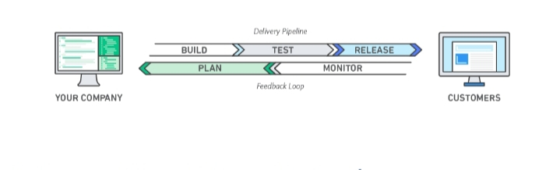
Figure1:- DevOps model

DevOps is the combination of cultural philosophies, practices and tools that increases an organizations ability to deliver applications and services at high velocity. It evolve and improve products at a faster pace than organizations using traditional software development and infrastructure management processes. This speed enables organization to better serve their customers and complete more effectively in the market.

1:- Introduction
1.1:- What is DevOps ?
DevOps is the collaboration between development and IT operations to make software production and deployment in repeatable way.
DevOps is a combination of two words,' Development ' and ‘Operations ’.

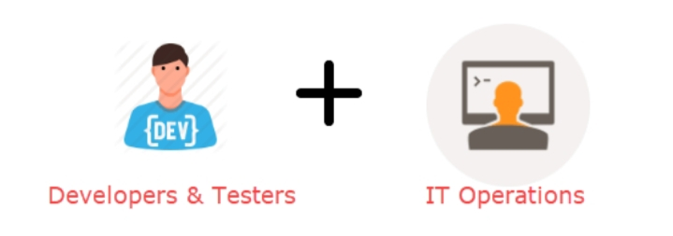
Figure 2:- Development and Operations
DevOps text to increase the organization speed to deliver soft via applications and Services it allows organizations to server the customers better and more strongly in the market.
1.2:- DevOps is a methodology ?
- A set of principal and practices.
- It helps both developers and operator to reach their goals.
- My difference between developer and operators is called Wall of confusion .
- Difference between ‘developers’ and ‘operators ’
The difference between development and operators is called ‘ Wall of confusion ’.
1.2.1:- Wall of confusion
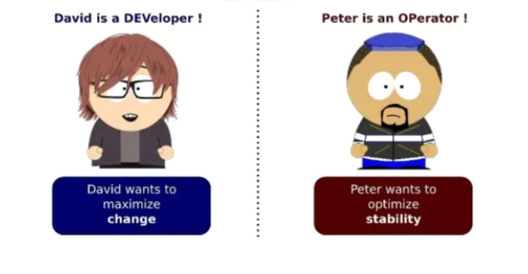
Figure 3:- Wall of confusion.
2:- Roles of Dev and Ops
- DevOps has become one of the most valuable business disciplines for enterprises or organizations. With the helps of DevOps quality and speed the application delivery has improved.
- DevOps is nothing but a practice or methodology of making ‘ Developers ' and ‘ Operations ’ work together.
- DevOps is a software development method that emphasizes on communication ,collaboration, integration, automation and measurement and cooperation between software developers and other IT professionals.
2.1:- Dev
- Dev create changes.
- Dev add or modify features.
2.2:- Ops
- Have a common goal.
- Working together.
- Optimization of team performance.

3:- Benefits of DevOps :-
3.1:- Speed
- Move at high velocity so you can invite for customers faster adapt to changing markets better, and group more efficient at driving business results. The DevOps model enable your developers and operations teams to achieve these results. For example, micro services and then release updates of them quick.
3.2:- Rapid delivery
Increase the frequency and pace of releases so you can innovate and improve your product faster. The quicker you can release new features and fix bugs, the faster you can respond to your customers’ needs and build competitive advantage. Continuous integration and continuous delivery are practices that automate the software release process, from build to deploy.
3.3:- Reliability
Ensure the quality of application updates and infrastructure changes so you can reliably deliver at a more rapid pace while maintaining a positive experience for end users. Use practices like continuous integration and continuous delivery to test that each change is functional and safe. Monitoring and logging practices help you stay informed of performance in real-time.
3.4:- Scale
Operate and manage your infrastructure and development processes at scale. Automation and consistency help you manage complex or changing systems efficiently and with reduced risk. For example, infrastructure as code helps you manage your development, testing, and production environments in a repeatable and more efficient manner.

4:- DevOps Architecture features

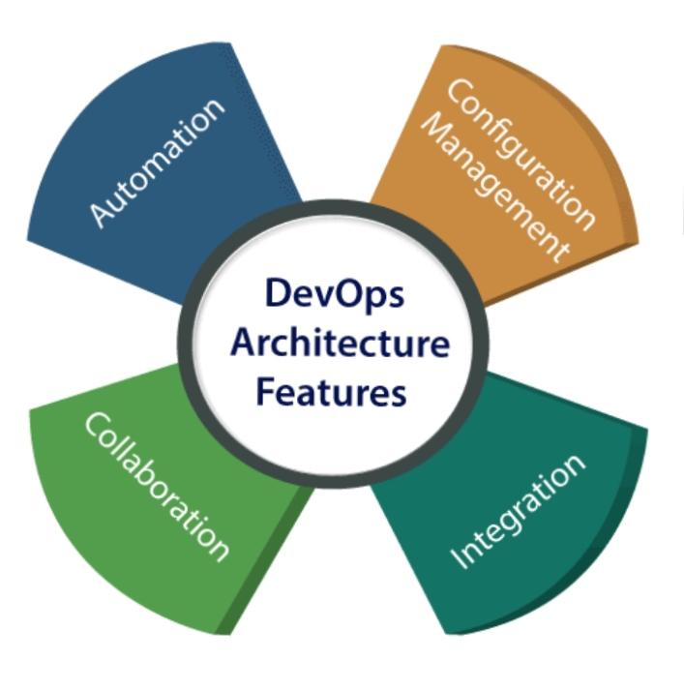

Figure 4:- DevOps architecture features

4.1:- Automation
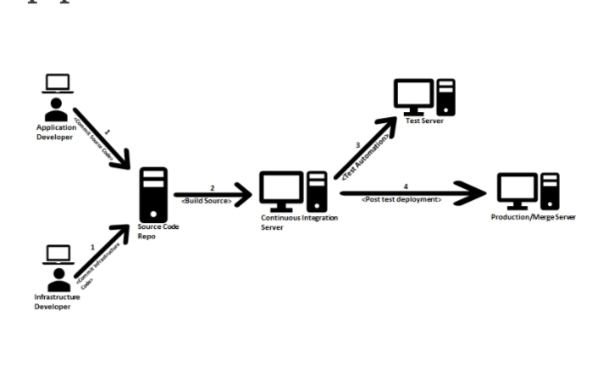
Figure 5:- Automation
Automation can reduce time consumption especially during testing and deployment phase. The productivity increases and releases are made quicker by automation.
For continuous delivery, each code is defined through automated tests. This promotes production busing automated deploys.

4.2:- Integration

Figure 6:- Integration
The integration phase is where the current code is combined with new function and then it tested. To overcome such problems, continuous integration and delivery are implemented to deliver in quicker, safer and reliable manner.
4.3:- Collaboration


Figure 7:- Communication
The Development and IT Operations team collaborates as a DevOps team. And improves the cultural model as the teams become more productive . The team share their responsibilities and work closely, which makes the deployment to production very faster.
4.4:- Configuration management
It ensures the application to interact with only those resources that are concerned with the environment in which it’s run. The configuration file can be written during deployment, or they can be loaded at the run time.
5:- DevOps advantages and Disadvantages
5.1:- Advantages
- DevOps is an excellent access for quick development and operations of application.
- It improves the customer experiences and enjoyment .
- It meant collection of responsibility that make the better team creativeness.
- It gives accuracy on product development and delivery .
- It responds very fast to the changes if market to improve business growth.
- It clarify our collaboration and all tools for customers to access.
- It sharp the business profit by decreasing software delivery time and transport cost.
5.2:- Disadvantages
- DevOps experts developers are less available .
- DevOps professional developers are also less available.
- The decrease in DevOps knowledge can be problem in continuous integration .
- It is so expensive by developing with DevOps .
- It is hard to manage in short time the new technology bof DevOps.
- The lack of DevOps knowledge can be problem in concord of automation projects.
6:- Why DevOps is needed ?
Before DevOps, the development and Operation would in team in complete isolation. Without using the DevOps, team members of the Developers and Operators are spending a large amount of their time in testing. So, that's why DevOps is needed.
7:- DevOps different from traditional IT ?
- In old process after placing an order for new servers the Development team works on testing and Operations team works on paperwork to deploy the infrastructure but in DevOps, after placing an order for new servers the deployment and Operations both team work together on paperwork to set the new servers.
- In old process, the operation team has no clue to progress the Development team but in DevOps, the Operation team completely aware of the progress of the Developers.
- In old process, before go-live , the load testing blast the application but in DevOps, before go-live, the load testing makes the application a bit slow.
8:- Why DevOps is used?
DevOps are used by some important reasons :-
8.1:- Reproductively :- Any version so that earlier version can be restored anytime .
8.2:- Maintainability:- The process of recovery is effortless in the event of a new release of disabling the current system.
8.3:- Predictability:- DevOps offers significantly lower failure rate new releases.
8.4:- Time to market :- DevOps reduces the time to market up 50% through symmetrically software delivery. This is the case for digital mobile applications
8.5:- Quality great and high:- DevOps both helps the team to provide improve quality of application development in infrastructure issues.
8.6:- Cost Efficiency:- DevOps office cost efficiency in the software development process which always an inspiration of IT companies management.
8.7:- Resiliency:- The operation state of the software is more stable, secure, and changes are auditable.
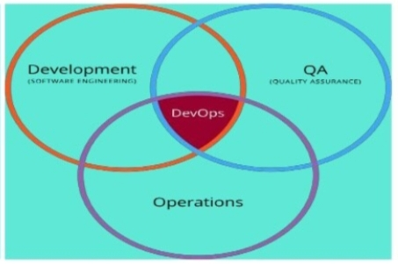
9:- DevOps – Working together
Figure 8:- DevOps work together
Improve technologic and process integration between development and operations.
- Have a common goal.
- Working together.
- Optimization of team performance.
- Work together for better performance.

Summary

DevOps is the talk of the town but many companies or Individuals had a wrong interpretation that, DevOps is a job? Or DevOps is a Software Product? DevOps is a concept with different interpretations and definitions, but when you get down to it, it’s all about developers and operations team working together to achieve the common goal.

Table of contents

Chapter | Topic |  |  | Page no.
 | CERTIFICATE
 | ACKNOWLEDGMENTS
 | ABSTRACT
 | TABLE OF CONTENTS
 | LIST OF FIGURES
1. | INTRODUCTION
1.1 | What is DevOps? |  |  | 5
1.2 | DevOps is methodology |  |  | 5
1.2.1 | Wall of confusion |  |  | 5
2. | Role of Dev and Ops |  |  | 5
2.1 | Dev |  |  | 6
2.2 | Ops |  |  | 6
3. | Benefits of devops |  |  | 7
3.1 | Speed |  |  | 7
3.2 | Rapid delivery |  |  | 7
3.3 | Reliability |  |  | 8
3.4 | Scale |  |  | 8
4. |  | DevOps architecture features | 9
4.1 |  | Automation | 10
4.2 |  | Integration | 10
4.3 |  | Collaboration | 11
4.4 |  | Configuration management | 11
5. |  | About DevOps | 12
5.1 |  | Advantage | 12
5.2 |  | Disadvantage | 12
6. |  | Why DevOps is needed? | 12
7. |  | DevOps different from traditional IT? | 13
8. |  | Why DevOps is used? | 13
8.1 |  | Reproducibility | 14
8.2 |  | Maintainability | 14
8.3 |  | Predictability | 14
8.4 |  | Time to market | 14
8.5 |  | Quality great and high | 14
8.6 |  | Cost efficiency | 14
8.7 |  | Reduced risk | 14
9. |  | SUMMARY | 15

List of figures
FIGURE | PAGE NO.
1. | 4
2. | 5
3. | 6
4. | 9
5. | 10
6. | 10
7. | 11
8. | 14

References:-

- Loukides, Mike (7 June 2012). "What is DevOps?". O'Reilly Media.
- ^ Dyck, Andrej; Penners, Ralf; Lichter, Horst (19 May 2015). "Towards Definitions for Release Engineering and DevOps". Proceedings of the 2015 IEEE/ACM 3rd International Workshop on Release Engineering. IEEE: 3. doi:10.1109/RELENG.2015.10. ISBN 978-1-4673-7070-7. S2CID 4659735.
- ^ Jabbari, Ramtin; bin Ali, Nauman; Petersen, Kai; Tanveer, Binish (May 2016). "What is DevOps?: A Systematic Mapping Study on Definitions and Practices". Proceedings of the 2016 Scientific Workshop. Association for Computing Machinery.
- ^ a b Erich, F.M.A.; Amrit, C.; Daneva, M. (June 2017). "A Qualitative Study of DevOps Usage in Practice". Journal of Software: Evolution and Process. 29 (6): e1885. doi:10.1002/smr.1885. S2CID 35914007.
- ^ Bass, Len; Weber, Ingo; Zhu, Liming (2015). DevOps: A Software Architect's Perspective. ISBN 978-0134049847.
- ^ Muñoz, Mirna; Negrete Rodríguez, Mario (April 2021). "A guidance to implement or reinforce a DevOps approach in organizations: A case study".
- ^ Chapman, M., Gatti, N: A model of a service life cycle, Proceedings of TINA '93, pp. I-205–I-215, Sep., 1993.
- ^ Crispin, Lisa; Gregory, Janet (October 2014). More Agile Testing. ISBN 9780133749571. Retrieved 6 May 2019.
- ^ a b Klein, Brandon Thorin (1 May 2021). "The DevOps: A Concise Understanding to the DevOps Philosophy and Science". doi:10.2172/1785164. OSTI 1785164. S2CID 236606284.
- ^ Gartner Market Trends: DevOps – Not a Market, but Tool-Centric Philosophy That supports a Continuous Delivery Value Chain (Report). Gartner. 18 February 2015.
- ^ "Principles behind the Agile Manifesto". agilemanifesto.org. Retrieved 6 December2020.
- ^ Castellanos, Camilo; Correal, Dario (15 September 2018). Executing Architectural Models for Big Data Analytics. Lecture Notes in Computer Science. 11048. pp. 364–371. doi:10.1007/978-3-030-00761-4_24. ISBN 978-3-030-00760-7.
- ^ Humble, Jez; Farley, David (2011). Continuous Delivery: reliable software releases through build, test, and deployment automation. Pearson Education Inc. ISBN 978-0-321-60191-9.
- ^ Chen, Lianping (2015). "Continuous Delivery: Huge Benefits, but Challenges Too". IEEE Software. 32 (2): 50–54. doi:10.1109/MS.2015.27. S2CID 1241241.
- ^ Beyer, Betsy; Jones, Chris; Petoff, Jennifer; Murphy, Niall Richard (April 2016). Site Reliability Engineering. O'Reilly Media. ISBN 978-1-4919-2909-4.
- ^ Emerging Technology Analysis: DevOps a Culture Shift, Not a Technology (Report). Gartner.
- ^ "Gartner IT Glossary – devops". Gartner. Retrieved 30 October 2015.
- ^ Jones, Stephen; Noppen, Joost; Lettice, Fiona (21 July 2016). Proceedings of the 2nd International Workshop on Quality-Aware DevOps - QUDOS 2016 (PDF). pp. 7–11. doi:10.1145/2945408.2945410. ISBN 9781450344111. S2CID 515140.
- ^ Mandi Walls (25 September 2015). "Building a DevOps culture". O'Reilly.
- ^ Chen, Lianping; Ali Babar, Muhammad (2014). "Towards an Evidence-Based Understanding of Emergence of Architecture through Continuous Refactoring in Agile Software Development". The 11th Working IEEE/IFIP Conference on Software Architecture(WICSA 2014). IEEE. doi:10.1109/WICSA.2014.45.
- ^ Teja Yarlagadda, Ravi (9 March 2021). "DevOps and Its Practices". SSRN 3798877.
- ^ Morisio, Maurizio (16 April 2021). DevOps: development of a toolchain in the banking domain. Politecnico di Torino (laurea). Retrieved 16 August 2021.

