Fundamentals of Databases
Biobank and Biospecimen Management System
Project Report

Fundamentals of Databases
Biobank and Biospecimen Management System
Project Report

Selected Topic: Biobank and Biospecimen Management System
DBMS Used: MySQL 8.0
Student Name: Ahmed Rami Fawzy
Student ID: 221000202
Course: CSCI305 – Fundamentals of Databases
Instructor: dr. Mohamed Mahmoud ElSayeh
Submission Date: 15/8/2026

1. Problem Statement, Scope, and Assumptions
1. Problem Statement, Scope, and Assumptions
1.1 Problem Statement
Biomedical research really relies on dependable collection, storage, and careful reusing of human biospecimens like blood, saliva, tissue, DNA and other similar materials. A biobank should be able to know which donor produced each specimen, what sort of consent that donor has given and also the history of withdrawal if it happened, where the specimen portion actually lives in real life storage, and which research projects used it, plus the reason or goal behind that use. Doing it with spreadsheets does not scale well, also introduces a bunch of practical hazards, because samples can get reused without the right consent, freezer inventory drifts out of alignment with what is actually inside, and tracing back a research outcome to its biological source becomes kind of messy and slow. In this project we design and implement a relational database for a Biobank and Biospecimen Management System (BBMS). The database organizes donors, informed consent, collection events, samples, the aliquots of each sample, storage locations, researchers, research projects, test requests, and the overall usage records showing how specimens get tied to specific research projects and their purposes.
1.2 Project Scope
The system focuses on the everyday operational heart of a research biobank, like the central workflows required to run it properly:
- Donor enrollment, and demographic record-keeping too.
- Informed consent capture, meaning consent type, withdrawal sequence or withdrawal tracking.
- Sample collection events, and the biological samples that are drawn during each event.
- Splitting those samples into individually tracked aliquots, plus their physic…
- Splitting of samples into individually tracked aliquots, and also where they physically sit (like freezer, rack, shelf, box position), basically all those details.
- Freezer temperature monitoring history, including the timeline and whatever is recorded, even if it looks kinda messy.
- Researcher and research project management, with project teams and roles, sorta.
- Test requests submitted by researchers or specific projects, plus the way those requests consume particular aliquots to fulfil them, even when it’s not the whole thing.
- Out of scope: billing/finance, laboratory instrument integration, external IRB workflow systems, and genomic/variant data storage (these are the obvious natural extensions but they’re not needed for the assessed scope of this project anyway).
1.3 Assumptions
- Each donor may participate in multiple collection events over time, for example a baseline visit then a follow-up later on.
- A donor can sign more than one consent form over time, e.g., an initial research-use consent and later a separate genetic-testing consent, and later a consent can be withdrawn without being physically deleted so the audit trail stays intact.
- A single collection event can yield more than one sample, like a blood tube and a saliva tube collected in the same visit.
- A sample is commonly split into multiple smaller aliquots, so different portions can be stored separately and used independently without freezing and thawing the whole original sample over and over.
- A research project has exactly one lead researcher but may have several additional team members collaborating on it, so it’s many-to-many between researchers and projects.
- Fulfilling a test request might involve consuming several different aliquots, and one aliquot may be partially used by more than one test request across its lifetime, as long as the volume remains sufficient.
- Volumes are recorded in millilitres (ml) and temperatures in degrees Celsius.

1.4 Rules
- A sample cannot exist without a parent, record or reference included and kept.Volume integrity: the combined volume of a sample's aliquots can never exceed the original recorded volume of that sample (enforced by trigger trg_aliquot_volume_check).
- Controlled consumption like, an aliquot may only be tied to a test request ( via SAMPLE_USAGE ) as long as it is still in storage and has enough remaining volume… when it gets consumed it updates its remaining volume automatically, and it flips it to Depleted once it is exhausted (this is enforced by trigger trg_usage_depletes_aliquot and the stored procedure sp_register_test_request).
- Also, a test request has to reference a valid existing research project and a researcher, not some “almost there” record.
- Referential integrity is enforced throughout too, with ON DELETE / ON UPDATE rules set up appropriately for each kind of relationship. So for owned or dependent bits such as consents and aliquots it uses CASCADE , but for reference data like sample types and storage locations it uses RESTRICT , because those can’t just vanish silently.

2. Entities, Attributes, and Key Decisions
The system is built from 13 tables: 9 strong/lookup entities, 2 weak entities (CONSENT and ALIQUOT), and 2 associative tables that resolve many-to-many relationships (PROJECT_RESEARCHER and SAMPLE_USAGE). A separate history-tracking entity (STORAGE_TEMP_LOG) records freezer temperature readings over time.
Entity | Primary Key | Other Attributes | Notes
DONOR | Donor_ID (PK) | First_Name, Last_Name, Date_Of_Birth, Sex, Email, Phone, Enrollment_Date, Status | Strong entity
CONSENT | Donor_ID (PK, FK), Consent_Seq (PK) | Consent_Type, Date_Signed, Date_Withdrawn, Consent_Form_Ref | Weak entity, owned by DONOR
COLLECTION_EVENT | Collection_ID (PK) | Donor_ID (FK), Collection_Date, Site, Collected_By, Notes | Strong entity
SAMPLE_TYPE | Sample_Type_ID (PK) | Type_Name, Default_Storage_Temp | Lookup / strong entity
SAMPLE | Sample_ID (PK) | Collection_ID (FK), Sample_Type_ID (FK), Volume_ml, Collection_Time, Quality_Status | Strong entity
STORAGE_LOCATION | Location_ID (PK) | Freezer_Name, Rack, Shelf, Box_Position, Current_Temp, Capacity | Strong entity
ALIQUOT | Sample_ID (PK, FK), Aliquot_Seq (PK) | Location_ID (FK), Volume_ml, Freeze_Thaw_Cycles, Status | Weak entity, owned by SAMPLE
RESEARCHER | Researcher_ID (PK) | First_Name, Last_Name, Email, Department, Institution | Strong entity
PROJECT | Project_ID (PK) | Lead_Researcher_ID (FK), Project_Title, IRB_Approval_No, Start_Date, End_Date | Strong entity
PROJECT_RESEARCHER | Project_ID (PK, FK), Researcher_ID (PK, FK) | Role_On_Project, Date_Joined | Associative table (M:N)
TEST_REQUEST | Request_ID (PK) | Project_ID (FK), Researcher_ID (FK), Request_Date, Test_Description, Status | Strong entity
SAMPLE_USAGE | Usage_ID (PK) | Sample_ID+Aliquot_Seq (FK), Request_ID (FK), Volume_Used_ml, Usage_Date, Result_Summary | Associative table (M:N)
STORAGE_TEMP_LOG | Log_ID (PK) | Location_ID (FK), Reading_Time, Temp_Reading, In_Range | History-tracking entity
Table 1: Entities, primary keys, attributes, and notes

2.1 Key Decisions

• DONOR.Donor_ID is basically a surrogate auto-increment key, not like a natural identifier such as a national ID. this is for donor privacy and also because national ID formats can differ, and honestly they are not required for the day to day operational scope of this system

• CONSENT and ALIQUOT are modeled as weak entities, because a consent record and an aliquot really only have meaning inside the context of their owning donor / sample. their partial keys (Consent_Seq, Aliquot_Seq) are unique only in the parent scope, and the full primary keys turn into composite keys (owner key + partial key)

• DONOR.Phone is handled as a simple single-valued attribute (VARCHAR) at the relational level, just for simplicity. but in the conceptual ER diagram it shows up as multivalued , since a donor might have more than one phone number in real life. if multiple numbers per donor ever need to be saved in a normalized way, then it would land in its own table, yeah

• There’s a composite Name attribute (First_Name, Last_Name) used for both DONOR and RESEARCHER. this matches standard practice for reporting and for pointing to a specific name component, like sorting by Last_Name or referencing part of the person

• SAMPLE_TYPE is kept as a separate lookup entity (not an ENUM column on SAMPLE). the point is so each sample type can store its own default storage temperature, and also so new sample types can be added later without forcing schema changes

3. Entity–Relationship Diagram
The diagram below uses Chen notation, consistent with the notation used throughout the course: rectangles represent entities (a double-outlined rectangle marks a weak entity), ellipses represent attributes (double-outlined = multivalued, dashed = derived, bold = key, and the partial key of a weak entity is shown in a distinct fill), and diamonds represent relationships (a double-outlined diamond marks an identifying relationship connecting a weak entity to its owner). Cardinality ratios (1, M, N) are shown on the connecting lines.
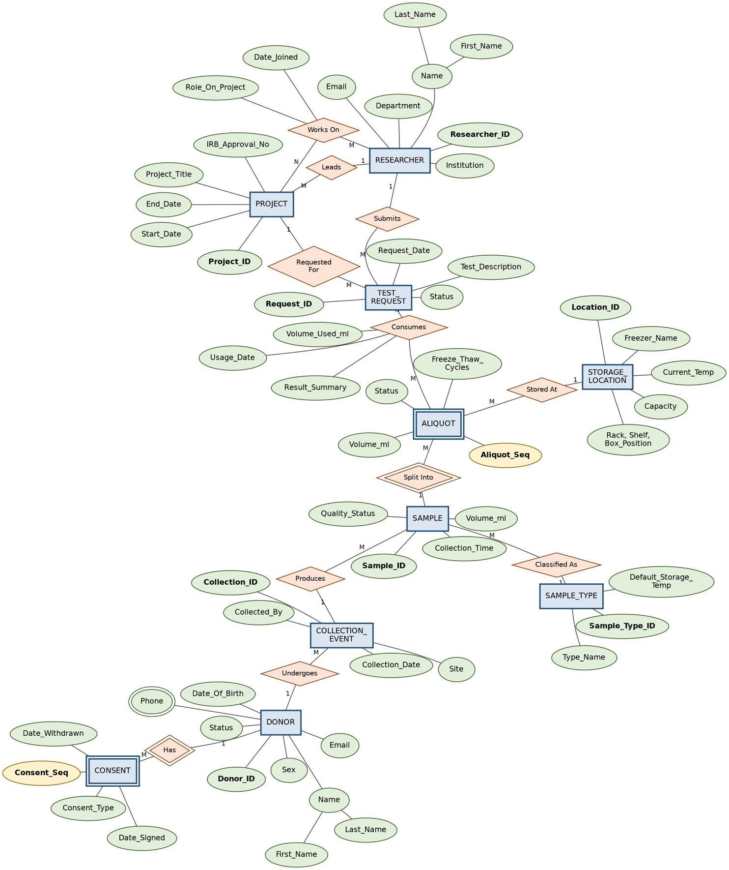Figure 1: Chen Notation Entity-Relationship Diagram for the Biobank and Biospecimen Management System

3.1 Relationships, Cardinalities, and Participation
Relationship | Entities | Cardinality | Participation
Has | DONOR – CONSENT | 1:M (identifying) | DONOR optional, CONSENT total
Undergoes | DONOR – COLLECTION_EVENT | 1:M | DONOR optional, EVENT total
Produces | COLLECTION_EVENT – SAMPLE | 1:M | EVENT optional, SAMPLE total
Classified As | SAMPLE – SAMPLE_TYPE | M:1 | SAMPLE total, TYPE optional
Split Into | SAMPLE – ALIQUOT | 1:M (identifying) | SAMPLE optional, ALIQUOT total
Stored At | ALIQUOT – STORAGE_LOCATION | M:1 | ALIQUOT total, LOCATION optional
Leads | RESEARCHER – PROJECT | 1:M | RESEARCHER optional, PROJECT total
Works On | RESEARCHER – PROJECT | M:N | both optional
Submits | RESEARCHER – TEST_REQUEST | 1:M | RESEARCHER optional, REQUEST total
Requested For | PROJECT – TEST_REQUEST | 1:M | PROJECT optional, REQUEST total
Consumes | ALIQUOT – TEST_REQUEST | M:N | both optional
Table 2: Relationship cardinalities and participation constraints

4. Relational Schema
The ER model was mapped to a relational schema following standard mapping rules: every entity becomes a table, 1:M relationships place the foreign key on the many side, M:N relationships are resolved through an associative table carrying both foreign keys, and each weak entity's table carries a composite primary key made of the owner's key plus its own partial key.
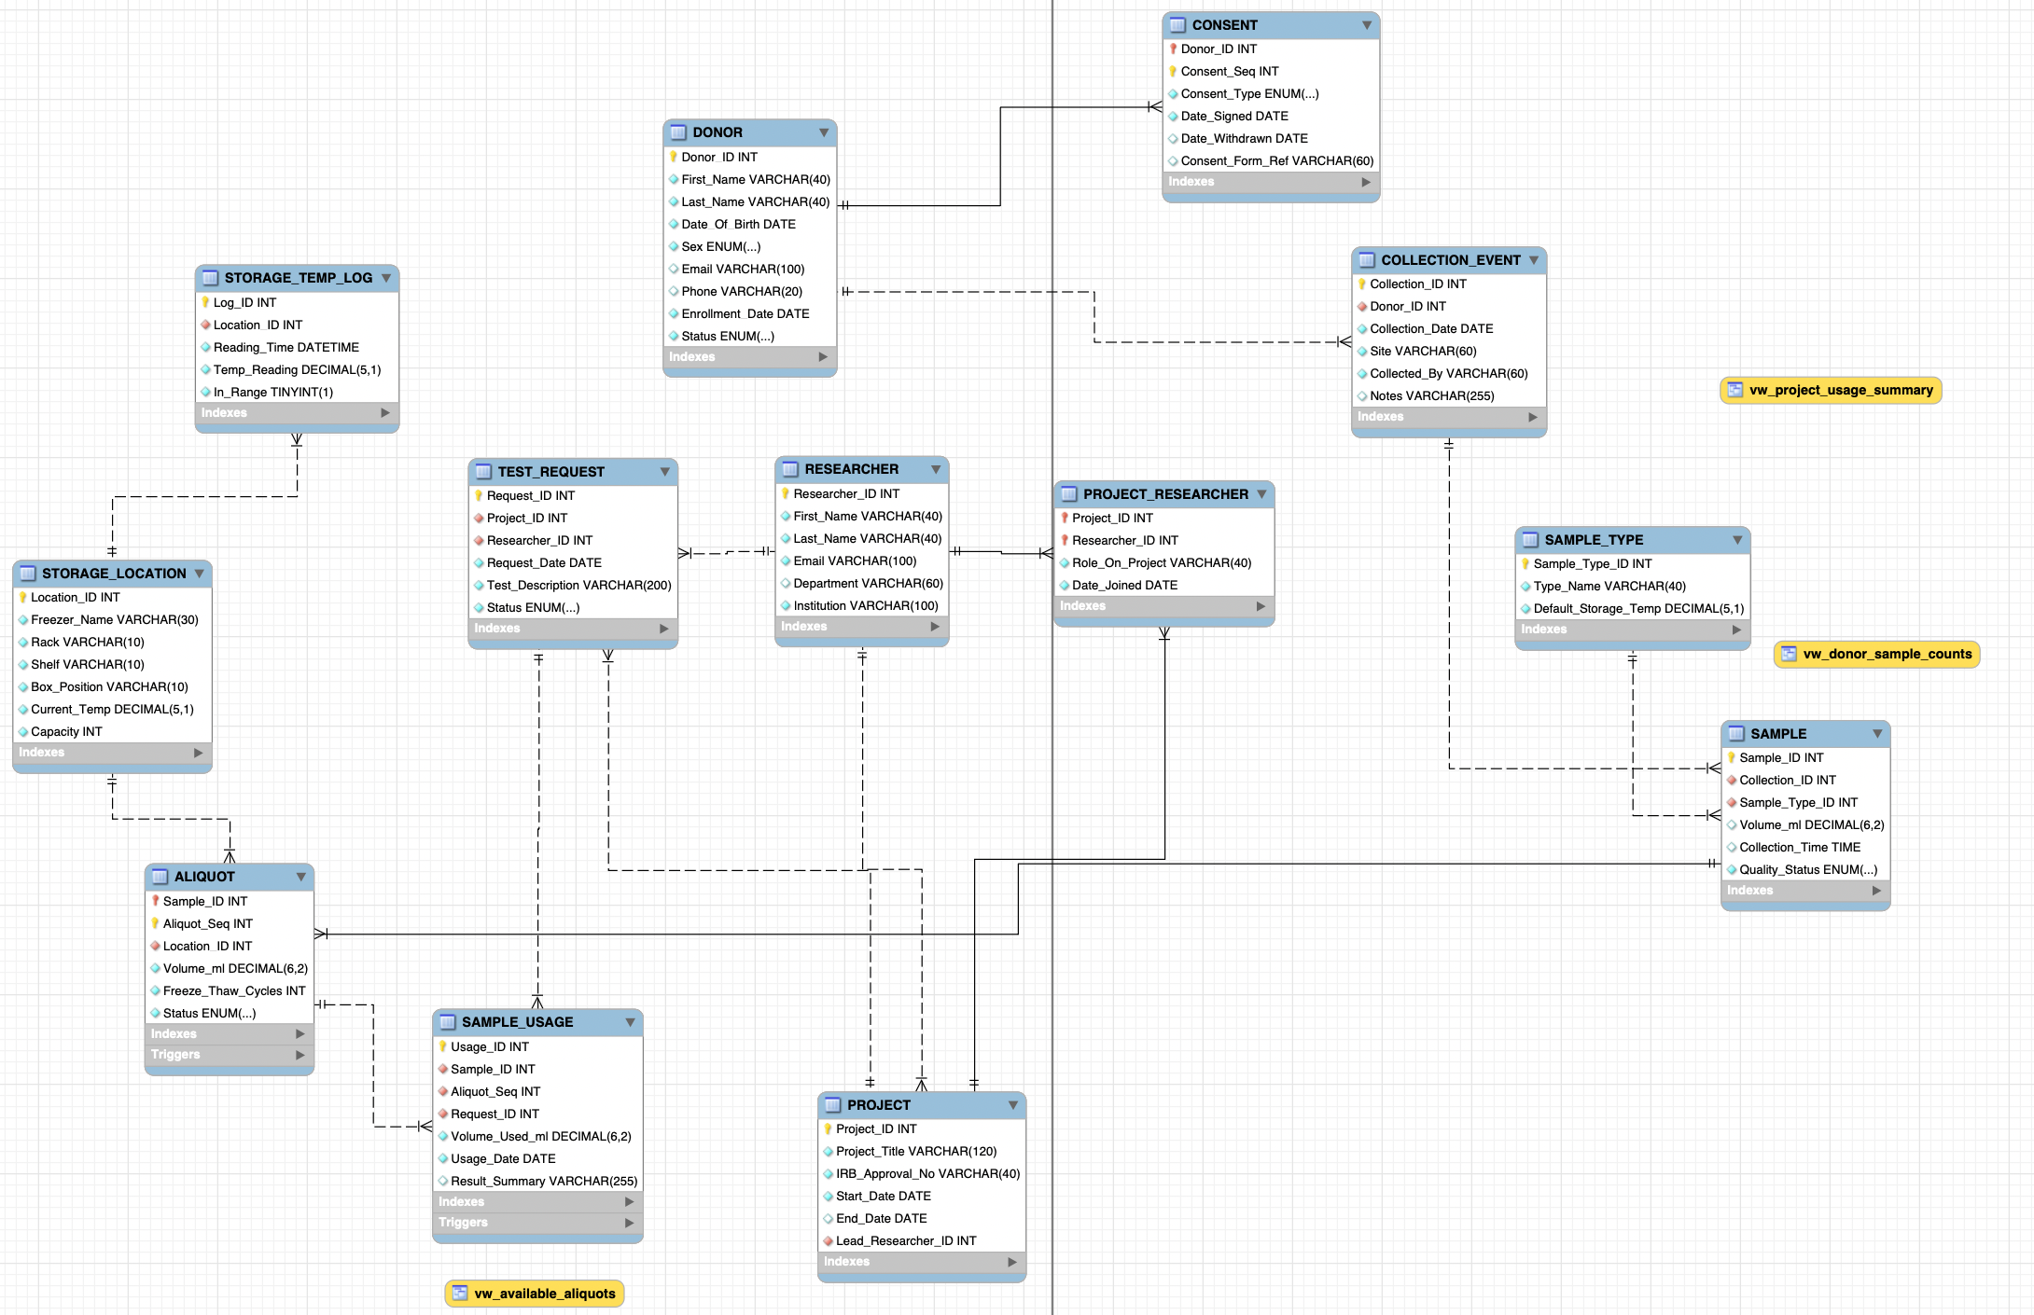Figure 2: Relational Schema Diagram showing tables, attributes, primary keys, and foreign key relationships

4.1 Constraints Summary
- Primary keys: every table has an explicit, non-null, unique primary key, several of which are composite (CONSENT, ALIQUOT, PROJECT_RESEARCHER).
- Foreign keys: 14 foreign key constraints tie dependent tables to their parents, each with an explicit ON DELETE / ON UPDATE action (CASCADE for owned data, RESTRICT for shared reference data such as SAMPLE_TYPE and STORAGE_LOCATION).
- Unique constraints: DONOR.Email, RESEARCHER.Email, PROJECT.IRB_Approval_No, SAMPLE_TYPE.Type_Name, and the (Freezer_Name, Rack, Shelf, Box_Position) combination on STORAGE_LOCATION.
- Check constraints: consent withdrawal date cannot precede the signing date; project end date cannot precede its start date; all recorded volumes must be strictly positive.
- Default values and ENUM domains restrict Status/Type-style columns (e.g., DONOR.Status, ALIQUOT.Status, TEST_REQUEST.Status) to a fixed, valid set of values.

4.2 Sample DDL Excerpt — ALIQUOT table
The ALIQUOT table demonstrates a weak entity with a composite primary key and two foreign keys with different referential actions:
CREATE TABLE IF NOT EXISTS ALIQUOT (
Sample_ID INT NOT NULL,
Aliquot_Seq INT NOT NULL,
Location_ID INT NOT NULL,
Volume_ml DECIMAL(6,2) NOT NULL,
Freeze_Thaw_Cycles INT NOT NULL DEFAULT 0,
Status ENUM('In Storage','In Use','Depleted','Discarded')
NOT NULL DEFAULT 'In Storage',
PRIMARY KEY (Sample_ID, Aliquot_Seq),
FOREIGN KEY (Sample_ID) REFERENCES SAMPLE(Sample_ID)
ON DELETE CASCADE ON UPDATE CASCADE,
FOREIGN KEY (Location_ID) REFERENCES STORAGE_LOCATION(Location_ID)
ON DELETE RESTRICT ON UPDATE CASCADE,
CONSTRAINT chk_aliquot_volume CHECK (Volume_ml > 0)
);

5. Normalization
Every table in the schema satisfies Third Normal Form (3NF). The reasoning is summarised below for the tables where normalization decisions were not immediately obvious.

5.1 First Normal Form (1NF)
All attributes are atomic. The one attribute that is conceptually multivalued in the real world — a donor's phone numbers — is represented in the ER diagram as multivalued for conceptual accuracy, but was deliberately simplified to a single VARCHAR field at the relational level, since the project's operational scope only requires one contact number per donor. If multiple numbers per donor were required, DONOR_PHONE would be split into its own table (Donor_ID, Phone) with a composite key, exactly as taught for multivalued attribute mapping.

5.2 Second Normal Form (2NF)
2NF requires that every non-key attribute depend on the whole primary key, which only matters for tables with composite keys. CONSENT's non-key attributes (Consent_Type, Date_Signed, Date_Withdrawn, Consent_Form_Ref) all describe a specific consent instance and depend on both Donor_ID and Consent_Seq together, not on either part alone. The same reasoning applies to ALIQUOT (Volume_ml, Freeze_Thaw_Cycles, Status depend on the specific Sample_ID + Aliquot_Seq pair) and PROJECT_RESEARCHER (Role_On_Project and Date_Joined depend on that specific researcher-project pairing, not on the project or researcher alone).

5.3 Third Normal Form (3NF)
3NF requires the elimination of transitive dependencies (non-key attributes depending on other non-key attributes rather than directly on the key). This was the main design driver behind splitting the schema as follows:
- SAMPLE_TYPE was factored out of SAMPLE. Default_Storage_Temp depends on the sample type, not on the individual sample — storing it directly in SAMPLE would mean Default_Storage_Temp is transitively dependent on Sample_ID through Sample_Type_ID, and would duplicate that value across every sample of the same type.
- STORAGE_LOCATION was factored out of ALIQUOT for the same reason: Freezer_Name, Rack, Shelf, and Capacity describe the location, not the individual aliquot stored there.
- RESEARCHER and PROJECT were kept separate, with PROJECT_RESEARCHER resolving the many-to-many team membership, rather than repeating researcher details on every project row.
- STORAGE_TEMP_LOG was kept as its own history table rather than adding Current_Temp columns with timestamps directly onto STORAGE_LOCATION, avoiding repeating group / update-anomaly problems that would arise from trying to store a growing time series inside a single-row entity.
No BCNF violations were introduced by any of these decisions, since every determinant in every table is a candidate key of that table.

6. Implementation Details

6.1 DBMS and Repository Layout
The database was implemented in MySQL 8.0. Scripts are organised as required by the project guidelines:
- sql/create_tables.sql — DDL: database, tables, primary/foreign keys, constraints, indexes.
- sql/load_data.sql — DML: test data (10+ records per main table).
- sql/queries.sql — retrieval, joins, aggregation, subqueries, insert/update/delete operations.
- sql/views.sql — three views.
- sql/triggers_procedures.sql — two triggers, one stored procedure, one function.

6.3 Indexes
In addition to the indexes automatically created for primary and unique keys, six supporting indexes were added on foreign key columns that are frequently filtered or joined on (e.g., idx_sample_collection, idx_aliquot_location, idx_usage_request), improving lookup performance for the traceability and reporting queries described in Section 8.

7. Sample Data and SQL Operations

7.1 Test Data Summary
load_data.sql populates the database with realistic test data. Every main table contains at least 10 records except the SAMPLE_TYPE lookup table (7 records), which is justified because it is a small, bounded reference list of specimen categories.
Table | Records | Table | Records
DONOR | 12 | RESEARCHER | 10
CONSENT | 14 | PROJECT | 8
COLLECTION_EVENT | 13 | PROJECT_RESEARCHER | 14
SAMPLE | 14 | TEST_REQUEST | 11
STORAGE_LOCATION | 10 | SAMPLE_USAGE | 11
ALIQUOT | 16 | STORAGE_TEMP_LOG | 12
SAMPLE_TYPE (lookup) | 7
Table 3: Record counts per table in the test data set

7.2 Representative Queries
queries.sql contains 17 statements organised into five sections. Representative examples are shown below; the full set is in the repository.

Join across the full traceability chain
SELECT
CONCAT(d.First_Name, ' ', d.Last_Name) AS Donor_Name,
s.Sample_ID, a.Aliquot_Seq,
su.Volume_Used_ml, su.Result_Summary,
p.Project_Title
FROM SAMPLE_USAGE su
JOIN ALIQUOT a ON su.Sample_ID = a.Sample_ID
AND su.Aliquot_Seq = a.Aliquot_Seq
JOIN SAMPLE s ON a.Sample_ID = s.Sample_ID
JOIN COLLECTION_EVENT ce ON s.Collection_ID = ce.Collection_ID
JOIN DONOR d ON ce.Donor_ID = d.Donor_ID
JOIN TEST_REQUEST tr ON su.Request_ID = tr.Request_ID
JOIN PROJECT p ON tr.Project_ID = p.Project_ID
ORDER BY d.Last_Name;

Correlated subquery
SELECT a1.Sample_ID, a1.Aliquot_Seq, a1.Volume_ml
FROM ALIQUOT a1
WHERE a1.Volume_ml < (
SELECT AVG(a2.Volume_ml)
FROM ALIQUOT a2
WHERE a2.Sample_ID = a1.Sample_ID
);
This finds every aliquot whose remaining volume is below the average of its sibling aliquots (aliquots split from the same original sample) — useful for flagging aliquots that may need re-balancing or prioritised use before they run low.

Aggregation with HAVING
SELECT d.Donor_ID, CONCAT(d.First_Name, ' ', d.Last_Name) AS Donor_Name,
SUM(s.Volume_ml) AS Total_Volume_ml,
ROUND(AVG(s.Volume_ml), 2) AS Avg_Volume_ml
FROM DONOR d
JOIN COLLECTION_EVENT ce ON d.Donor_ID = ce.Donor_ID
JOIN SAMPLE s ON ce.Collection_ID = s.Collection_ID
GROUP BY d.Donor_ID, d.First_Name, d.Last_Name
HAVING SUM(s.Volume_ml) > 5
ORDER BY Total_Volume_ml DESC;

8. Views, Trigger/Procedure/Function, and Their Purpose

8.1 Views

vw_available_aliquots
Gives lab staff a single place to see every aliquot that is still physically in storage and usable for a new test request, together with the donor, sample type, and exact freezer location — avoiding the need to manually join five tables every time inventory needs to be checked.
DROP VIEW IF EXISTS vw_available_aliquots;
CREATE VIEW vw_available_aliquots AS
SELECT
a.Sample_ID,
a.Aliquot_Seq,
st.Type_Name AS Sample_Type,
a.Volume_ml,
a.Freeze_Thaw_Cycles,
d.Donor_ID,
CONCAT(d.First_Name, ' ', d.Last_Name) AS Donor_Name,
sl.Freezer_Name,
sl.Rack,
sl.Shelf,
sl.Box_Position
FROM ALIQUOT a
JOIN SAMPLE s ON a.Sample_ID = s.Sample_ID
JOIN SAMPLE_TYPE st ON s.Sample_Type_ID = st.Sample_Type_ID
JOIN COLLECTION_EVENT ce ON s.Collection_ID = ce.Collection_ID
JOIN DONOR d ON ce.Donor_ID = d.Donor_ID
JOIN STORAGE_LOCATION sl ON a.Location_ID = sl.Location_ID
WHERE a.Status = 'In Storage';

vw_project_usage_summary
Gives a project-level summary of how many test requests and how much sample volume each research project has consumed, intended for reporting to a biobank oversight or ethics committee.
DROP VIEW IF EXISTS vw_project_usage_summary;
CREATE VIEW vw_project_usage_summary AS
SELECT
p.Project_ID,
p.Project_Title,
CONCAT(r.First_Name, ' ', r.Last_Name) AS Lead_Researcher,
COUNT(DISTINCT tr.Request_ID) AS Num_Requests,
COUNT(su.Usage_ID) AS Num_Sample_Usages,
COALESCE(SUM(su.Volume_Used_ml), 0) AS Total_Volume_Used_ml
FROM PROJECT p
JOIN RESEARCHER r ON p.Lead_Researcher_ID = r.Researcher_ID
LEFT JOIN TEST_REQUEST tr ON p.Project_ID = tr.Project_ID
LEFT JOIN SAMPLE_USAGE su ON tr.Request_ID = su.Request_ID
GROUP BY p.Project_ID, p.Project_Title, r.First_Name, r.Last_Name;

vw_donor_sample_counts
A quick roster of each donor with counts of their collection events, samples, and aliquots — useful for donor management and for identifying highly-sampled or under-sampled donors.
DROP VIEW IF EXISTS vw_donor_sample_counts;
CREATE VIEW vw_donor_sample_counts AS
SELECT
d.Donor_ID,
CONCAT(d.First_Name, ' ', d.Last_Name) AS Donor_Name,
d.Status,
COUNT(DISTINCT ce.Collection_ID) AS Num_Collections,
COUNT(DISTINCT s.Sample_ID) AS Num_Samples,
COUNT(a.Sample_ID) AS Num_Aliquots
FROM DONOR d
LEFT JOIN COLLECTION_EVENT ce ON d.Donor_ID = ce.Donor_ID
LEFT JOIN SAMPLE s ON ce.Collection_ID = s.Collection_ID
LEFT JOIN ALIQUOT a ON s.Sample_ID = a.Sample_ID
GROUP BY d.Donor_ID, d.First_Name, d.Last_Name, d.Status;

8.2 Trigger 1: trg_aliquot_volume_check
Fires BEFORE INSERT on ALIQUOT. The rule enforced: the combined volume of all aliquots created from a sample can never exceed that sample's originally recorded volume. Without this check, lab staff could accidentally record more material split into aliquots than was actually collected, silently corrupting the inventory.
DELIMITER //
CREATE TRIGGER trg_aliquot_volume_check
BEFORE INSERT ON ALIQUOT
FOR EACH ROW
BEGIN
DECLARE used_volumeDECIMAL(10,2);
DECLARE sample_volume DECIMAL(10,2);
SELECT SUM(Volume_ml) INTO used_volume
FROM ALIQUOT
WHERE Sample_ID = NEW.Sample_ID;
SELECT Volume_ml INTO sample_volume
FROM SAMPLE
WHERE Sample_ID = NEW.Sample_ID;
IF used_volumeIS NULL THEN
SET used_volume= 0;
END IF;
IF (used_volume+ NEW.Volume_ml) > sample_volume THEN
SIGNAL SQLSTATE '45000'
SET MESSAGE_TEXT = 'Aliquot volume exceeds remaining sample volume.';
END IF;
END//
DELIMITER ;

8.3 Trigger 2: trg_usage_depletes_aliquot
Fires AFTER INSERT on SAMPLE_USAGE. Whenever a test request consumes part of an aliquot, this trigger automatically deducts the used volume from that aliquot's remaining volume and flips its Status to 'Depleted' once nothing is left, keeping the physical inventory synchronised with usage history without relying on lab staff to remember a manual update step.
DELIMITER //
CREATE TRIGGER trg_usage_depletes_aliquot
AFTER INSERT ON SAMPLE_USAGE
FOR EACH ROW
BEGIN
UPDATE ALIQUOT
SET Volume_ml = Volume_ml - NEW.Volume_Used_ml
WHERE Sample_ID = NEW.Sample_ID AND Aliquot_Seq = NEW.Aliquot_Seq;

UPDATE ALIQUOT
SET Status = 'Depleted'
WHERE Sample_ID = NEW.Sample_ID
AND Aliquot_Seq = NEW.Aliquot_Seq
AND Volume_ml <= 0;
END//
DELIMITER ;

8.4 Stored Procedure: sp_register_test_request
Registers a new test request and immediately links it to a chosen aliquot in a single transactional call. It checks the aliquot is actually in storage and has enough remaining volume before doing anything, and wraps both inserts (TEST_REQUEST and SAMPLE_USAGE) in one transaction so the system can never end up with a request that has no matching usage record, or vice versa.
DROP PROCEDURE IF EXISTS sp_register_test_request;
DELIMITER $$
CREATE PROCEDURE sp_register_test_request (
IN p_Project_ID INT,
IN p_Researcher_ID INT,
IN p_Description VARCHAR(200),
IN p_Sample_ID INT,
IN p_Aliquot_Seq INT,
IN p_Volume_Used DECIMAL(6,2),
OUT p_Request_ID INT
)
BEGIN
DECLARE avail_volume DECIMAL(6,2);
SELECT Volume_ml INTO avail_volume
FROM ALIQUOT
WHERE Sample_ID = p_Sample_ID AND Aliquot_Seq = p_Aliquot_Seq
AND Status = 'In Storage';
IF avail_volume IS NULL THEN
SIGNAL SQLSTATE '45000'
SET MESSAGE_TEXT = 'Aliquot not found or not available for use.';
ELSEIF avail_volume < p_Volume_Used THEN
SIGNAL SQLSTATE '45000'
SET MESSAGE_TEXT = 'Requested volume exceeds available aliquot volume.';
ELSE
START TRANSACTION;
INSERT INTO TEST_REQUEST (Project_ID, Researcher_ID, Test_Description, Status)
VALUES (p_Project_ID, p_Researcher_ID, p_Description, 'Approved');
SET p_Request_ID = LAST_INSERT_ID();
INSERT INTO SAMPLE_USAGE (Sample_ID, Aliquot_Seq, Request_ID, Volume_Used_ml)
VALUES (p_Sample_ID, p_Aliquot_Seq, p_Request_ID, p_Volume_Used);
COMMIT;
END IF;
END$$
DELIMITER ;

8.5 Function: fn_donor_active_consent
A deterministic scalar function that returns 1 if a donor currently has at least one active (non-withdrawn) research-use consent on file, or 0 otherwise. This can be used to gate whether a donor's samples are eligible to be released for new research use, and demonstrates encapsulating a reusable rule as a callable function rather than repeating the same subquery everywhere.
DELIMITER //
CREATE FUNCTION fn_donor_active_consent(
p_Donor_ID INT
) RETURNS BOOLEAN DETERMINISTIC
BEGIN
DECLARE active_count INT DEFAULT 0;
SELECT COUNT(*)
INTO active_count
FROM CONSENT
WHERE Donor_ID = p_Donor_ID
AND Consent_Type = 'Research Use'
AND Date_Withdrawn IS NULL;
IF active_count > 0 THEN
RETURN TRUE;
ELSE
RETURN FALSE;
END IF;
END//
DELIMITER ;

9. Testing, Results, Limitations, and Conclusion

9.1 Test Cases and Results
The following test cases were executed against a freshly loaded database (create_tables.sql followed by load_data.sql) to confirm that constraints and rules behave as designed.
ID | Test | Expected Result | Outcome
TC-01 | Insert an aliquot whose volume, combined with existing aliquots of the same sample, exceeds the sample's recorded volume. | INSERT rejected with SQLSTATE 45000 'Aliquot volume exceeds remaining sample volume.' | Pass
TC-02 | Insert a SAMPLE_USAGE row consuming 2 ml from an aliquot that has exactly 2 ml remaining. | AFTER INSERT trigger sets the aliquot's Volume_ml to 0 and Status to 'Depleted'. | Pass
TC-03 | Call sp_register_test_request for an aliquot that is not in 'In Storage' status. | Procedure raises SQLSTATE 45000 'Aliquot not found or not available for use.' and no rows are inserted. | Pass
TC-04 | Call sp_register_test_request requesting more volume than the aliquot has left. | Procedure raises SQLSTATE 45000 'Requested volume exceeds available aliquot volume.' | Pass
TC-05 | Delete a DONOR row. | CONSENT and COLLECTION_EVENT rows for that donor cascade-delete automatically (ON DELETE CASCADE). | Pass
TC-06 | Insert a SAMPLE_TYPE reference used by an existing SAMPLE, then attempt to delete that SAMPLE_TYPE. | DELETE rejected (ON DELETE RESTRICT) because SAMPLE still references it. | Pass
TC-07 | Insert a CONSENT with Date_Withdrawn earlier than Date_Signed. | INSERT rejected by chk_consent_dates CHECK constraint. | Pass
TC-08 | Call fn_donor_active_consent for a donor whose only research-use consent has Date_Withdrawn set. | Function returns 0. | Pass
TC-09 | Query vw_available_aliquots after TC-02's aliquot is depleted. | The depleted aliquot no longer appears in the view (WHERE Status = 'In Storage'). | Pass
TC-10 | Insert a duplicate PROJECT.IRB_Approval_No value. | INSERT rejected by the UNIQUE constraint on IRB_Approval_No. | Pass
Table 4: Test cases executed against the database and their outcomes
9.2 Limitations
•The schema does not really model laboratory instruments or raw sequencing / genomic output; it sort of ends at tracking which specimen was used for which test, not the actual biological result data itself, in a structured way. (Result_Summary stays as free text, so not great for strict queries.)
•Donor phone numbers are reduced to one single field in the relational design instead of a fully normalized multivalued setup (see Section 5.1). This is an ok simplification for the operational scope of this project, but it would need revisiting later if the system has to support multiple contact numbers per donor, in a proper production context.
•The system does not yet implement row level access control, like limiting a researcher to only view aliquots tied to their own approved projects. In practice, this would be managed in the application layer, or maybe through MySQL views / roles, once it goes into production.
•Consent workflow is simplified to signed / withdrawn. A real biobank would usually require versioned consent documents and more granular consent scopes, for example per study consent, not just the high level state.

9.3 Conclusion
This project produced a full relational database for a Biobank and Biospecimen Management System, and it matched the development lifecycle that the assignment asked for: requirements analysis, Chen-notation ER modelling with weak entities, plus multiple many-to-many relationships. Then it moved into mapping into a normalized (3NF) relational schema, MySQL implementation with solid constraints, meaningful test data, a wide set of SQL operations (retrieval, joins, aggregation, correlated and non-correlated subqueries, plus data modification). It also included three views, two triggers, a stored procedure, and a function.
Overall, the system enforces the biobank core rules, most notably that specimen volume can never be over-allocated and that consumed inventory is always kept in sync automatically — which were the two rules judged most critical to data integrity in this domain.

10. References
- MySQL 8.0 Reference Manual. Oracle Corporation. https://dev.mysql.com/doc/refman/8.0/en/
- Course lab materials, CSCI305 – Fundamentals of Databases: Lab 1 (ER Diagrams), Lab 2 (EER – Supertypes/Subtypes), Lab 3 (Relational Mapping), Lab 4 (DDL), Lab 5 (DML), Lab 6 (Joins and Subqueries), Lab 7 (Views).
- Biobank domain background: ISBER Best Practices for Repositories (International Society for Biological and Environmental Repositories), used only as general domain background on biobank operations, not as a data source.
- Graphviz — Graph Visualization Software, used to render the ER diagram and relational schema diagram. https://graphviz.org/
- All SQL code, schema design, and test data in this project were written by the student for this assignment. No external datasets were used; all sample data is fictitious.

Appendix B: GitHub Repository Structure
biobank-management-system/
├── README.md
├── report.pdf
├── presentation.pptx
├── sql/
│ ├── create_tables.sql
│ ├── load_data.sql
│ ├── queries.sql
│ ├── views.sql
│ └── triggers_procedures.sql
├── diagrams/
│ ├── ERD.png
│ └── Schema.png
└── video/
└── (Link to hosted video presentation)

