Name :- Pralay K Kalaskar

Mail :- ([pkkdkalaskar71@gmail.com](mailto:pkkdkalaskar71@gmail.com))

Phone :- +91-7066216365

Linkedin :- [www.linkedin.com/in/pralay-kalaskar-1010](http://www.linkedin.com/in/pralay-kalaskar-1010)

SQL Mock – (24aug2024)

Starts Here :- P.T.O.



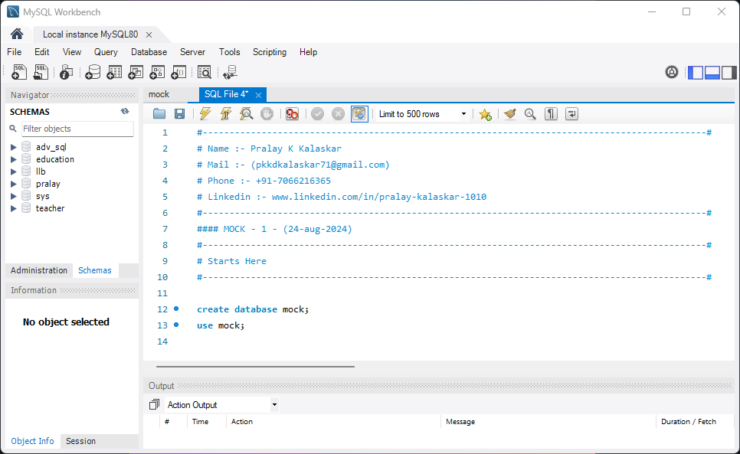

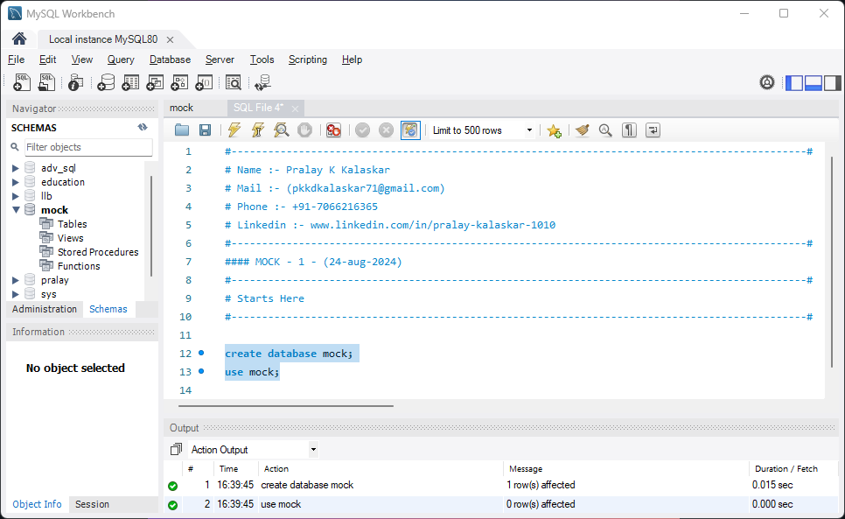

**Question 01 :-** Perform calculation on sales from 1 previous , current and 2 next value

**Answer :-**

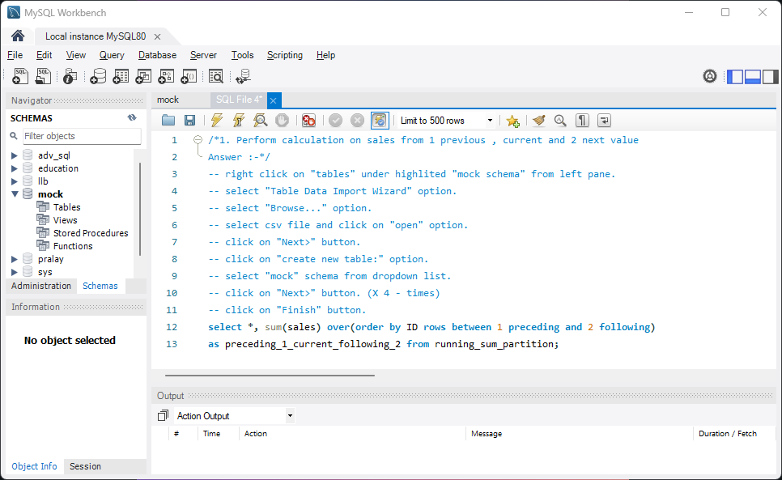

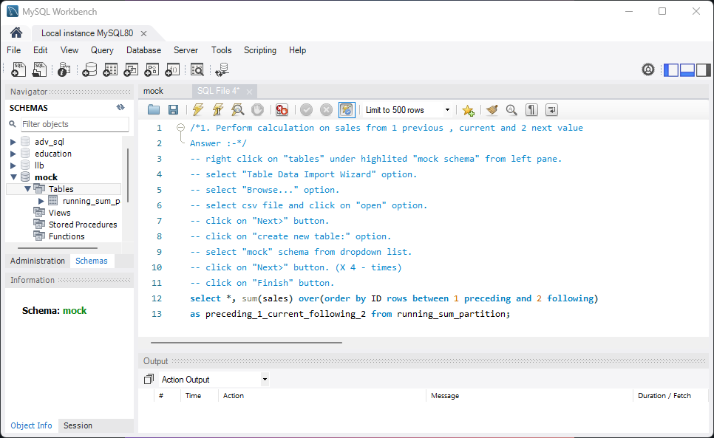

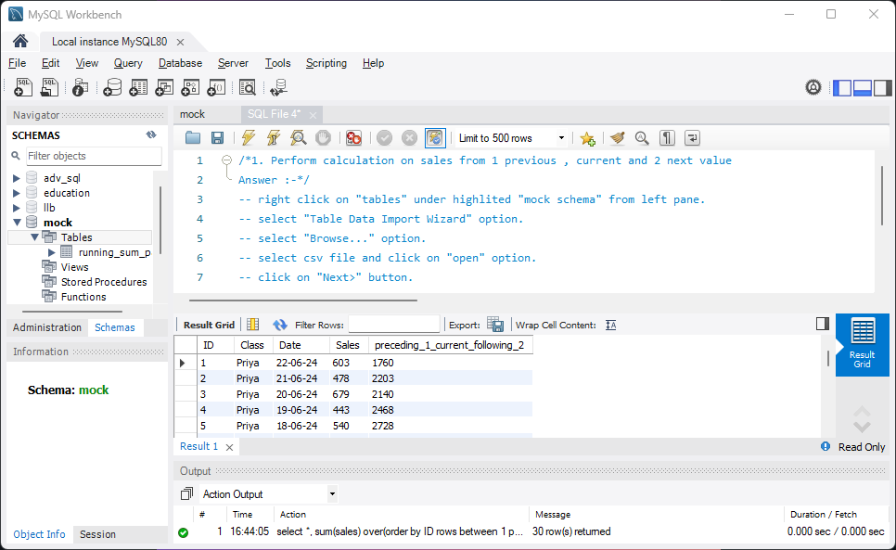

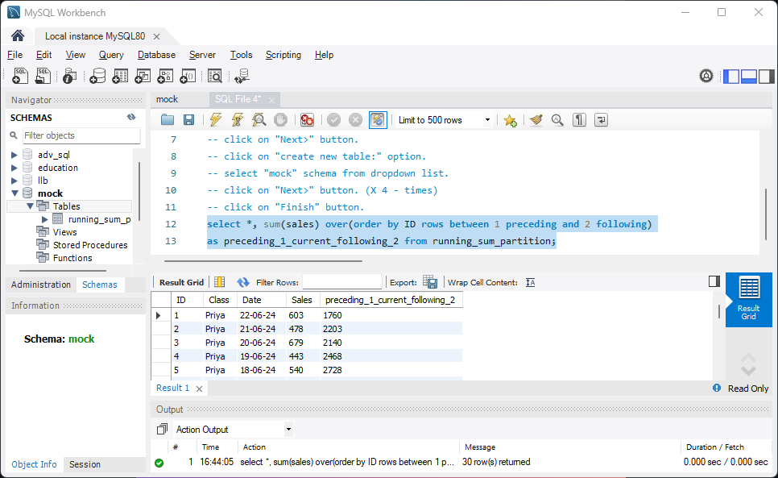

**Question 02 :-** Perform calculation on sales from 3 previous , current and 2 next value

**Answer :-**

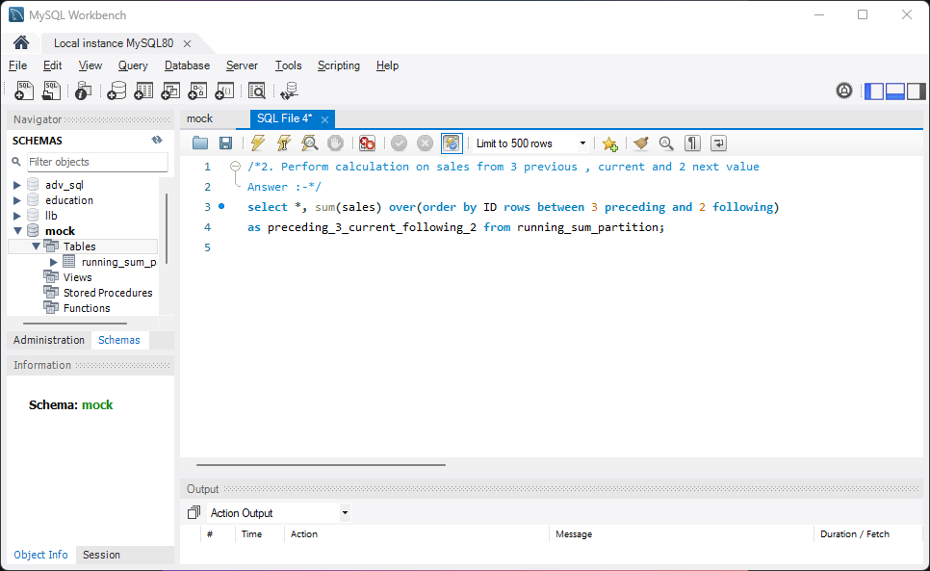

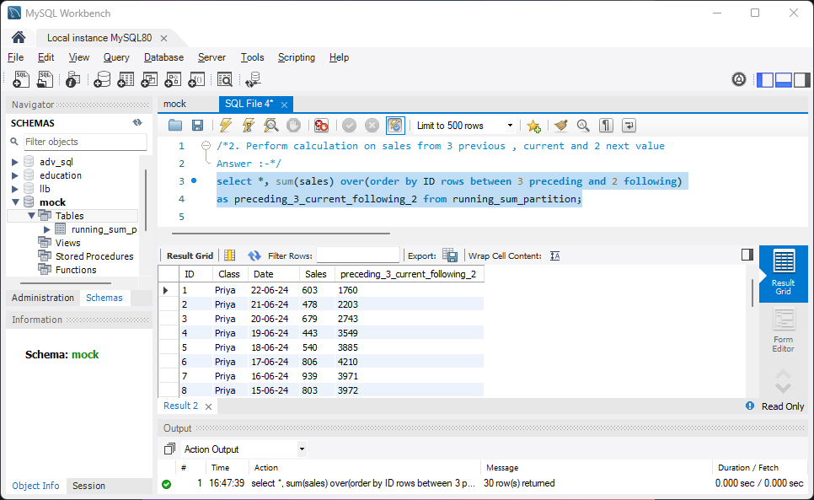

**Question 03 :-** For the following relation schema :

* Table 1 :- employee(employee-name, street, city)
* Table 2 :- works(employee-name, company-name, salary)
* Table 3 :- company(company-name, city)
* Table 4 :- manages(employee-name, manager-name)

Give an expression in SQL for each of the following queries:

1. Find the names, street address, and cities of residence for all employees who work for 'First Bank Corporation' and earn more than $10,000.
2. Find the names of all employees in the database who live in the same cities as the companies for which they work
3. Find the names of all employees in the database who live in the same cities and on the same streets as do their managers.

**Answer :-**

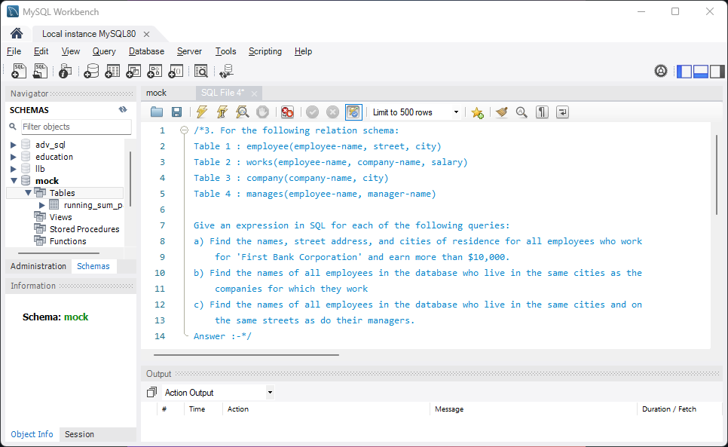

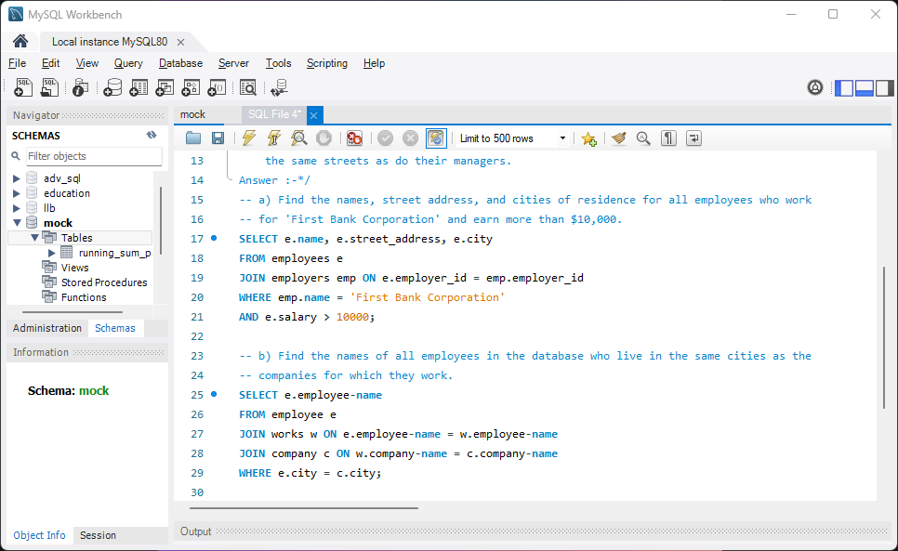

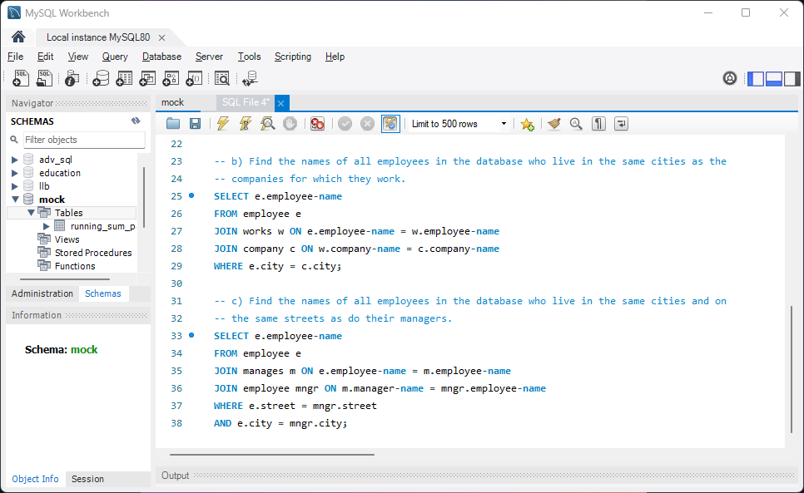

**Question 04 :-** Create foreign key on :

* Department table

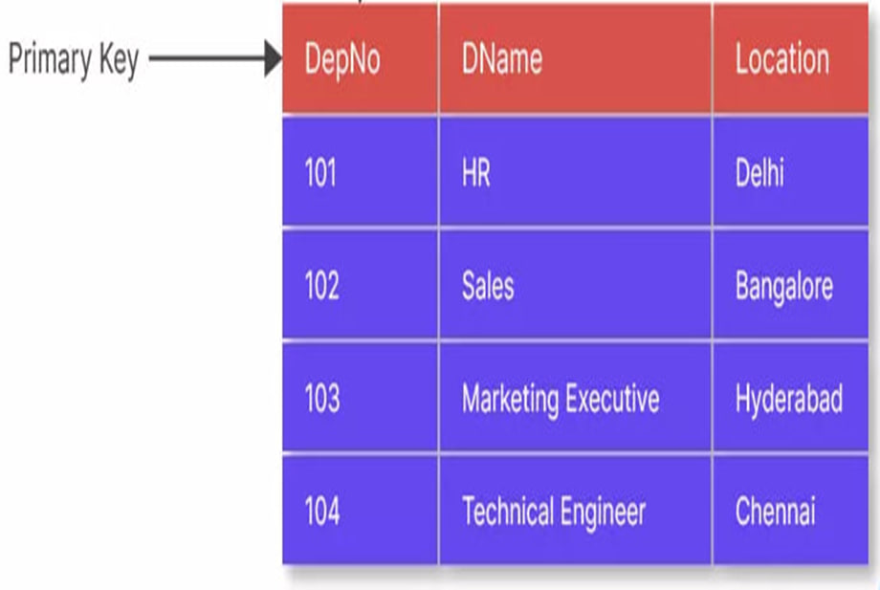

* Employee table

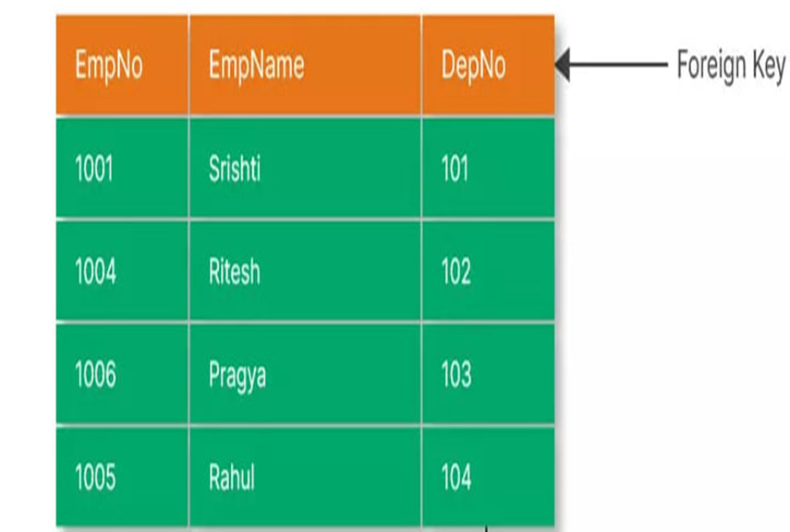

**Answer :-**

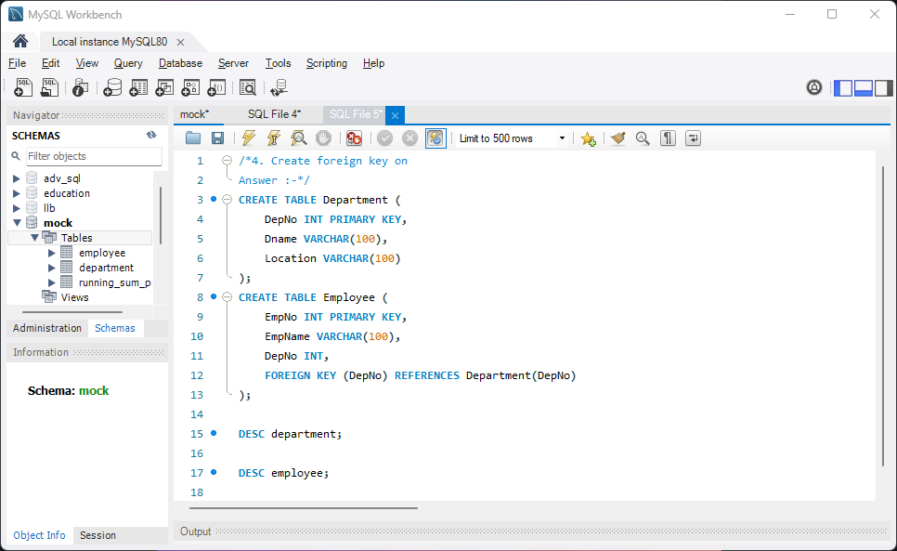

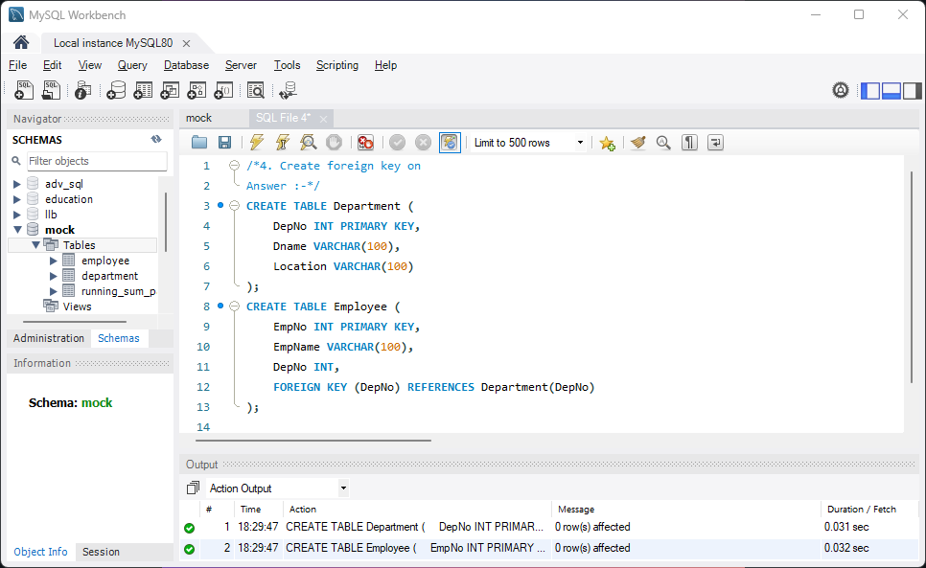

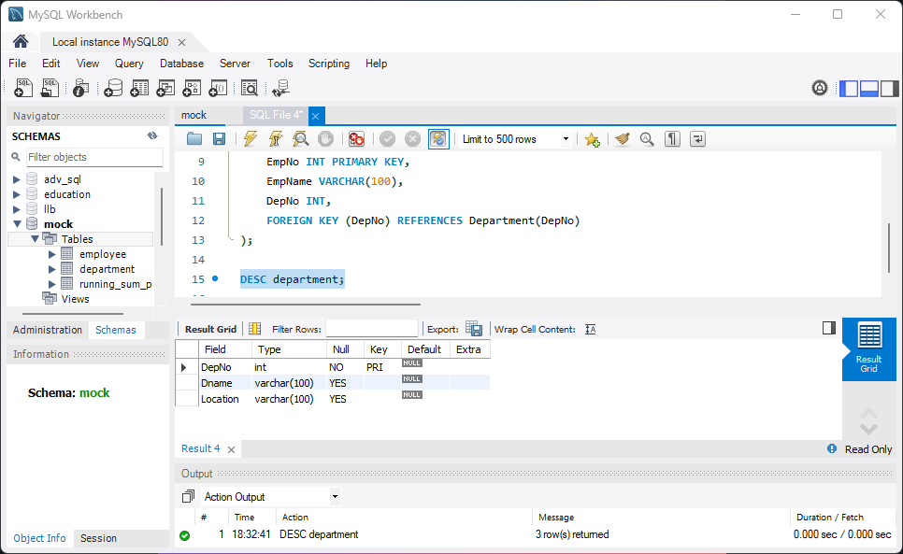

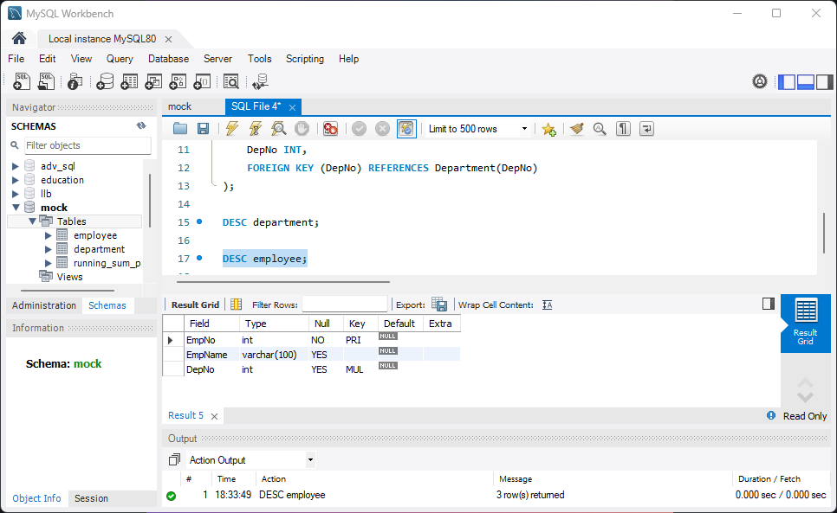

**Question 05 :-** Create foreign key on student id in Library :

* Student table

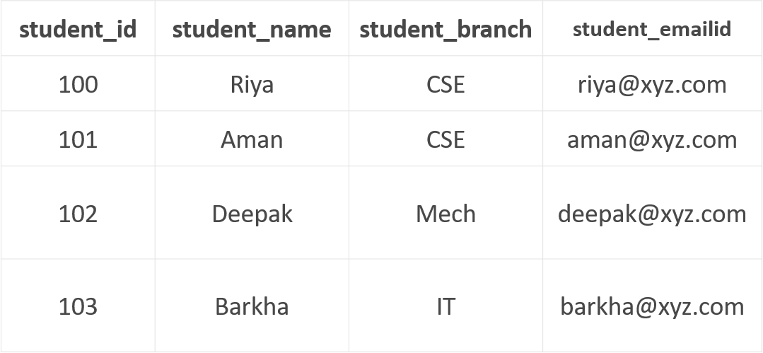

* Library table

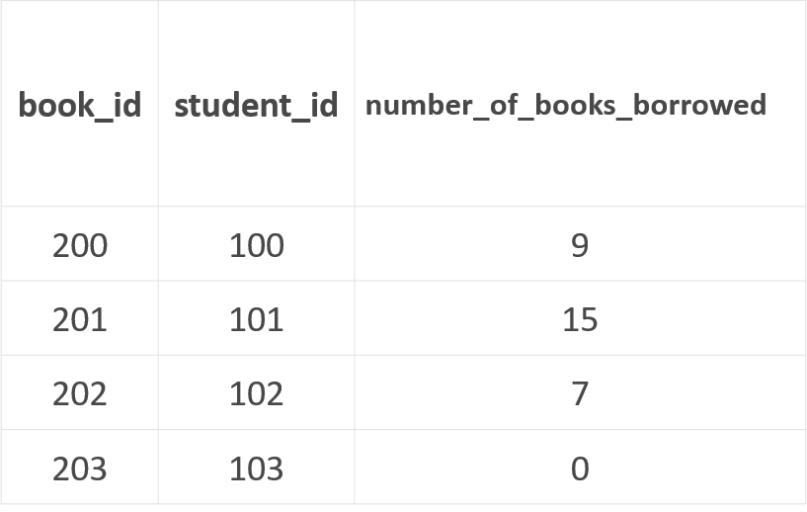

**Answer :-**

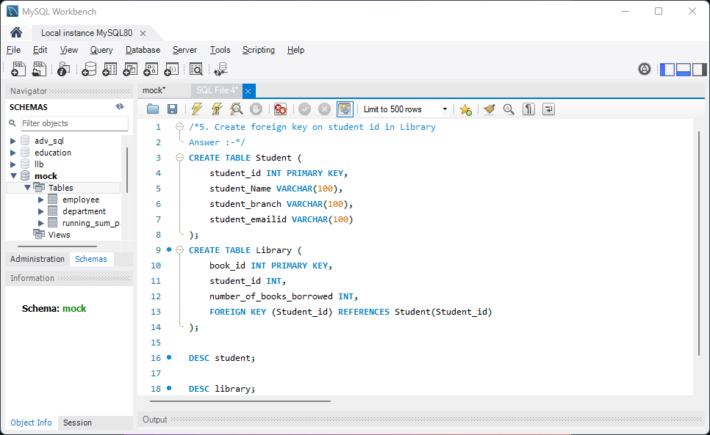

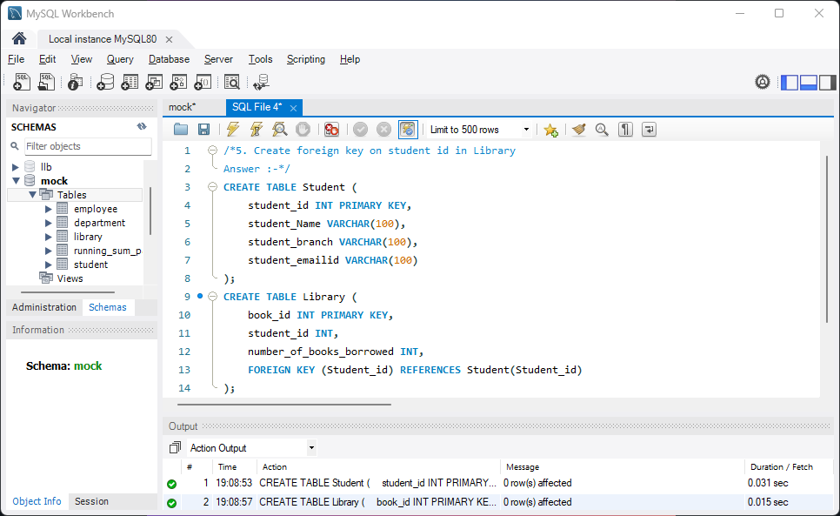

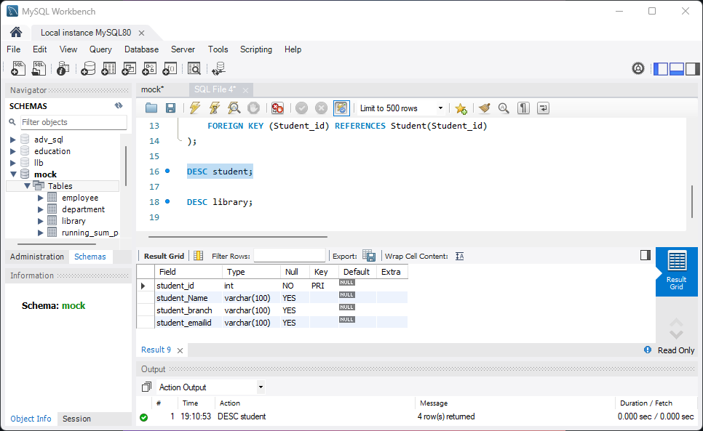

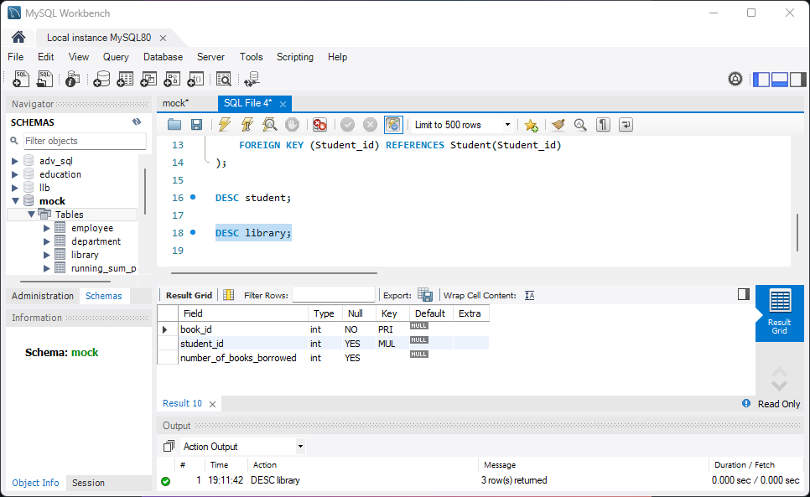

**Question 06 :-** Get the output using table partition_by_ground_yr_ind_orde

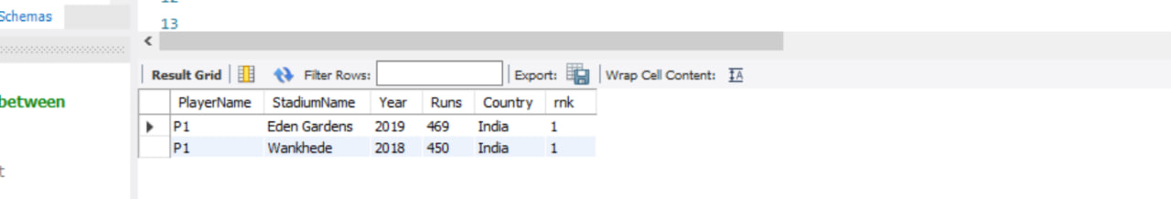

**Answer :-**

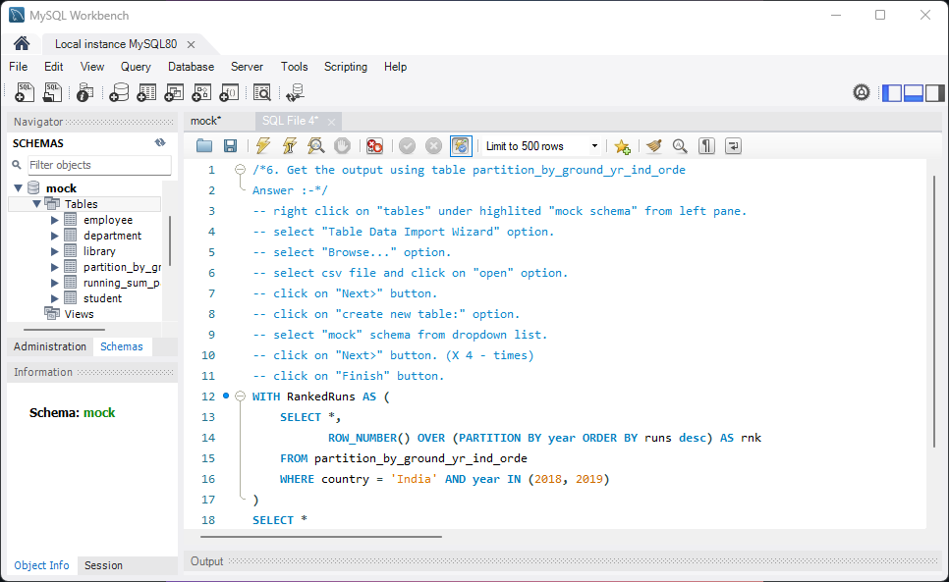

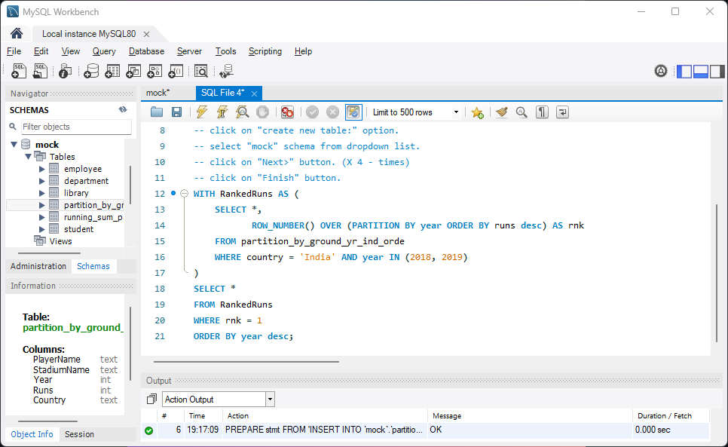

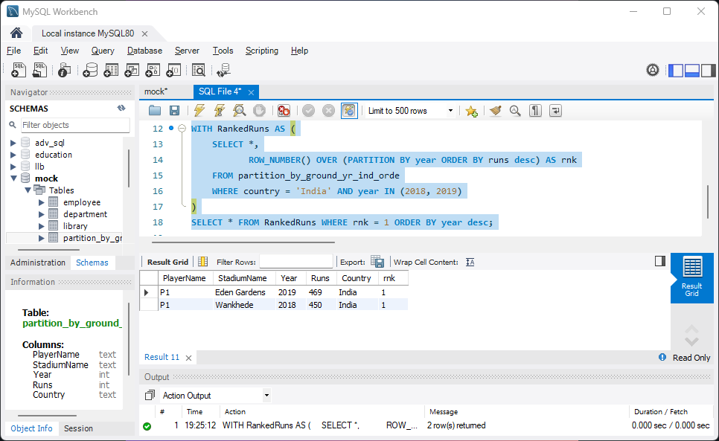

**Question 07 :-** Get the output using table partition_by_ground_yr_ind_orde

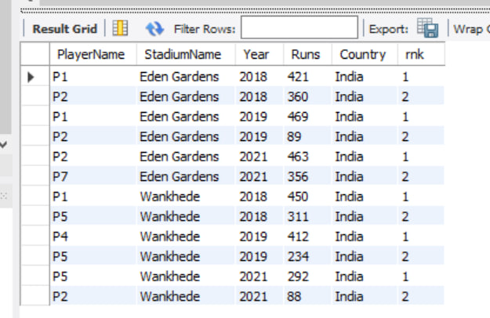

**Answer :-**

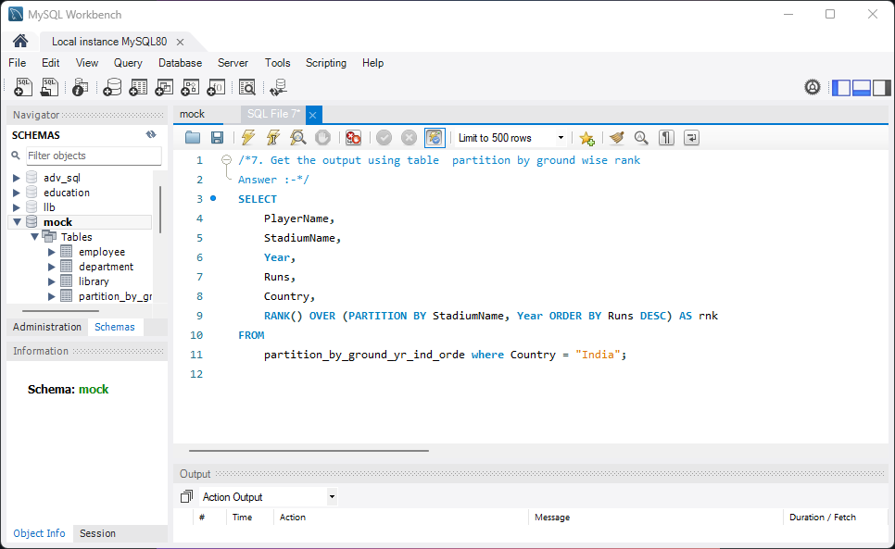

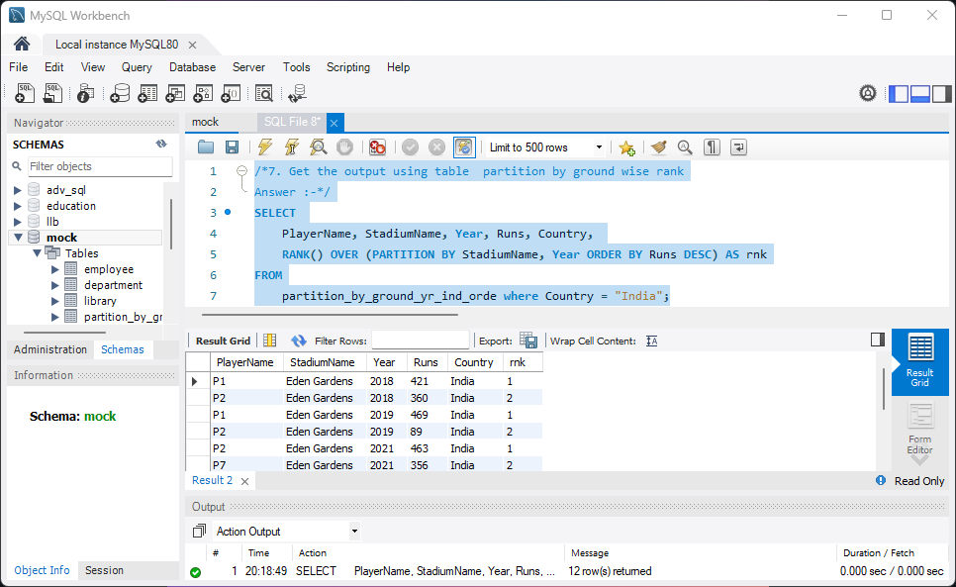

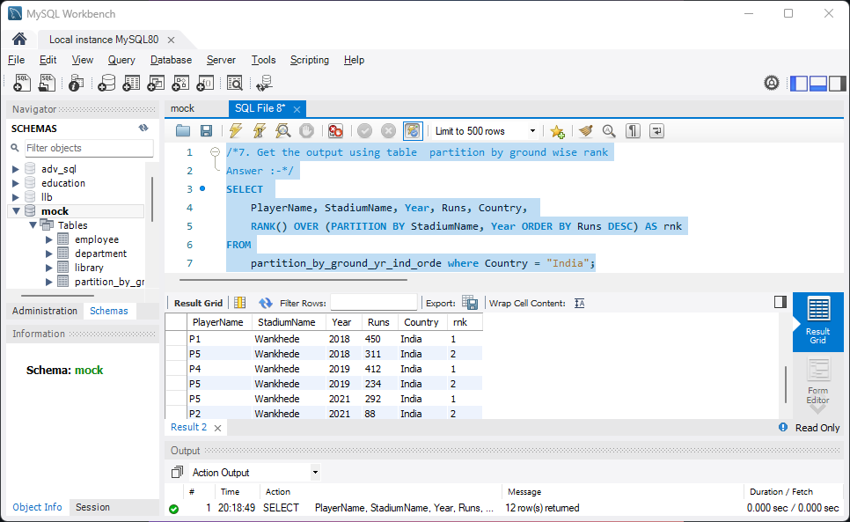

END..