**How To Request Executable Pricing**

1. Once the Indicative Quotes come back as “Pricing Complete”, you can request executable pricing.
2. Click the “Executable Price” button.

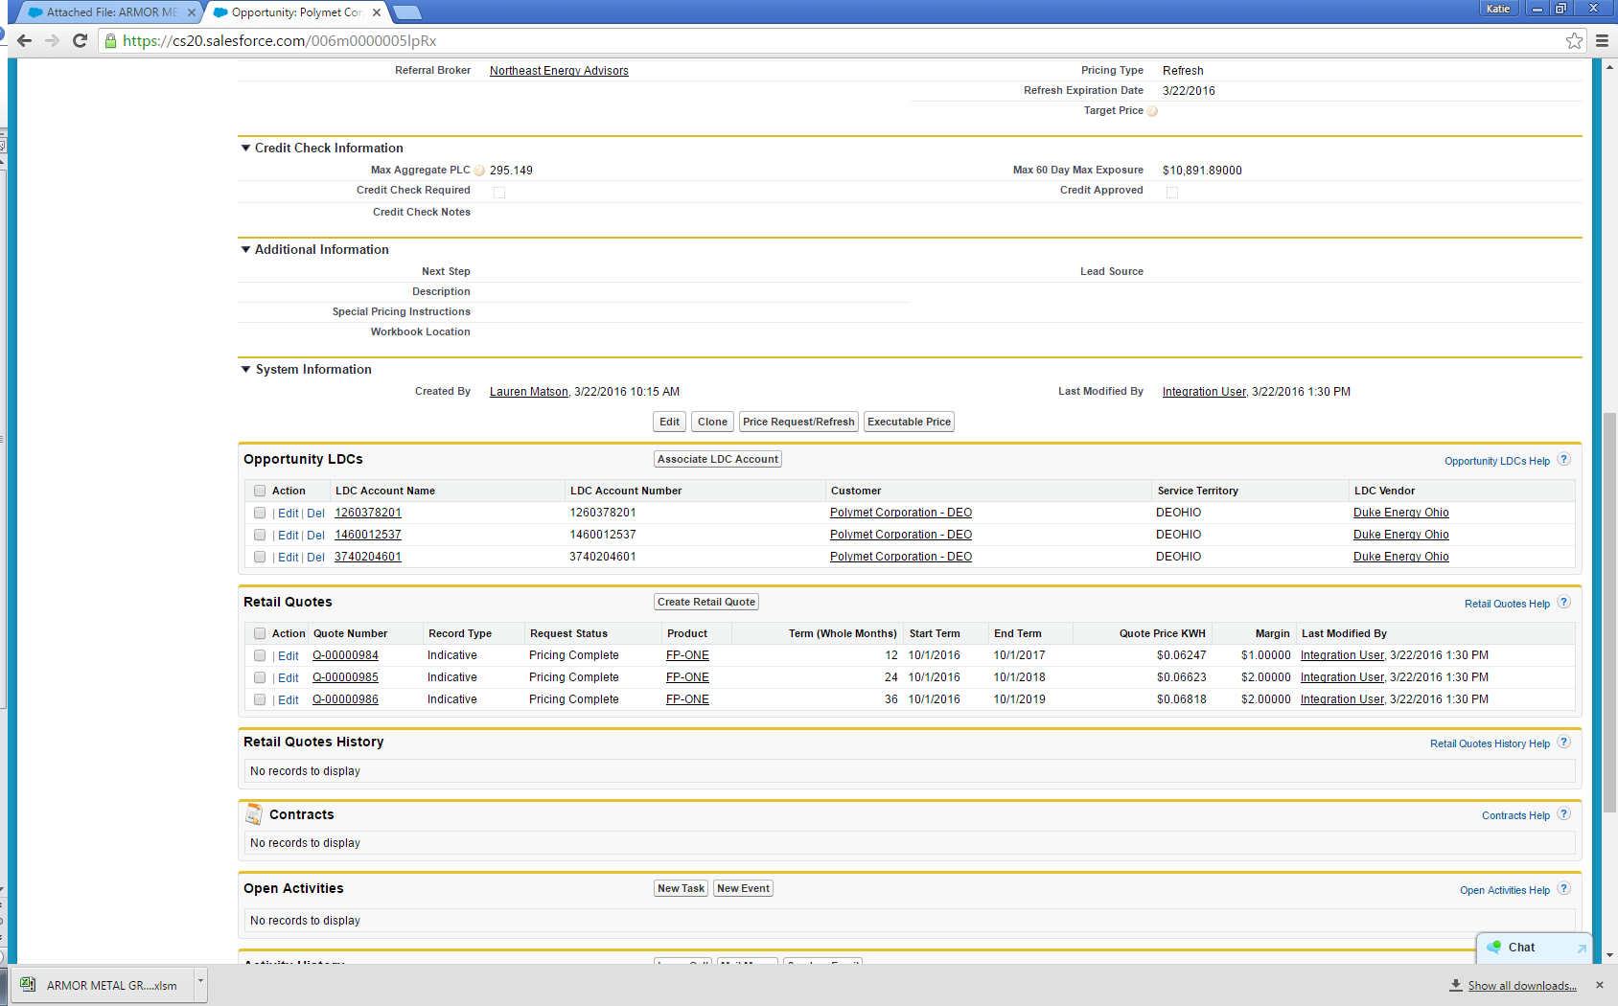

1. A pop-up window opens to allow user to select Quote Number(s) to include in Executable Request

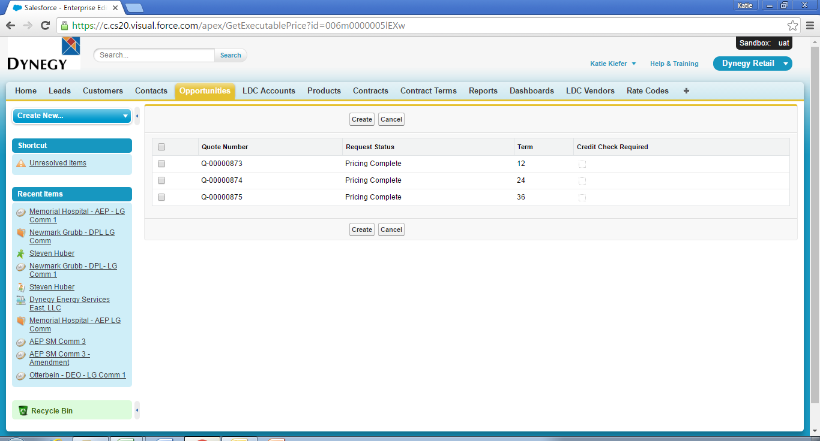

1. Select the quotes to make executable and click Create

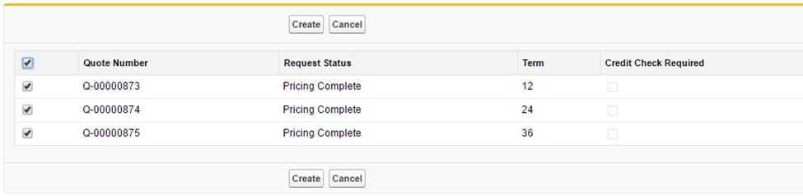

1. The Record Type will change to “Executable” and the Request Status will change to “Waiting on Load Data”

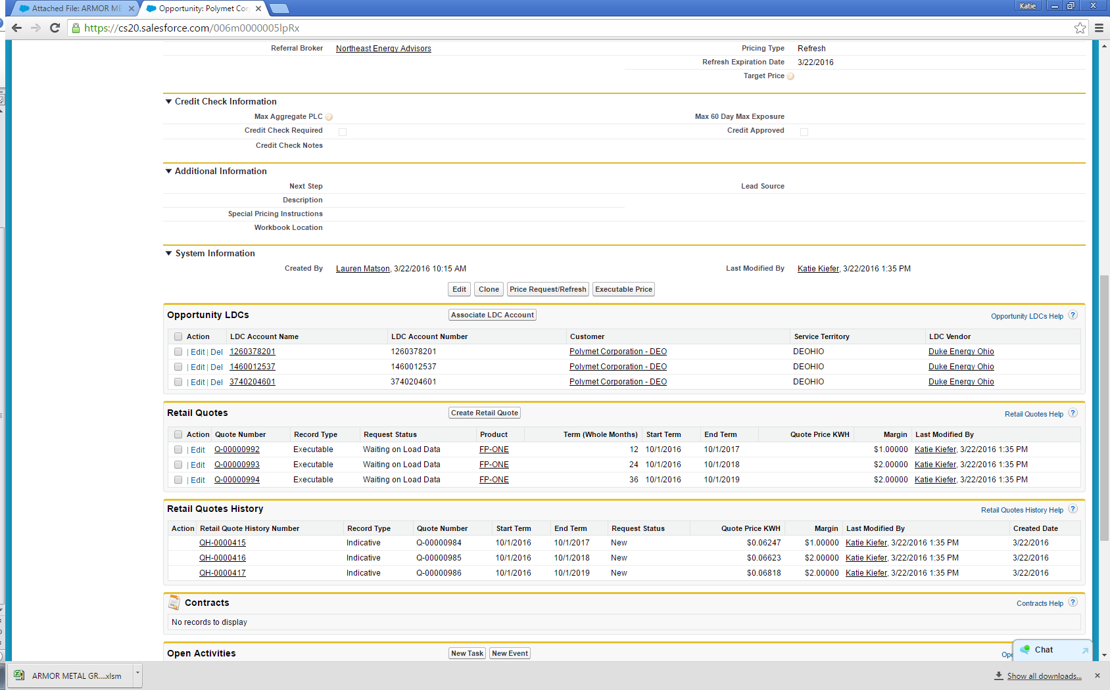

1. This will send the executable pricing request to the Pricing Team for final review and approval.
2. Once Pricing approves the request, the status will change to “Pricing Complete” and a contract can be created.

