**How-To Create Prospecting Opportunities**

Section I.

*Skip to Section II if creating prospect *without* LDC accounts

1. Open Customer with recently “Closed Won” or “Closed Lost” opportunity
2. Click “New Opportunity”

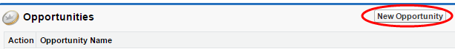

1. Select “Standard Opportunity” and click “Continue”

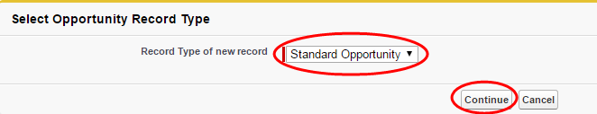

1. Enter “Opportunity Name” including the word “Prospecting”

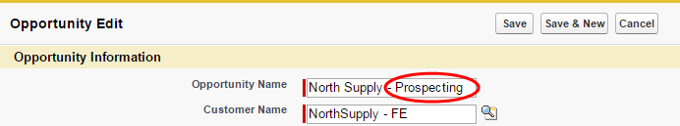

1. If creating a Prospect for a “Closed Won” opportunity: Select a “Close Date” equal to the last day of the same month the most recently “Closed Won” opportunity term ends.

Closed Won *Opportunity*:

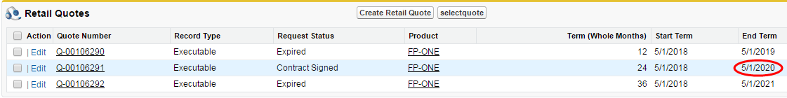

Closed Won *Prospect*:



1. If creating a Prospect for a “Closed Lost” opportunity: Select a “Close Date” equal to the last day of the month the competitor contract ends (if unknown, use 12 mo. as default term).

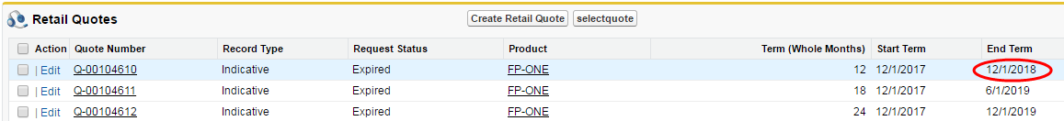Closed Lost *Opportunity*:

Closed Lost *Prospect*:



1. Select “Prospecting” from “Stage” drop-down box

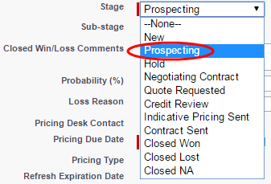

1. Complete all other required fields & click “Save”



1. Associate all accounts included in the “Closed Won” or “Closed Lost” opportunity

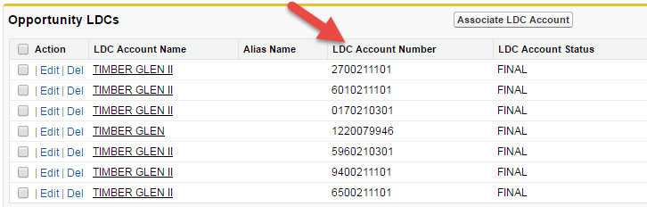Closed *Won* or *Lost* Opportunity :

*Prospect* Opportunity:

* 1. 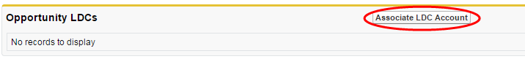Click “Associate LDC Account”:
  2. Select accounts and click “Save”:

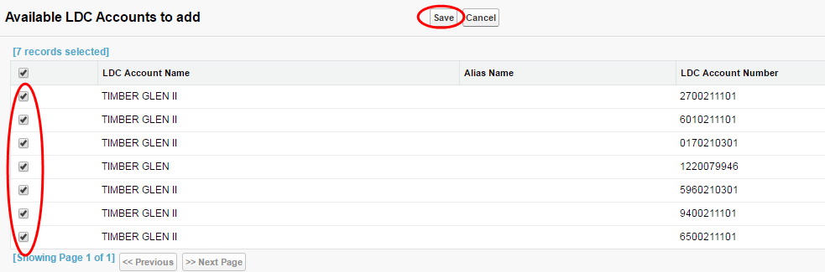

Note: Retail quotes are not required since usage will pull from the associated LDC Accounts.

Section II.

1. Click the “Leads” tab

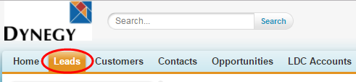

1. Select “New”

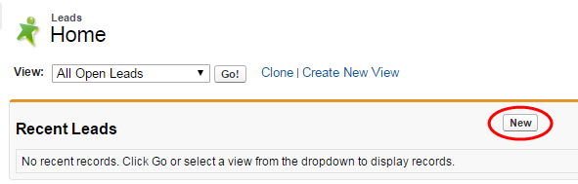

1. Fill out all required fields, any additional fields you have information for, and click “Save”



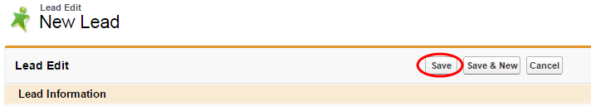

1. Leads can later be converted into Opportunities when ready to be priced

