**How To Create A Lead**

***Leads can be used when prospecting and gathering initial Customer information. You can skip this step and create a Customer, Opportunity, and Contact individually if desired.***

1. Click the “Leads” tab

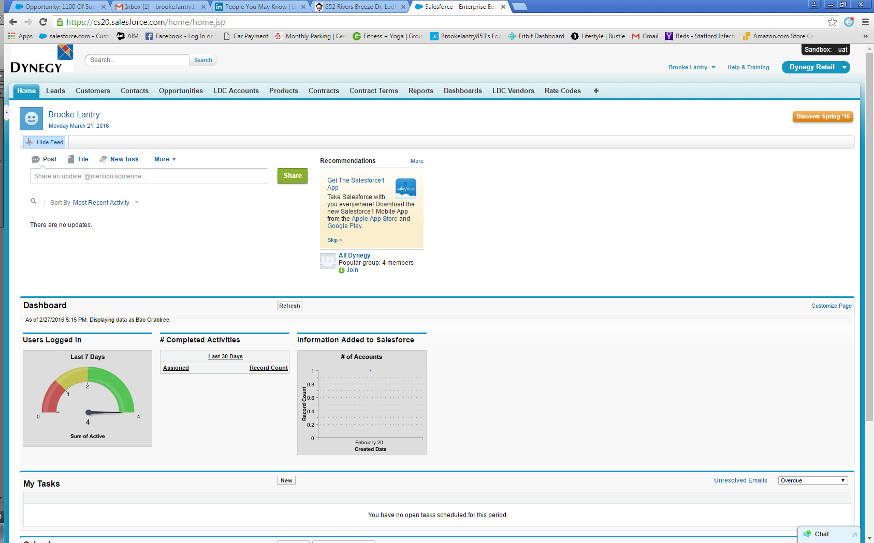

1. Click “New”

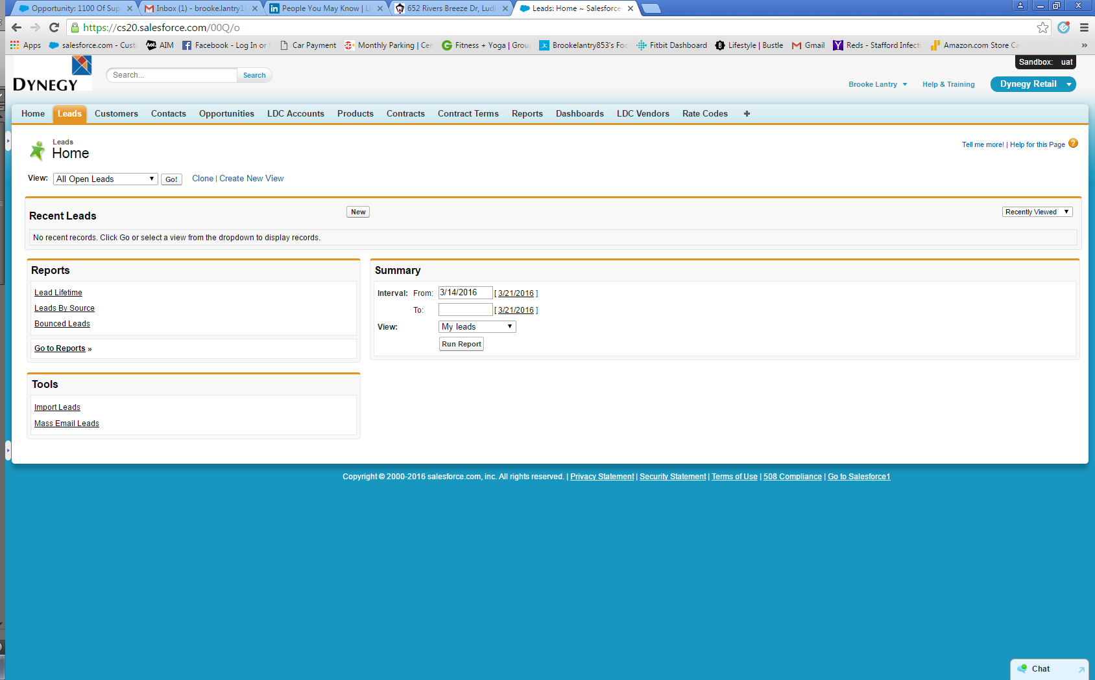

1. Enter as much lead information as possible. You must enter all red-highlighted fields.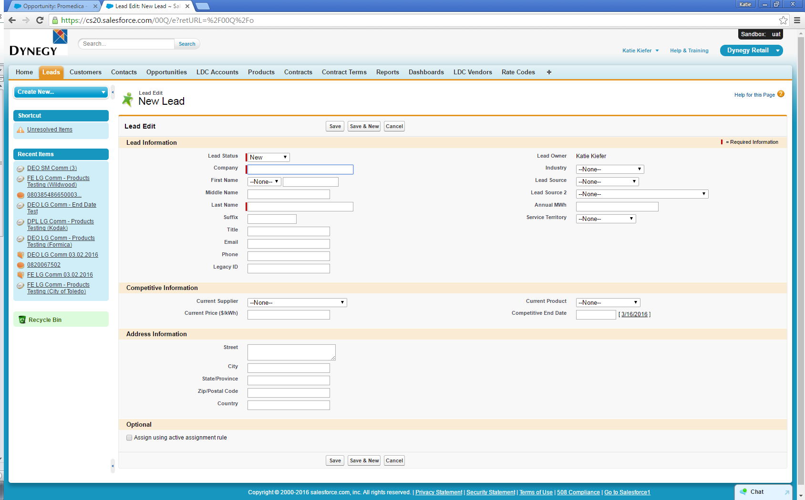
2. Save record.

