**How To Convert a Lead**

***Conversion creates a Customer, Opportunity, and Contact.***

1. Open the Lead.
2. Click on the “Convert” tab.

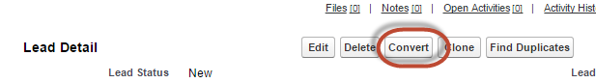

1. Update Opportunity Name and add Tasks as needed. Adding a Subject is NOT required, even though it is red-highlighted.

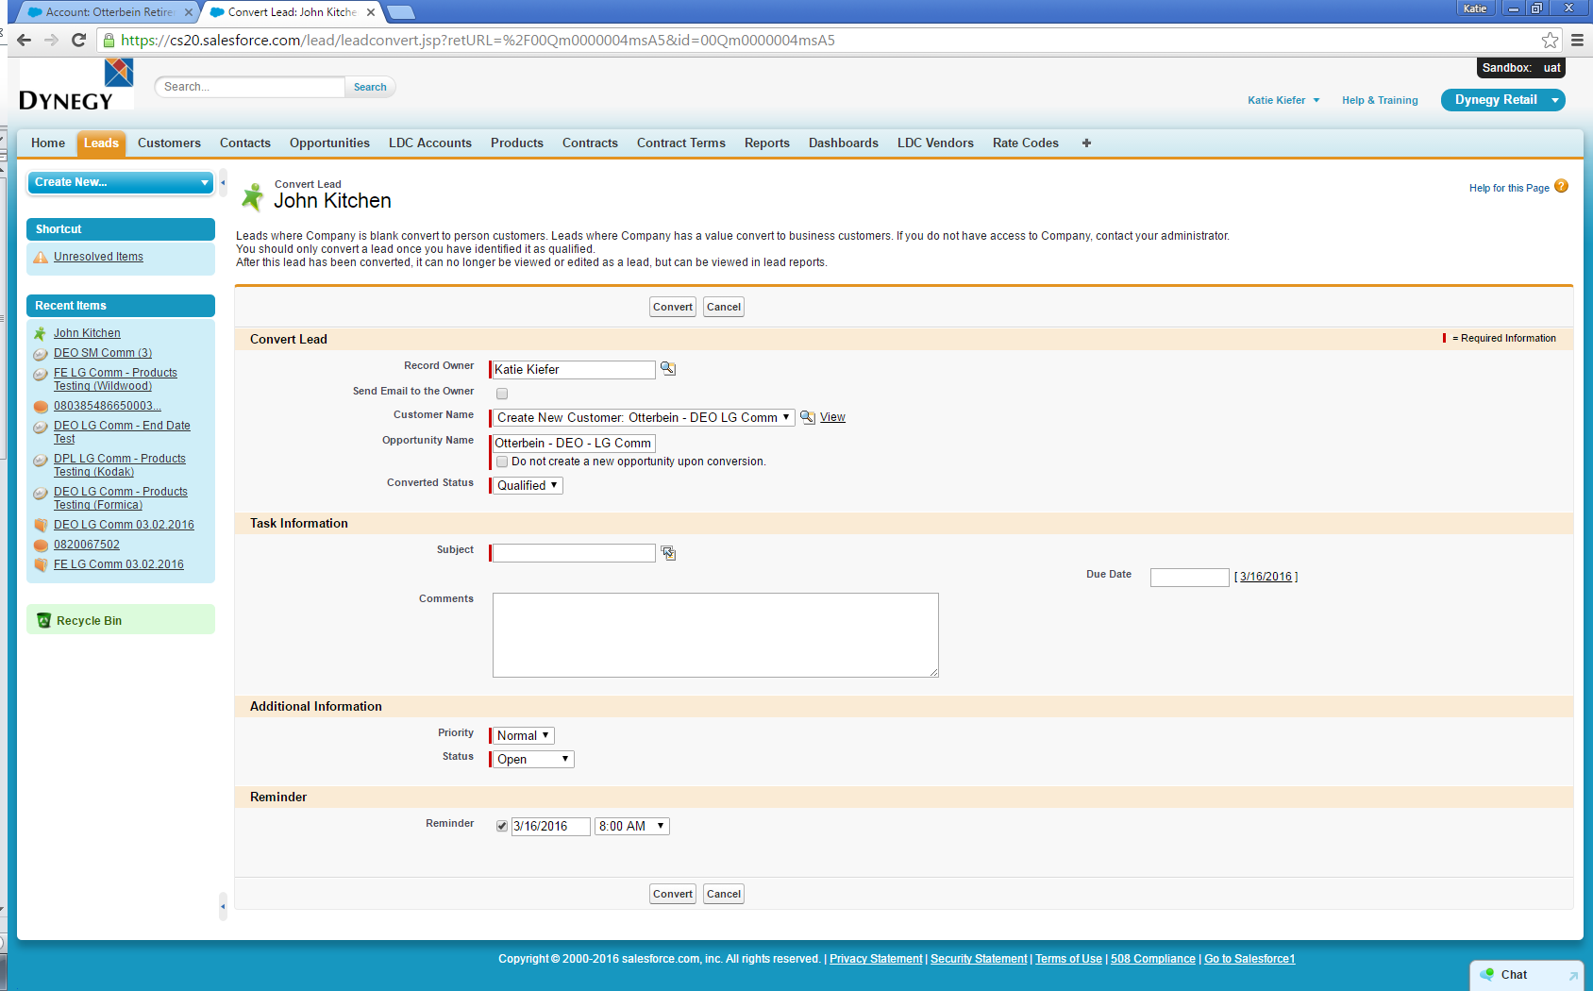

1. Click “Convert” button.



1. A new Customer, Opportunity, and Contact will be created.