**How To Create a Customer**

1. Click the “Customers” tab

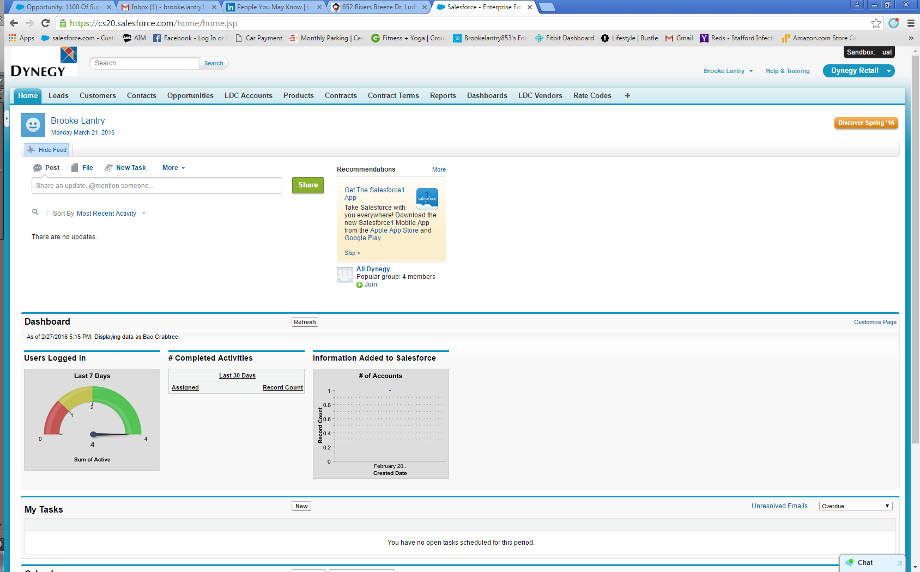

1. Click “New”

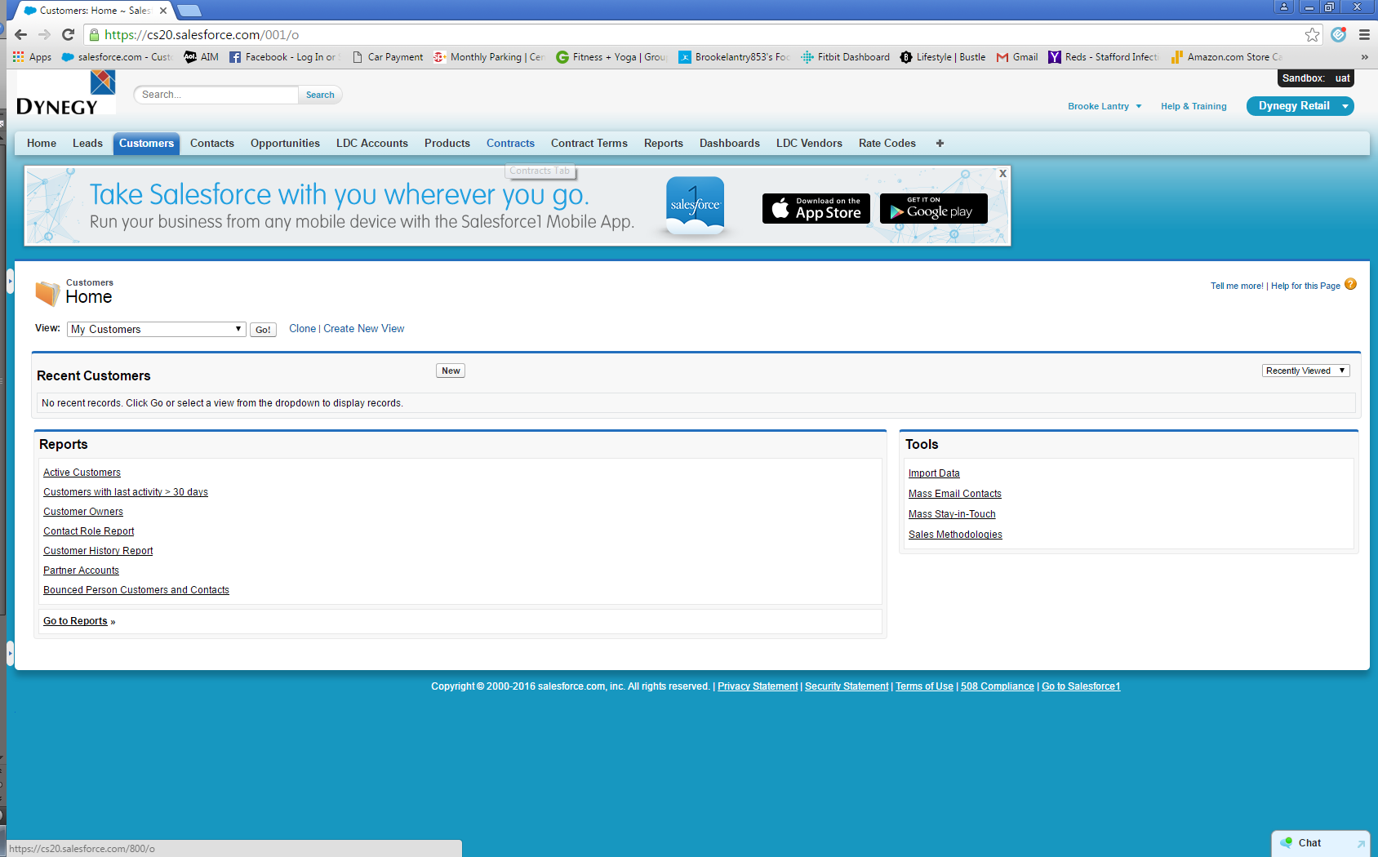

1. Select Customer Record Type [Defaults to C&I Customer] and Click ‘Continue’. You can select ABC to create a new broker in the system.

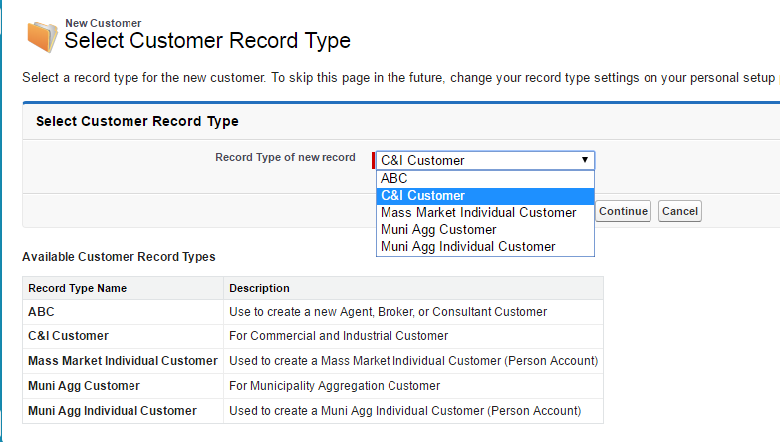

1. Enter Customer information. All red-highlighted fields are required.

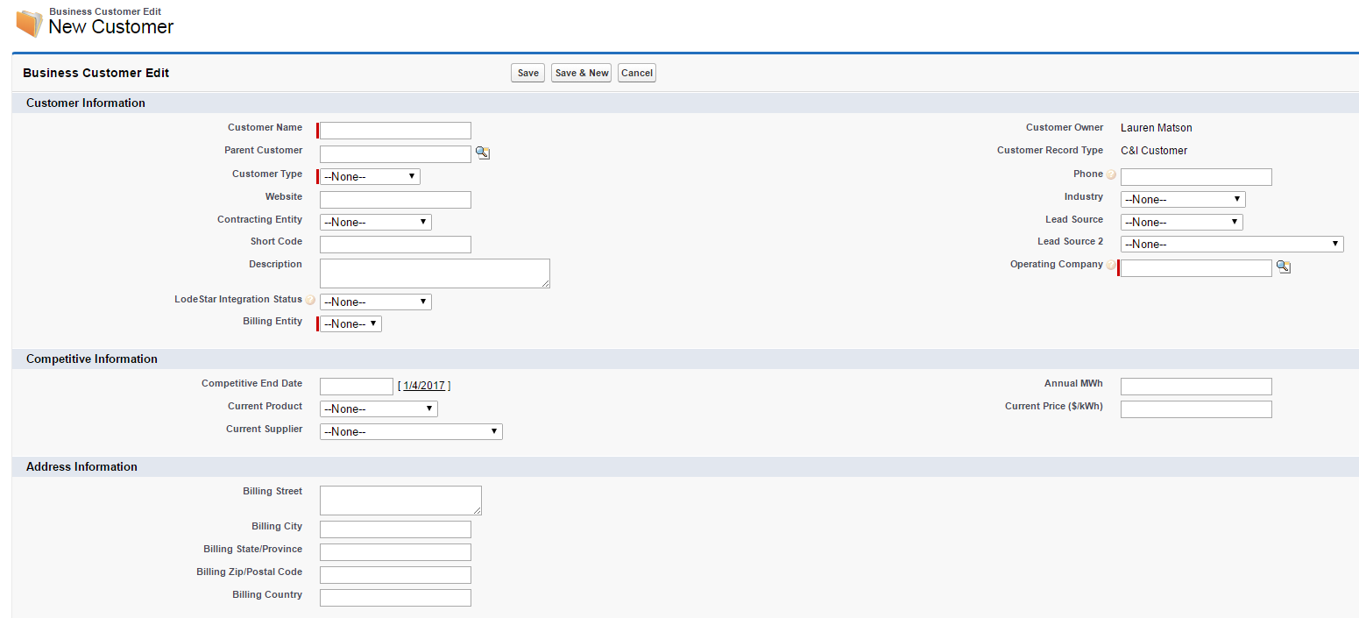

1. Save record.

