**How To Create a Contact**

***There are two ways to create a Contact. Both versions are listed below.***

***Version 1***

1. Chose the Customer record you wish to create the Contact under. Be sure the customer record is open.
2. Scroll down in the Customer record to the “Contacts” section. Click “New Contact”.

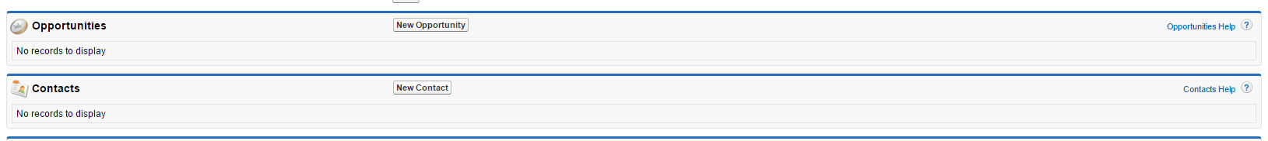

1. Enter the information for the contact. All red-highlighted fields are required.

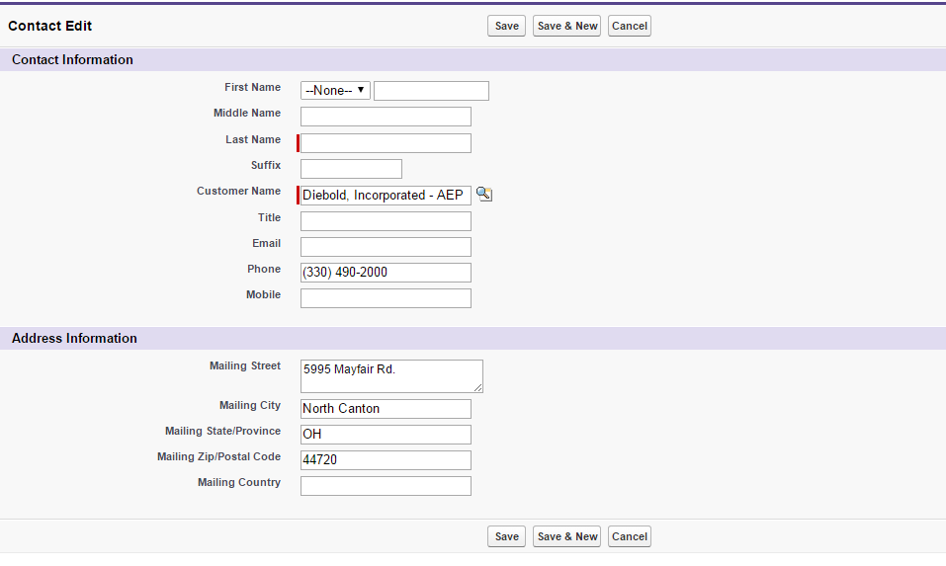

1. Click Save.

***Version 2***

1. Click the “Contacts” tab.

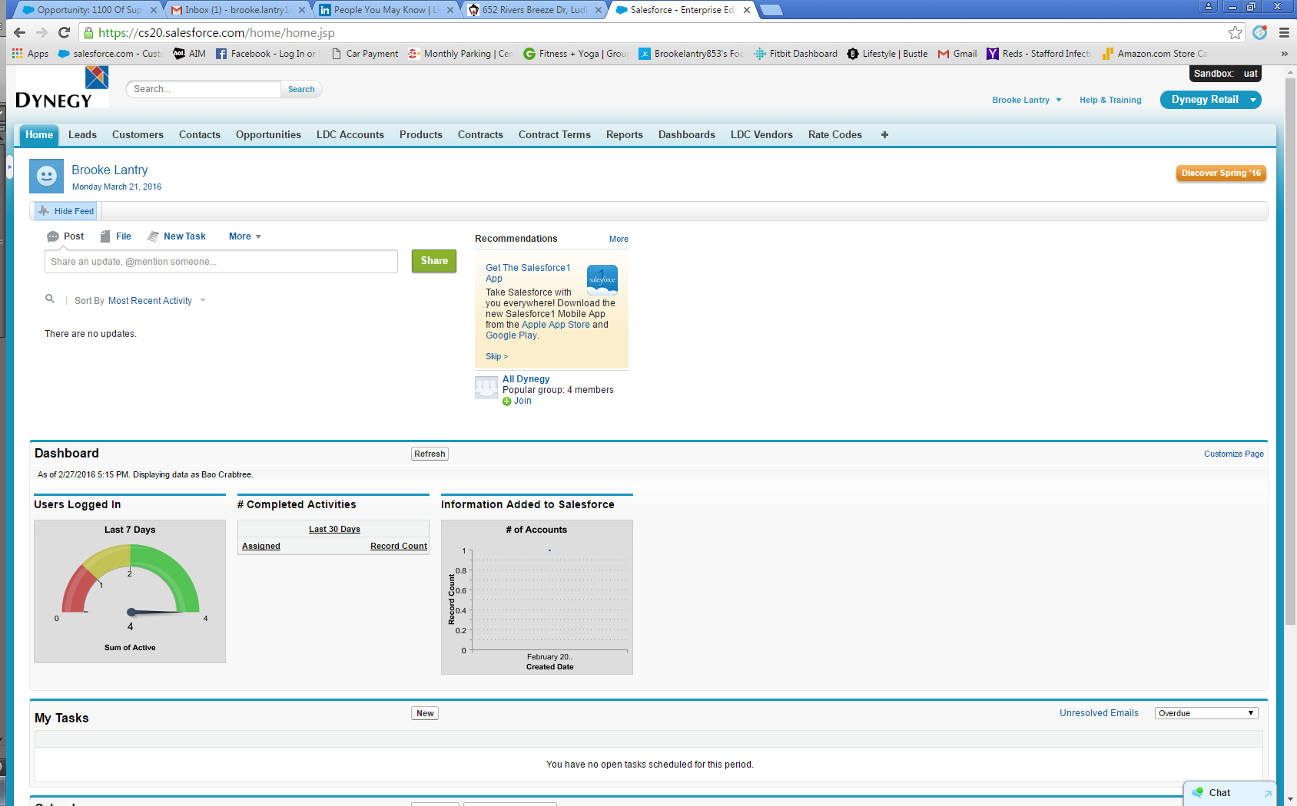

1. Click “New”

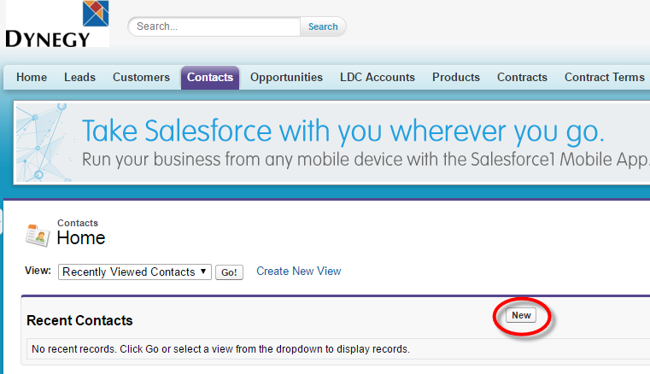

1. Enter contact information in required fields.

* **Customer Name is used to tie a Contact to a Customer in Salesforce**

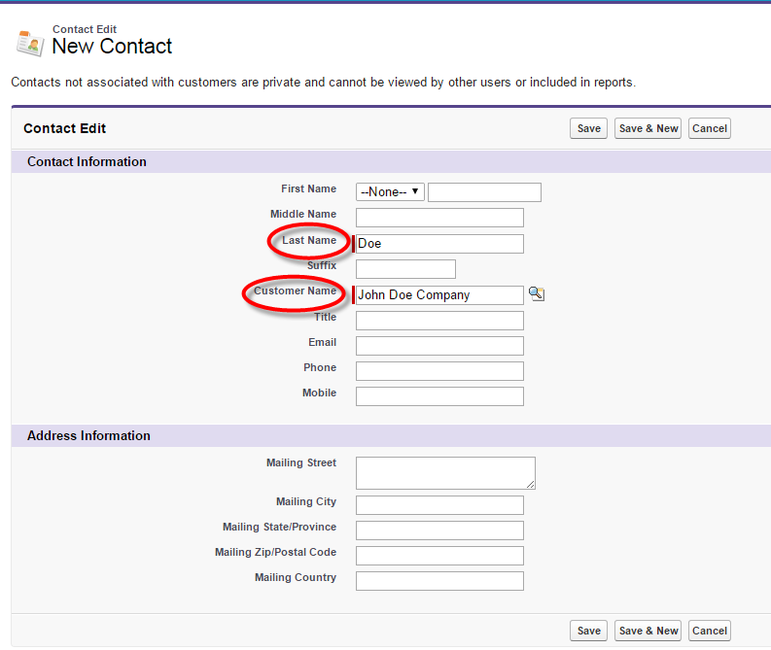



* May click magnifying glass ( ) to lookup current customer name.

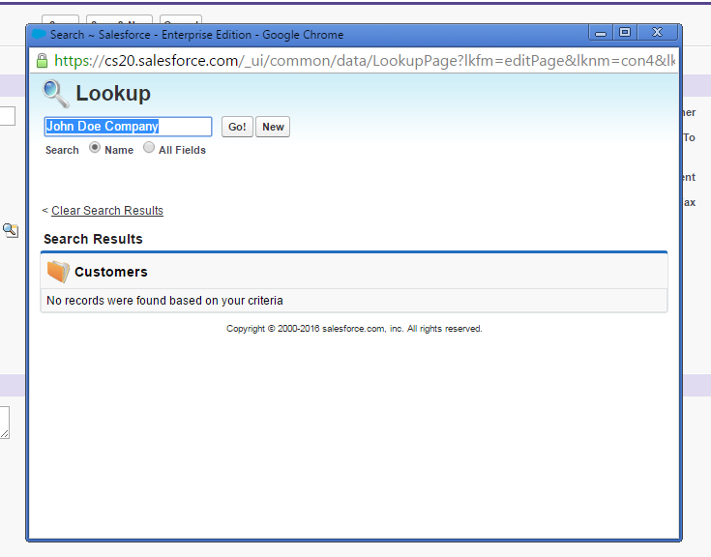

1. Continue entering any other know contact information.

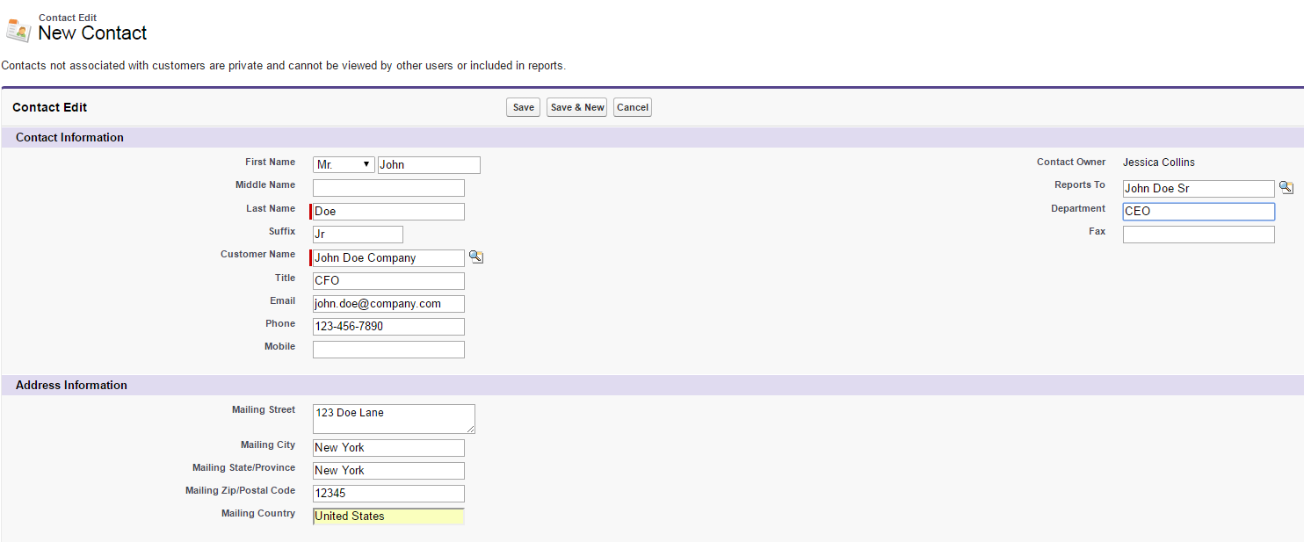

1. Click “Save”. 