**How To Bulk Upload LDC Account Numbers**

1. After creating a Customer in Sales Force, open the Bulk Account Upload Template.xlsm
2. Paste in the Customer ID from the Sales Force link in Column A of the Template.

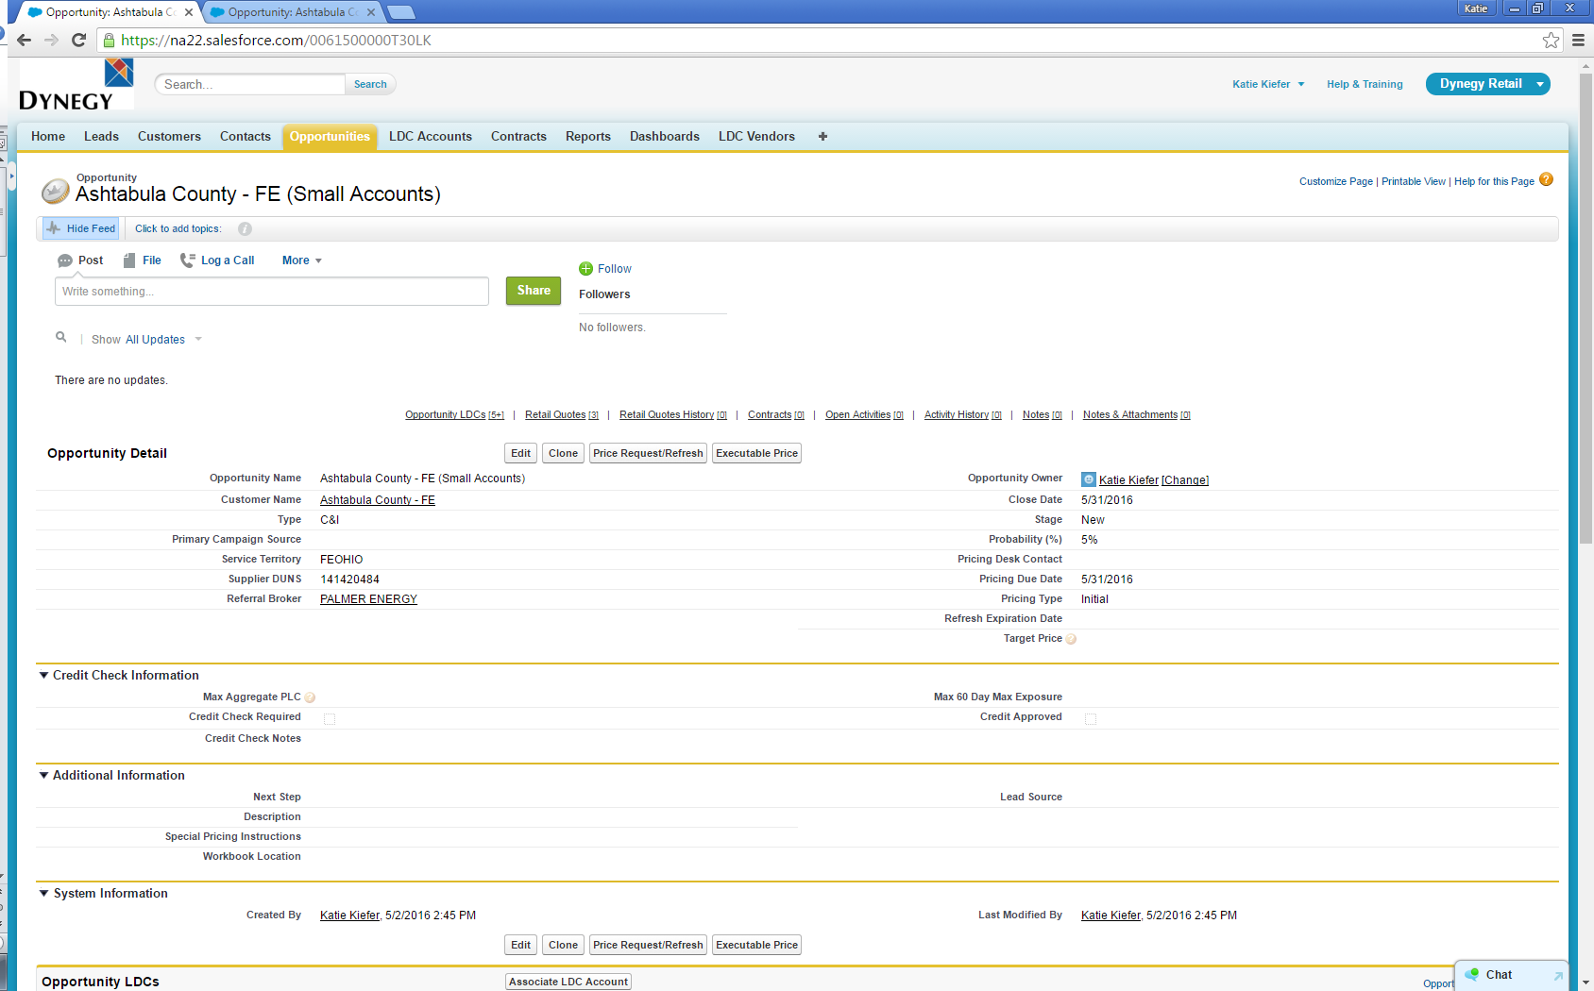

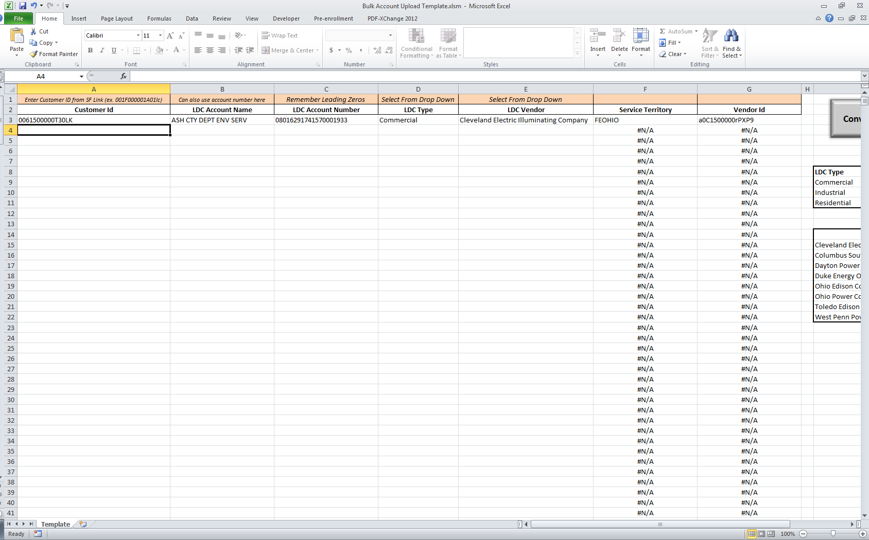

1. Enter the LDC Account Names and LDC Account Numbers onto the template.
2. Select the LDC Type from the drop down: Commercial, Industrial, or Residential.
3. Select the LDC Vendor from the drop down.



1. The Service Territory and Vendor ID will auto-populate.
2. Once, you have entered all the LDC Accounts and Information, click “Convert to CSV File”

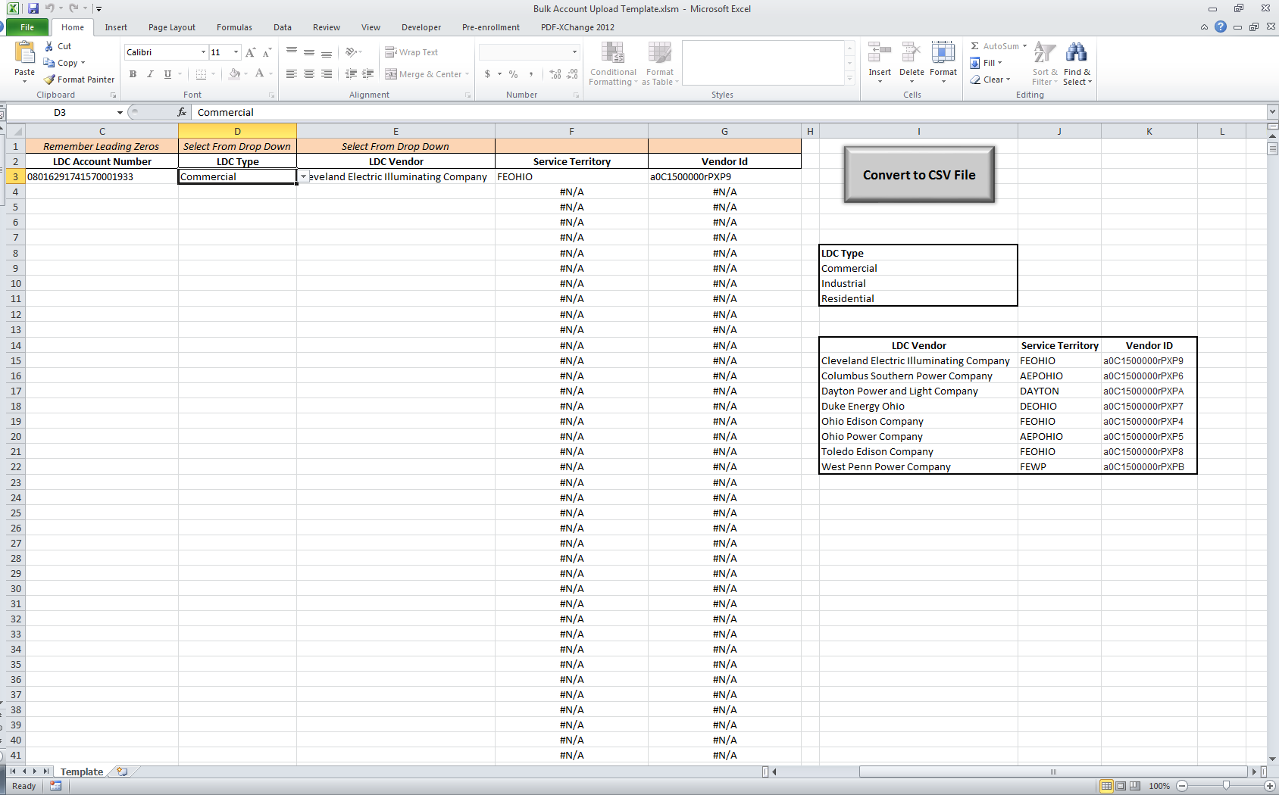

1. This will save a CSV file in your folder where the template is saved.
2. Launch Data Loader from your Programs
3. Click “Insert”

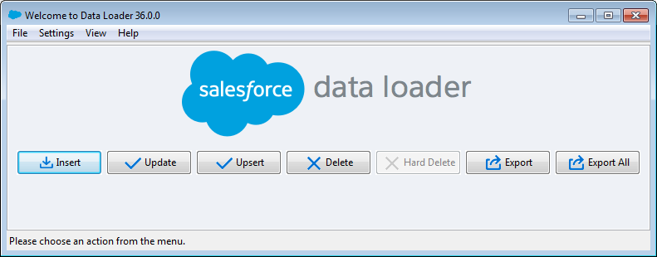

1. Log In to the Data Loader OAuth 🡪 Environment: Production
2. Click on “Log in”
3. A Log In Screen will pop up.
4. Click on “Use Custom Domain”
   1. Under Customer Domain, type: **dynegy.my.salesforce.com**

A login screen will pop up.

* 1. Enter your Network User ID and Password and click on ‘Logon’

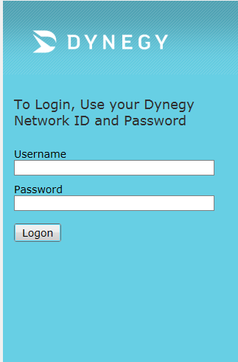

1. A small Salesforce Screen will pop-up, close this window.

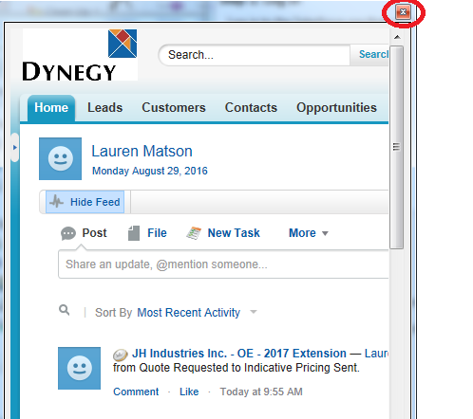

1. Click on ‘Log in’ on the previous window. An Allow Access Window will pop-up. Click on ‘Allow’

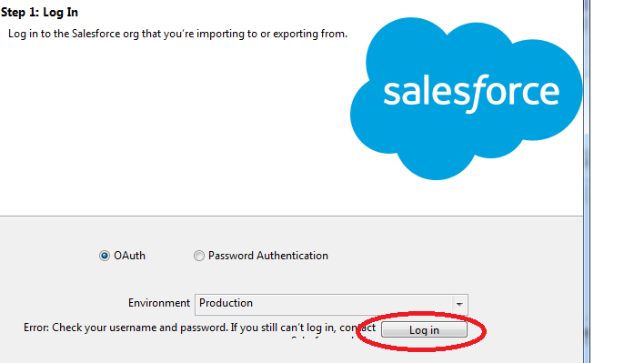

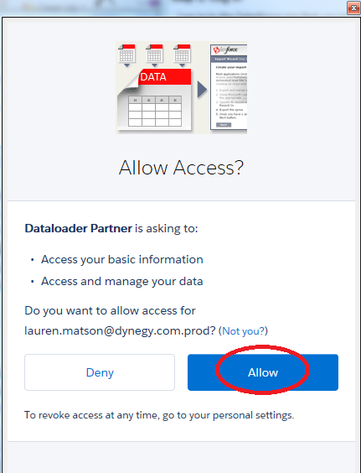

1. Login status will change to “Login Successful”

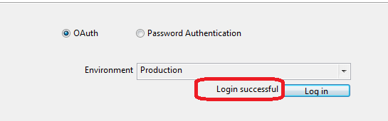

1. Click on “Next”
2. Click the “LDC Account (LDC_Account_c)” object
3. Click “Browse” and choose your CSV File created from the Bulk Account Upload Template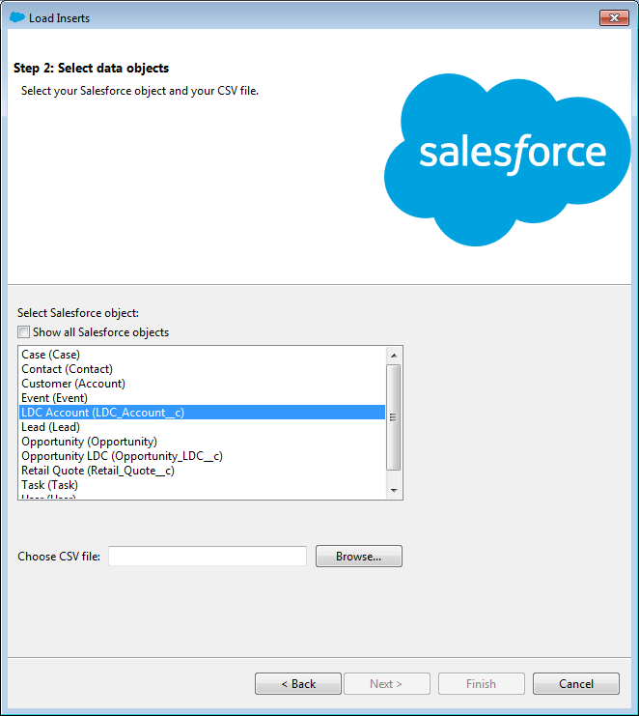
4. Click “Next”
5. A pop-up window will open stating “Your operation will contain X records.” Click OK

[X Records should match the number of LDC Accounts you are trying to add to the Customer]

1. Click the button “Choose an Existing Map” and find the path to the “LDCAccountUpload.sdl”
2. Click Next
3. Click Finish (If this is your first attempt to bulk upload, see Step 28)

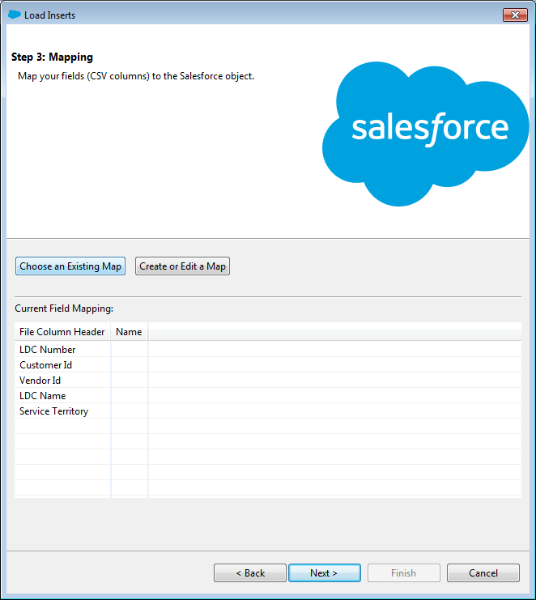

1. Click “Yes” on the Warning pop up

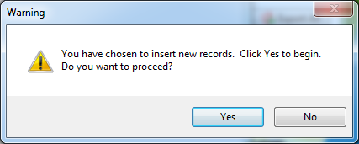

1. On the first upload, you will need to pick the directory to send the “Success” or “Errors” file. Your Desktop is a good place. And then click “Finish”

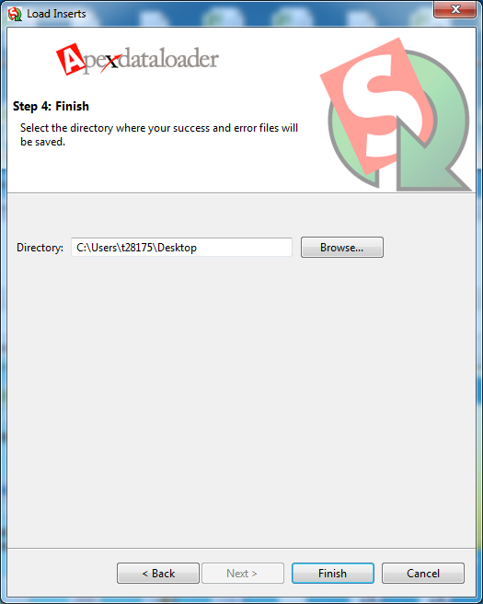

1. Click “Yes” on the Warning pop up



1. Click “OK” when the Operation Finished pops up

