**How To Add LDC Account Numbers to the Customer Tab**

1. Open Desired Customer by searching in the Salesforce Search Window and clicking on the desired Customer.



***Example: Polymet Corporation***

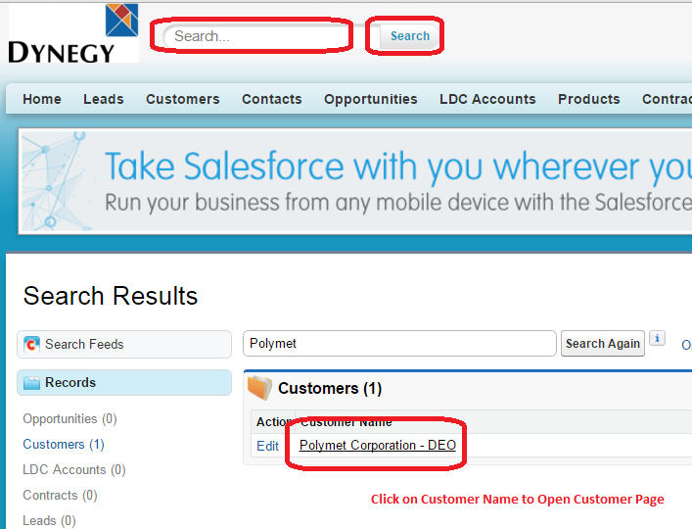

1. Scroll down to the Section ‘LDC Accounts (Account)’ on the Customer page and Click on ‘New LDC Account’

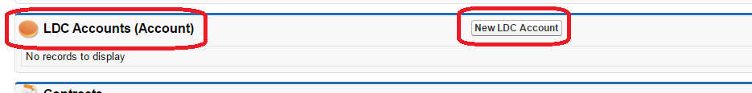

1. The New LDC Account window opens

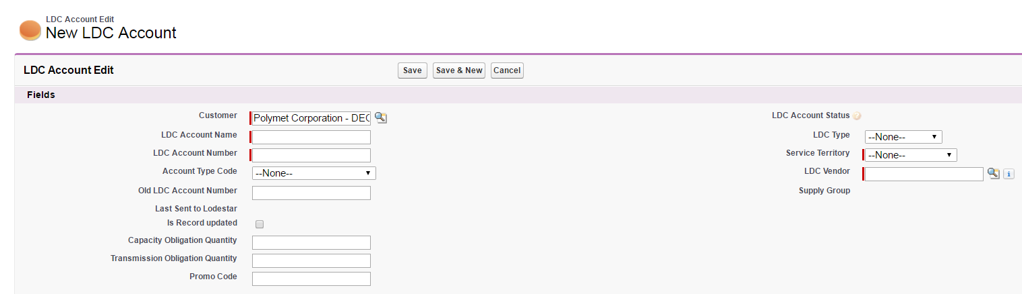

1. The following red-highlighted fields are Required to add a LDC Account
   * **Customer** (this should auto populate with the Customer Name you have open)
   * **LDC Account Name** (Use Desired Name or Utility LDC Account Number)
   * **LDC Account Number** (Use Utility LDC Account Number)
   * **LDC Type** (drop down menu. Majority of the time you will select ‘Commercial’)
   * **Service Territory** (drop down menu)
   * **LDC Vendor** (Click on the Magnifying Glass and begin to type LDC Vendor name and click ‘Go!.’ LDC Vendor Name is driven from the Service Territory previously Selected.)

[**See Service Territory/LDC Vendor Options on the Next Page]**

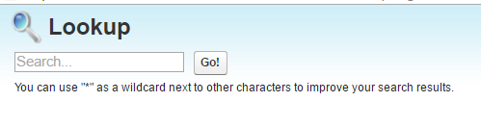

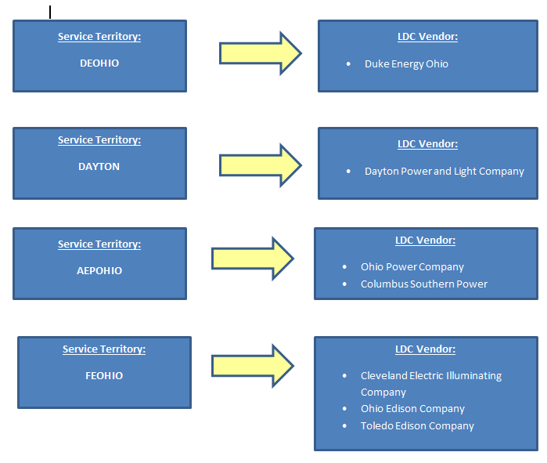

***Example: Polymet Corpration – 3 DEO Accounts: 1260378201, 1460012537, & 3740204601***

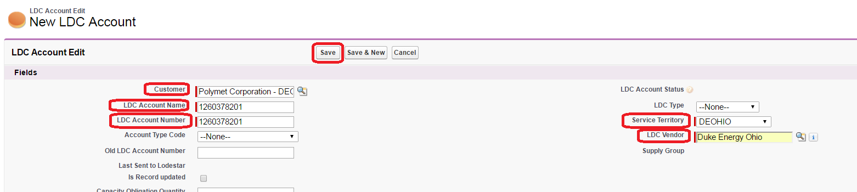

1. Once required fields are completed, click on ‘Save’ at the top of the page or ‘Save & New’ if you need to add multiple LDC Accounts. You can also click ‘Save’ and then ‘Clone’ to add an additional account. When cloning an account, be sure to update the required fields including the LDC Account Number. Once changes are made, click on ‘Save.’

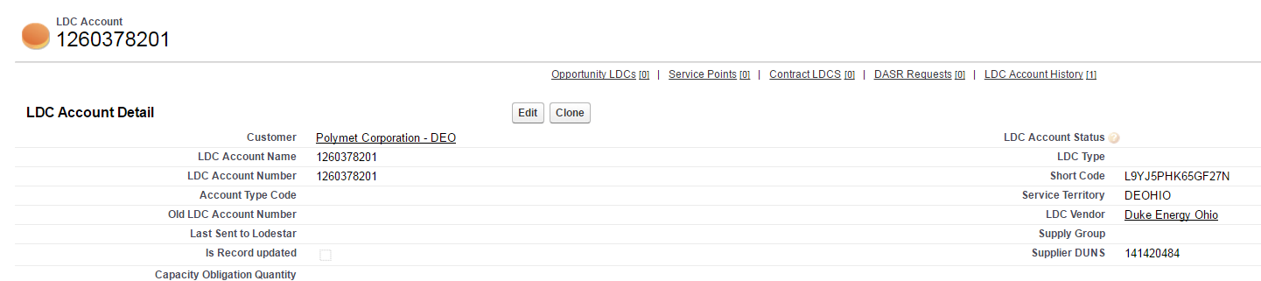

1. Once all LDC Accounts are added, click on Customer Name to return to Customer Page and verify that all LDC Accounts are added

