**How to Create an Opportunity**

1. Search for desired Customer in the Salesforce Search Window

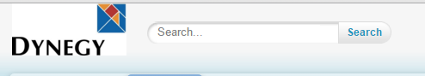

1. From the search results, click on the desired Customer name
2. On the Customer page, scroll down to the Opportunities section and click New Opportunity

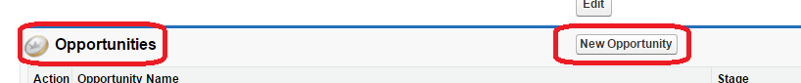

1. Select Opportunity Record Type of New Record
   * Choose ‘Standard Opportunity’ from the Drop Down Menu [Defaults to this record type]
   * Click on ‘Continue’

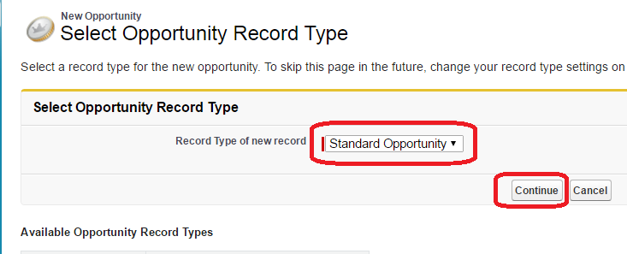

**Available Opportunity Record Types:**

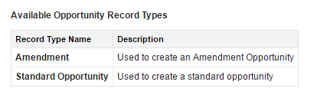

* *Choose an Amendment Record Type to: (1) Add Account(s) to an Existing Agreement; (2) Change Contracted Product; (3) Purchase an Additional Block of Energy; or (4) Purchase an additional Percentage of Energy.*

1. An Opportunity Edit Window will open where fields can be entered with Customer/Opportunity Information

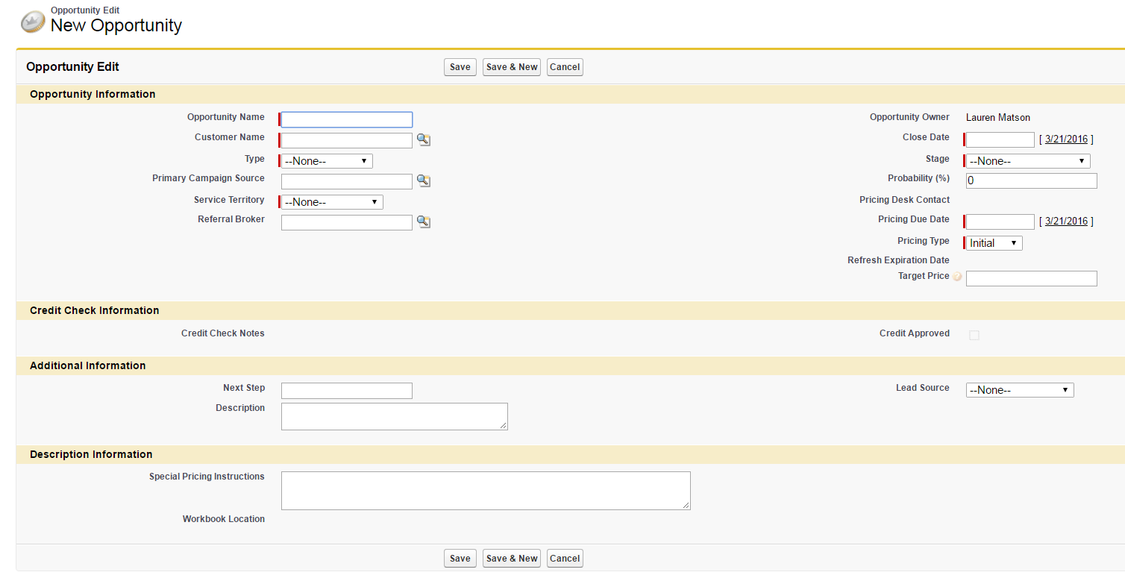

1. Enter Opportunity Name
2. Customer Name will be populated with the Customer name you selected to create the Opportunity under
3. Required Fields to Create an Opportunity:
   * **Opportunity Name *–*** *This name can be changed to better identify the opportunity but should still relate to the Customer name, for example: Apple, Inc – FE – 2016.*
   * **Type** *– Drop Down Menu: C&I, Small Business, Muni-Agg, Mass Market, Other*
   * **Service Territory -** *Utility*
   * **Referral Broker (if Applicable)** *– Pick List – Begin to type the Broker’s name and click on the magnifying glass – this will pull a list of brokers to select*
   * **Close Date** *– Start Month + 1 (for example, June 2016 Start would have an end date of 7/31/2016)*
   * **Stage *–*** *Select from Drop Down Menu – Typically ‘New’ or ‘Quote Requested’ when creating an Opportunity.*
   * **Pricing Due Date** *– Date the Pricing is due from the Pricing Desk*

***Example: Customer – Polymet Corporation - DEO***

* ***Opportunity Name: Polymet Corporation – DEO***
* ***Type: C&I***
* ***Service Territory: DEOHIO***
* ***Referral Broker: Northeast Energy Advisors***
* ***Close Date: 11/30/2016 [Start Date October 2016]***
* ***Stage: New***
* ***Pricing Due Date: 3/24/2016***

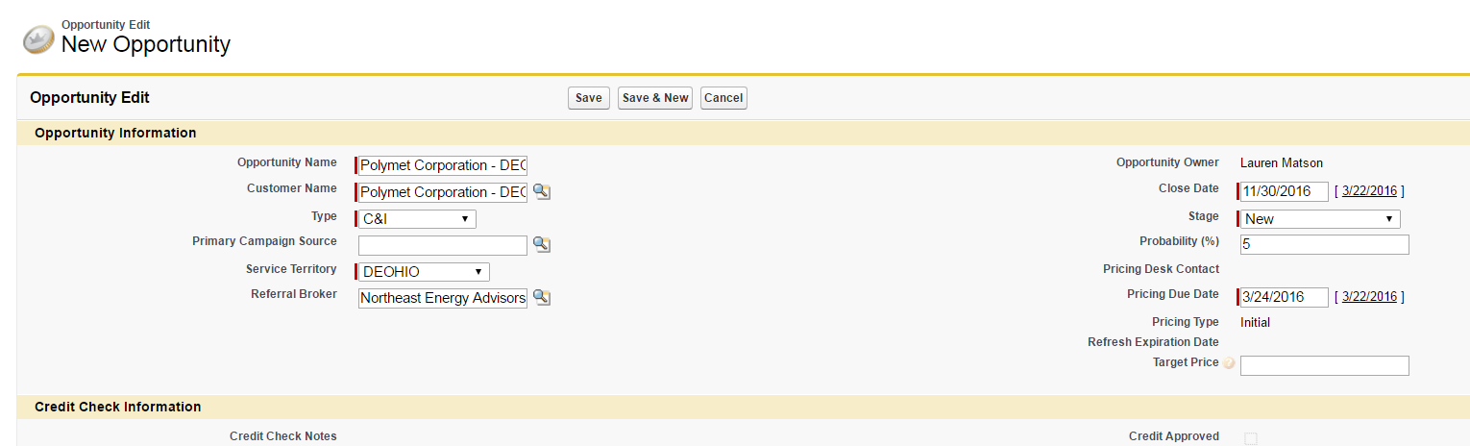

1. Once all Opportunity data is entered, Click on ‘Save’

**How to Create an Amendment Opportunity**

1. Search for desired Customer in the Salesforce Search Window



1. From the search results, click on the desired Customer name
2. On the Customer page, scroll down to the Opportunities section and click New Opportunity



1. Select Opportunity Record Type of New Record
   * Choose ‘Amendment’ from the Drop Down Menu
   * Click on ‘Continue’

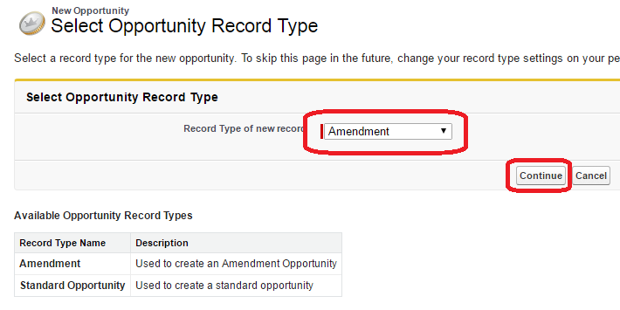

1. An Opportunity Edit Window will open where fields can be entered with Customer/Opportunity Information

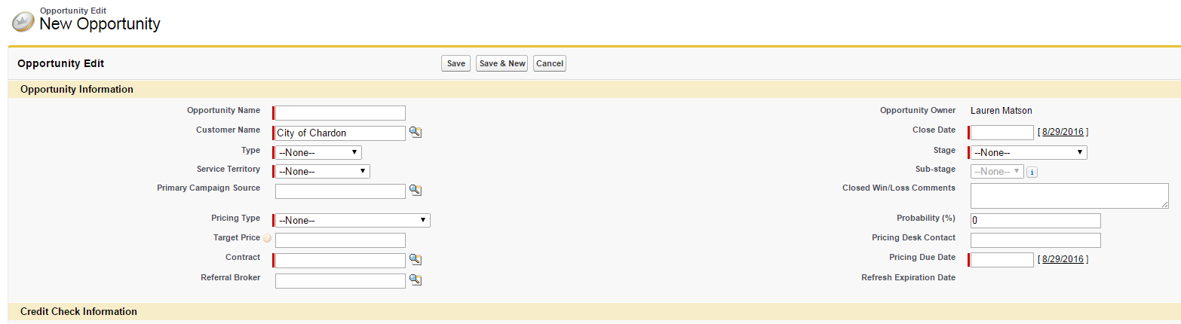

1. Enter Opportunity Name
2. Customer Name will be populated with the Customer name you selected to create the Opportunity under
3. Required Fields to Create an Opportunity:
   * **Opportunity Name *–*** *This name can be changed to better identify the opportunity but should still relate to the Customer name*
   * **Type** *– Drop Down Menu: C&I, Small Business, Muni-Agg, Mass Market, Other*
   * **Service Territory -** *Utility*
   * **Pricing Type –** *Account Add, Product Change, or Energy Purchase (block or percentage)*
   * **Target Price –***Used if trying to match an existing agreement’s contracted rate*
   * **Contract –***Contract Number assigned to this customer (Typically C-0000XXXX). This number can be found under the previous ‘Closed Won’ Opportunity.*
   * **Referral Broker (if Applicable)** *– Pick List – Begin to type the Broker’s name and click on ‘Go!’ – this will pull a list of brokers to select*
   * **Close Date** *– Start Month + 1 (for example, June 2016 Start would have an end date of 7/31/2016)*
   * **Stage *–*** *Select from Drop Down Menu – Typically ‘New’ or ‘Quote Requested’ when creating an Opportunity*
   * **Pricing Due Date** *– Date the Pricing is due from the Pricing Desk*
4. Once all Opportunity data is entered, Click on ‘Save’