**How To Associate LDC Accounts to the Opportunity**

1. Open the desired Opportunity

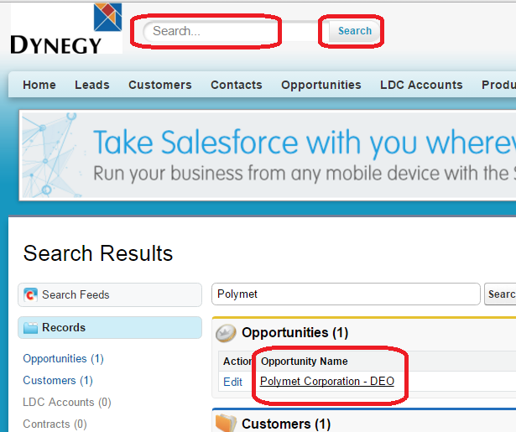

1. Scroll down to the ‘Opportunity LDC’s’ Section and click on ‘Associate LDC Account’

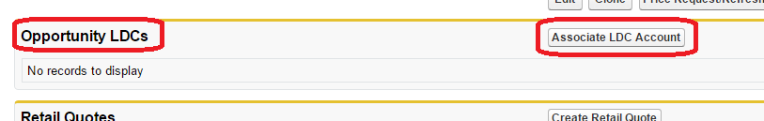

1. ‘Available LDC Accounts to Add’ Window Opens

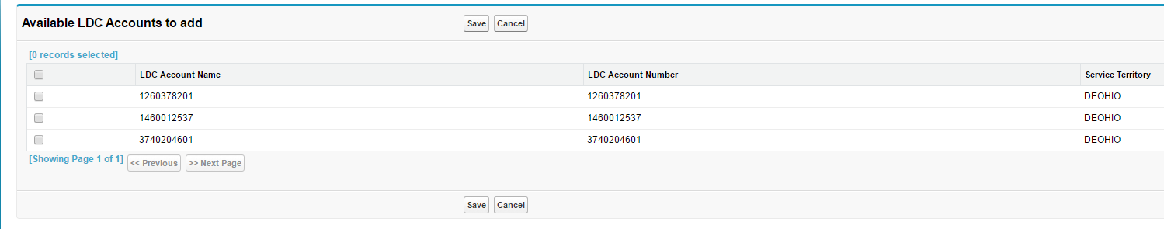

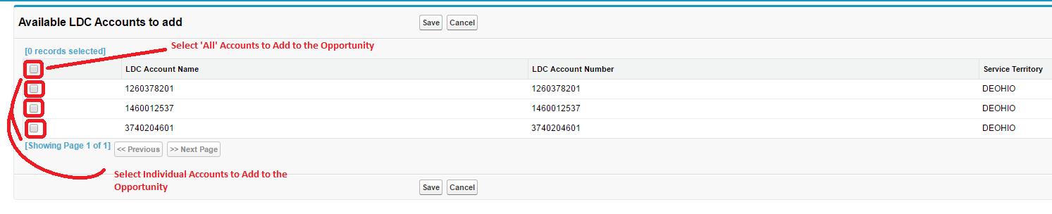

1. Select All or Individual Accounts to Associate to the opportunity by clicking on the corresponding checkboxes

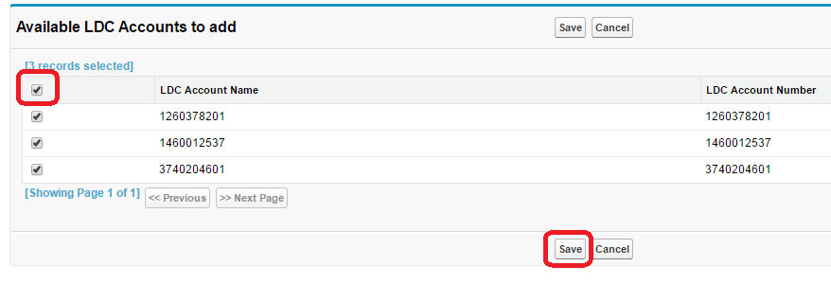

1. Click on ‘Save’
2. LDC Accounts Associated to Opportunity
3. Double Check: Go to the Opportunity LDCs Section of the Opportunity and verify that the LDC Accounts are listed

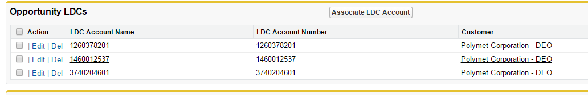

***Example: Opportunity - Polymet Corporation – DEO***

***LDC Accounts Added: 1260378201, 1460012537, & 3740204601***