**How to Create Quotes**

1. Search for desired Customer in the Salesforce Search Window

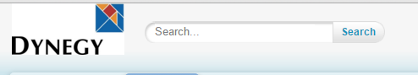

1. From the search results, click on the desired Opportunity name
2. On the Opportunity page, scroll down to the Retail Quotes section and click Create Retail Quote

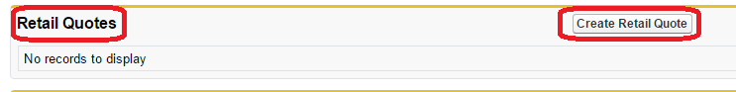

1. New Retail Quote Window Opens

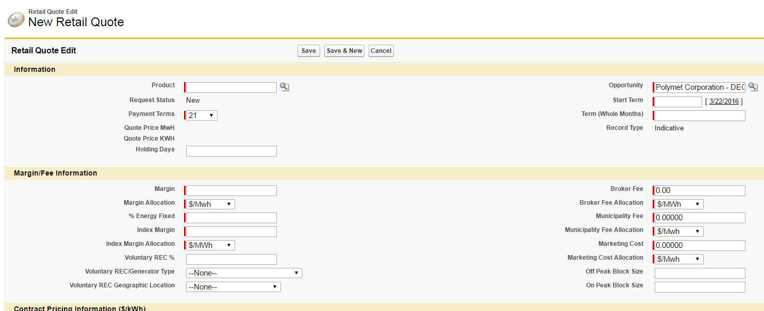

1. Required Fields to create a retail quote:
   * **Product** *– Pricing Product – Click on the Magnifying Glass to see a full list of Pricing Products (sample screenshot on next page)*
   * **Payment Terms** – *Defaults to 21 (Days)*
   * **Opportunity –** *Defaults to the Opportunity Quotes are being requested for*
   * **Start Term –** Choose the 1st of the Desired Start Month. If pricing for a late meter read cycle that can still meet the deadline for a current month start, you can choose the current calendar day.
   * **Term (Whole Months) –** *Can only be 1 number. Separate terms would require multiple quotes (Example – 12/24/36 months would require 3 quotes)*
   * **Margin** – *Desired margin on the quote ($/MWh)*
   * **Margin Allocation** *– Defaults to $/MWh*
   * **% Energy Fixed –** *Should be 100% if doing a Fixed, All-in product. Varies if doing Percentage Energy Products.*
   * **Index Margin** – *Should be ‘0’ if not quoting an Index Product. If quoting an index product, all margin should be allocated to the Index Margin.*
   * **Broker Fee –** *Desired broker fee ($/MWh)*
   * **Broker Fee Allocation –** *Defaults to $/MWh*
   * **Municipality Fee** *– Should be ‘0’ for C&I (Defaults to 0.00000)*
   * **Municipality Fee Allocation –** *Defaults to $/MWh*
   * **Marketing Cost** *– Should be ‘0’ for C&I (Defaults to 0.00000)*
   * **Marketing Cost Allocation –** *Defaults to $/MWh*

**Pricing Products:**

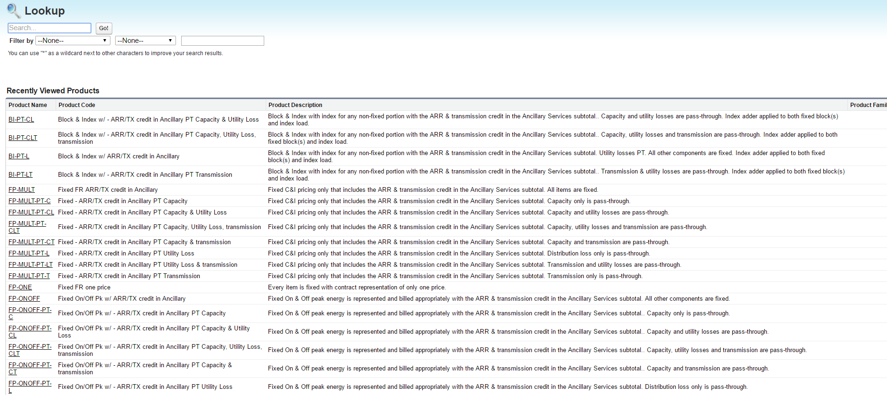

***Example – Opportunity: Polymet Corporation – DEO***

***Quote Requirements – Fixed Price with an October 2016 Start for 12/24/36 months with 3 mils to Northeast Energy Advisors***

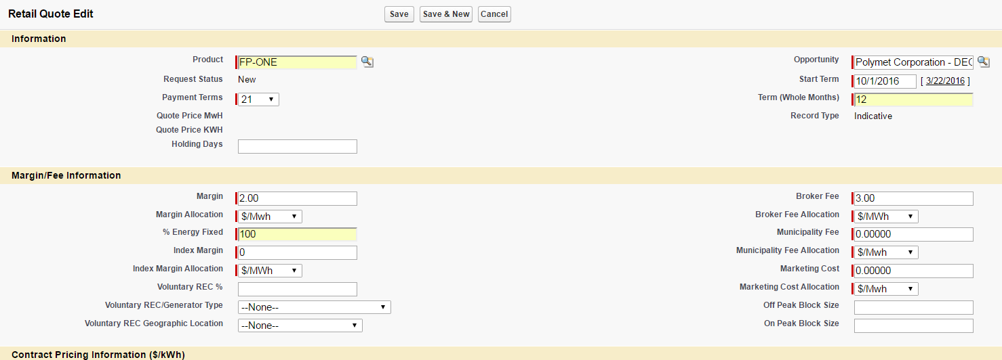

1. Click Save
2. After saving the Quote, you will be defaulted back to the Opportunity screen.
3. To request multiple terms (12, 24, 36 months), scroll down and click the link to the Quote you created to reopen it by clicking on the ‘Quote Number’

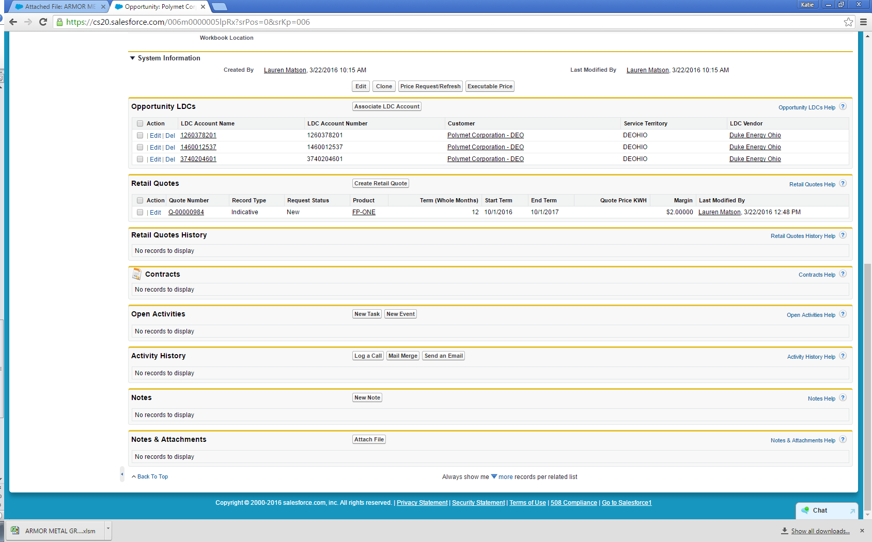

1. Click Clone.

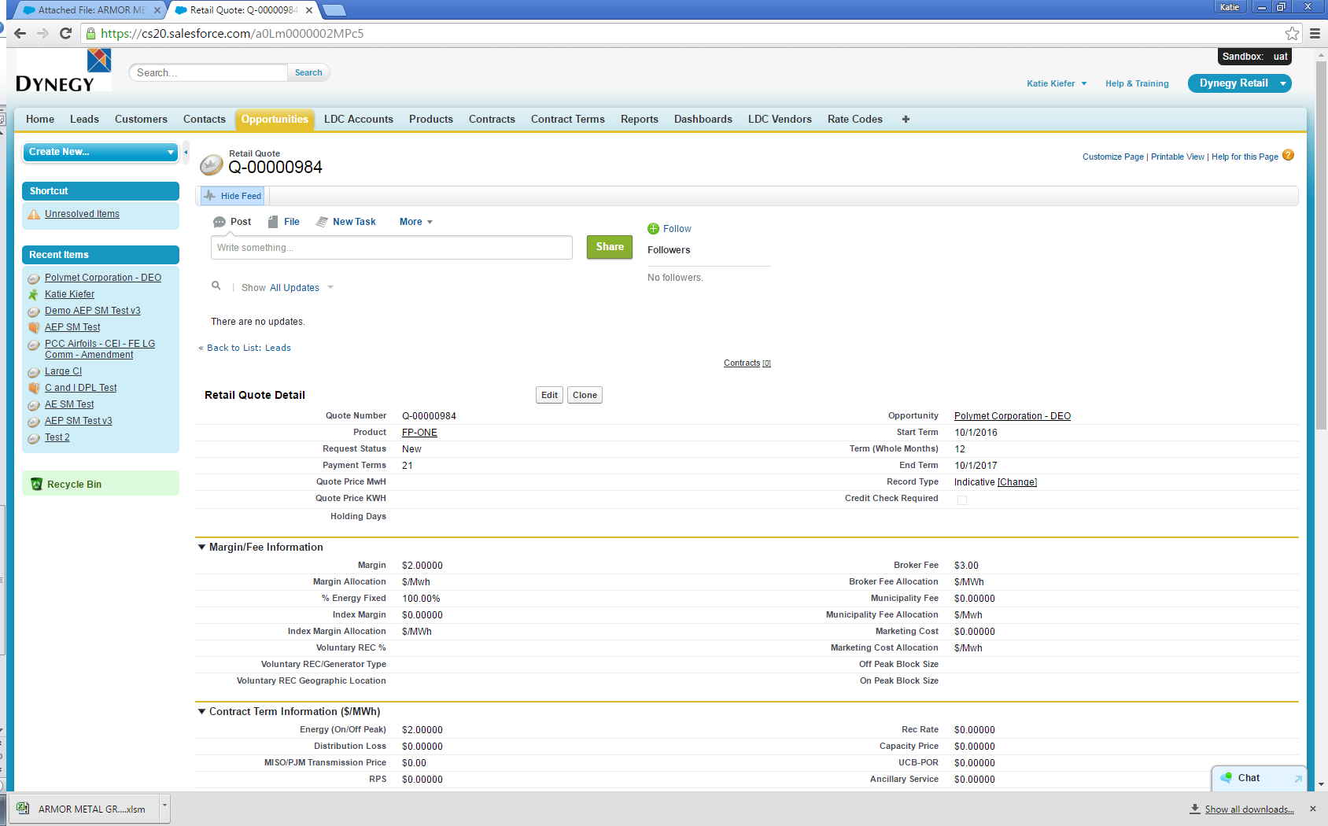

1. Change the Term to 24.

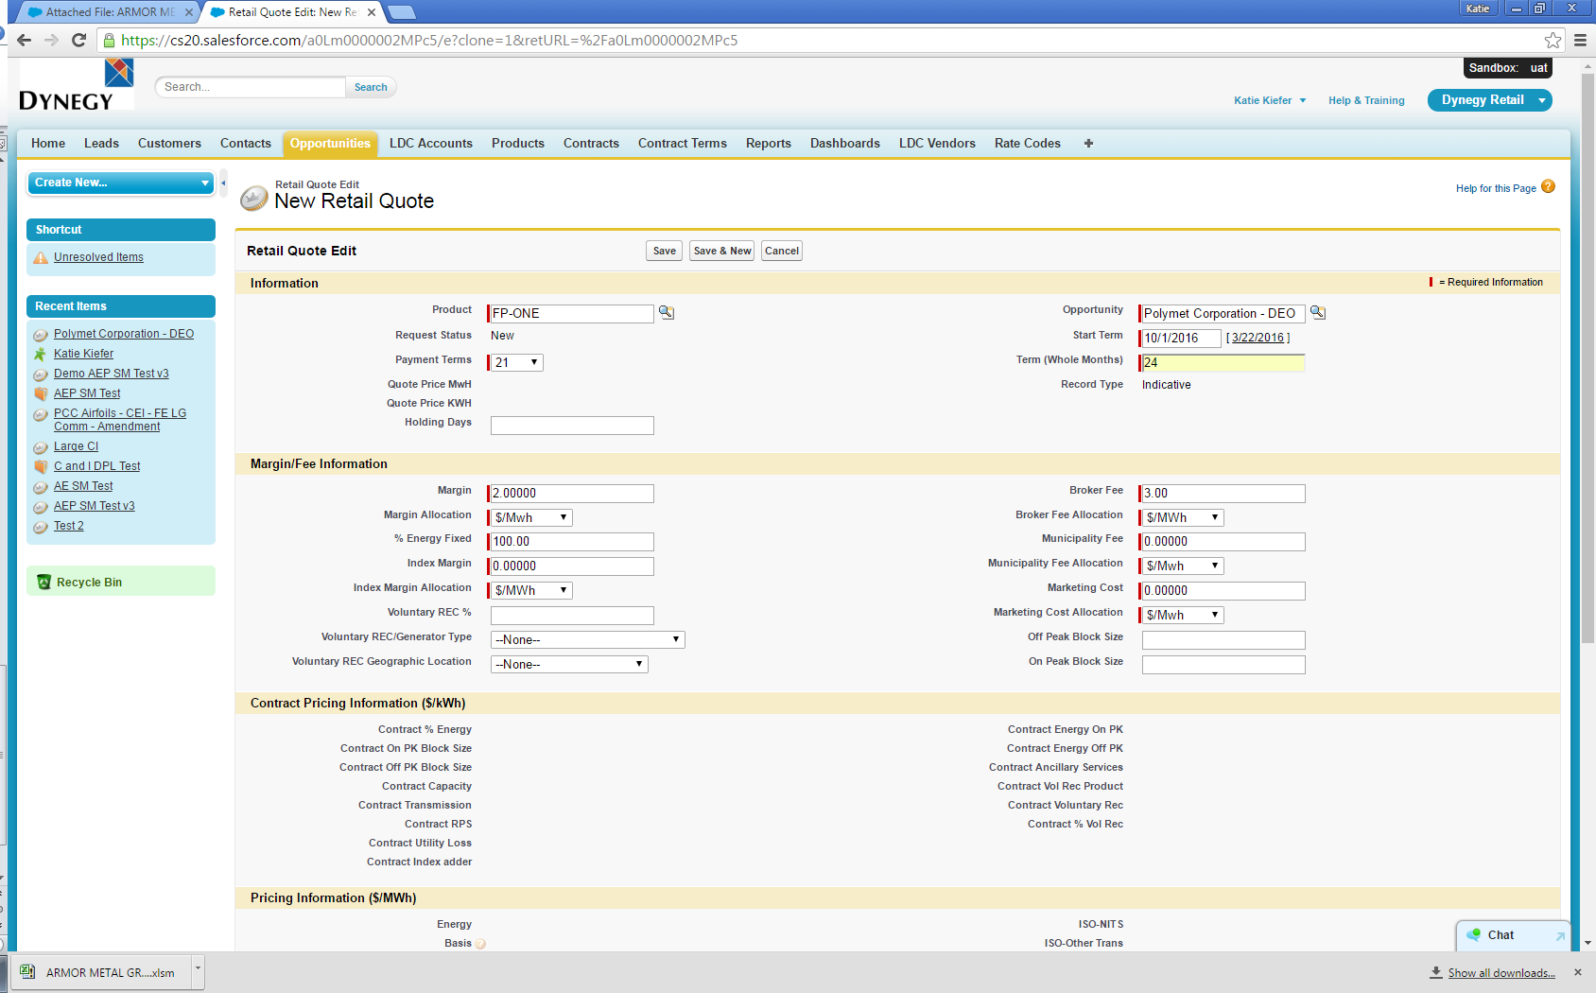

1. Click Save.



1. Click Clone.



1. Change the Term to 36.

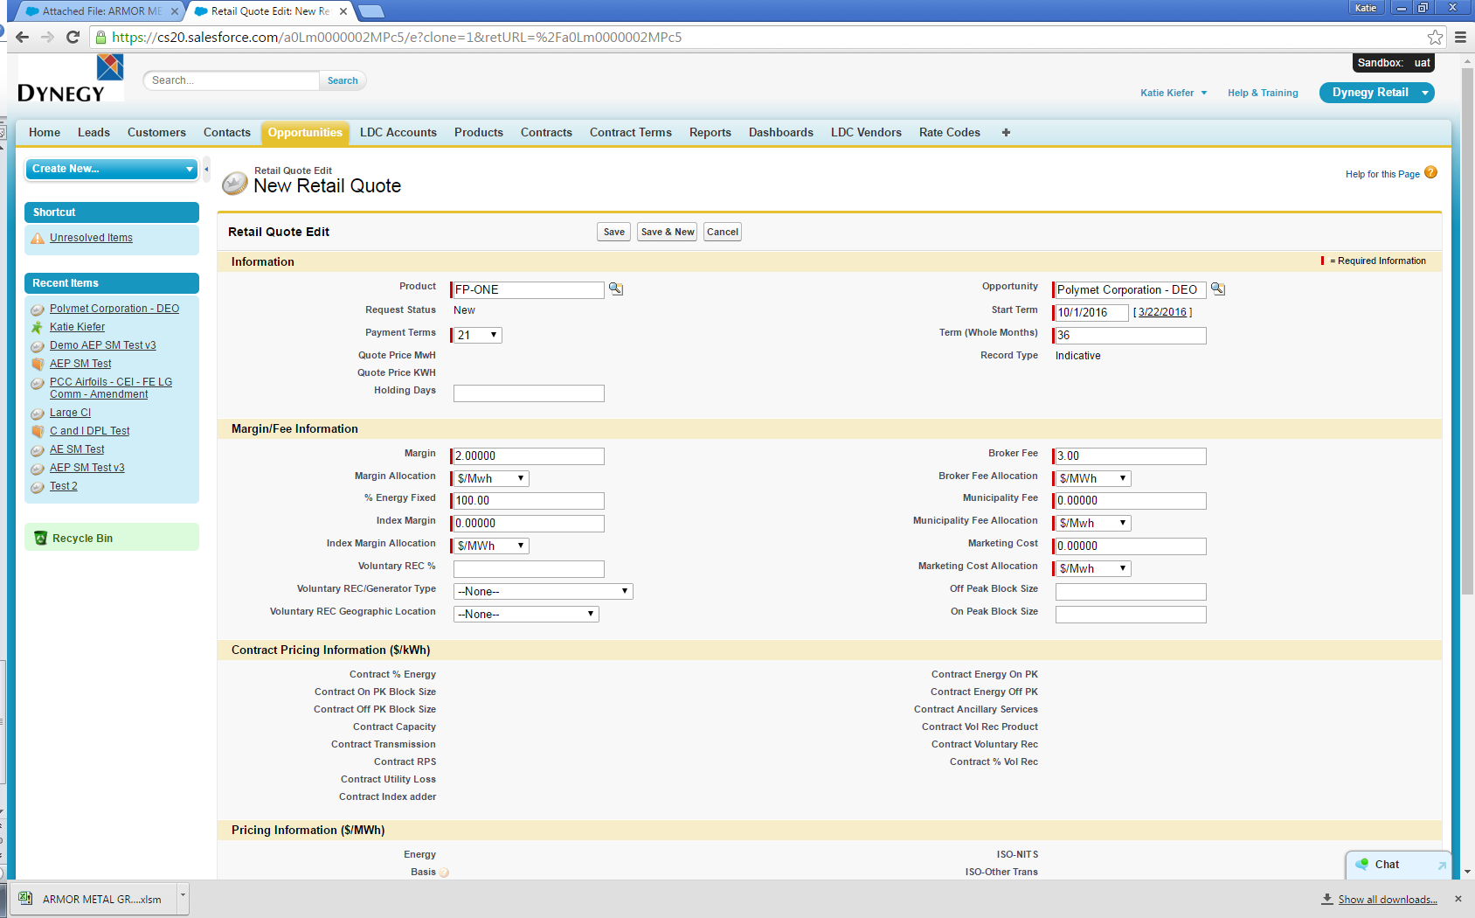

1. Click Save.



1. Click the Opportunity link to go back to the Opportunity screen.

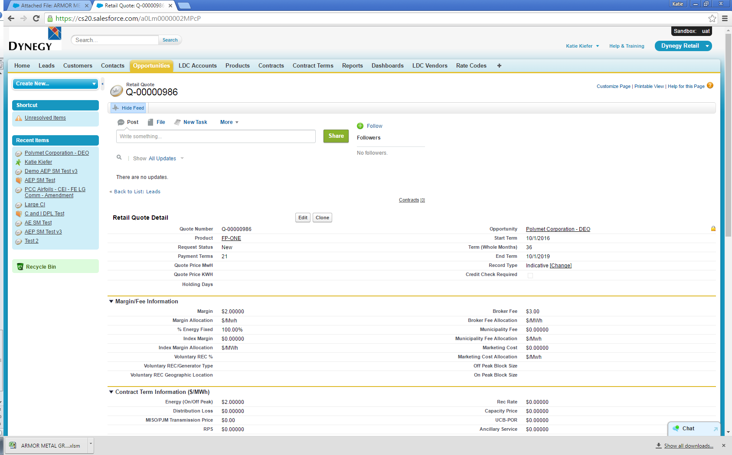

1. Scroll down and confirm quotes for all terms have been created.

