**How To Request Indicative Pricing and Change Margin**

1. After you have created your desired Retail Quotes, click the “Price Request/Refresh” button to submit the quotes to pricing.

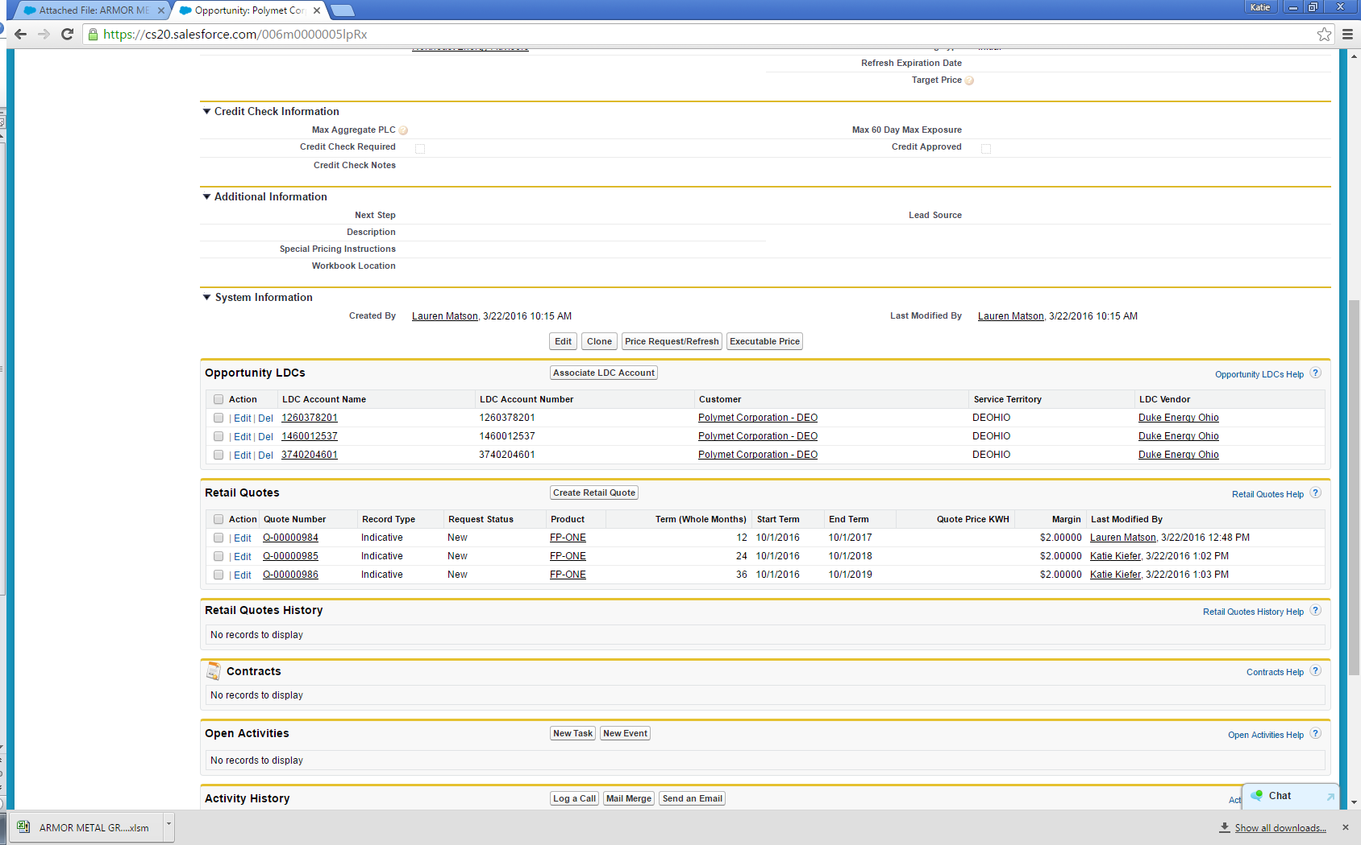

1. A pop-up window will open saying “All valid quotes have been sent to the Pricing System”
2. Click OK.

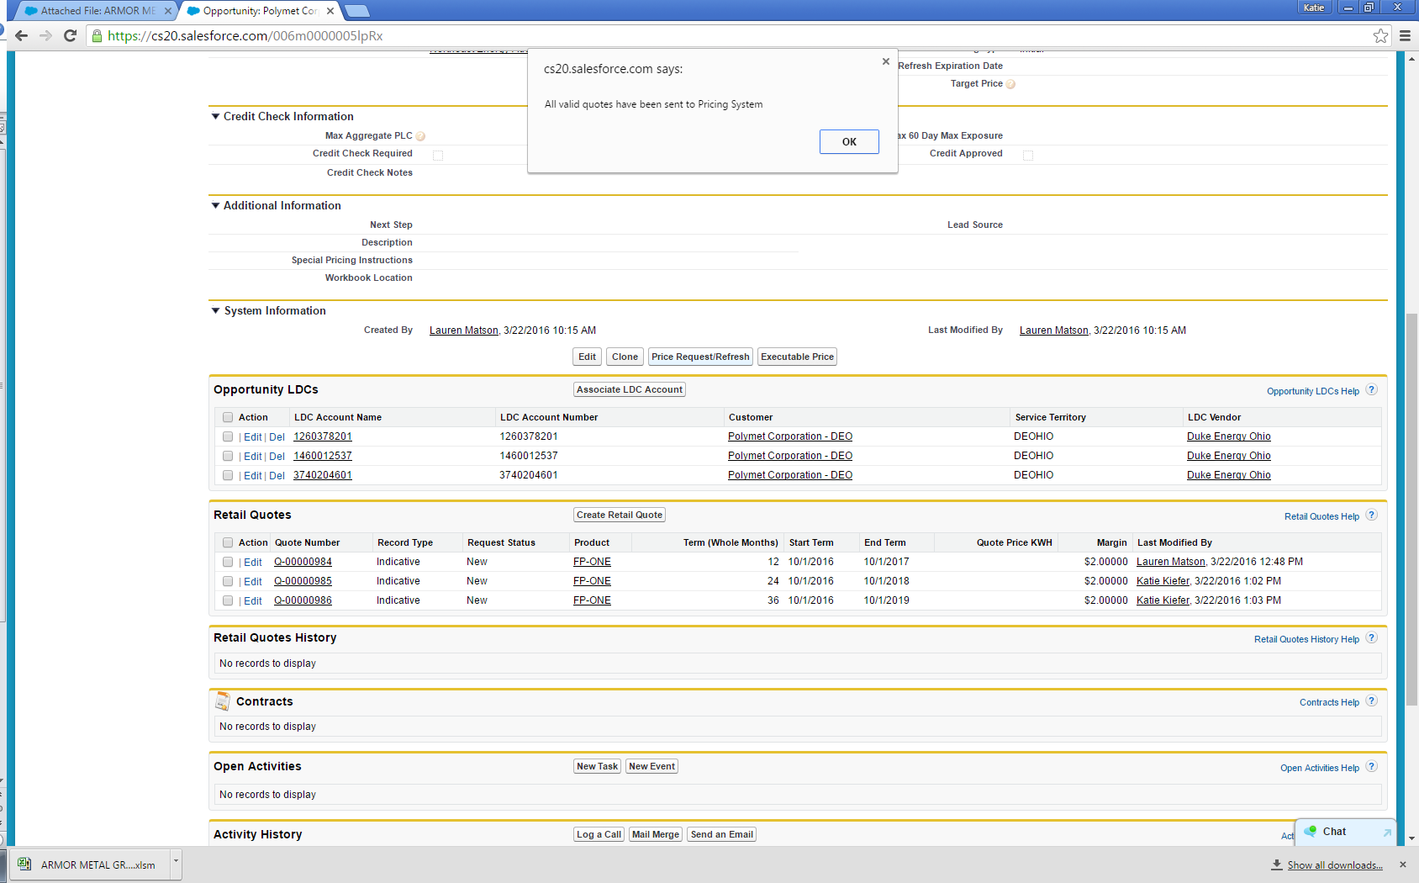

1. The Request Status on the Retail Quotes will change to “Waiting on Load Data”

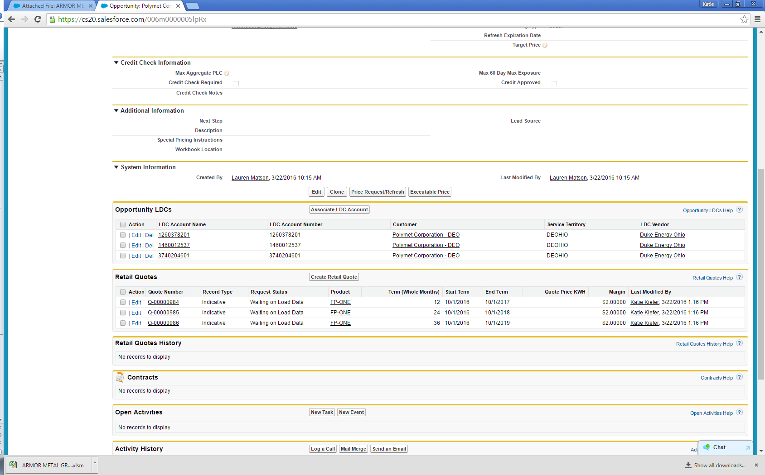

1. The system will do a webscrape to pull the load data for each LDC Account. Then the Pricing team will price the quotes. (Webscrapes for AEP, DEO, & DP&L are instantaneous whereas webscrapes in FE can take up to 3 days to get data).
2. Once this process is complete, the Request Status on the Retail Quotes will change to “Pricing Complete” and the end user will be notified by an email.

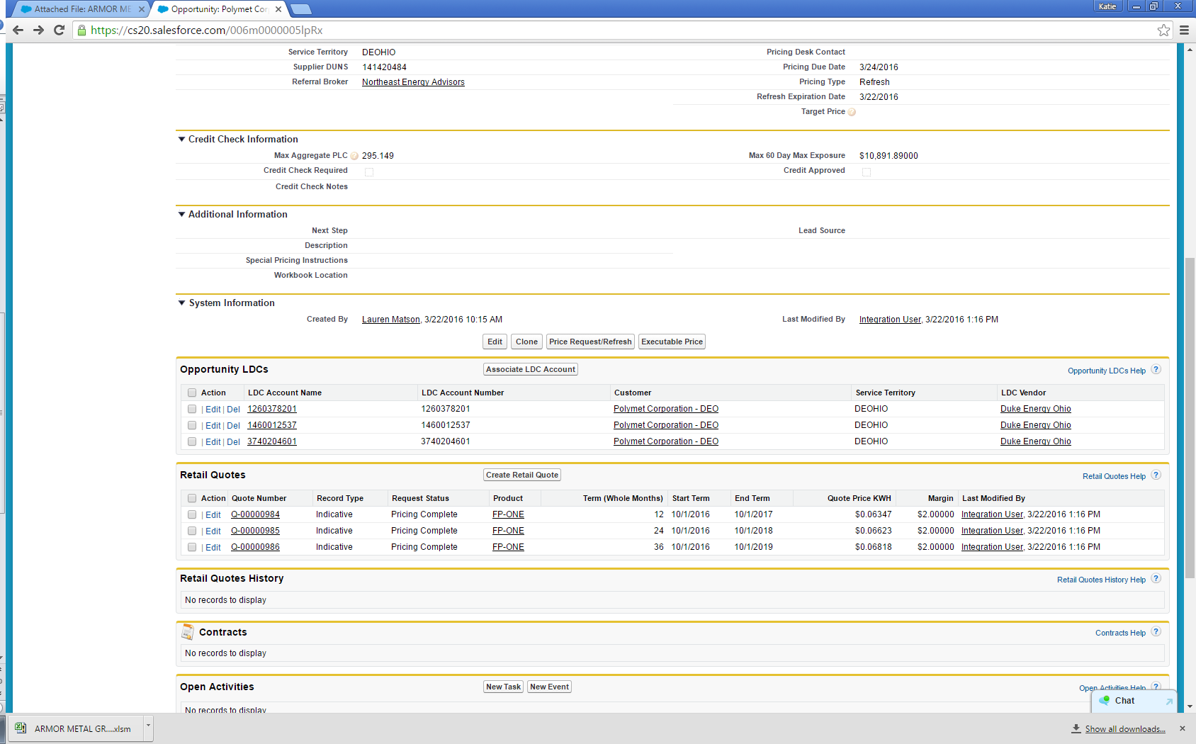

**Changing Margin on Indicative Quotes**

1. After the Indicative Pricing comes back as “Pricing Complete”, you can still change the margin.
2. Click the link to the Retail Quote you want to change.

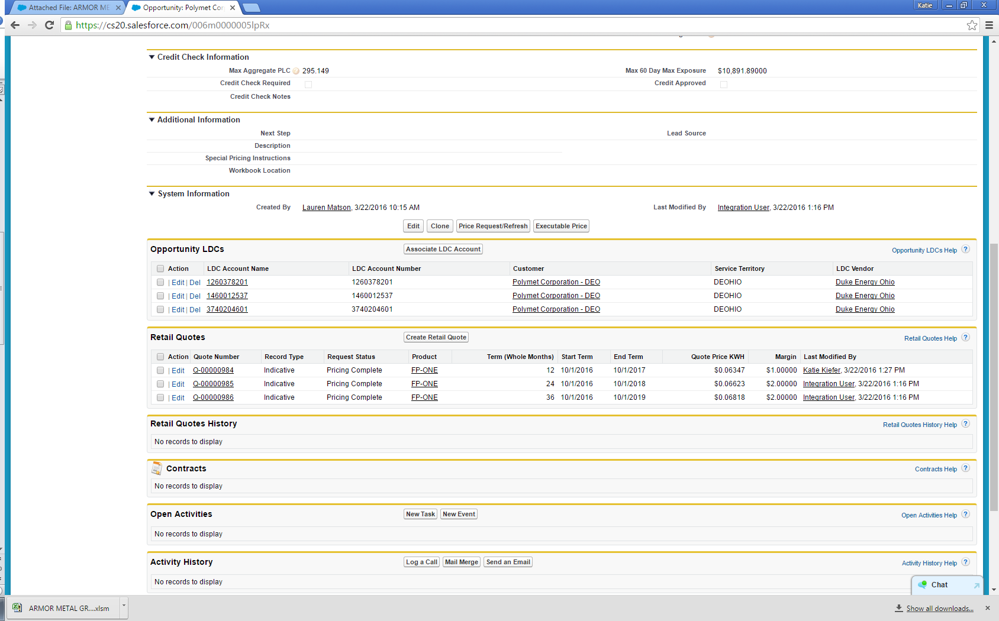

1. Click Edit.

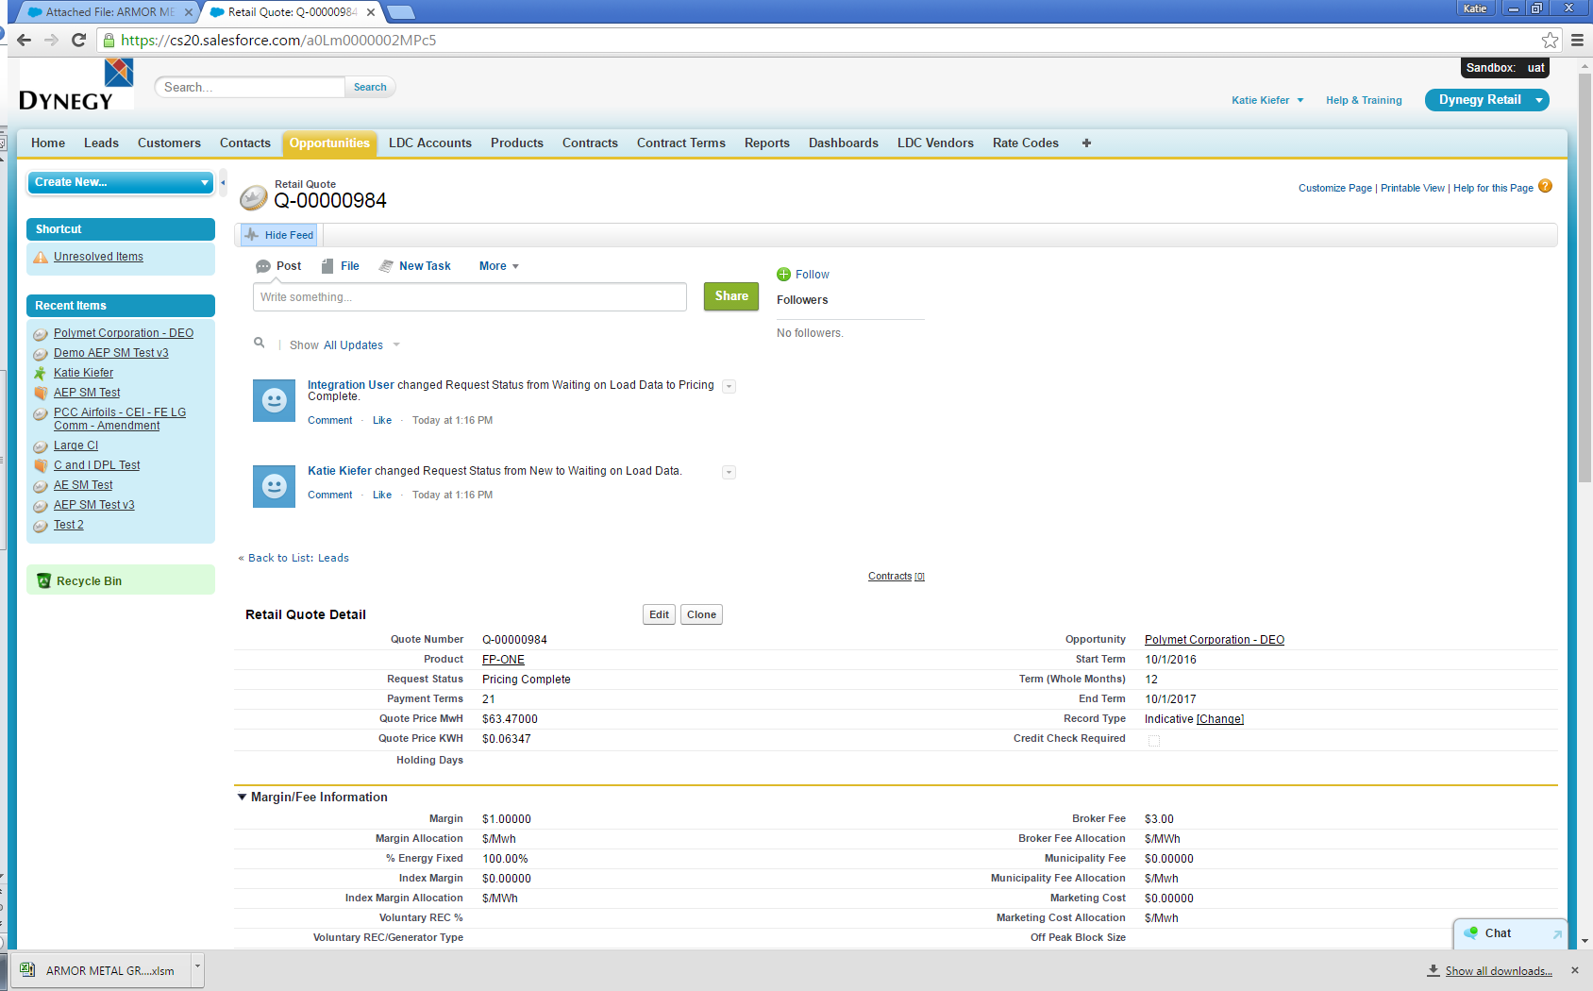

1. Change the desired Margin.

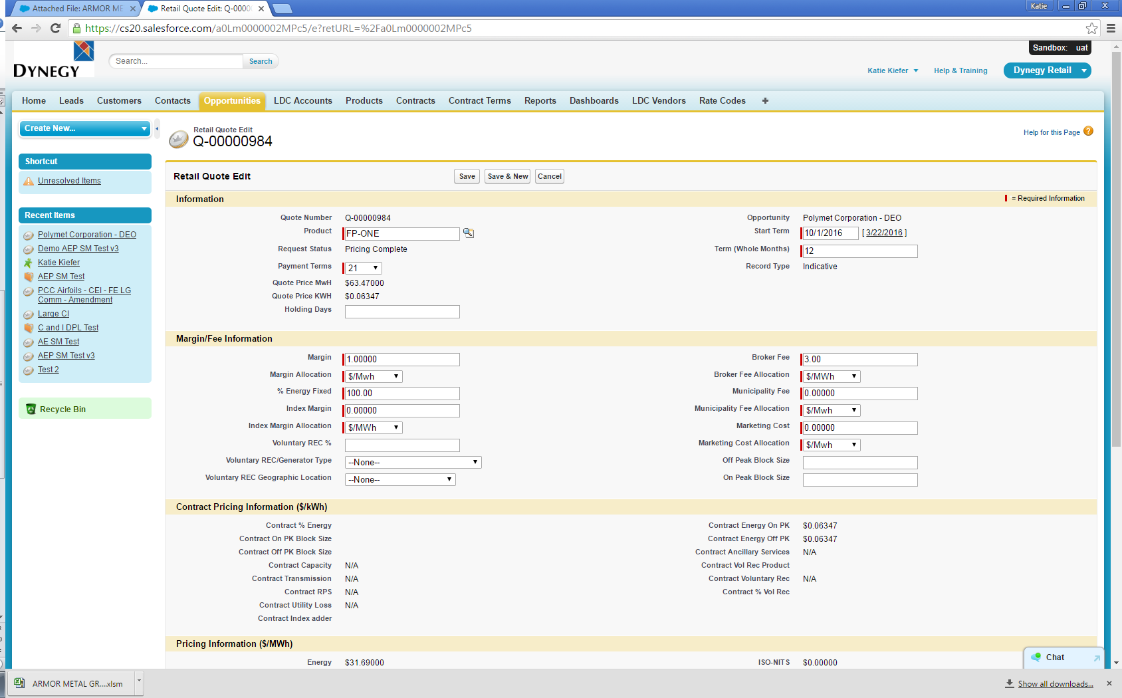

1. Click Save.
2. Click the “Price Request/Refresh” button to submit the quotes to pricing.



1. A pop-up window will open saying “All valid quotes have been sent to the Pricing System”
2. Click ‘OK.’
3. The system will refresh the margin and price.
4. Once this process is complete, the Request Status on the Retail Quotes will change to “Pricing Complete” and the end user will be notified by an email.

**Refreshing Expired Indicative Quotes**

1. Once a quote becomes “Expired”, you can refresh this again by clicking the “Price Request/Refresh” button.



1. A pop-up window will open saying “All valid quotes have been sent to the Pricing System”
2. Click OK.



1. The Request Status on the Retail Quotes will change to “Waiting on Load Data”
2. The system will refresh the underlying curves.
3. Once this process is complete, the Request Status on the Retail Quotes will change to “Pricing Complete” and the end user will be notified by an email.

