**IL Muni-Agg Person Account Validation for Person Accounts**

This procedure will allow to “Validate” person accounts. The rule is that person accounts do not require as detailed review as the Business customers. If the Business Customer has already been validated and exists in Lodestar, the person customers can be sent without review.

1. Receive the file muniagg.csv via email. Save locally. File is received at 8 AM and 2 PM CST.
2. Use Data Loader to update the flag.
3. Login
4. Click Update

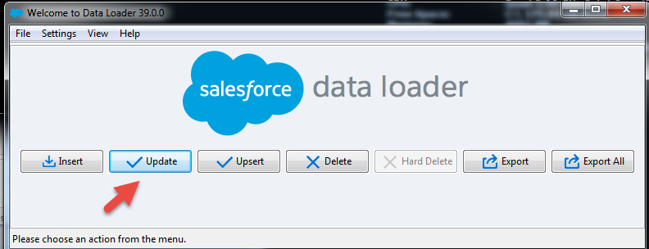

1. Select “Customer” and browse to the desired CSV.

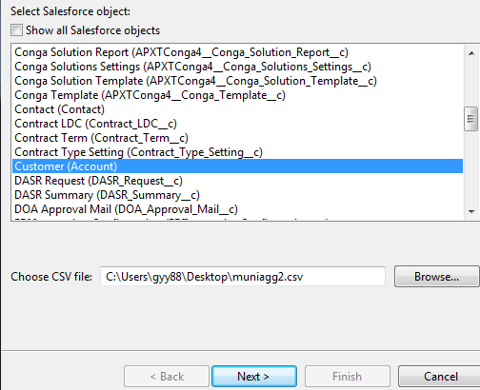

1. Click “OK” on the next screen
2. Select this map. Then “Next”



1. Specify a folder where you want to write the logs

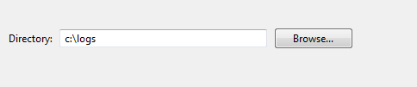

1. Click “Finish”
2. Review the message for Success or Error logs.

*** END OF PROCEDURE ***