The George Washington University
Department of Statistics

STAT 4197/STAT 6197

Week 1: SAS System, Interfaces, and Basic Concepts
- SAS System and its Products
- SAS Interfaces
- SAS Statements, Variable Names, Data Types, Missing Values, and SAS System Options
- DATA Step and PROC Step
- SAS Files and SAS Libraries

Statistical Analysis System® or SAS® - An Overview
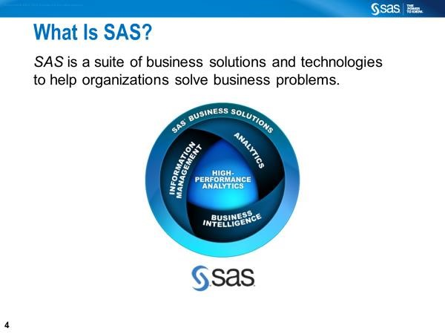

SAS is widely used in government agencies, healthcare and pharmaceuticals, insurance, and policy research. It ensures the correctness, reproducibility, and auditability of the results.

SAS’s core strengths include reliability, regulatory acceptance, integrated design, and statistically rigorous procedures. In R or Python, updating packages (e.g., dplyr, statsmodels) may alter defaults, warnings, or results unless versions are carefully frozen.
You can read raw data, clean it, analyze it, and produce a report—all in one SAS program.
- One system
- One language
- One execution environment
- One log documenting everything
In contrast, for example, in Python, this workflow may require pandas, numpy, statsmodels, matplotlib, and LaTeX/HTML tools, each with separate dependencies.

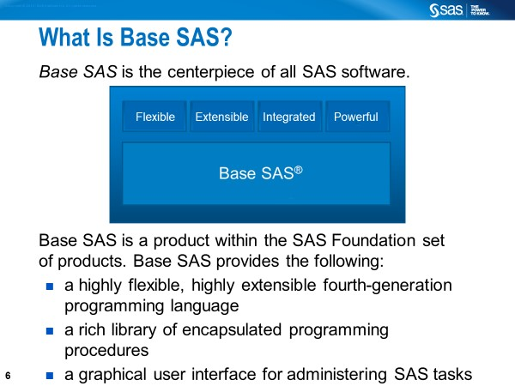

History

1966: SAS was created by Anthony Barr (a graduate student at UNC).
1976: SAS Institute, Inc. was incorporated by Barr, Goodnight, Sall, and Helwig.
2023, 2024: Over $3 billion in annual sales, with reports highlighting stability and growth in recent years.

The SAS software suite includes more than 200 components (examples below).
- Base SAS (reading data into SAS, manipulating, aggregating, reporting, macro facility)
- SAS/STAT (Statistical analysis and modeling)
- SAS/GRAPH (Graphs, Charts, and Plots)
- SAS/ETS (Econometrics and Time Series Analysis)
- SAS/PH (Clinical Trial Analysis)
- SAS/IML (SAS Interactive Matrix Language)
- Enterprise Miner (Data Mining)
- Enterprise Guide (GUI-based code editor and project manager)

To find the version and SAS products on your computer, run the following SAS code: PROC SETINIT; run;
To see what products have been installed on your computer, run the following SAS

code: PROC PRODUCT_STATUS; RUN;
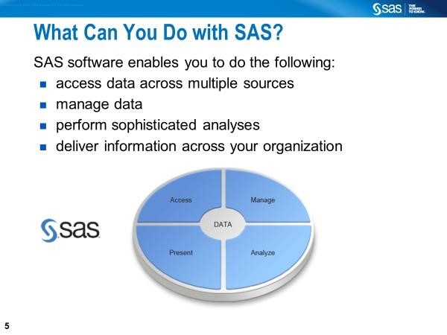
You can run SAS on many platforms, including Windows and Unix.

Ways to Run SAS
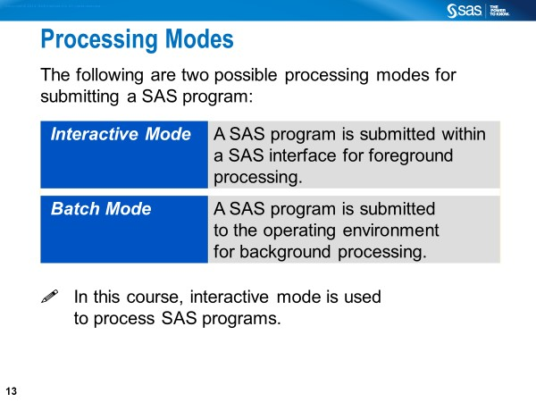

Standard SAS interfaces for running SAS programs in an interactive environment.

SAS Licensed Software
- Windowing Environment (by default, if you have already installed the licensed SAS software on your Windows laptop)
- Jupyter Lab (after installing SASPy kernel on your Windows laptop)
- Enterprise Guide
- SAS Studio (Single-User)

SAS On Demand for Academics (ODA) - Free Software
- SAS Studio
- Jupyter Lab - Extending SAS OnDemand for Academics with Python (after setting up SAS ODA); Working with Python, including Jupyter Notebook

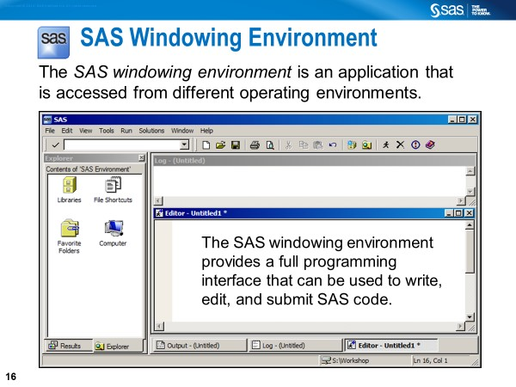
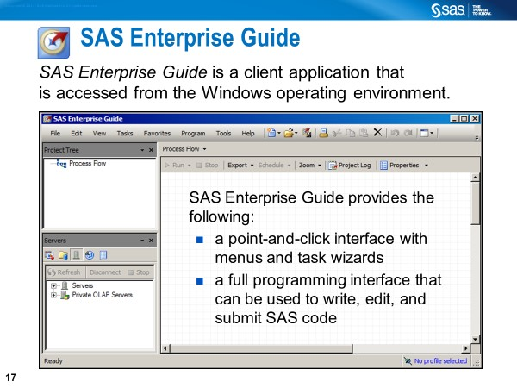

Windowing Environment for Licensed SAS Software - Various Components
Enhanced Editor provides color-coding to identify SAS program elements. To run the code, you click the Submit button (“running person” icon) in the toolbar or select Run >> Submit in the main menu.
Log file can be saved as filename.log. Remember that the log window will always show activity when you submit a SAS program in the SAS windowing environment.
Results tab provides a tree-like listing. Helps you locate items in the SAS Output Window and delete duplicate items. Starting with SAS 9.3, HTML is the default method for viewing output (which can be saved as filenanme.mht). The default method is changeable as follows: From the menu bar, Select Tool >> Option >> Preference >>

Output shows the results of the SAS output (Pre-SAS 9.3 default method for viewing output, which can be saved as filename.lst).

Explorer allows the user to access various resources, including SAS libraries.

**************

SAS Windowing Environment: The SAS Menus

File: Allows you to open and save SAS programs, import and export data, and print files. Select File >> Save As from the menu bar and specify your program's name by assigning an extension (e.g., DataStep1.SAS). Assign the extension (.SAS) to your SAS programs to distinguish them from other types of SAS files (e.g., .LOG for log files, .OUT for output files, and .DAT for raw data files).

Edit: Allows you to copy, cut, and paste text, and find and replace text when writing a SAS program. After you run your SAS program, you will find some text in the Log window, and you may find text/results in the Output window. To clear the Output window, Program Editor window, or Log window individually, select Edit ➩ Clear All.
View: Allows you to go back and forth between the Editor window, Log window, Output window, Results window, and Explorer window, etc.

Tools: Allows you to open programs for graphics and viewing tables, etc.

Run: Allows you to submit SAS programs. A SAS program, when submitted by clicking the ‘running man’ icon, disappears from the program editor window. You can recall it by selecting Run ➩ Recall Last Submit.

Help: Allows you to obtain help for writing your SAS source code. Invoke the Help window by selecting Help >> SAS Help and Documentation in the main menu.

Some Common Data Formats

Jupyter Notebook/Jupyter Lab for Licensed SAS Software
Installing SASPy Kernel for Jupyter Notebooks and Jupyter Lab
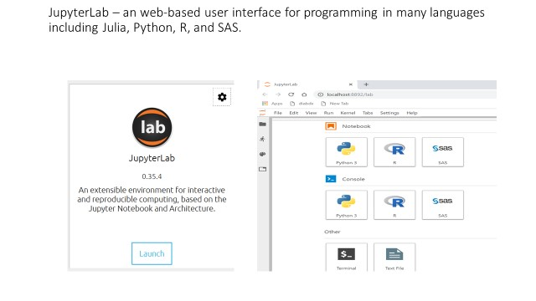

Additional resource: How to run SAS programs in Jupyter Notebook

A typical SAS program generally consists of DATA step(s) and PROC steps with or without global statements (e.g., OPTIONS statement, LIBNAME statement).

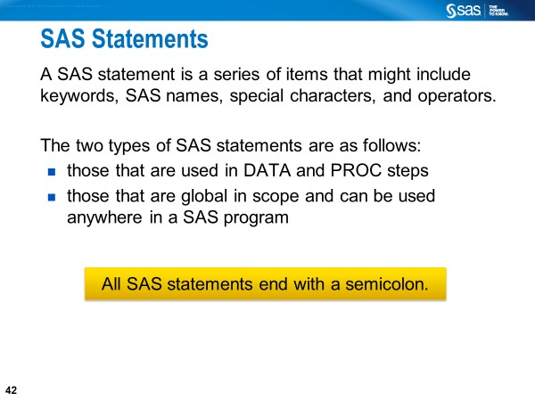

Characteristics of SAS Statements
- Begin with a keyword (e.g., DATA, PROC) or keywords (e.g., CALL MISSING) and end with a semicolon.
- Can begin and end anywhere on a line or over several lines (or several statements can be on the same line).
- Can be entered in uppercase or lowercase.
- Can have blank or special characters that separate words.
- Can have words that are separated by blanks or special characters but cannot have words that are entered across lines.

Two types of SAS statements are used in a data step:

- declarative statements that provide information and do their work during the compilation phase (e.g., ARRAY, BY, DROP, FORMAT, INFORMAT, KEEP, LABEL, LENGTH, RENAME, RETAIN)

- executable statements that result in some action during the individual iteration of the data step (e.g., ABORT, CALL, CONTINUE, DELETE, DESCRIBE, DISPLAY, DO, DO UNTIL, DO WHILE, ERROR, EXECUTE, FILE, IFTHEN/ELSE, INPUT, INFILE, GO TO, LEAVE, LINK, LIST, LOSTCARD,
MERGE, MODIFY, OUTPUT, PUT, REDIRECT, REMOVE, REPLACE,
RETURN, MERGE, RETURN, SELECT, SET, STOP, and UPDATE)

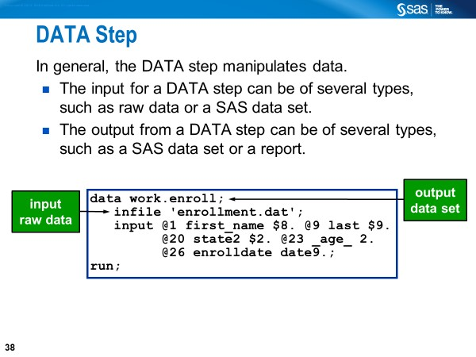
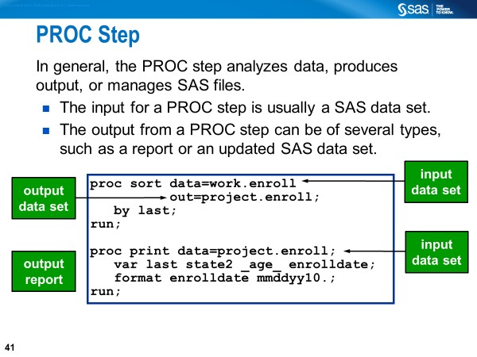
•

SAS Step Boundary

A step boundary may begin with

- a DATA statement
- a PROC statement

A step boundary may end with
- a DATA statement
- a PROC statement
- a RUN statement (for DATA steps and most PROCs)
- a QUIT statement (for some PROCs)
- a null (;) statement

Commenting Out in SAS Programs
- Statement-type comment
- Delimited comment
- Block-type comment

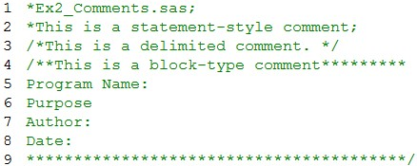

The above lines are commented out. None of the lines is a valid SAS statement. When submitted, they are not compiled or executed.

- Lines 1 and 2: Statement-style comments.
- Line 3: Delimited type comment.
- Lines 4-9: Block type comment.

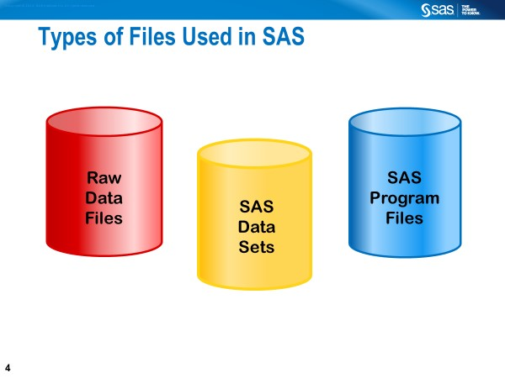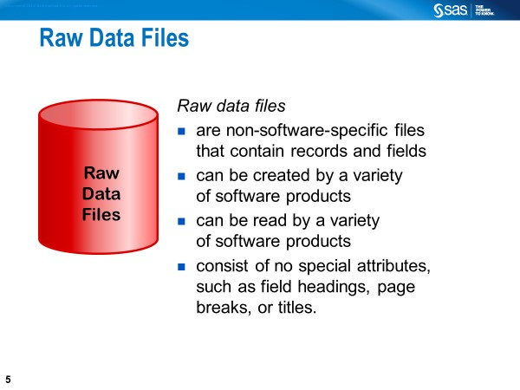
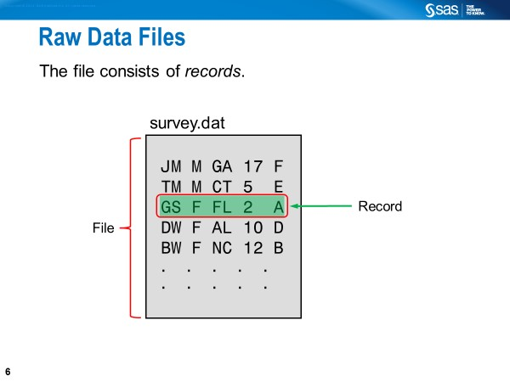

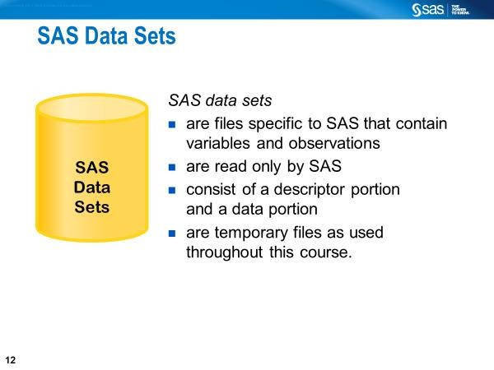
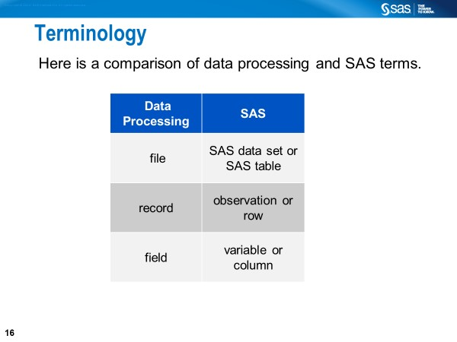
Definition of a SAS Name
There are two types of names in SAS:
- names of elements of the SAS language
- names supplied by SAS users

Below are some of the SAS name tokens that represent (Link))
• | variables | • | SAS  data sets | • | formats or  informats | • | SAS procedures
• | options | • | arrays | • | statement  labels | • | SAS macros or  macro variables
• | SAS  catalog entries | • | Librefs | • | filerefs | • | component objects

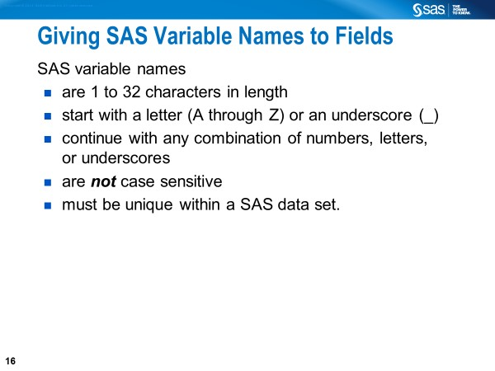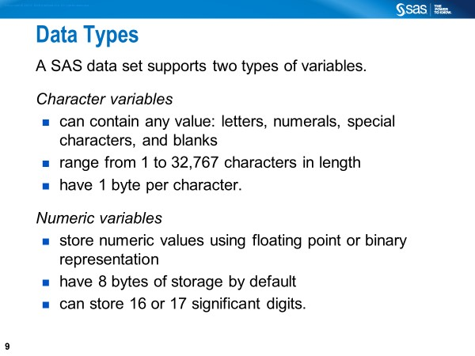
Some Rules for Reading Numeric and Character Data (SAS Documentation)

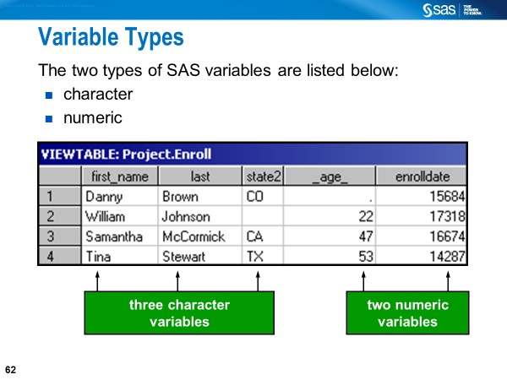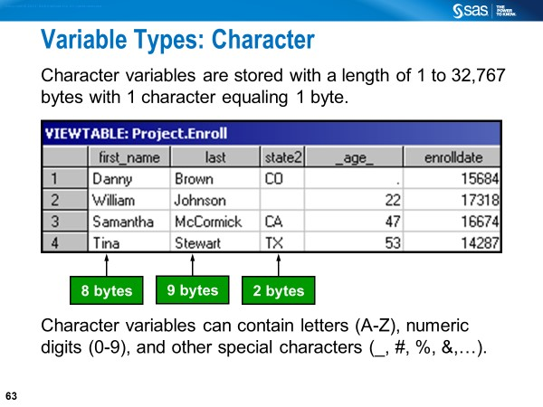
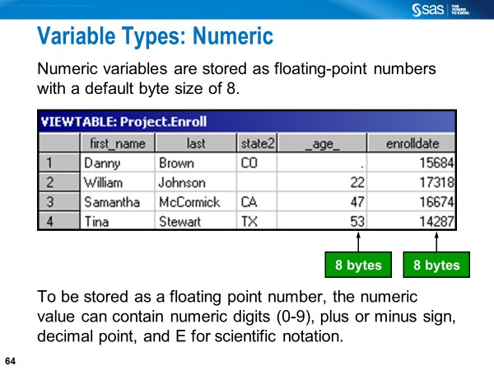

8
Copyright © 2014, SAS
Institute Inc. All rights reserved.
Standard and Nonstandard Data (Review)
Standard data is data that SAS can read without any
additional instruction.
◼
Character data is always standard.
◼
Some numeric values are standard and some are not.
Nonstandard
Numeric Data
5,823
12
May
2009
(23)
01/12/2010
$67.23
67.23
5.67E5
58
00.99
-
23
1.2
E
-
2
Standard
Numeric Data
The following are the only acceptable characters in a standard numeric field:
0 1 2 3 4 5 6 7 8 9 . E e D d - +
Leading or trailing blanks are also acceptable.
 E, e, D, and d represent exponential notation in a standard numeric field. An alternate way of writing 300000, for example, is 3E5.

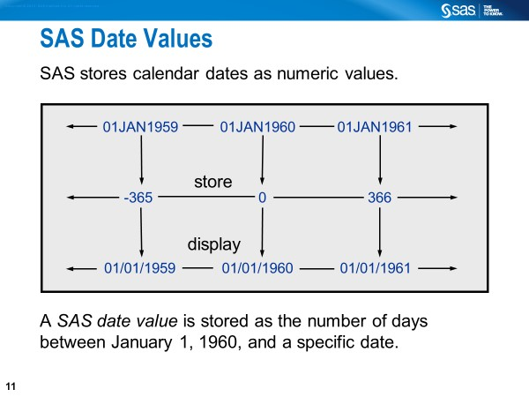

SAS can read and perform calculations on dates starting from A.D. 1582 through A. D. 19,900.
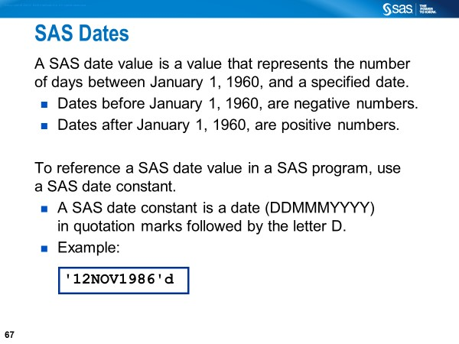
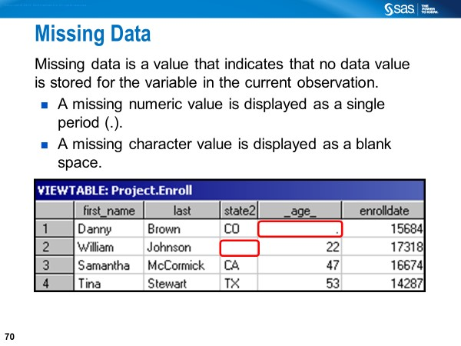

SAS Statements Explained
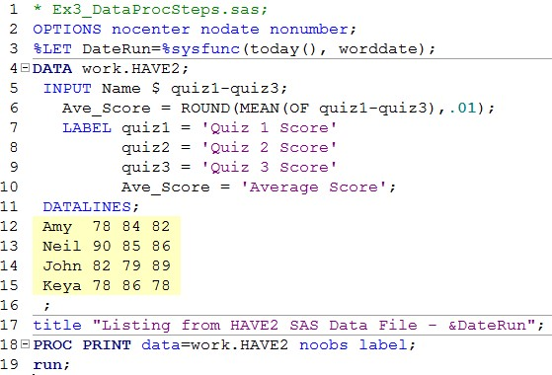
Line 1: This is a “Statement-Style Comment” preventing this line from execution.
Line 2: The OPTIONS statement is a global statement and used here to specify 3 options. NOCENTER prevents centering SAS output. NODATE prevents printing the date on the output. NONUMBER prevents printing page numbers on the output. Some Additional Common SAS System Options are shown below.
FIRSTOBS=1 | First obs. of the Data file to be processed
LINESIZE=98 | Line size for the printed output
MISSING=. | Character printed for numeric missing values
OBS=MAX | Number of last observation to be processed
PAGENO=1 | Resets the current page number on SAS output
PAGESIZE=58 Number of lines printed per page of output
Line 3: The %LET statement defines the macro variable (i.e., DateRun) before the SAS program is executed.

SAS Statements Explained (continued)

Line 4: The DATA statement marks the beginning of the data step. WORK.HAVE is a user-given SAS Data Set name (specifying work. is optional). After a successful run, WORK.HAVE gets created. Note that WORK is a temporary SAS library, which is automatically created by SAS in a data step session, in which a temporary SAS data set is created, even if WORK is not specified. In the above example, WORK.HAVE gets deleted after we exit the SAS session.
Line 5: The INPUT statement lists variable names. NAME is an alphanumeric variable, as indicated by the $. QUIZ1-QUIZ3 are numeric variables; the dash operator enables us to list variables that are numbered sequentially.
Line 6: This is an assignment statement used to create a new variable called AVE_SCORE. AVE_SCORE (Average Score) is on the left-hand side of the assignment statement. The right-hand side of the assignment statement includes two numeric functions: ROIUND () and MEAN(). The first argument of the ROUND() is the MEAN () with three numeric arguments (i.e., quiz1, quiz2, and quiz3). The second argument of the ROUND() is .01 to tell SAS to round-up the returned value to the nearest hundredth.

SAS Statements Explained (continued)

Lines 7-10: The LABEL statement defines permanent labels (up to 256 characters in length) for four variables namely, QUIZ1, QUIZ2, QUIZ3, and AVE_SCORE in the DATA step. Alternatively, you can use the LABEL statement in a PROC PRINT step to define temporary labels for the variables created in the DATA step.

Line 11: The DATALINES statement tells SAS that the data are located in the next lines and that data records will continue to be read until a line with a semicolon is encountered. Instead of the DATALINES statement you can also use the CARDS statement. There are also DATALINES4 and CARDS4 statements, which are enhanced versions of the DATALINES and CARDS statements, respectively. DATALINES4 and CARDS4 statements each allows semicolon to be placed in the instream data; however, you must use four semicolons to mark the end of the instream data.
Line 16: This is a null statement, which signals the end of the data lines that occur in the above program. The semi-colon after the data lines causes the DATA Step to execute.

SAS Statements Explained (continued)

Line 17: The TITLE statement is a global statement because the operations with this statement are not tied to a particular data or proc step. It remains in effect until you cancel or change it or until you end your SAS session. Although the regular text in the TITLE statement is put in single quotes, the text that includes the macro variable reference (i.e., &DateRun) must be put in double quotes in order to substitute the parameter value (i.e., today’s date) for the macro variable reference.

Line 18: The PROC PRINT statement marks the beginning of a new step. The NOOBS option suppresses the observation number. The LABEL option is specified to display descriptive labels that are saved in a SAS Data Set (or the labels that are temporarily defined in this proc step). Alternatively, you can use the SPLIT= option to display the labels as well as specify a split character to control line breaks in column headings.
Line 19: The RUN statement is the step boundary for the PRINT procedure that begins in the previous line.

How to Automatically Create Log and Output Files
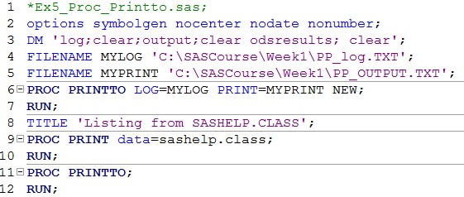
Line 3: The DM statement automatically clears LOG, OUTPUT, and ODSRESULTS.
Line 4: The FILENAME statement associates a fileref (i.e., MYLOG) with an external file that is used for output (i.e., PP_log.txt).
Line 5: The FILENAME statement associates a fileref (i.e., MYPRINT) with an external file that is used for output (i.e., PP_OUTPUT.txt).
Lines 6-7: This PROC PRINTTO step writes the log and print output to disk for the PROC PRINT STEP in lines 9-10.
Lines 11-12: This "null" or "dummy" PROC PRINTTO step is required to close the log and print files.

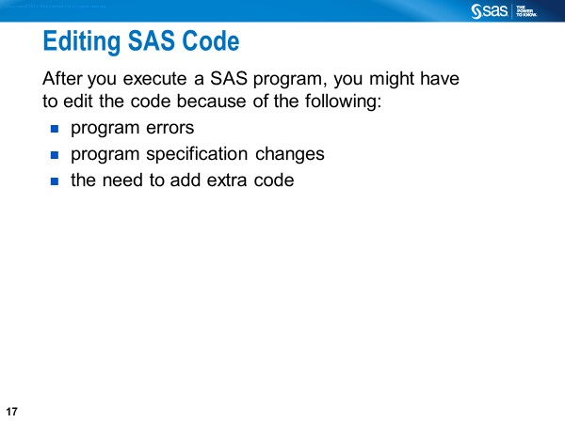
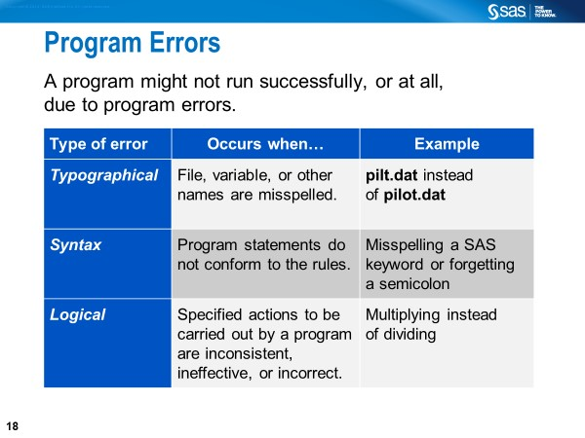
•

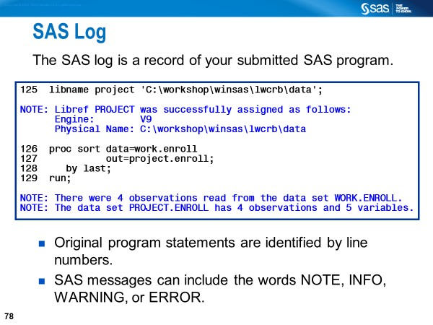
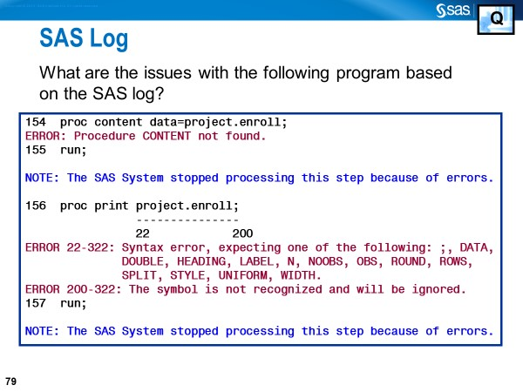
•
•
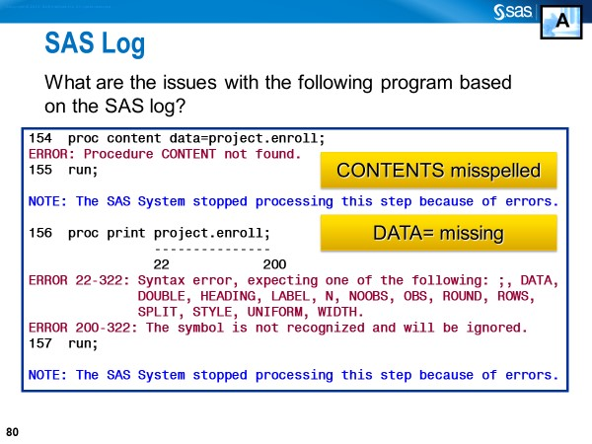

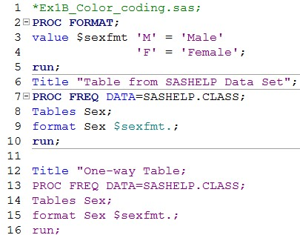

Lines 2-10
Keywords: DATA, value, Tables, format [Blue]
Format Name: $SEXFMT. [Green]
Text within single or double quotes: e.g., ‘M’ [Red] Variable or Data Set Name SASHELP.CLASS [Black]
PROC Name: e.g., PROC FORMAT or PROC FREQ [Dark Blue]

Lines 12-16
Note that we are missing an end quote in Line 12 and that all of the syntax is red.

SAS Files Concepts
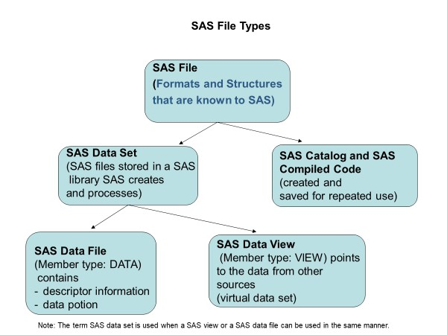
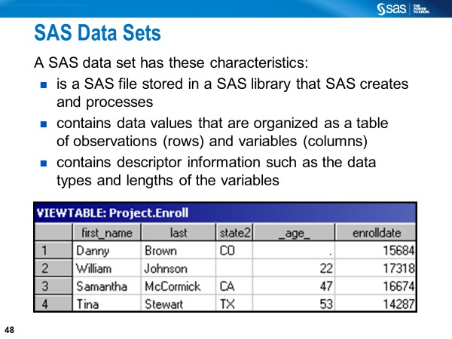

Definition of a SAS Data File

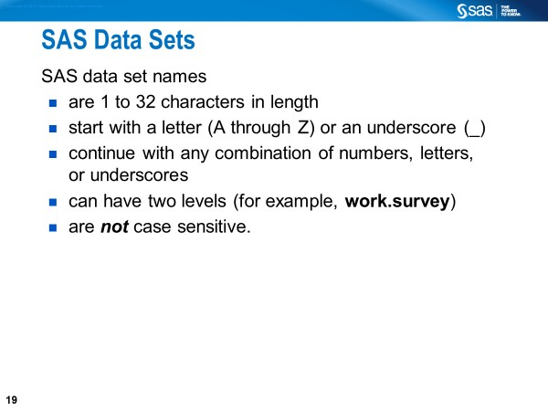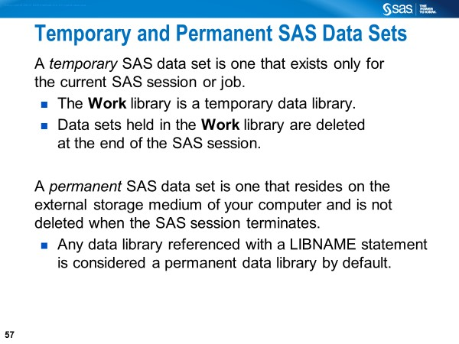
Consider creating a permanent SAS data set if you think you would access it frequently for further data manipulation or analysis.

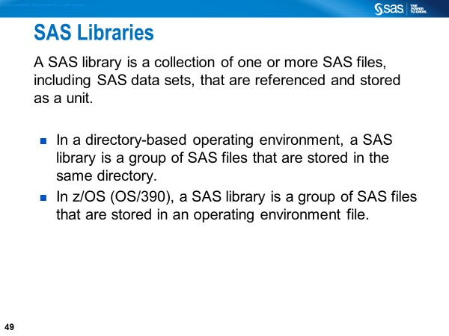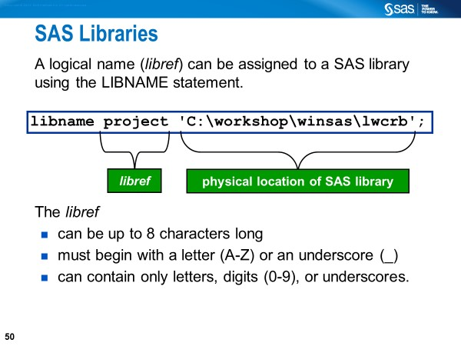
“A libref is a name that you associate with the physical location of the SAS library. You should not use SASHELP, SASUSER or SASWORK as librefs.” – SAS Documentation.
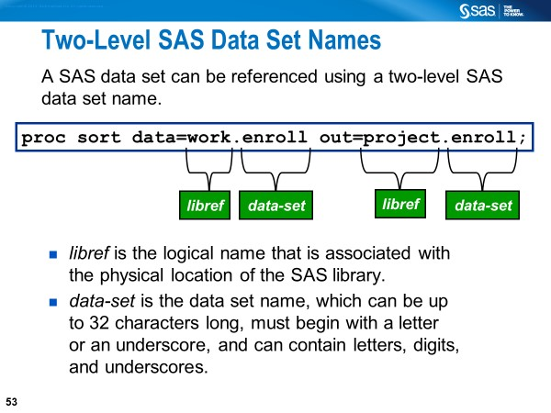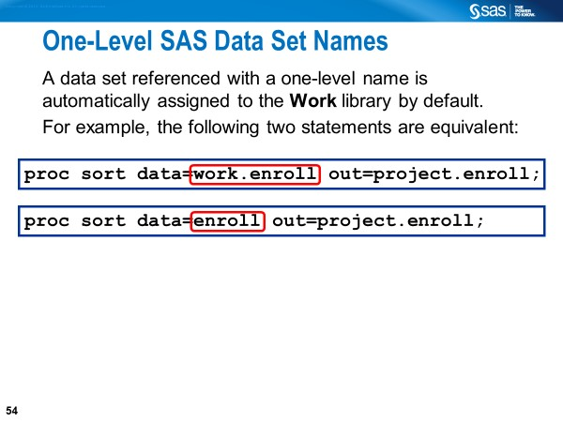

Built-in SAS Libraries

SASHELP and SASUSER are built-in libraries that will always be available when SAS is invoked.

• The SASHELP library (predefined by SAS) is where SAS has stored all the demonstration data files and catalogs; there are about 200 SAS data sets (i.e. Tables) in this library. This is a read-only library. Try the following SAS code to see the folder locations of the SASHELP library.

%put %sysfunc(pathname(SASHELP));

• SASUSER is a permanent library (predefined by SAS) that contains SAS files in the profile catalog that stores your personal settings. This is also a convenient place where users can store their own SAS files. Try the following SAS code to see the folder locations of the SASUSER library.

%put %sysfunc(pathname(SASUSER));

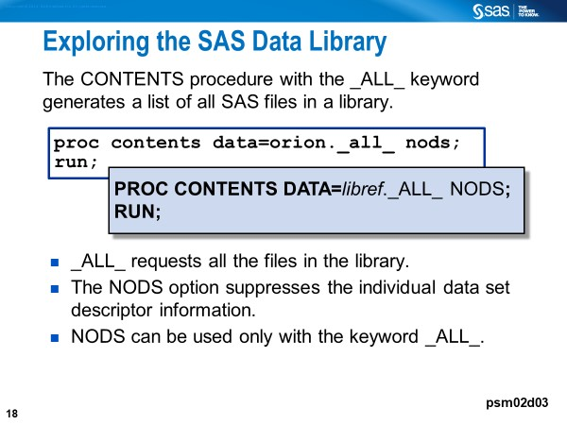
The following example code will generate listing of the contents of the SAS library.

Proc contents data=sashelp._ALL_ nods; run;

Contents of SAS Data Sets
- Descriptor portion - contains information, including the
- Data file name
- member type
- date and time the data file was created
- number of observations
- attributes of the variables

- Data portion - contains the data values in the form of a rectangular table that consists of observations and variables
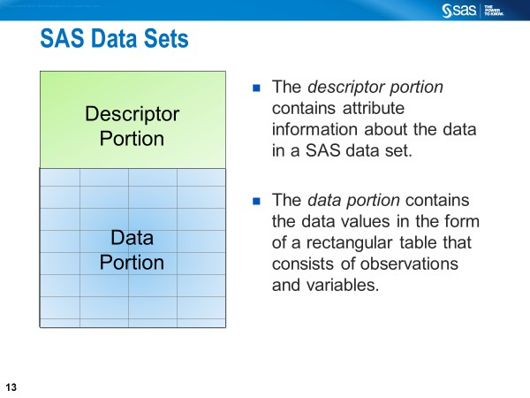
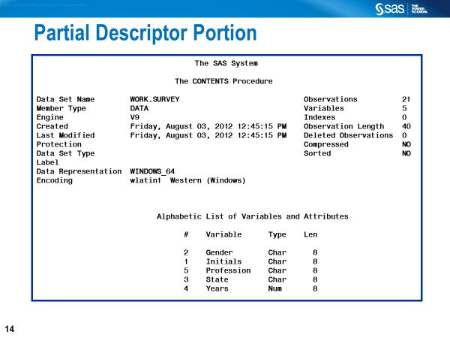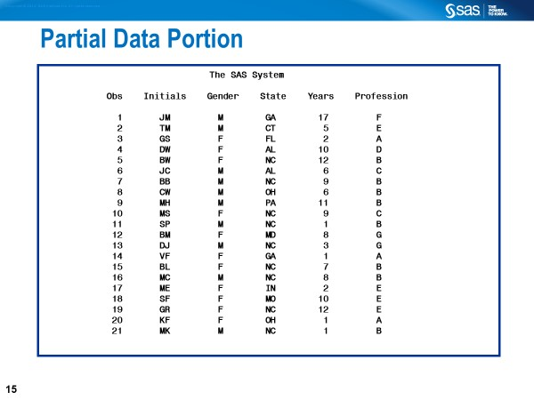

Generating Contents of a SAS Data Set (Various Ways)

options nocenter nodate nonumber;

proc contents data=sashelp.heart;
run;

proc contents data=sashelp.heart varnum;
run;
proc contents data=sashelp.iris position;
ods select variables;
run;
proc sql;
select memname, nobs format =comma9. ,
nvar format=comma9.
from dictionary.tables
where libname='SASHELP' and memname like 'IRIS';
quit;

Comparable R and Python Code

/************************************************************
# R Code
data(iris)
str(iris)
****************************************************************/

/*****************************************************************
# Python Code
import seaborn as sns
import seaborn as sns
iris = sns.load_dataset('iris')
iris.info()

