The George Washington University
Department of Statistics

STAT 4197/STAT 6197

Week 10: Macro Processing and Macro Functions
Detailed Topics:
- Mechanics of Macro Processing
- Macro Variable Functions
- Macro Quoting Functions

https://documentation.sas.com/doc/en/pgmsascdc/9.4_3.5/mcrolref/n1mcxptbxr3qhwn 1q6swv33z8akq.htm.

Types of Tokens in SAS Language
In SAS, there are four basic types of words or tokens.
Name | Literal (i.e., characters enclosed in quotation marks) | Number | Special characters
- DATA  - _var  - FIRSTOBS  - year_99  - descending • _n_  - Percent8.2 | - 'Stat6197'  - "1990-91"  - 'Mary Delany'  - "Final Exam" | - 3283 • 8.05  - 0b0x  - -5  - 6.4E-1  - '04July18'd | - = • ; • ' • + • @  - /

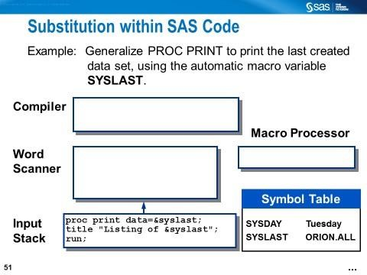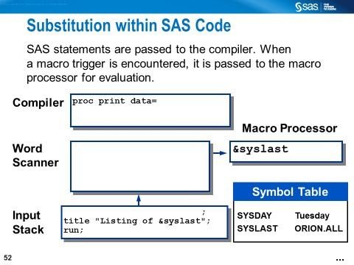
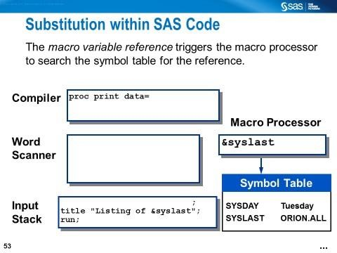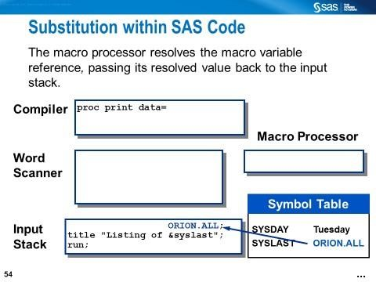
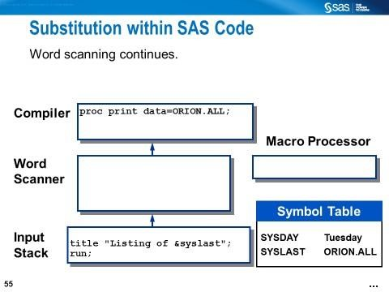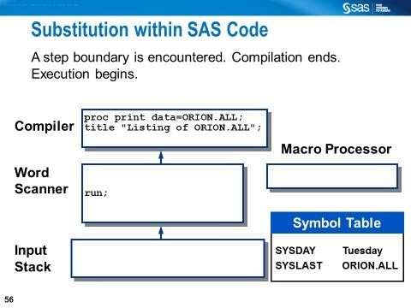

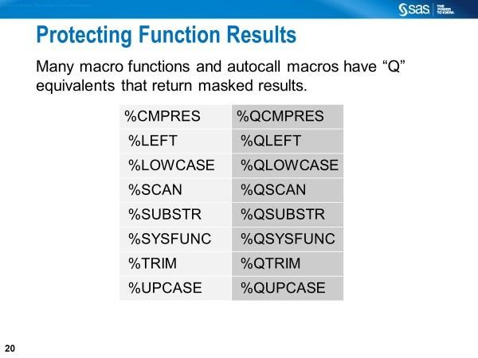
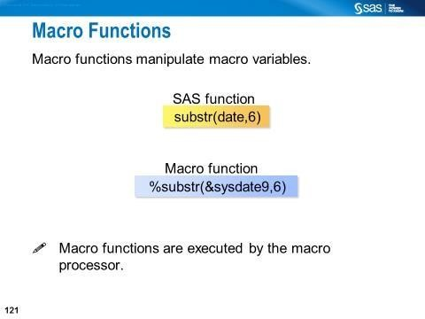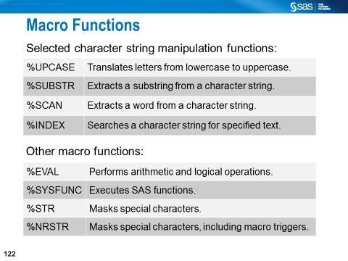
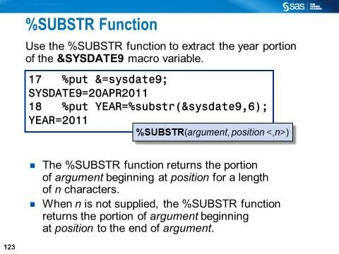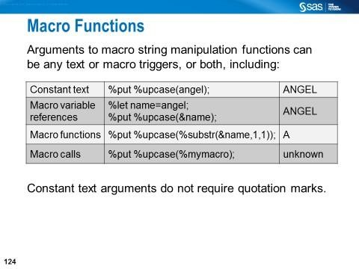
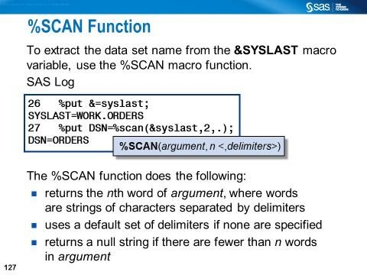
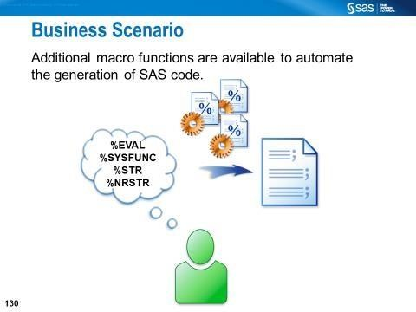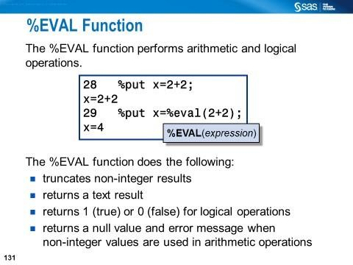
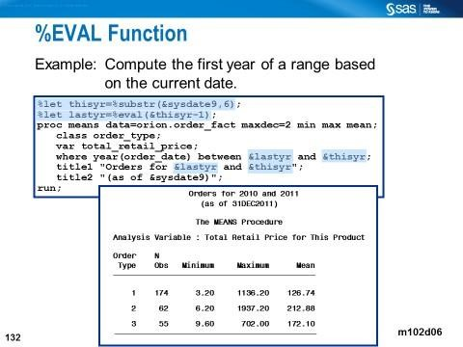
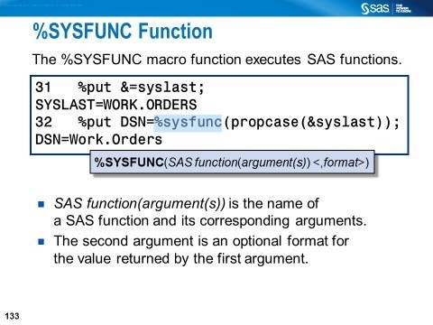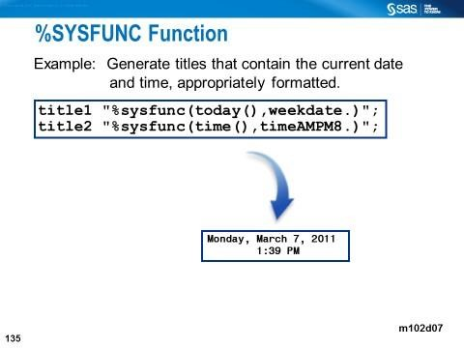

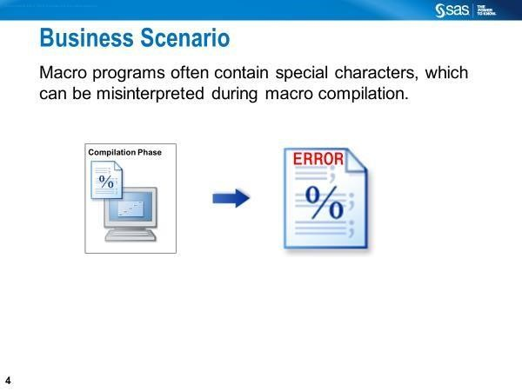

Macro Quoting Functions

The value you want to assign to a macro variable can contain certain special characters (for example, semicolons, quotation marks, ampersands, and percent signs) or mnemonics (for example, AND, OR, or LT). You must use a macro quoting function to mask the special characters. Otherwise, the macro processor might misinterpret the special character or mnemonic. For more information, see Macro Quoting.

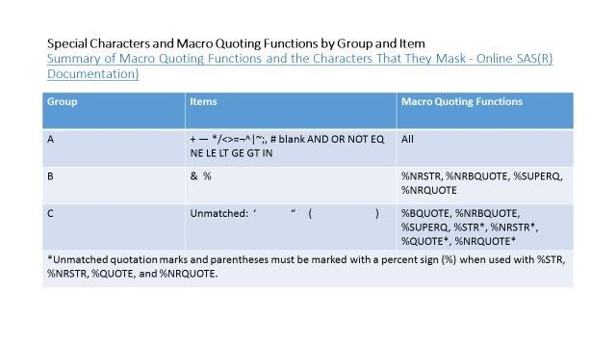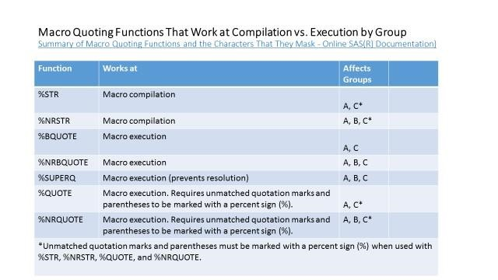
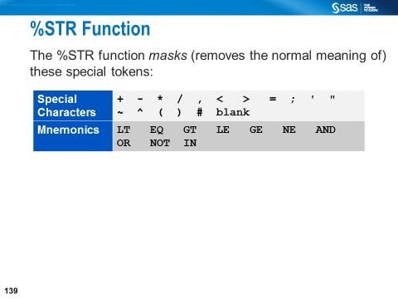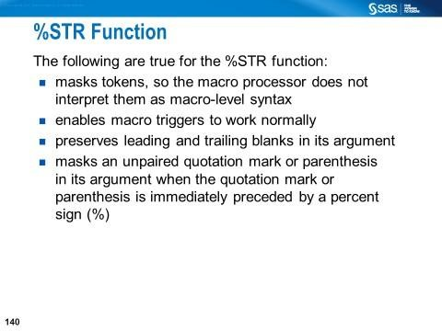
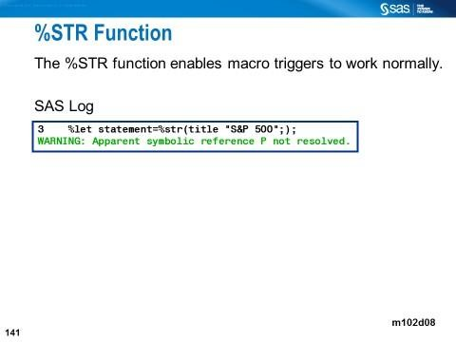
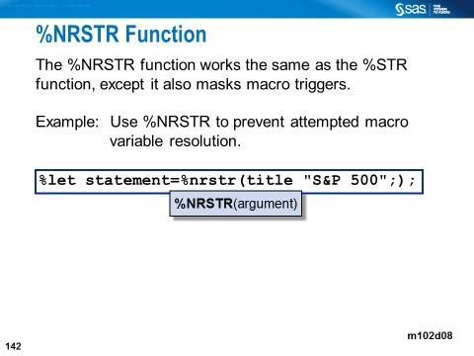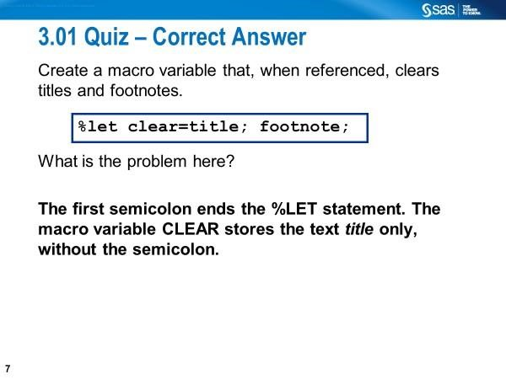
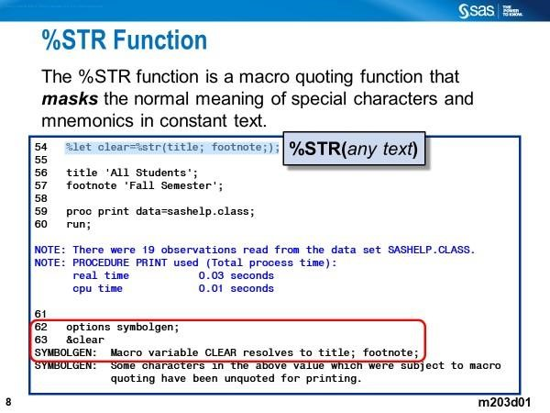
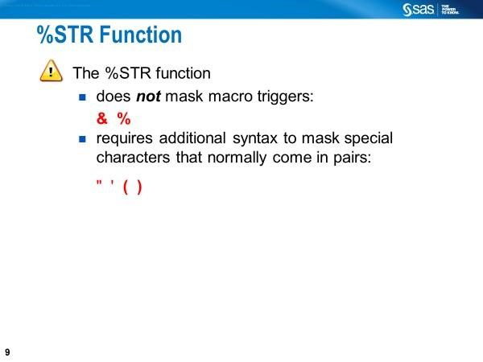
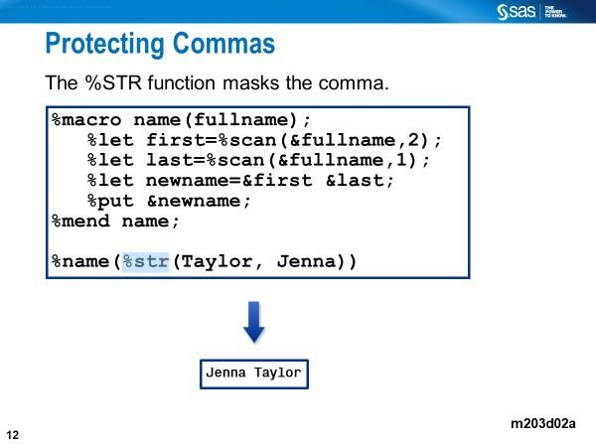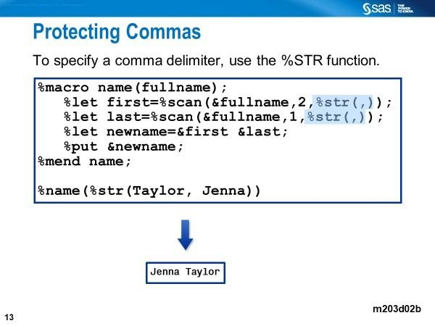
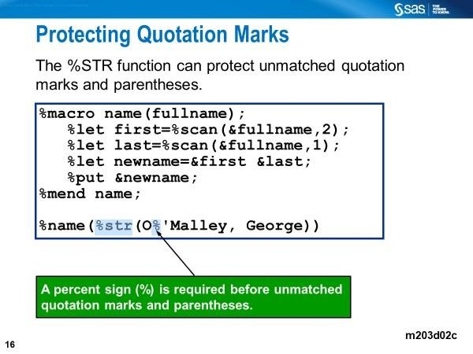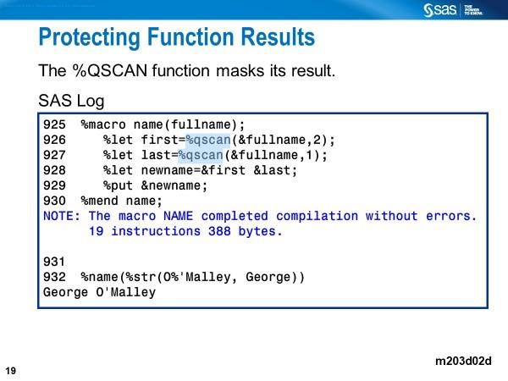

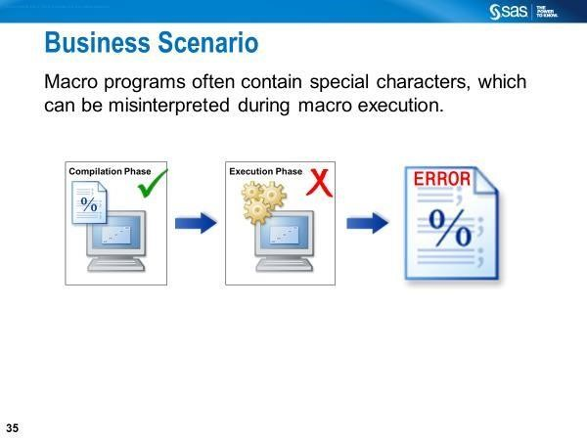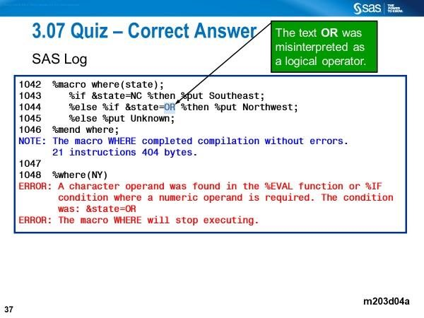
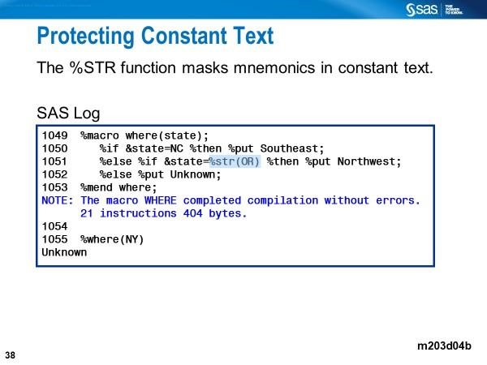
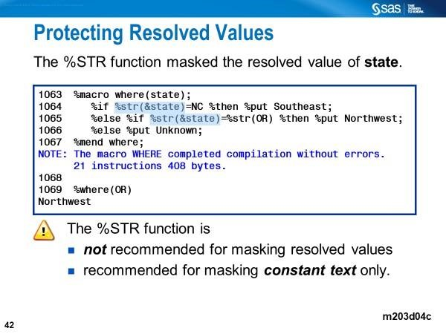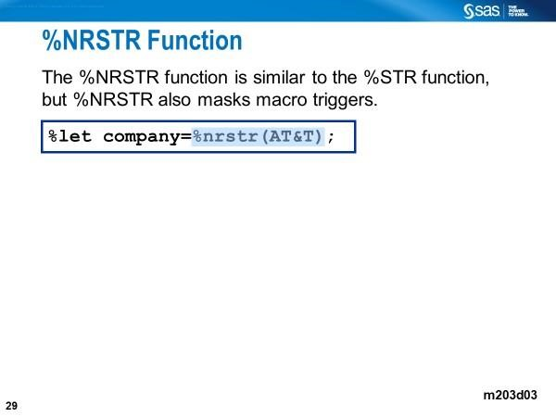
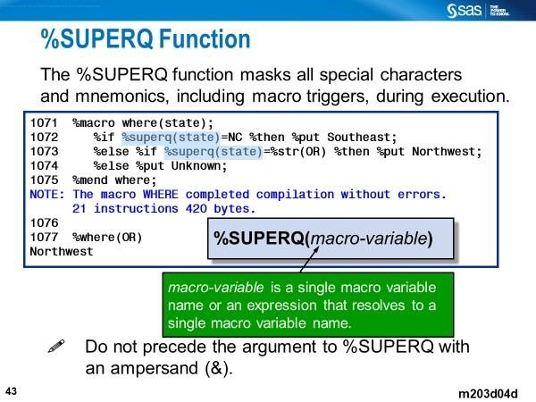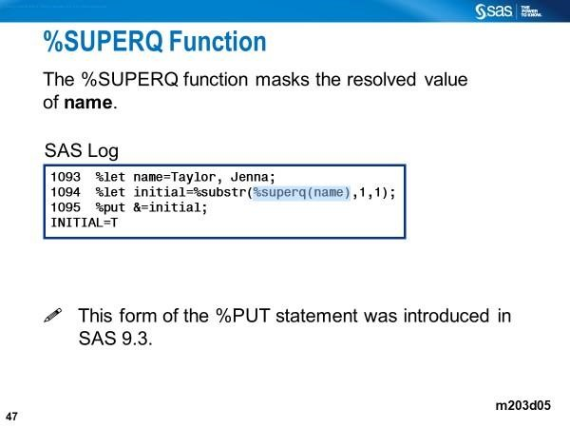

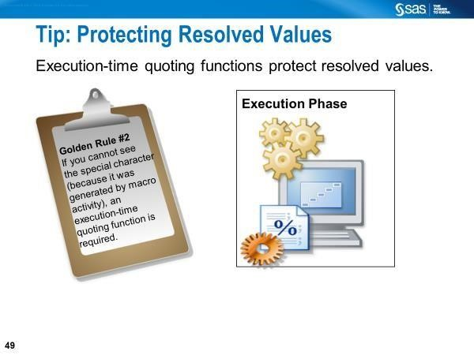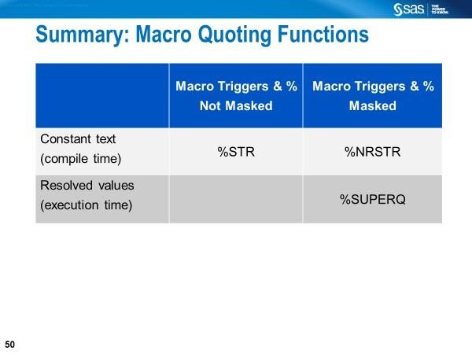

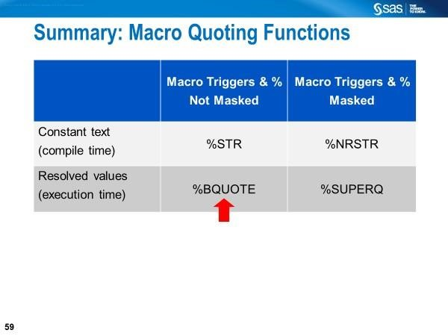

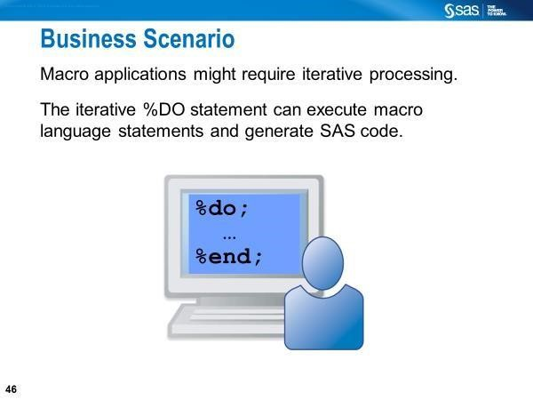

Review Questions

- Describe the types of tokens SAS recognizes when compiling a SAS program.
- What are the macro triggers?
- What does the macro processor do when macro triggers are detected?
- Explain the significance of the following macro quoting functions:
    - %STR
    - %NRSTR
    - %BQUOTE
    - %NRBQUOTE
    - %UNQUOTE
    - %SUPERQ
    - %QUOTE
    - %NRQUOTE
- Describe how each of the following functions works:
  - %SUBSTR
  - %SCAN
  - %QSCAN
  - %UPCASE
  - %QUPCASE
- Explain the significance of %SYSFUNC.

