The George Washington University
Department of Statistics

STAT 4197/STAT 6197

Week 11: Working with Macros
Detailed Topics:
- Macros – Why Do We Use Them?
- Modular macros
- Iterative Processing for Generating SAS Code (Sequential vs. Non-Sequential Processing)
- Conditional Processing Using Macro Facility
- Creating and Accessing Stored Compiled Macros

Macro variables in SAS help store and substitute text values. Macro variable substitution happens before SAS executes the code. The macro processor scans the code, identifies macro variables (preceded by &), replaces them with their corresponding values, and then passes the modified code to the SAS compiler for execution. Thus, macro variables enable you to define values once and reuse them throughout your program, thereby reducing the need for manual updates. Consider the following code snippets.
%let ds=sashelp.class;
title "Listing form &ds";
proc contents data=&ds position;
ods select variables;
run;
proc print data=&ds;
run;
proc means data=&ds;
run;
However, macro variables don't execute the conditional logic or do loops, and macros are needed for that purpose. Consider the following program.
%macro test(yrs=);
data class;
set sashelp.class;
if age gt &yrs;
run;

proc print data=class;
title "Report for age gt &yrs";
run;
%mend test;
options mprint mlogic symbolgen;
%test(yrs=14)
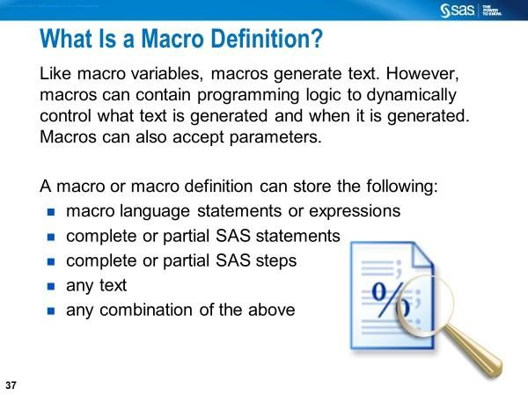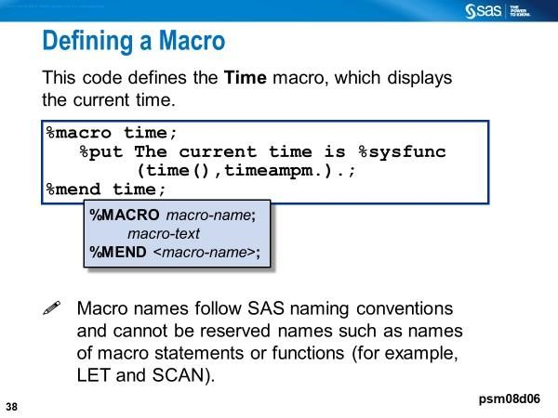

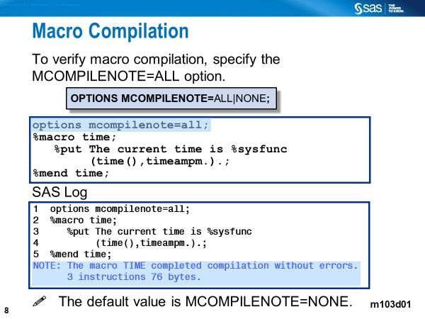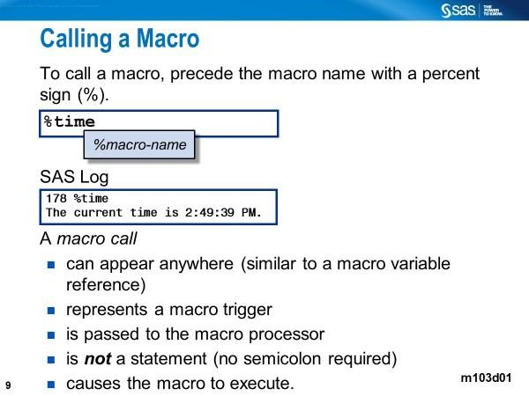

Macro Compilation Process | Macro Execution Process
- The user submits the macro definition (%MACRO to %END sandwich).  - The macro facility  - intercepts the macro definition  - performs a macro compilation  - The compiled macro definition gets stored in WORK.SAMACR | - SAS checks for the existence of the macro in the catalog  WORK.SASMACR.  - If the macro exists, it gets executed.  - The macro call is replaced by any text generated by the macro  - Generated code is compiled and executed by Base SAS.

Data-driven dynamic programming that uses the iterative %DO loop within a SAS macro to do the following:
- Increment an index macro variable whose value ranges from 2005 to 2015
- Produce SAS statements for reading raw data from six data files yob2005 through yob2015 that are stored in a zipped file
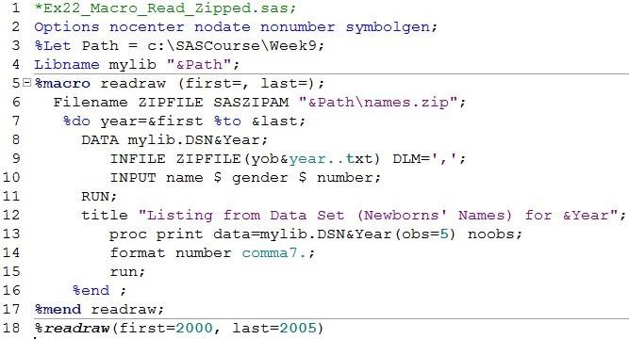

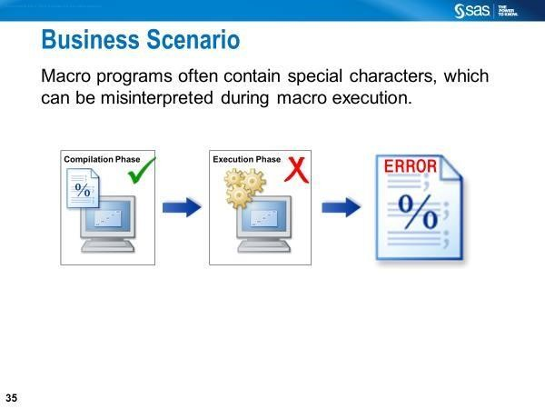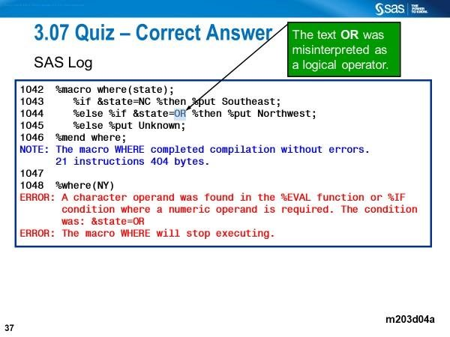
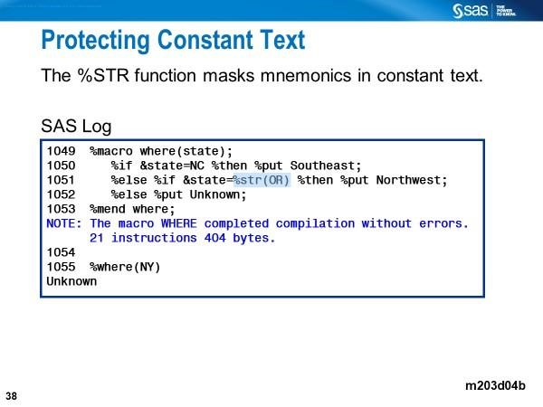
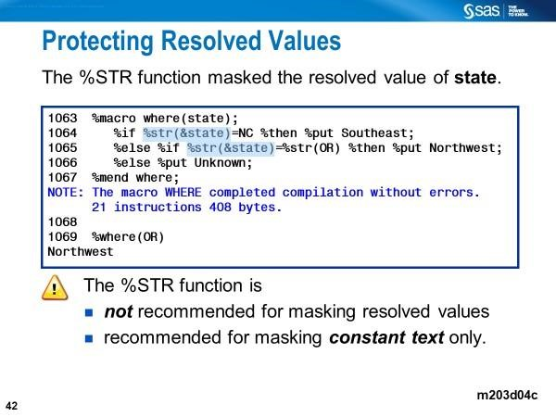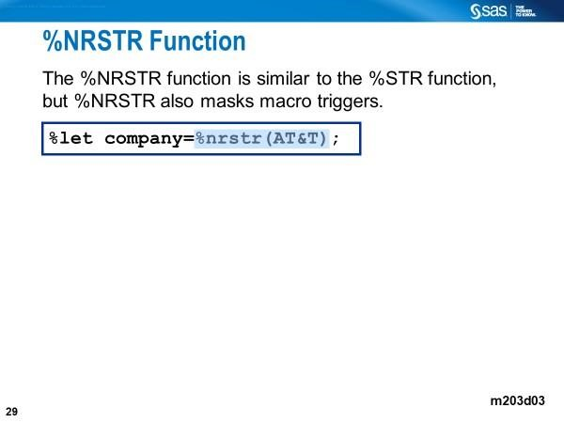
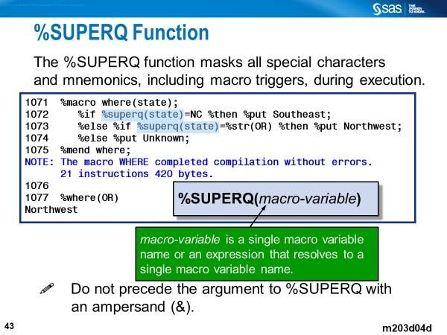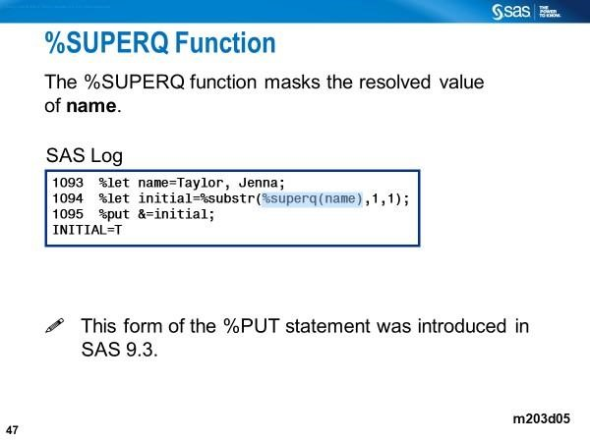

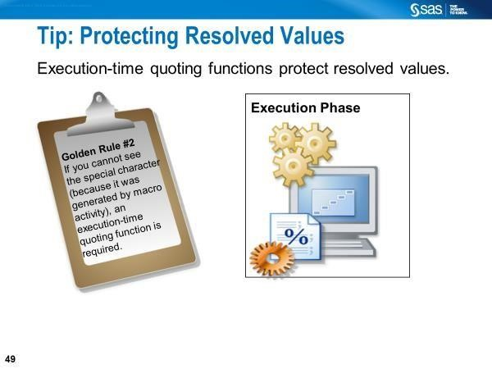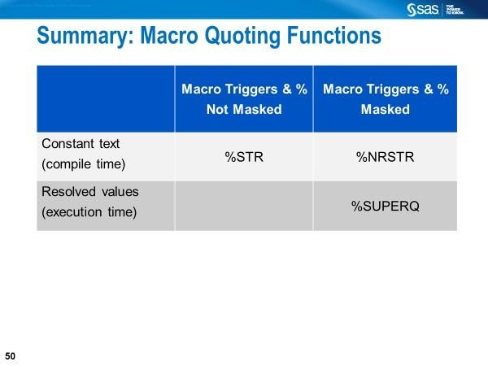

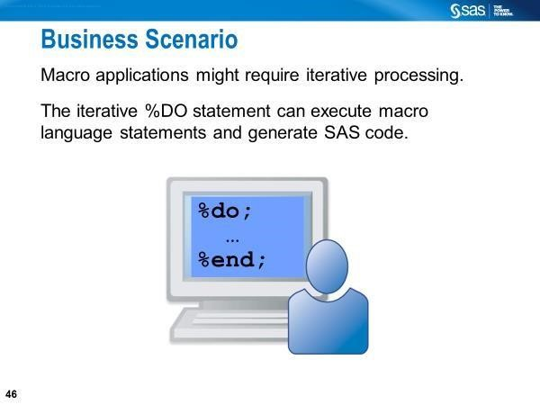

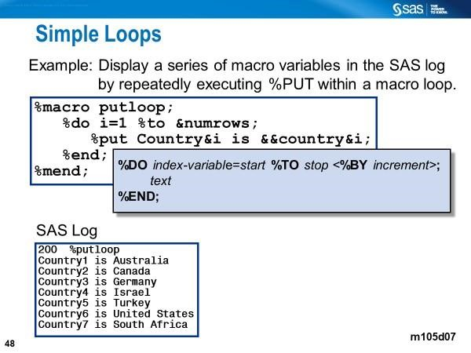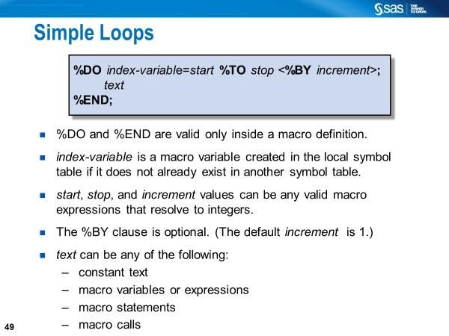

Generating SAS Code Iteratively with a Macro Goals:
- To create 8 separate data sets, each containing 1 observation and 2 variables, using a macro with %DO-%END statements.
- To concatenate the data sets (DATA step - non-macro code).
- To get the listing of 8 observations (PROC step – non-macro code)

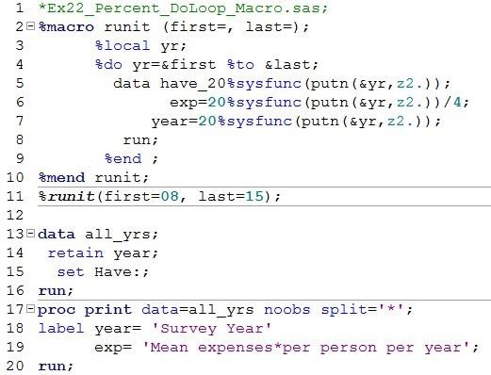
Lines 2-10: Define the macro.
Line 3: Declare the macro loop index variable as a local macro variable.
Line 2: Specify the keyword parameters in the %macro statement.
Line 11: Invoke the macro to create eight separate data sets.
Line 13-16: Concatenate them. Line 17-20: Generate listing.

Here is an example of data-driven dynamic programming that uses the iterative %DO loop within a SAS macro to do the following:
- increment an index macro variable whose value ranges from 2005 to 2015
- produce SAS statements for reading raw data from six data files yob2005 through yob2015 that are stored in a zipped file


- Macro %Do %End Processing with a Non-Sequential List of Values of a Macro Variable
- Macro with a series of macro variables (common prefix with a numeric suffix)
- Macro with a list of values of a macro Variable (No keyword or positional parameters)

%Do-%End Processing with a Non-Sequential List of Values of a Macro Variable

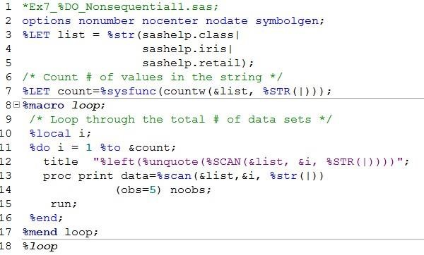

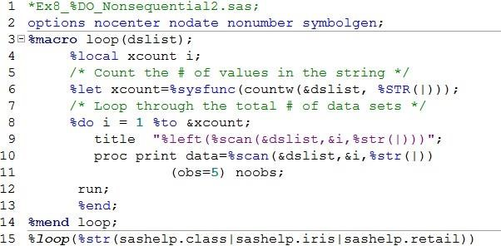

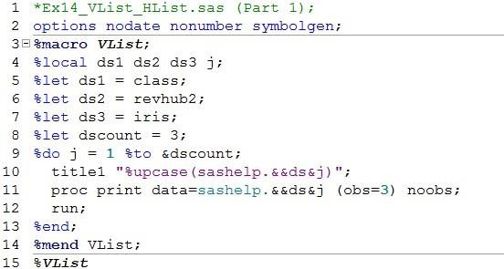

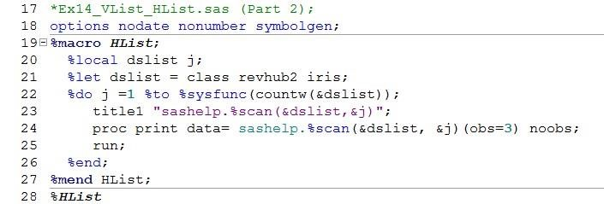

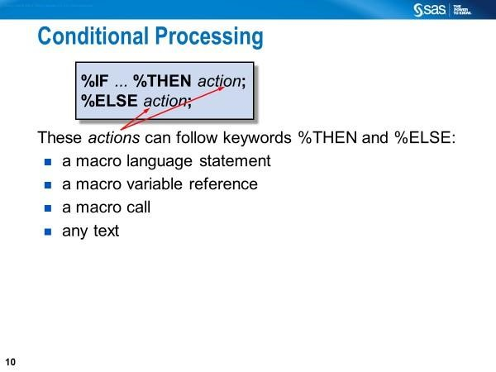
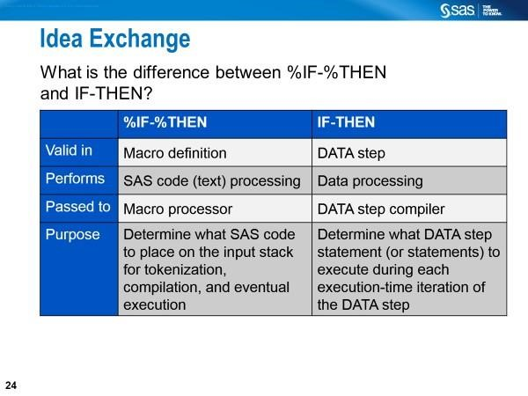

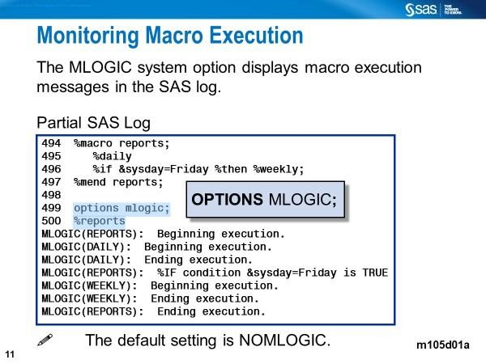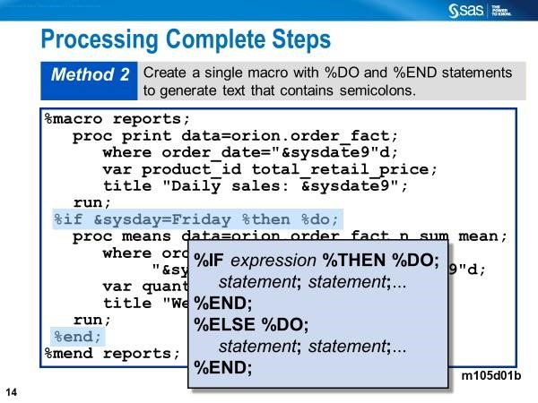

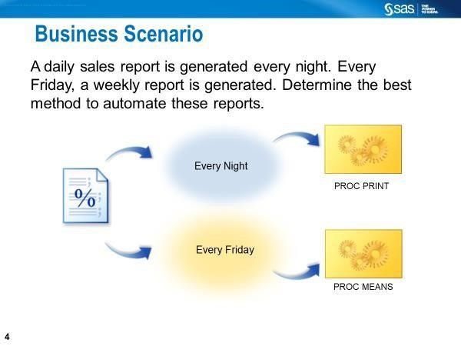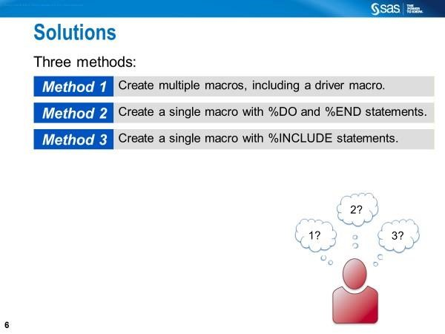
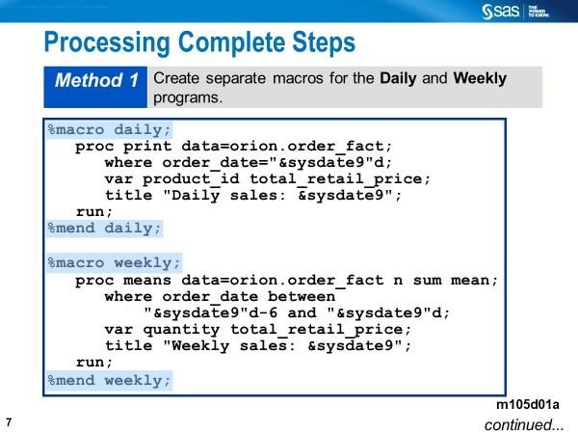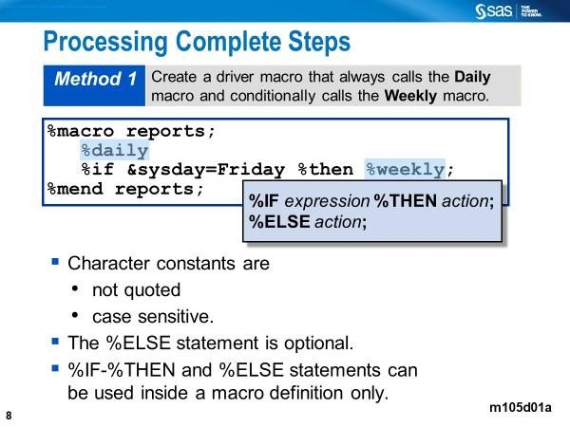

Adding variable names dynamically to the PROC FREQ step using the %IF-%then in a macro
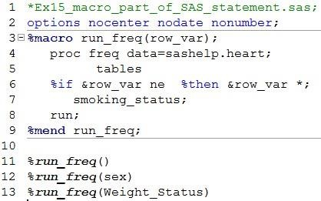

Line 6: Here, we conditionally insert text into the middle of a statement to generate one-way or two-way frequency tables.

Using a Macro Variable Reference to Select a List of Character Values in the PROC PRINT Step with a Macro

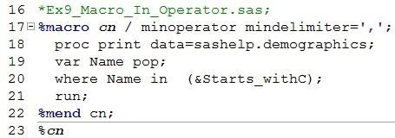

The compiled macro is stored in a SAS catalog (WORK.SASMACR).
LINE 15: The MINOPERATOR specifies that the macro processor recognizes and evaluates the mnemonic IN and the special character # as logical operators when evaluating arithmetic or logical expressions during the execution of the macro. The MINDELIMETER=’,’ specifies the character to be used as the delimiter for the macro In operator.

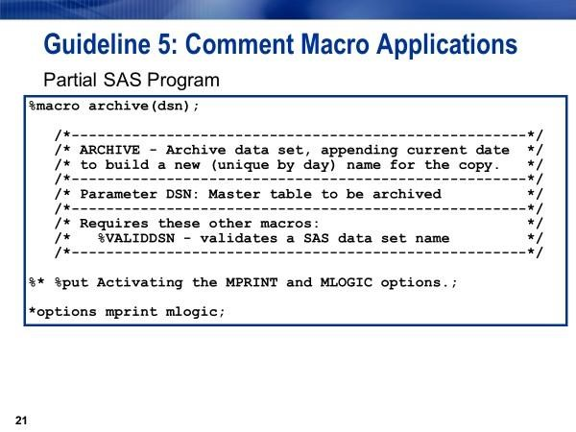

Ways to Store/Access Macros
- %INCLUDE of source entries non-compiled (macro definitions)
- Stored Compiled macros (Compiled macro definitions)
- AUTOCALL libraries that include macros

%INCLUDE Statement
- retrieves macro definitions from an external file and places it on the input stack
- is a global SAS statement, not a macro language statement

Consider the following macro definition saved in a file.
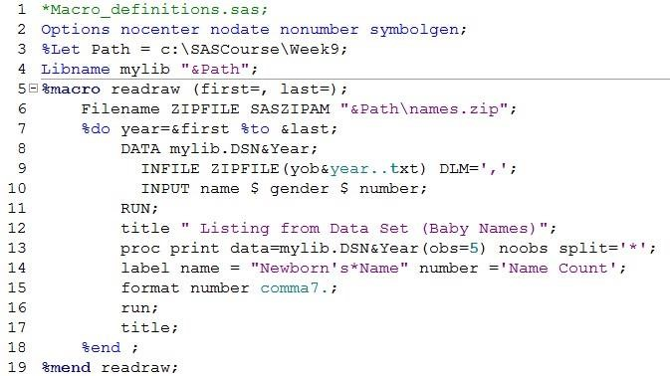

Line 2: The quoted (Windows) filename includes the macro definitions. The SOURCE2 option displays inserted SAS statements in the SAS log. Note that the % include is a global statement, not a macro statement.
Below is an example of use of the %INCLUDE statement, each containing a DATA or PROC step.

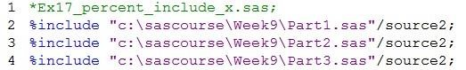
Alternatively, you can use the SAS filename statement to associate fileref with an external file as shown below.
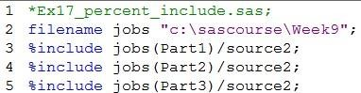

Lines 3-5: %INCLUDE brings in SAS statements stored in external files (part1, part2, and part3). The SOURCE2 option displays inserted SAS statements in the SAS log. Note that the % include is not a macro statement.

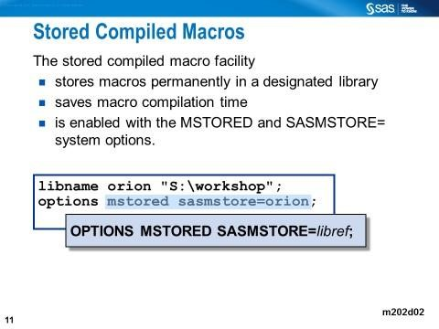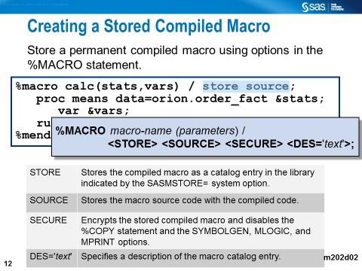
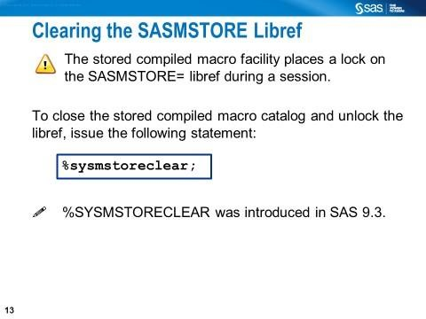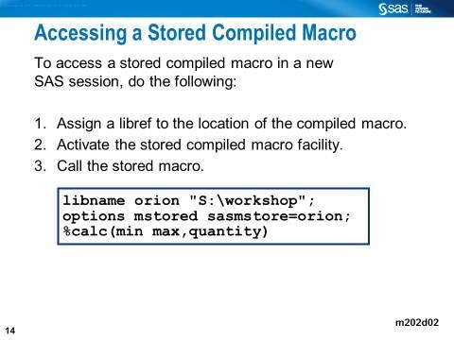

Storing Macros Using the Stored Compiled Macro Facility
Macros can be compiled and then stored temporarily or permanently for later use. When you compile a macro, it is usually stored in the temporary WORK.SASMACR catalog. However, you can store a macro in compiled form in a SAS macro catalog also named SASMACR, but in a permanent library. The following code is adapted from Simon (2017).

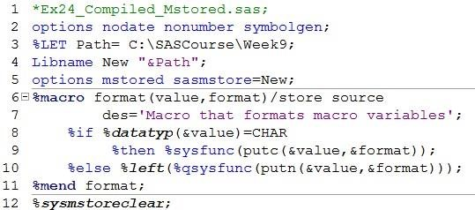
Line 5: In the OPTIONS statement, the system option MSTORED turns on the use of stored compiled macros. The system option SASMSTORE= specifies the libref that contains a SAS catalog named SASMACR.

Lines 6-11: This is the macro definition. Note the STORE option (required), the
SOURCE option, and the DES option on the %MACRO statement. The NEW.SASMACR catalog is opened when the entire macro written to it.
Line 12: The %SYSMSTORECLEAR statement closes the SASMACR catalog, preventing the libref from being reassigned.

Displaying the Information from the Catalog
The CATALOG procedure can display the relevant information, including the description specified when the macro was compiled and stored. Below is an example.

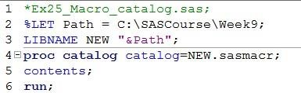

Calling a Compiled-Stored Macro
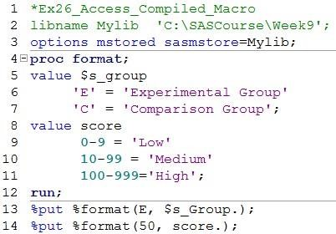

Line 3: In the OPTIONS statement, the system option MSTORED turns on storing compiled macros. The system option SASMSTORE= specifies the libref that contains a SAS catalog named SASMACR.
Lines 5-6: %format is macro call. The format macro was earlier compiled and stored permanently in the folder specified in line 2.
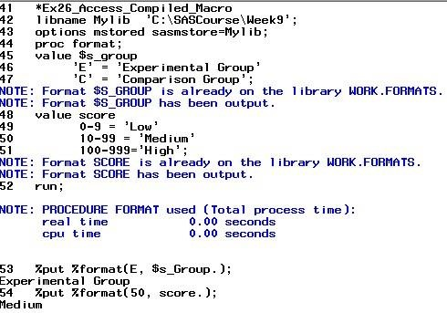

Making the Autocall Macro Available

The following macro definition uses %SYSFUNC to call the DATE function. When invoked, the macro call retrieves the current date (a numeric value) and then displays it as a formatted character string (Carpenter, 2016).
The name of the macro and the file name that includes the macro definition must be the same for an autocall macro. The example code below meets this requirement.

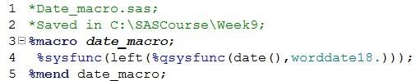

With the MATOSOURCE and SASAUTOS= options (Line 3 below), you can access the macro automatically. Notice that the macro call (%date_macro) is in double quotes in the TITLE statement.

