The George Washington University
Department of Statistics

STAT 4197/STAT 6197 – Spring 2025

Week 1: SAS Programming Efficiency and Miscellaneous

- Programming Efficiency in SAS
- Simulating Data with SAS
- Calling R in a SAS/IML Session
- Data Driven Macro (Case Study)

Simulations
Simulations provide a way to answer questions and explore properties of statistical estimators and procedures (Kleinman and Horton, 2014).
In statistics, data are commonly simulated to
- generate random samples from a statistical distribution (discrete or continuous) with known properties
- estimate the sampling distributions of basic measures such as means, medians, and Pearson correlations
- evaluate statistical techniques
- ascertain the statistical power of hypothesis tests
(Source: Simulating Data with SAS® by Rick Wicklin, 2013)
Some standard functions used in simulation
- PDF Function
- CDF Function
- Quantile Function
- RAND Function

Generating Data
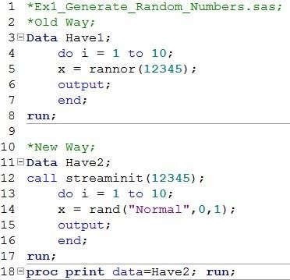
Line 12: The routine is used to set the seed for the random number stream.
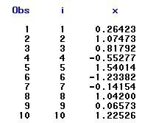

The following DATA step simulates 100 independent values from various distributions.
The subsequent PROC PRINT step displays the first five observations.
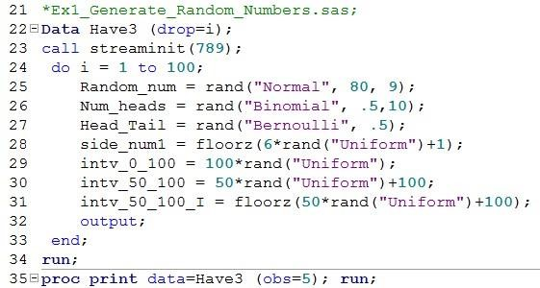
Line 23: This routine sets the seed value.
Line 24: The DO loop iterates 100 times.
Line 25: Normal distribution with mean = 80 and standard deviation = 9. Line
26: Binomial distribution with p (a numeric probability of success) = .5 and n (an integer parameter that counts the number of independent Bernoulli trials) = 10. Line 27: Bernoulli distribution with p = .5.
Line 28: The Floorz converts the result to integers.

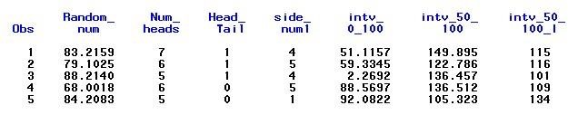
Some Other Distributions: Geometric, Poisson, and Exponential.

Assigning 19 Subjects in the data set SASHELP.CLASS to the Drug or Placebo Randomly

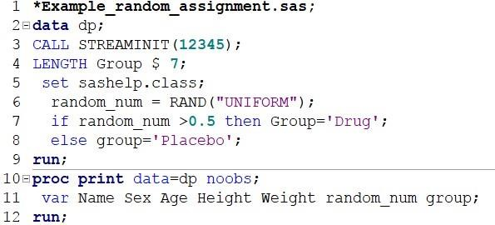

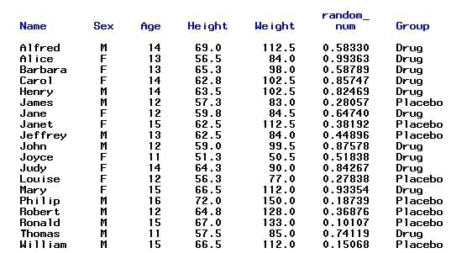
Simulating Data from a Discrete Distribution (See Wicklin, 2015)
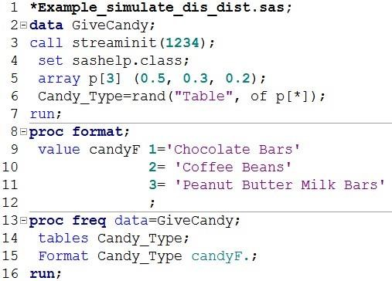
Line 6: The RAND function uses a “Table” distribution to specify a table of probabilities for each outcome.

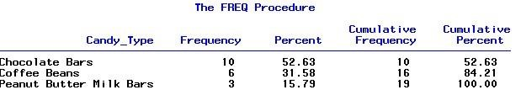

Calling R in a SAS Session with PROC IML
Requirements:

Both R and SAS software packages must be installed  The RLANG system option in SAS must also be enabled.

Run the following code in SAS to check whether the permission to use R within SAS is enabled.
PROC OPTIONS OPTION=RLANG; RUN;
If the permission to use R within SAS is not enabled, you must modify the sasv9.cfg file, which is typically found in "C:\Program Files\SASHome\SASFoundation\9.3\nls\en\”, in order to reset this option by adding a –RLANG line to the config file.

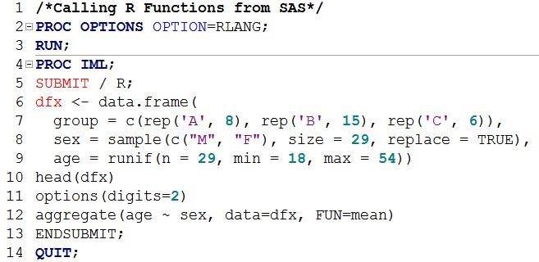
Output from line 11 (Listing of 6 observations)
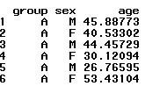
Output from Lines 11-12
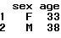

- "./Ex1_Generate_Random_Numbers.sas"
- "./Ex10_simulate.sas"
- "./Ex11_simulate.sas"
- "./Ex12_simulate.sas"
- "./Ex13_simulate.sas"
- "./Ex14_data_driven_simu.sas"
- "./Ex15_calling_R_from_SAS.sas"
- "./Ex16_calling_R_from_SAS.sas"
- "./Ex17_calling_R_from_SAS.sas"
- "./Ex18_collapse_multiple_cols.sas"
- "./Ex19_count_repeated_rows.sas"
- "./Ex2_DoLoop_Mod_Func.sas"
- "./Ex20_macro_case_study.sas"
- "./Ex21_Load.sas"
- "./Ex22_R_List_of_Files.sas"
- "./Ex3_call_symputx_dates.sas"
- "./Ex4_generate_dates_sashelp_class.sas"
- "./Ex5_generate_SSN_dates_other_vars.sas"
- "./Ex6_random_assignment.sas"
- "./Ex7_simualte_randomID.sas"
- "./Ex8_simulate.sas"
- "./Ex9_simulate.sas"

