The George Washington University
Department of Statistics

STAT 4197/6197

Week 2: Reading Data into SAS and Creating Reports

- Reading Raw Data into SAS Data Sets Using

  - Column Input
  - Formatted Input
  - List Input
  - Named Input

- Reading Microsoft Excel Data into SAS Data Sets
- Handling Missing Values
- SAS Processing
- Creating Raw Tabular Data Files or Reports Using DATA _NULL_
- Creating a SAS List Report

Reading Raw Data with the Input Statement

Use the above link to study the SAS codes for various input styles.

Input Styles
 | Style | Use for Reading
 | Column input | Standard data in fixed columns
 | Formatted input | Standard and nonstandard data in fixed columns
 | List input | Standard and nonstandard data separated by blanks or some other delimiter
 | Named input | Standard data that is preceded by the name of the variable and an equal sign (=)
Column input, formatted input, list input, and named input are all styles of writing INPUT statement specifications.
7
The list input style that handles standard data and character variables whose values are no longer than 8 bytes is called simple list input.

The list input style that additionally handles nonstandard data and character variables whose values are more than 8 bytes long is called modified list input.

Modified List Input = List input + some features of Formatted Input.

When to Use Column Input
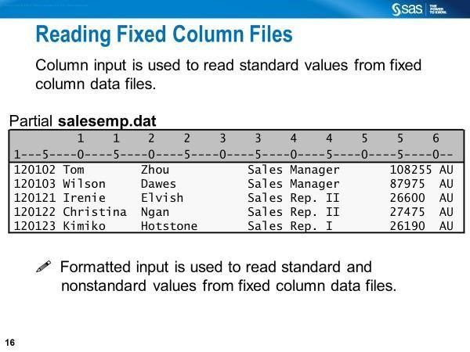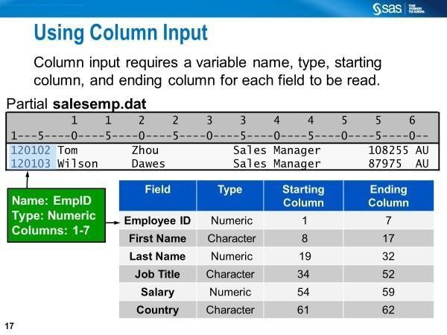

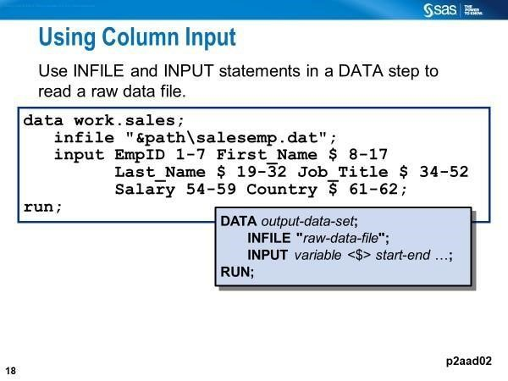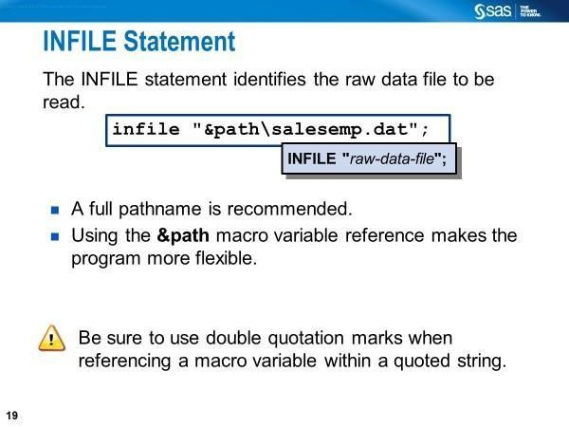

In the INFILE statement, you can specify either the external file's name or point to the external file with a fileref defined with the FILENAME statement, unless you have instream data following the DATALINES statement. You may also need to specify one or more options for this statement.

Advantages of Column Input

- Data fields can be read in any order. The same field can be reread.
- Parts of a data field can be read.
- Both leading and trailing blanks within the field are ignored.
- Character values can contain embedded blanks.
- Placeholders (e.g., period) are not required for missing data.

Disadvantage: The Column Input cannot read nonstandard data values

When to Use Formatted Input
Records with standard numeric, nonstandard numeric, or character data fields aligned in columns

Features of the formatted input style
- Starting position
- Variable
- INFORMAT
The informat name must contain a period (.) at the end for SAS to distinguish it (i.e., informat name) from a variable name, as seen in the code below.

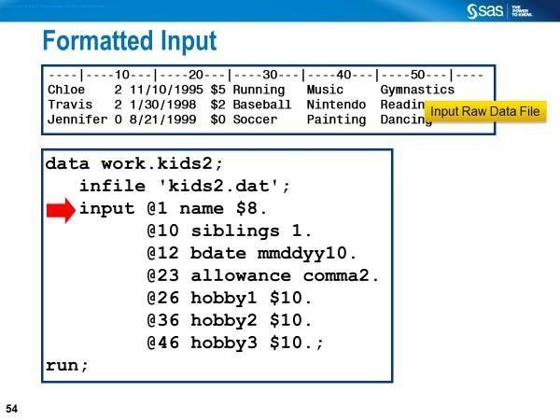

Formatted Input: Use of Absolute Pointer Control vs. Relative Pointer Control

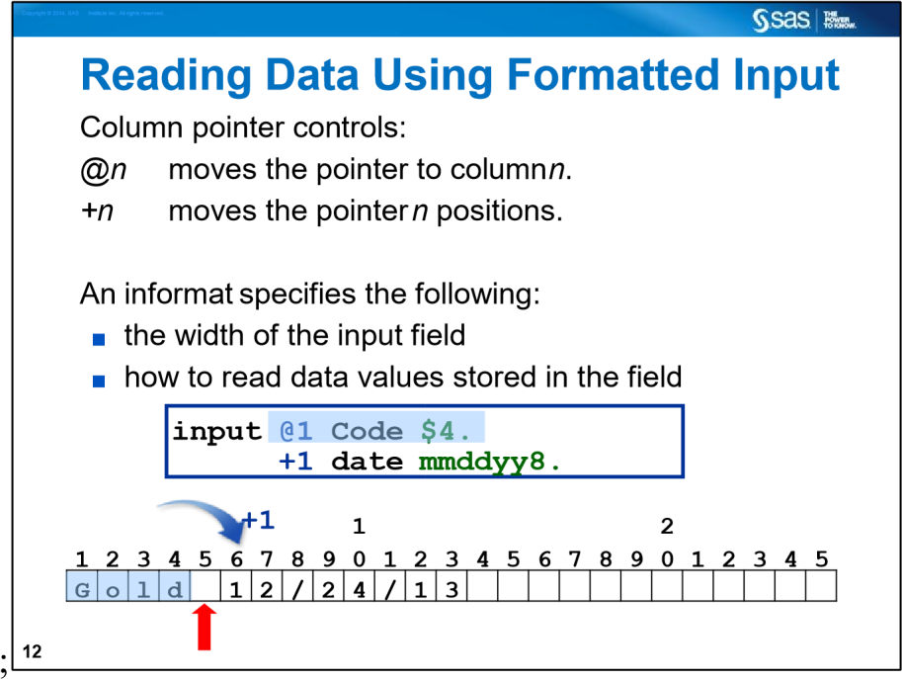

Remember that when you use formatted input, the column pointer control moves to the first column following the field that was just read.
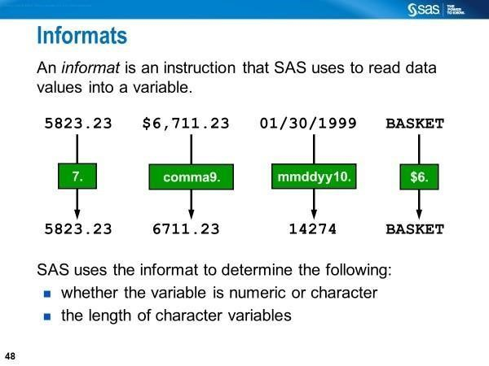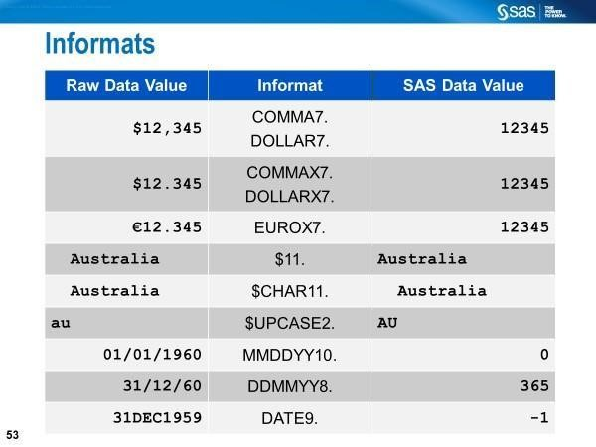

a

The ANYDTDTEw. informat can be used to read data that has a variety of date forms.
Informats always contain a w value to indicate the width of the raw data field. A perod (.) ends the informat or separates the w value from the optional d value, which specifies the number of decimal places.

Column Input: Reading Data in Fixed Columns with Some Shorter Records from an external file

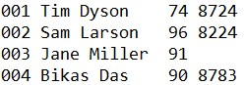

The third record above is shorter than expected.
Data HAVE;
infile 'C:\SASCourse\Week2\short_records.txt' lrecl=25 PAD;
input id 1-3 name $ 5-16 score 18-19 @21 some_value 5.2;
run;

With the PAD option on the INFILE statement, SAS pads the records in fixed columns read from an external file with blanks to the length specified in the LRECL= option or implied by the column position.

Column Input: Reading Data in Fixed Columns with Some Values in Fewer than the Number of Columns Specified from an external file

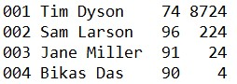

The last field holds values in fewer than four columns among the last three records above.
data HAVE;
infile 'C:\SASCourse\Week2\short_values.txt' TRUNCOVER;
input id 1-3 name $ 5-16 score 18-19 @21 some_value 5.2; run;

The TRUNCOVER option on the INFILE statement correctly assigns the contents of the input buffer to the last field.
When to Use List Input 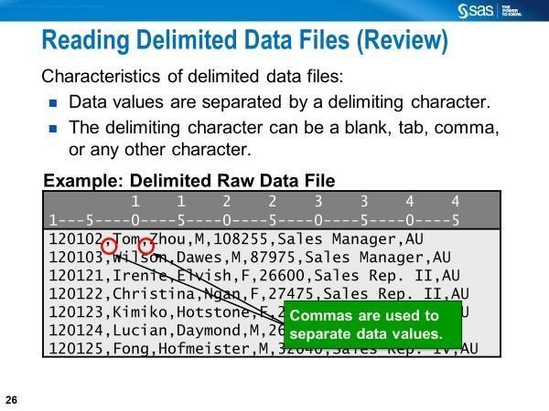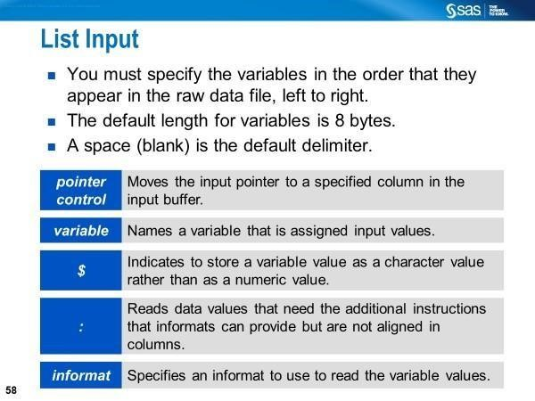

-

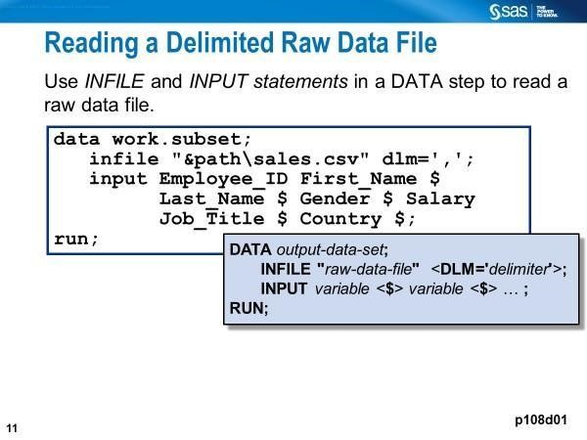
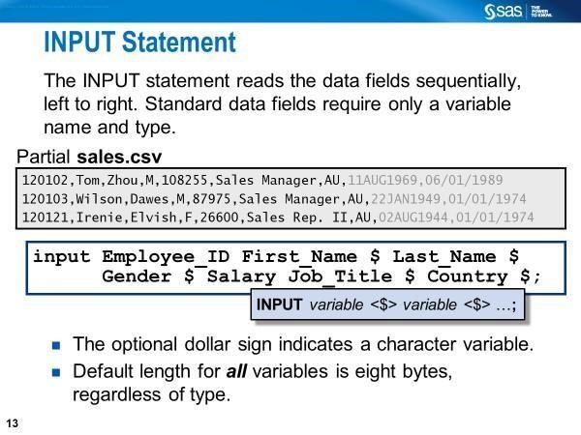

Modified List Input: Using the Colon Modifier in the Input Statement

- Free-Format Data
- Data fields separated by 1+ blanks or other delimiters
- Data fields have standard numeric values or characters more than 8 bytes • Data fields have non-standard numeric values

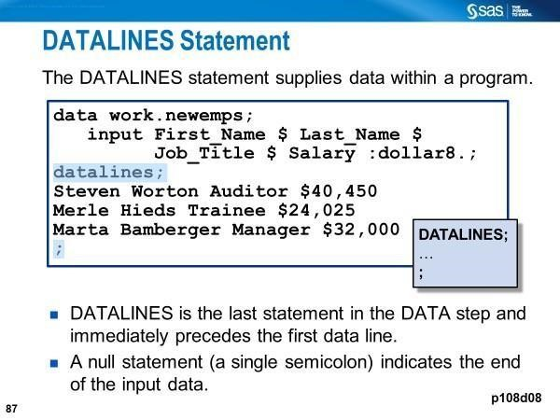

The colon (:) format modifier enables you to use list input but also to specify an informat after a variable name, whether character or numeric. SAS reads until it encounters a blank column, the defined length of the variable (character only), or the end of the data line, whichever comes first.

Here, the INFORMAT specifies the length for each character variable, not the number of columns that are read.

The LENGTH Statement
A LENGTH statement contains the names of the variables followed by the number of bytes to be used for storage.
The length of a variable is the number of bytes SAS allocates for storing the variable. It is not necessarily the same as the number of characters in the variable. The LENGTH statement is used in the data step to reduce the size (in terms of disk space) of SAS data sets. By default, SAS uses 8 bytes to store numeric variables. Variables containing integer values can be stored using less than 8 bytes.

Largest integer represented exactly by length for SAS variables under
Windows
Length in bytes | Largest integer represented exactly
3 | 8,192
4 | 2,097,152
5 | 536,870,912
6 | 137,438,953,472
7 | 35,184,372,088,832
8 | 9,007,199,254,740,990

Data sets containing many integer variables (such are common with data collected by questionnaire) or indicator variables can be reduced in size by more than 50%.

Variables containing real numbers should be left with the default length of 8. Note that specifying a length less than that required will result in a loss of precision without any warning being given.

LENGTH Statement to Define the Length of Both Numeric and Character Variables

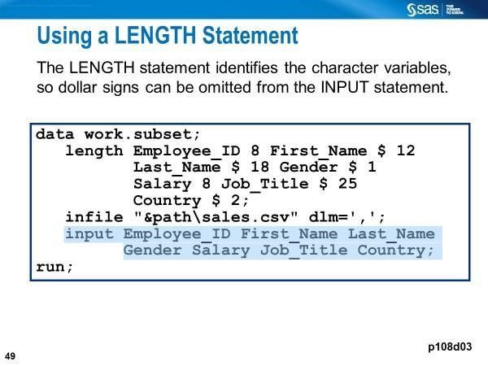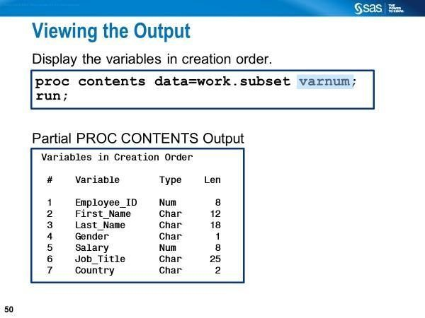

Reading Non-Standard Data: Modifier with an Informat instead of the Informat Statement

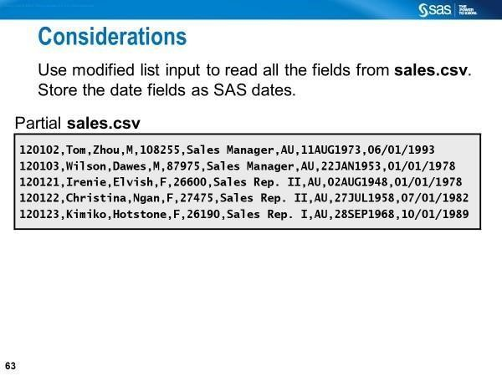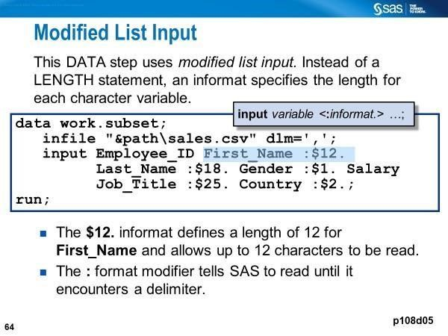

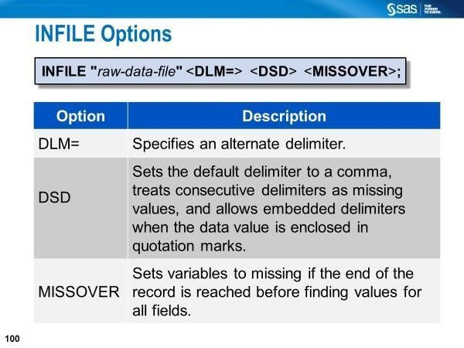

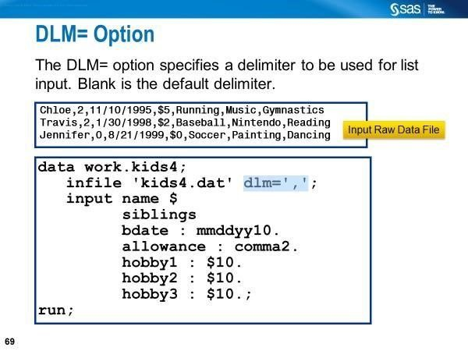

Modified List Input and DSD Option on the Infile Statement

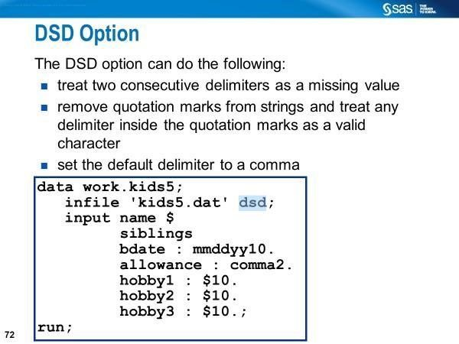

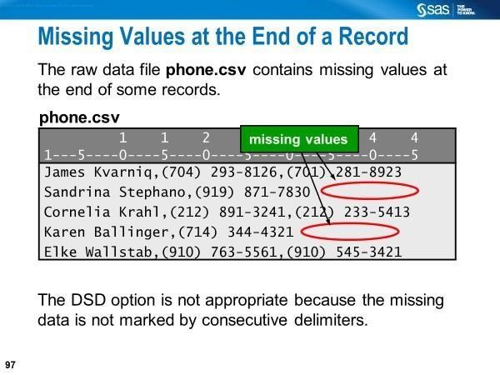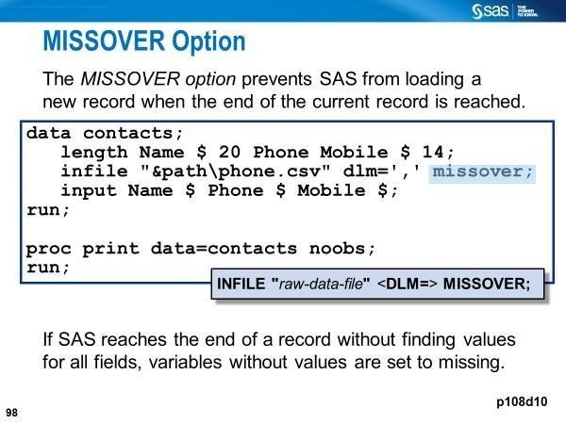
Use MISSOVER if the last field or fields might be missing and you want SAS to assign missing values to the corresponding variable.

The Ampersand (&) Modifier

The ampersand (&) format modifier enables you to read character values that contain embedded blanks with list input and specify a character informat. SAS reads until it encounters two consecutive blanks, the defined variable length, or the end of the input line, whichever comes first.

*Ex6_Formated_Input_Dates.sas (Part 7);
options yearcutoff=1720; data yc;
INPUT state_name & $22. date_entry :mmddyy.;
FORMAT date_entry :mmddyy10.;
DATALINES;
Delaware 12/07/87
Pennsylvania 12/12/87
New Jersey 12/18/87
South Carolina 05/23/88
;
proc print data=yc noobs;
run;

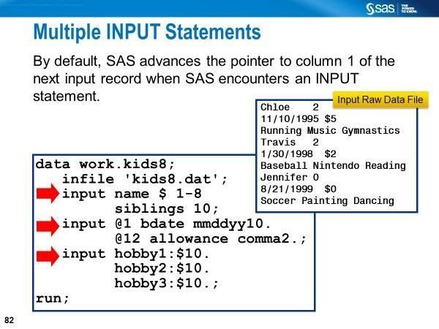
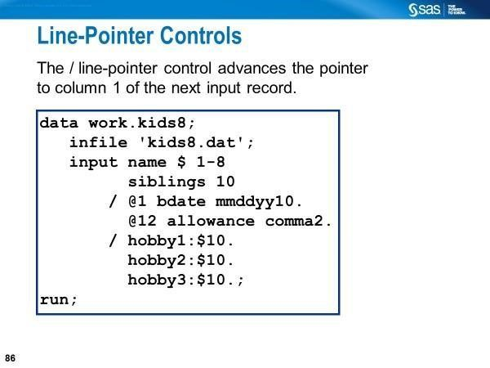
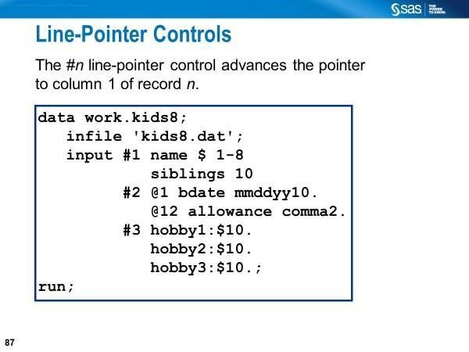

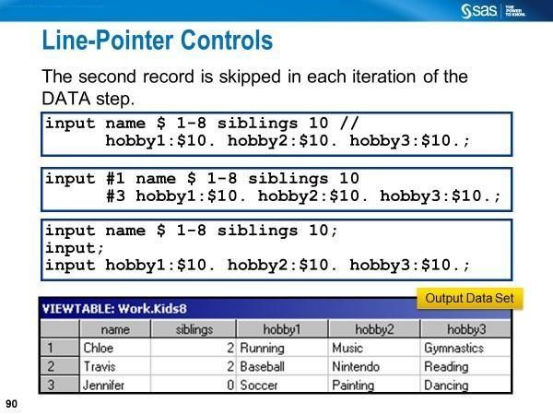

When to Use the Forward Slash (/) Line Pointer Control
You have data elements that need to be read sequentially from multiple records to create a single observation.

The Use of Multiple Input Statements
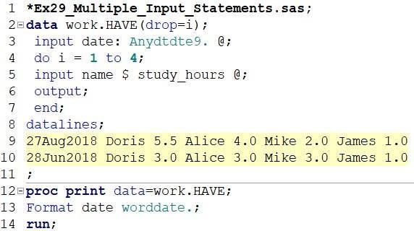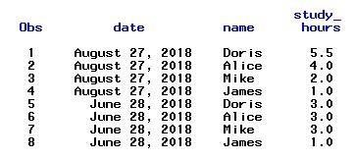

Normally, each INPUT statement in a DATA step reads a new data record into the input buffer. However, when you use a trailing @, the following things occur:

- The pointer position does not change.
- No new record is read into the input buffer.
- The next INPUT statement for the same iteration of the DATA step continues to read the same record rather than a new one.
SAS releases a record held by a trailing @ when a null INPUT statement executes (input;).
- An INPUT statement without a trailing @ executes the next iteration of the DATA step.

List Input with a Double Trailing @ at the End of the Input Statement

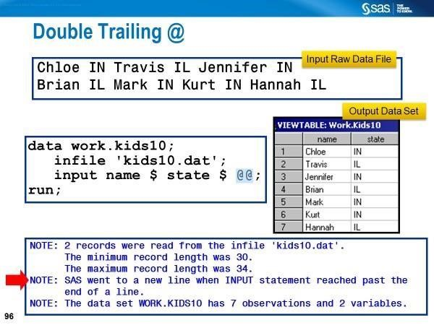

Modified List Input with a double @ at the End of the Input Statement

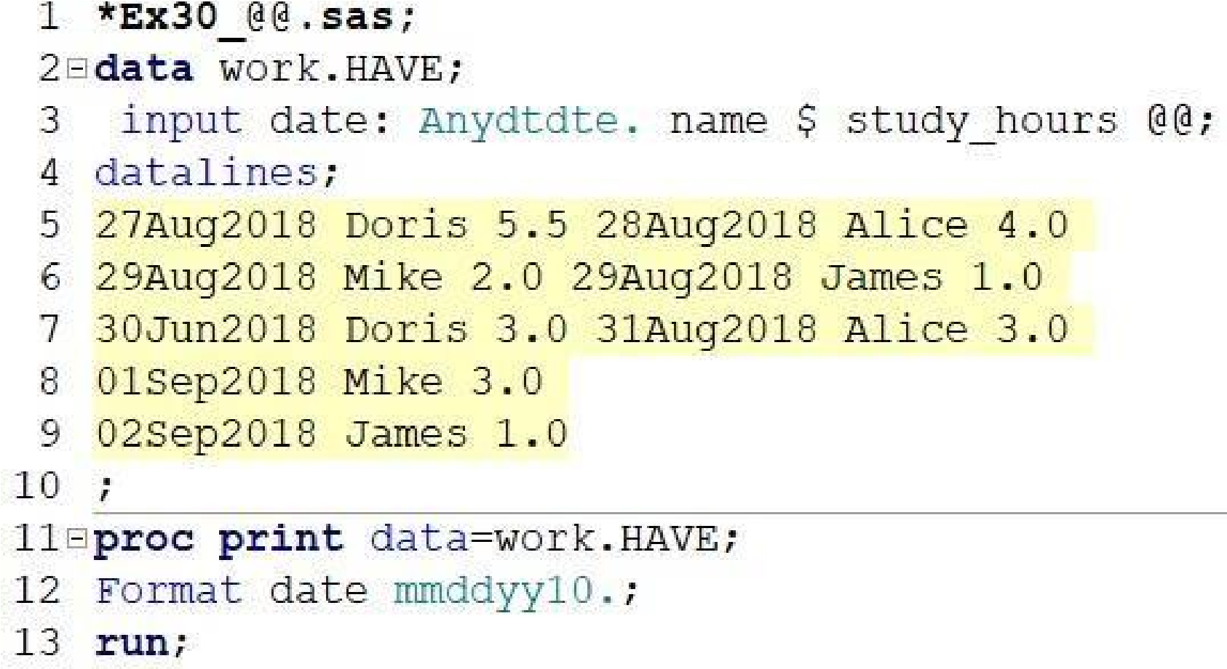

In the above program, we are reading 5 lines of data with the Datalines statement.
Lines 5, 6, and 7 each have two records, and lines 8 and 9 each have one record. Here, our goal is to create a SAS data file that will have one observation from each record – a total of 8 observations.

Notice that the Informat for the variable date does not specify a w value because we are reading data using List Input with a colon modifier; here, SAS reads data fields until it encounters a blank.

When to Use Named Input

- Data records contain both variable names and values

What to Specify on the Input Statement (Named Input)

- Each variable name must be followed by an equal sign on the INPUT statement
- Each variable name must be followed by an equal sign on the data as well
- Character variables must be indicated by a "$" following the equals sign on the INPUT statement
- Appropriate format modifiers and informats must be specified
- The"/" at the end of the line must be used to read the next data line to complete the observation

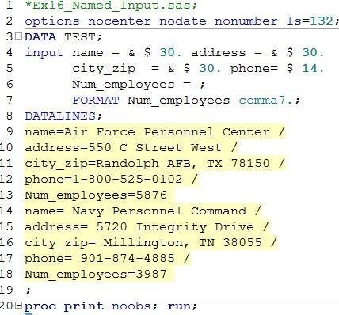

Processing a DATA Step: A Walk-through

Exploring SAS Data Step Processing
- After the SAS program is submitted, the codes are copied into a memory area called the input stack
- The word scanner reads the text from the input stack and breaks it into fundamental units called tokens, which are of four types:
- Literal - a string of characters enclosed in quotation marks (e.g., “GWU”)
- Number - digits, date values, time values, and hexadecimal numbers
(e.g., 1234 ‘13mar2016’dv 20e4v 14.5)
- Name - a string of characters beginning with an underscore or letter (_N_ , Descending, means)
- Special characters – other than a letter, number, or underscore that have a special meaning to the SAS system (e.g., * / + - % &)
- The word scanner passes tokens, one at a time, to the appropriate compiler (regular SAS compiler, or macro compiler) as appropriate. The compiler requests tokens until it receives a semicolon. The word scanner repeats this process for each SAS statement.
- The compilation is suspended after the step boundary is encountered.
- SAS statements are scanned for syntax errors o missing semicolons o misspelled keywords o unmatched quotation marks o invalid options
- If there is no compilation error for the step, SAS executes the compiled code.

Compilation Phase
- The input buffer is created to hold a data record from the raw data file
- The program data vector (PDV) is created for two automatic variables (_N_ and _ERROR_)
- The descriptor portion of the SAS data file is created: data file name, # of observations, and the number, names, and attributes of variables

Execution Phase • Variables in the PDV are initialized to missing before each execution of the data step
• The DATA step executes once for each record in the input file, unless otherwise directed by additional statements

• Each record in the raw data file is read into the input buffer, copied to the
PDV, and then written to the SAS data file at the end of the DATA step
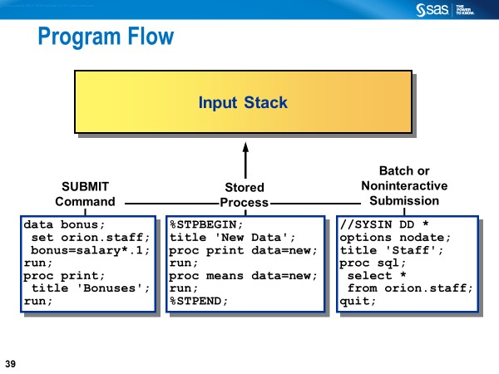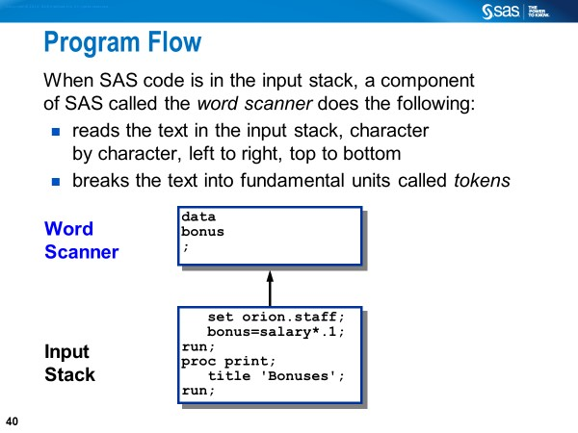
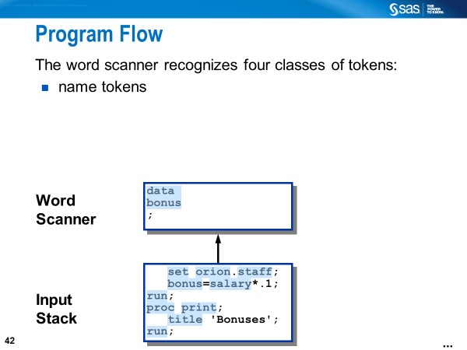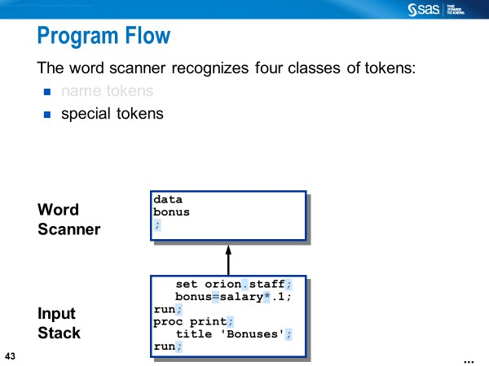
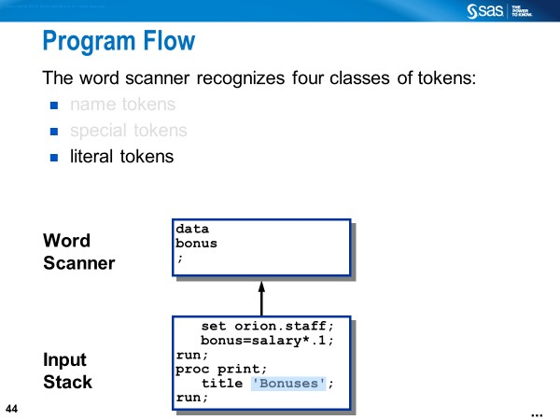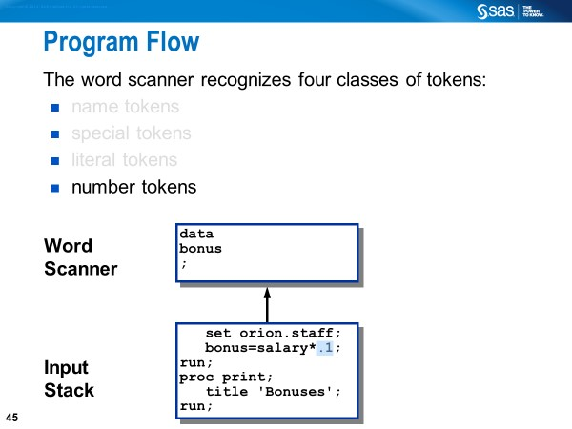

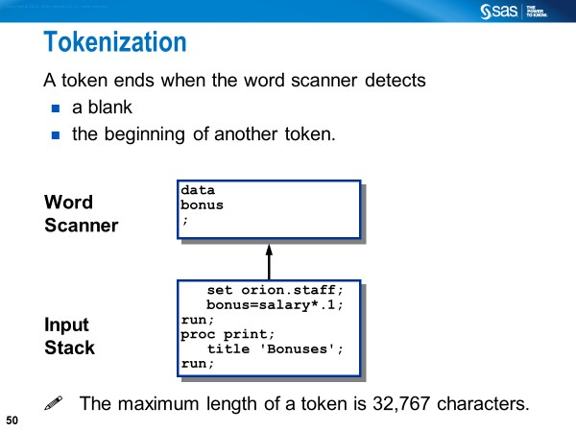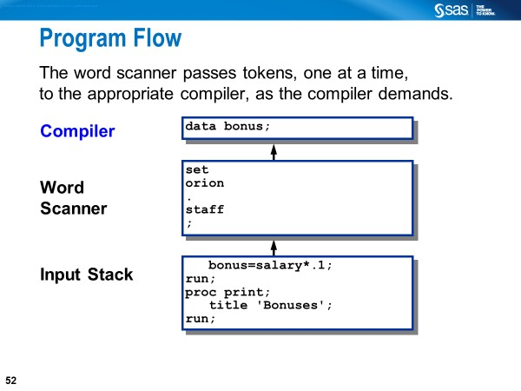

How to represent missing values

When you have a space-delimited file, and you have a missing value, you have to represent the missing value as a period when reading data using list or modified list input.

When you have a comma-delimited file or any type of delimited file, you do not have to have a period as a missing value because you normally have multiple delimiters in a row to indicate a missing value.

When you have a space-delimited file that is column-aligned, then you do not have to have a period to represent a missing value because you are using column input to read the data.

Handling Missing Values

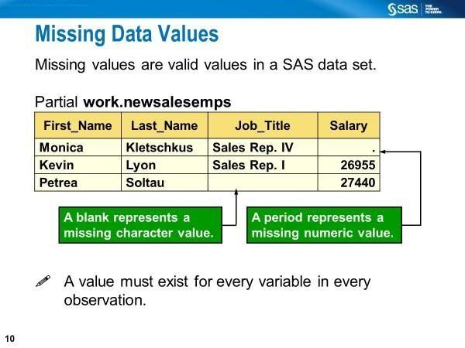
In addition to the above two ordinary missing values, 26 special missing values only apply to the numeric variable.

The MISSING= system option allows specifying a character to be printed when numeric variables contain ordinary missing values (.).

If your data contains characters that represent special missing values, such as a or z, do not use the MISSING= system option to define them; simply define these values in a
MISSING statement.

Reading Microsoft Excel Data into SAS Data Sets

Creating Raw Tabular Data Files or Reports Using DATA _NULL_ PUT and PUTLOG Statements

In general, the PUT statement writes to the LOG or to an External File with a FILE statement, but the PUTLOG statement always writes to the LOG.

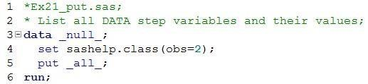

Line 3: The keyword _NULL_ on the DATA statement is used to execute the data step without creating a data set.

Line 5: The PUT statement is used to create output records to the LOG window. The special SAS name list _ALL_ refers to all variables on the data step and program data vector, including _N_ and _ERROR_.

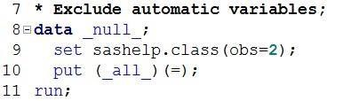

Line 10: In the PUT statement, the variable list argument is _ALL_ [i.e., all variables on the data step and program data vector excluding _N_ and _ERROR_]; the format argument is the equal sign so that the variable name precedes its value.

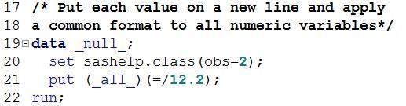

Line 21: The PUT statement is used to tell SAS to write each of the variables in the data step and program data vector (except _N_ and _ERROR_) that must precede its value. An additional format argument / is used so that each variable and its value, separated by an equal sign, is output to a separate line. Note the FORMATw.d (i.e., 12.2) that applies to all numeric variables.

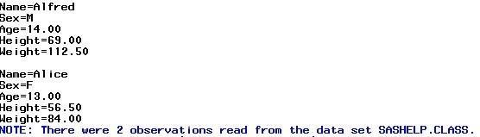

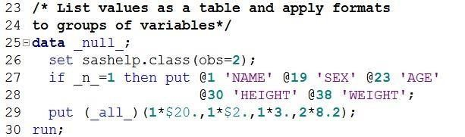

Line 27: During the first iteration, the variable names are printed, each starting with the column position specified, to the LOG window by default.

Line 29: This is an example of the FORMATTED PUT statement. There is no equal sign or slash as a format-list argument. Formats specified as format-list arguments. For example, a character format $20. is applied to the variable NAME. Another character format $2. is applied to the variable SEX. A numeric format 3. is applied to the variable AGE. Another numeric format, 8.2, is applied to the variables HEIGHT and WEIGHT.

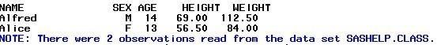

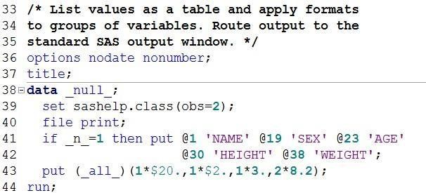

Line 40: This statement creates the tabular output to the OUTPUT window, not the LOG window.

(Partial SAS Log)
Snapshot from the SAS output window
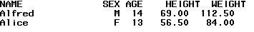

The PUT statement in a DATA step always writes to the SAS log, unless it is preceded by a FILE statement that specifies otherwise. [SAS® Documentation]
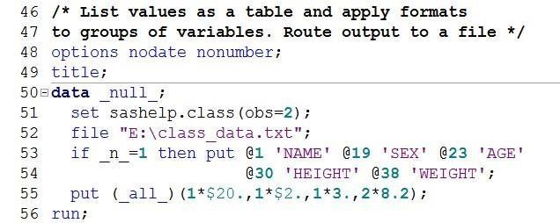
Line 52: This statement creates a tabular raw data file named
CLASS_DATA.TXT in the path specified, all enclosed in quotation mark.

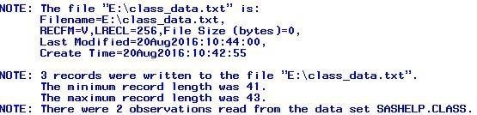

Automatic variable _INFILE_ specifies a character variable that references the contents of the current input buffer for this INFILE statement.

You can use the variable in the same way as any other variable, even as the target of an assignment. The variable is automatically retained and initialized to blanks. As with automatic variables, the _INFILE_= variable is not written to the data set.

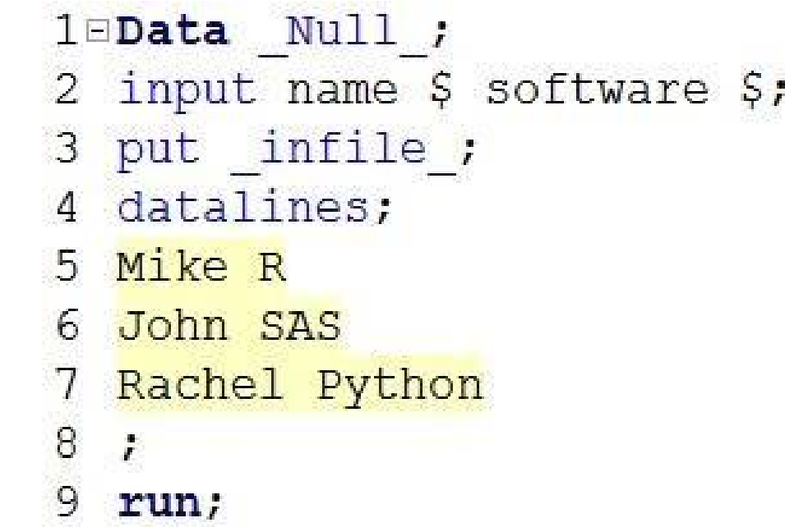 | 

_N_ and _ERROR_

These two variables are created by the SAS engine during compilation. These variables are used for processing, but are never written into the SAS data set created.

_N_ is initially set to 1. Each time the DATA step loops past the DATA statement, the variable _N_ increments by 1.

_N_ =1 means that the program left the DATA statement for the first time. If the data set has 5 observations, it will leave the DATA statement six times.

_ERROR_ is 0 by default but is set to 1 whenever an error is encountered, such as an input data error, a conversion error, or a math error, as in division by 0 or a floating point overflow. You can use the value of this variable to help locate errors in data records and to print an error message to the SAS log.

Source: SAS Documentation

Creating a SAS List Report

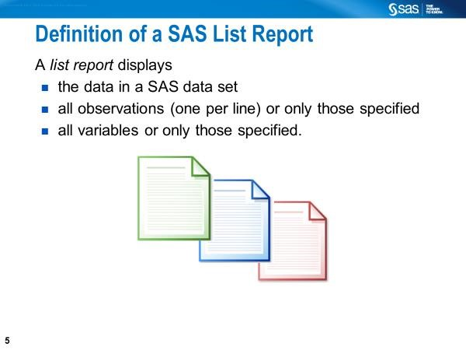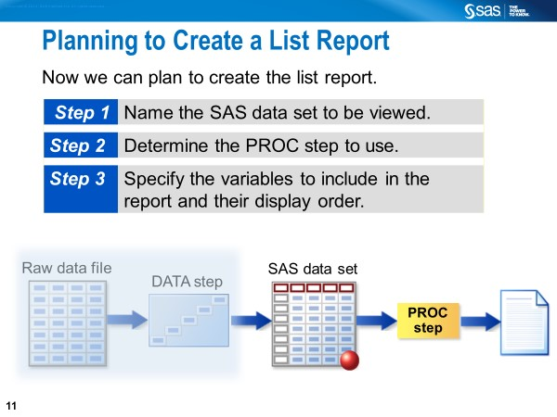

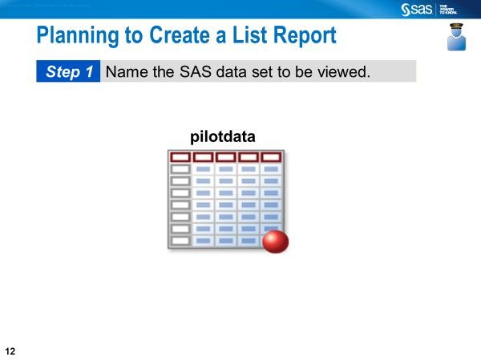

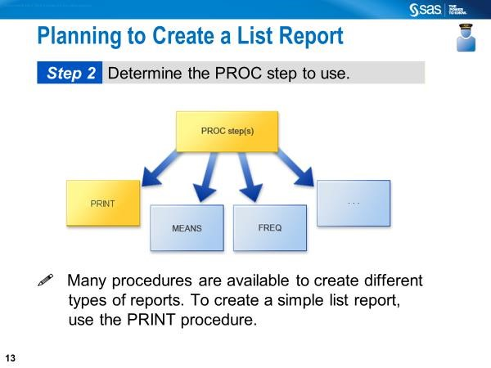

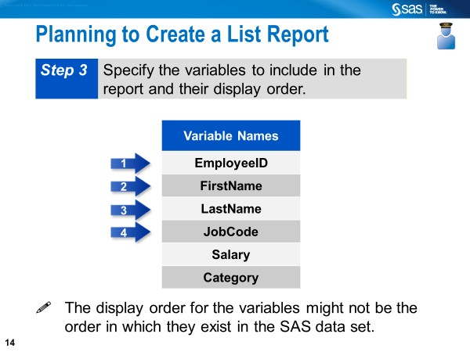
PROC PRINT (a reporting procedure)
- displays data values (numeric or character)
- can provide summary totals for numeric variables (their values cannot be added, subtracted, multiplied or divided against each other)
- does not have OUT= data set option
- does not support the ODS OUTPUT statement

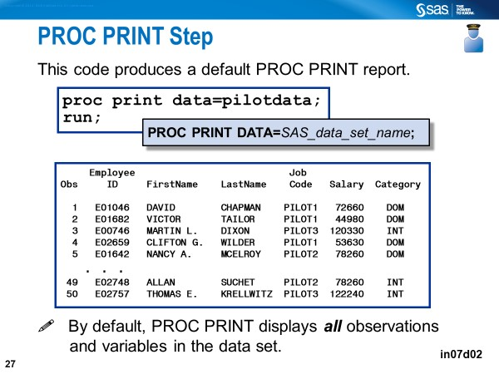
OBS is a column that is automatically displayed in a PROC PRINT report. It represents the number of an observation.

