The George Washington University
Department of Statistics

STAT 4197/STAT 6197

Week 5: Controlling and Managing SAS Data Sets
Detailed Topics:
- Controlling SAS Data Sets with Options/Statements
- Filtering Observations
- Sorting Data
- Accessing Data Directly
- Copying/Modifying SAS Data Sets
- Downloading Zipped SAS Transport Files from the Web
- Converting SAS Transport Files into SAS Data Sets
- Restructuring Data

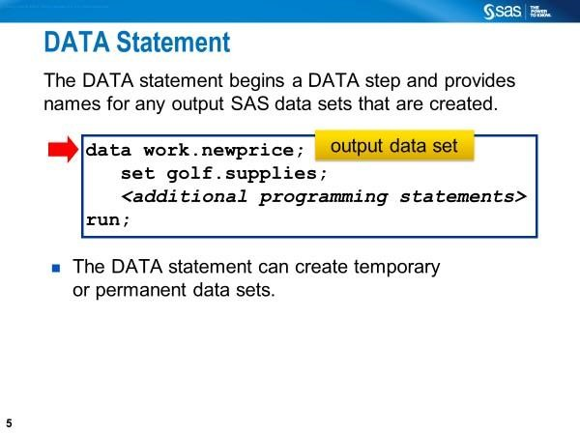
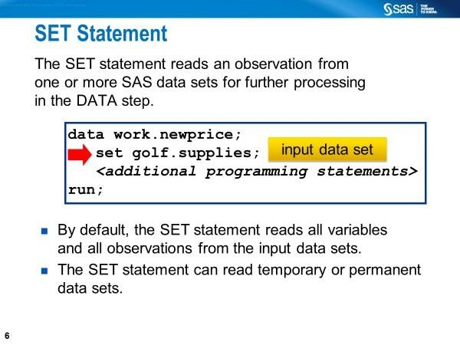
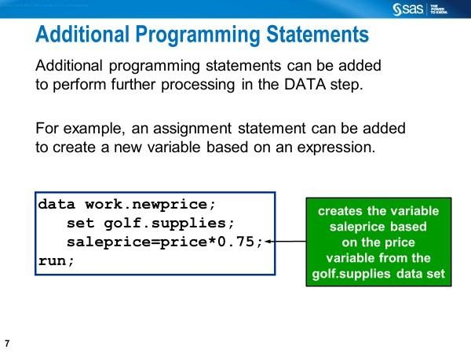
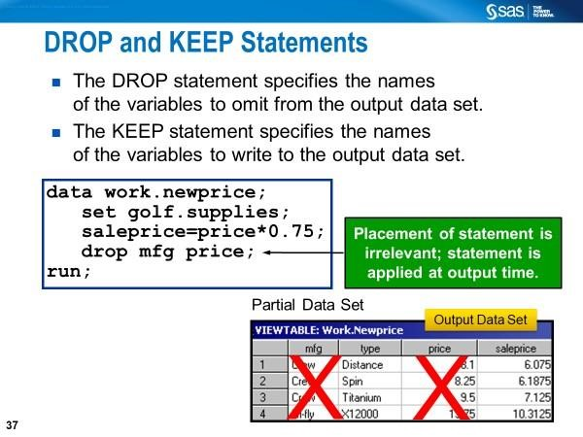
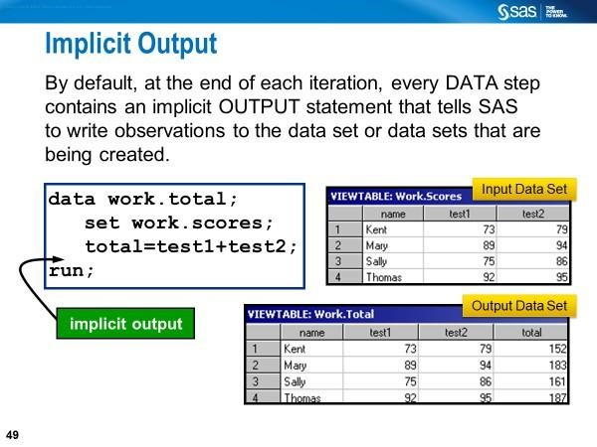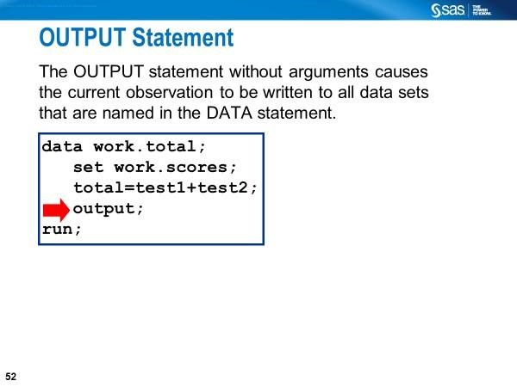

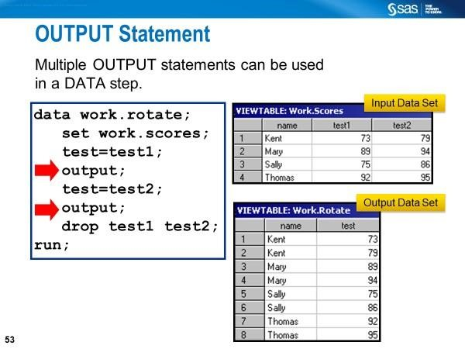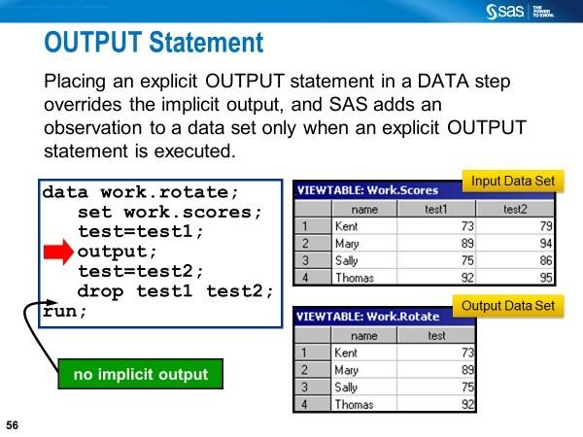
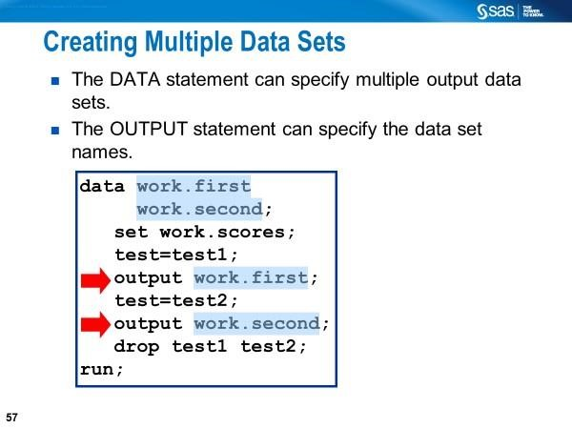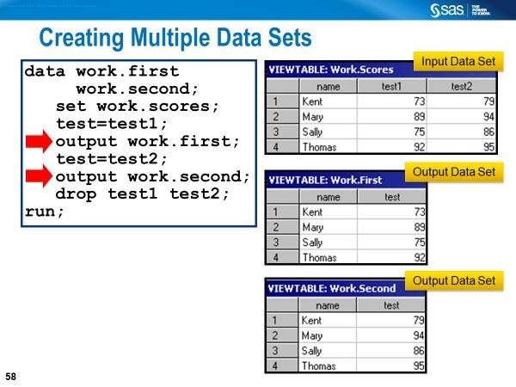
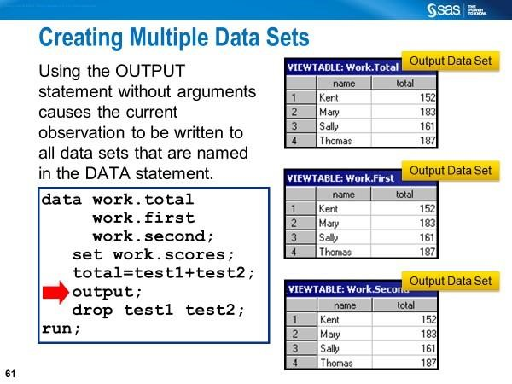
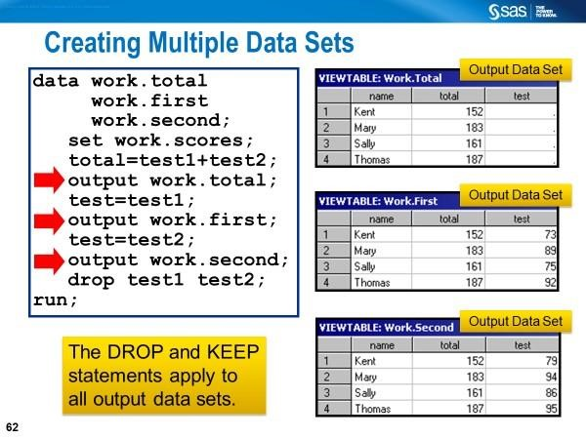
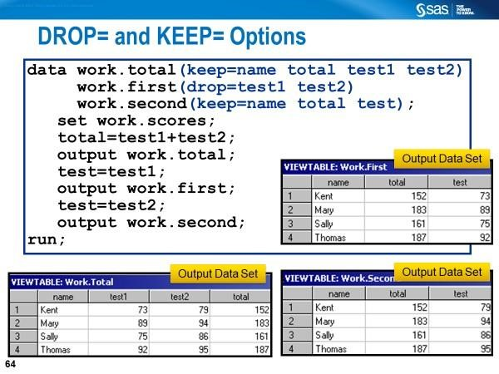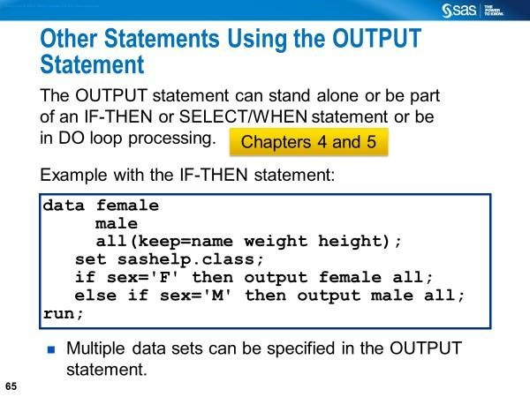
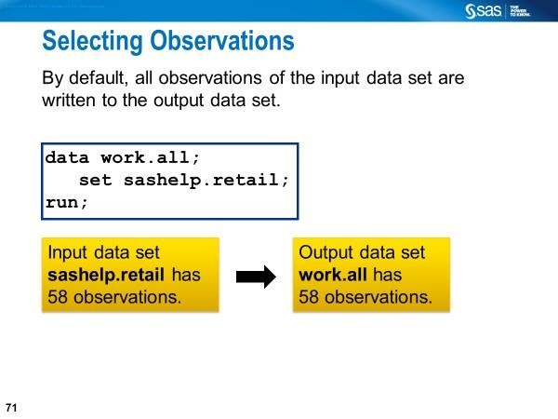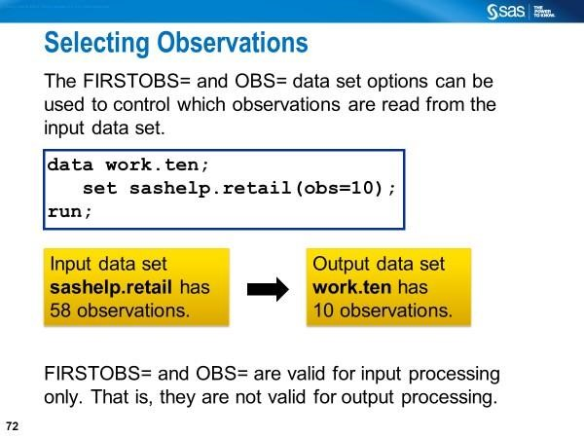
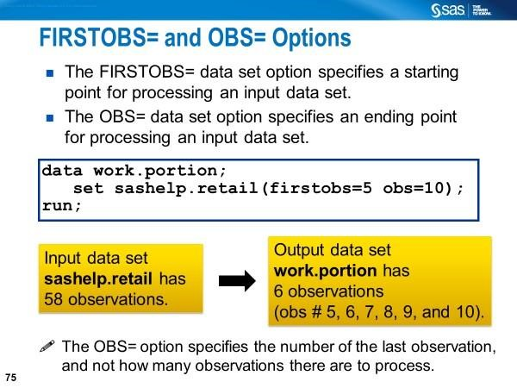

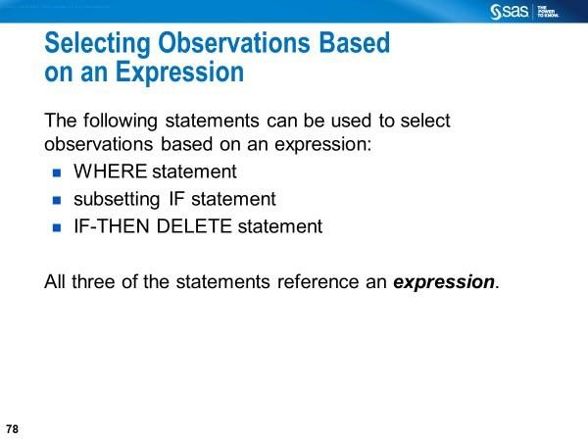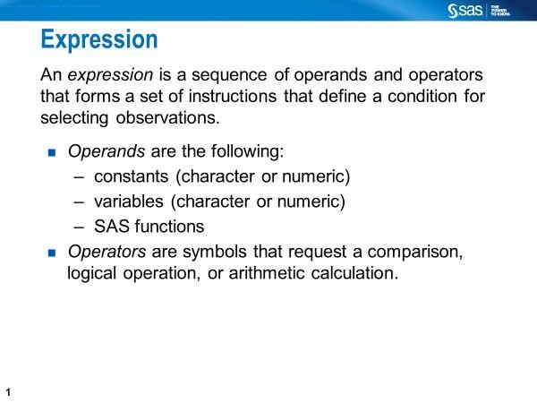
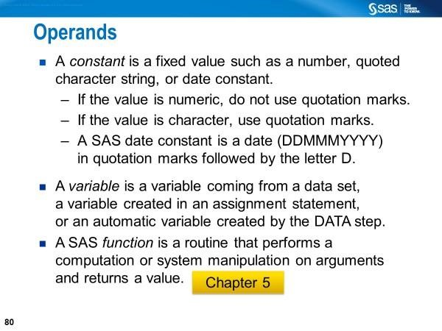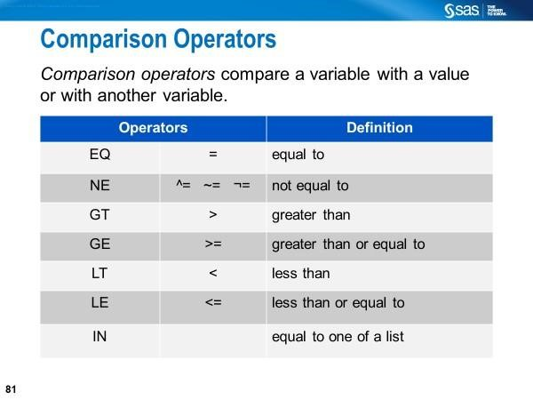
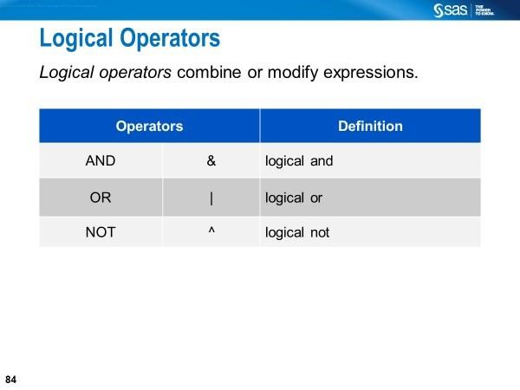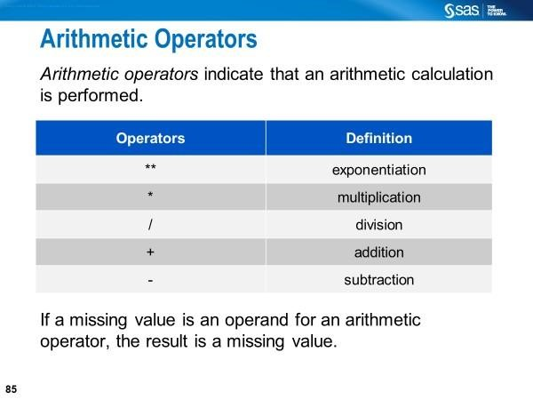
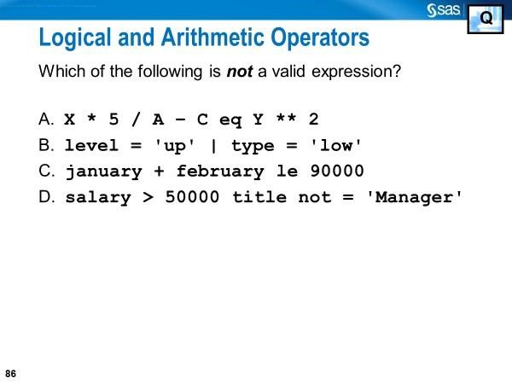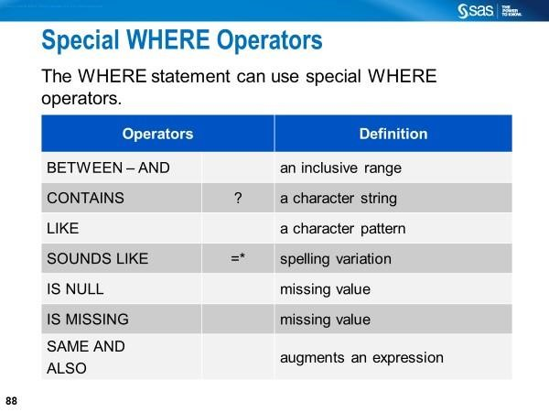
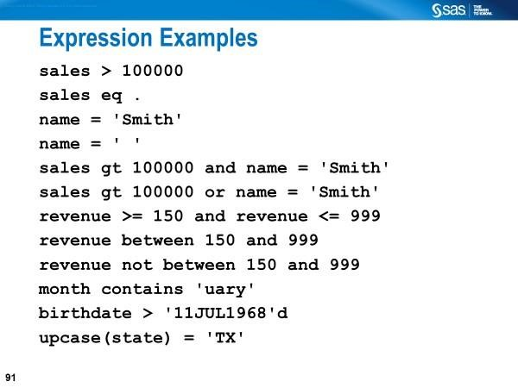
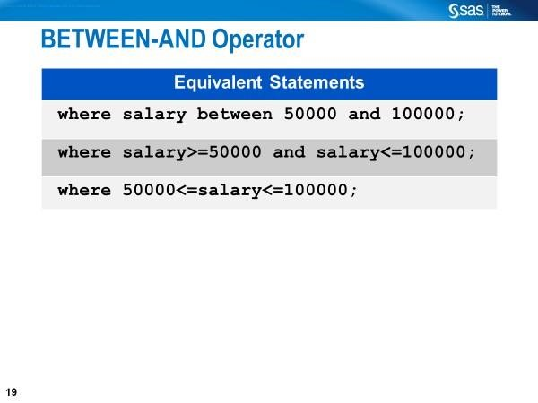
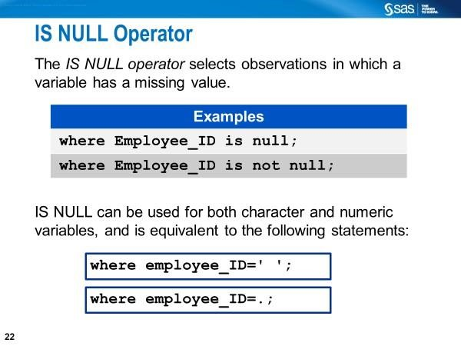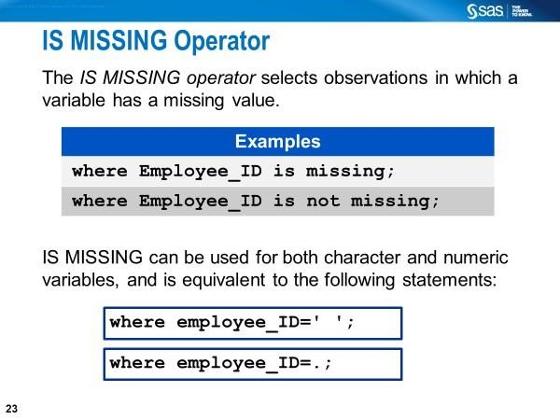
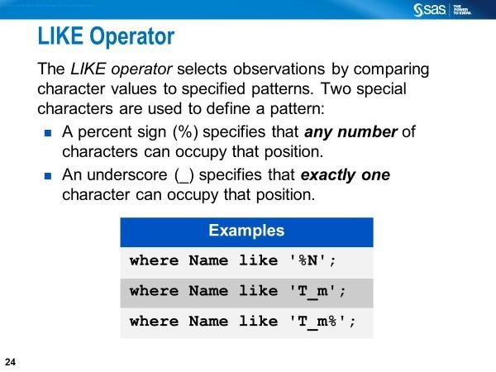
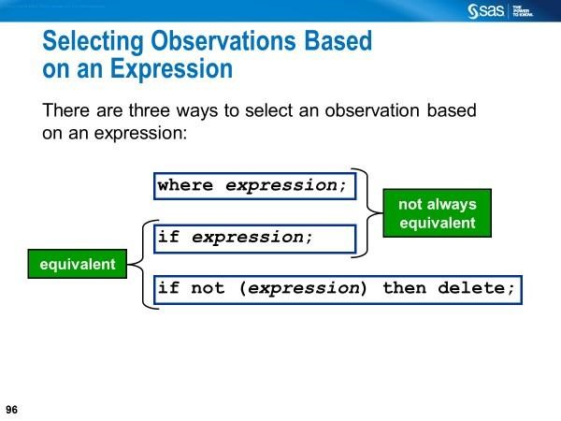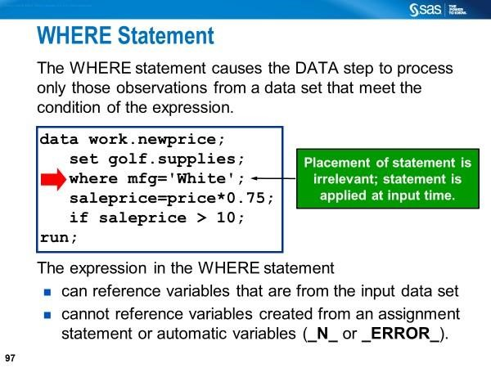
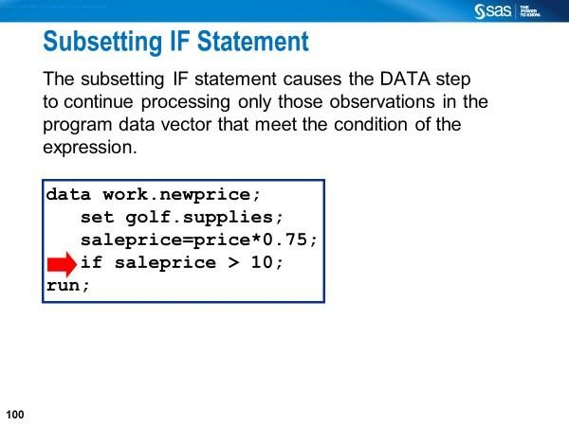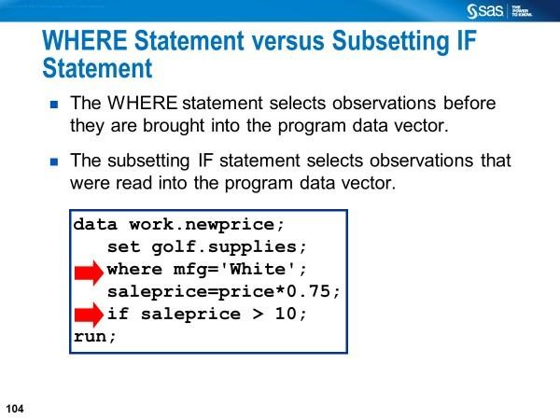
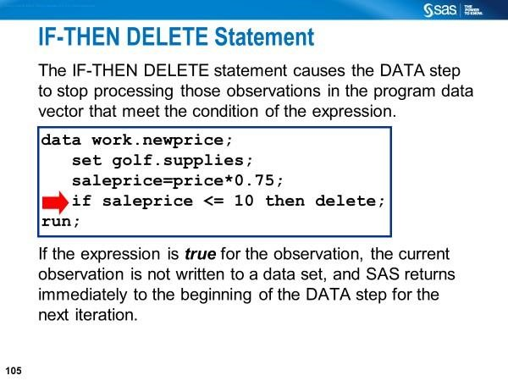
Read the following blog post.
Create training, validation, and test data sets in SAS by Rick Wicklin - The DO Loop (SAS Blogs)
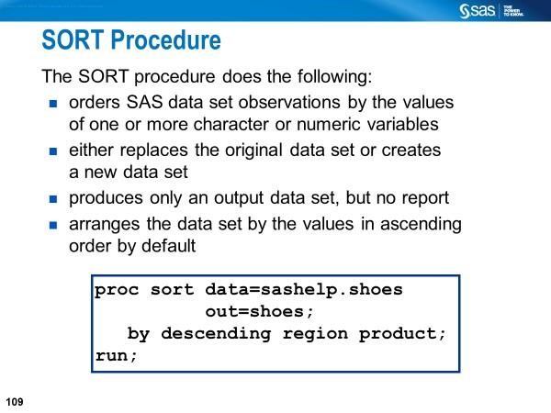
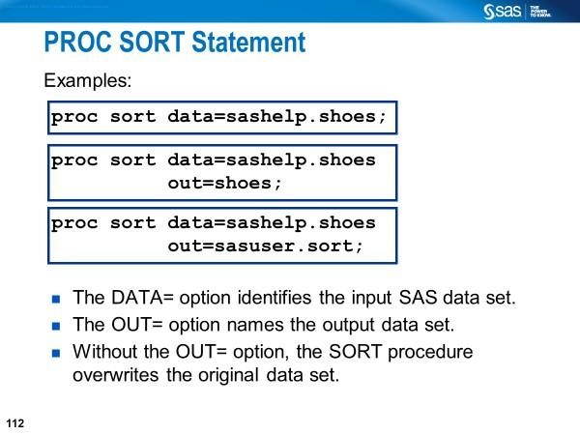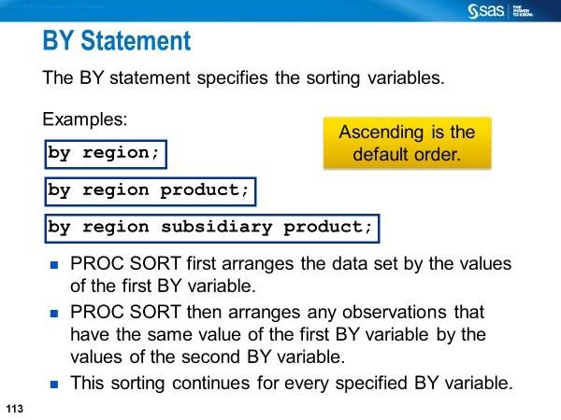
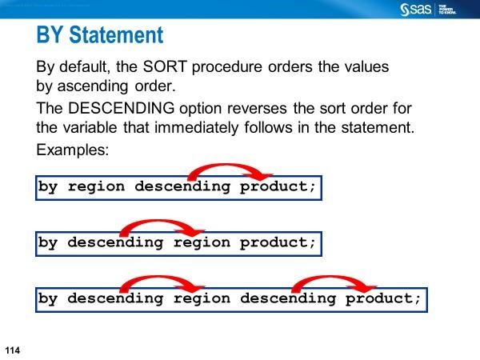
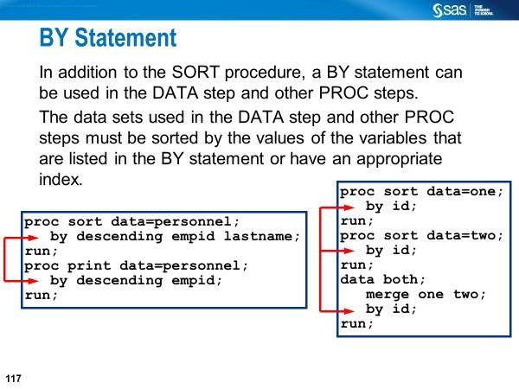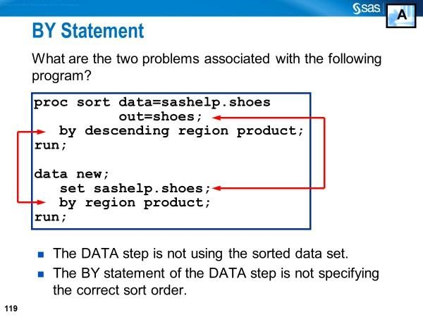

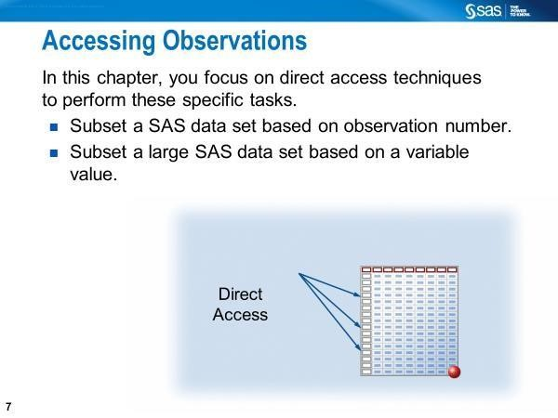

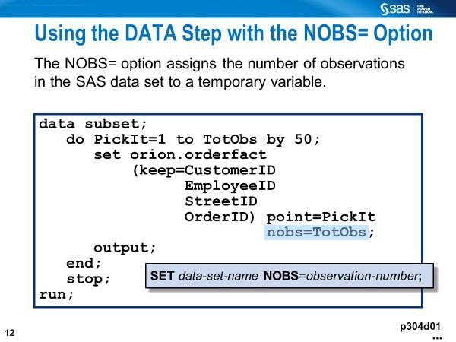
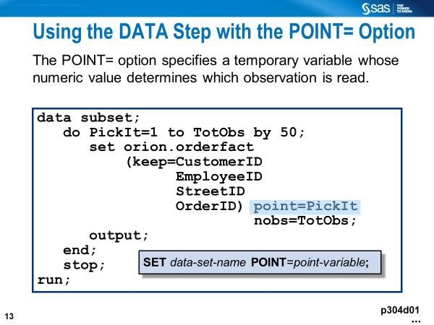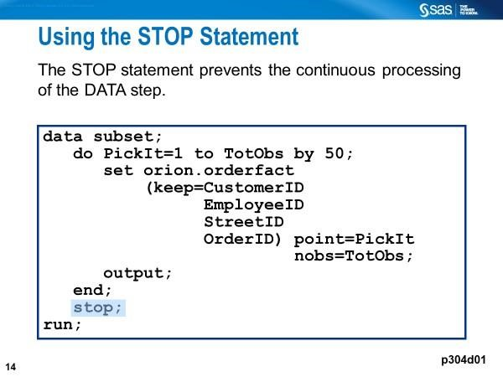
Ex3_Direct_Access.sas
Ex4_sample_select.sas

Transposing Data
Transposing means converting rows (i.e., observations) to columns
(variables) or vice versa. This can be accomplished using at least through
  - Data Step (ARRAY statement and DO Loop)
  - PROC TRANSPOSE

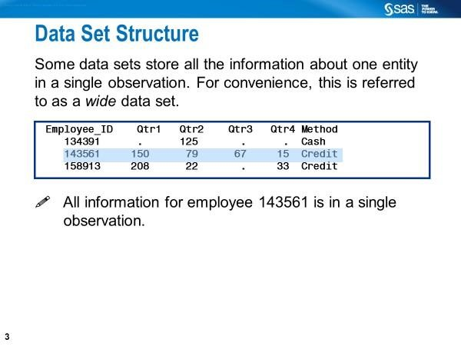
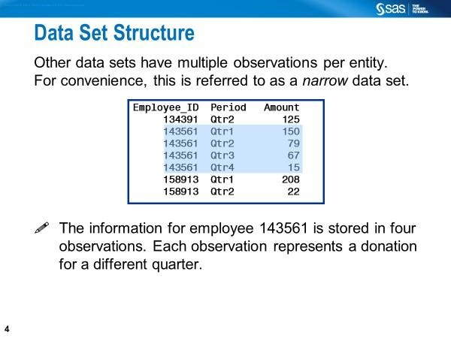
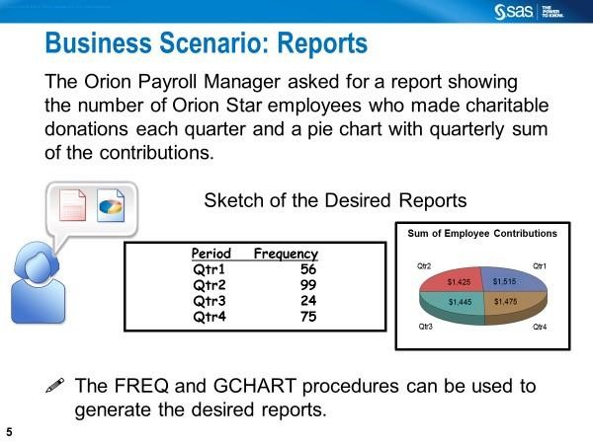
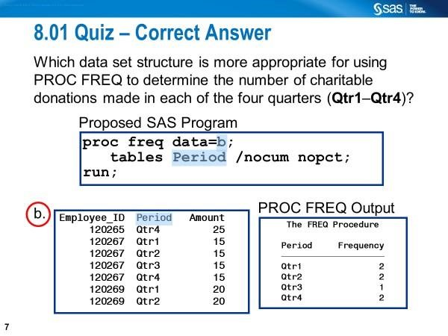

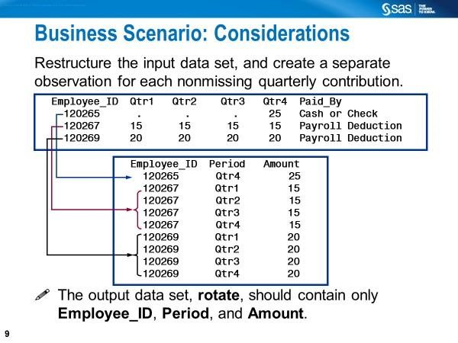

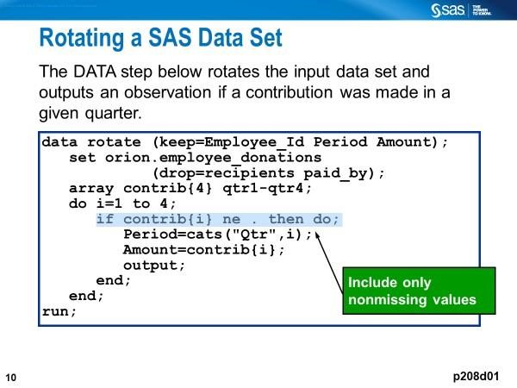
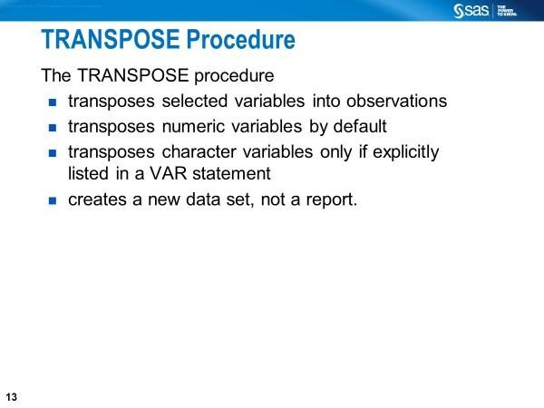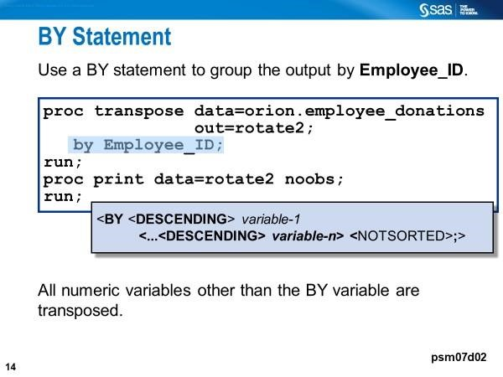
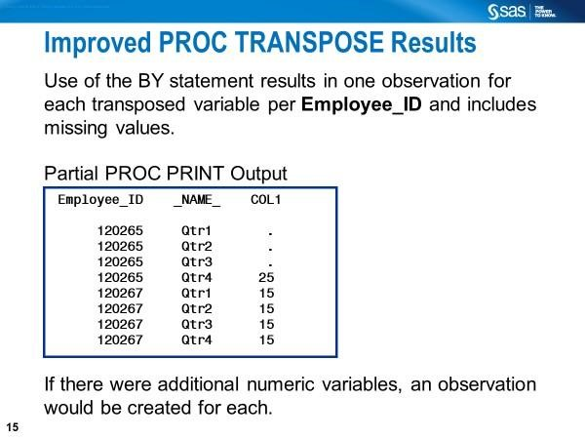
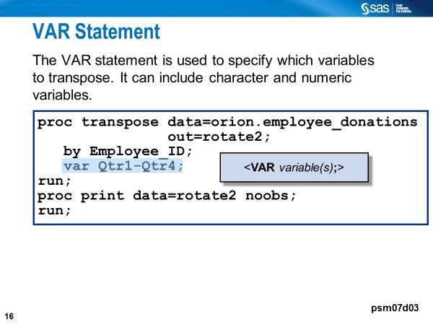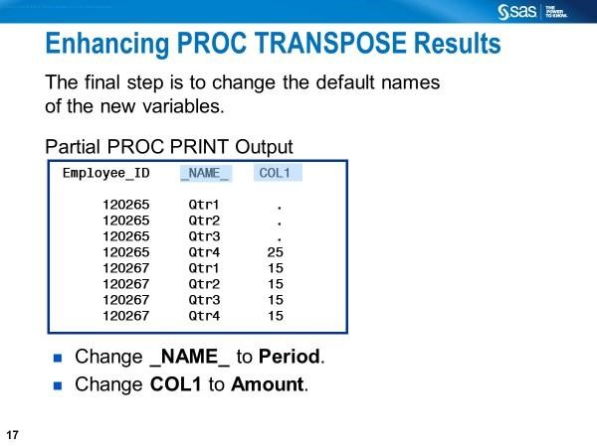
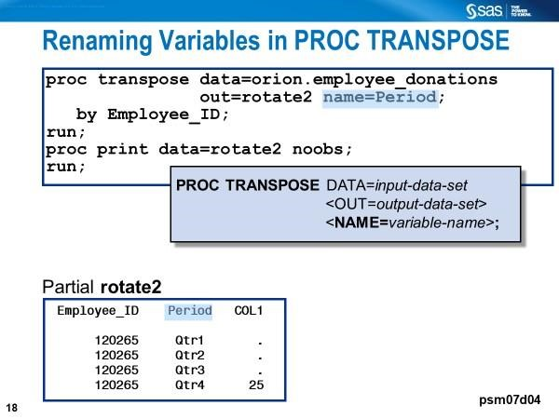

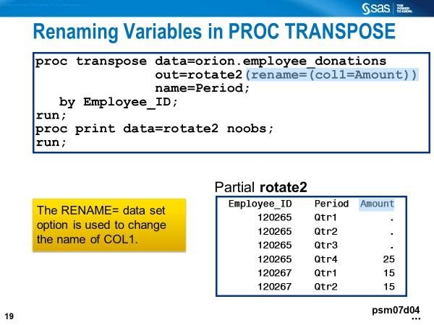
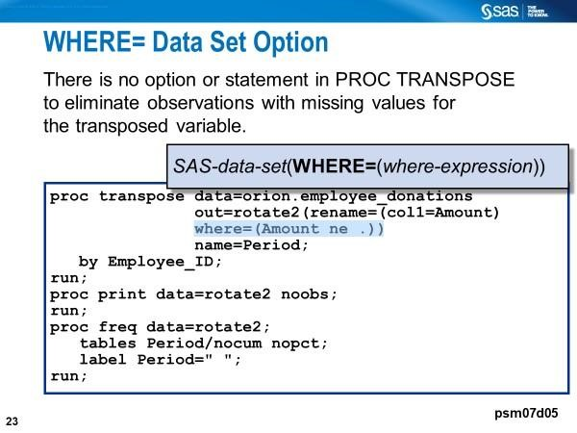

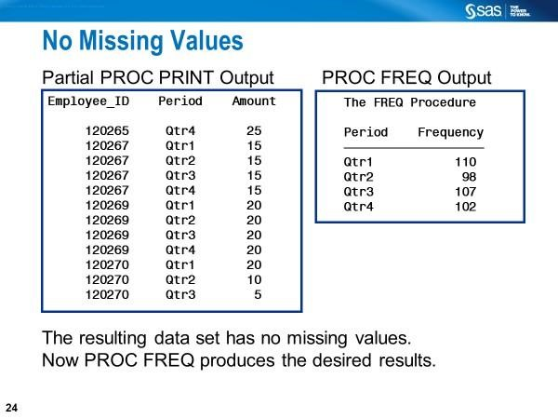

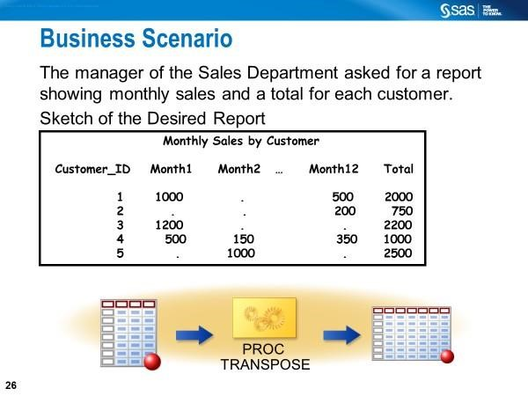
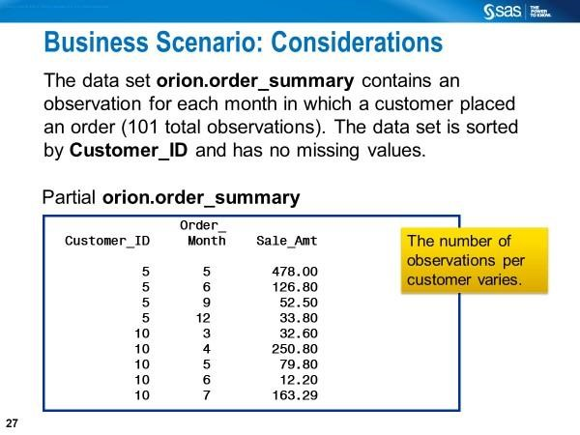
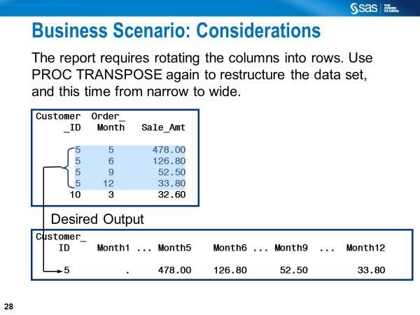
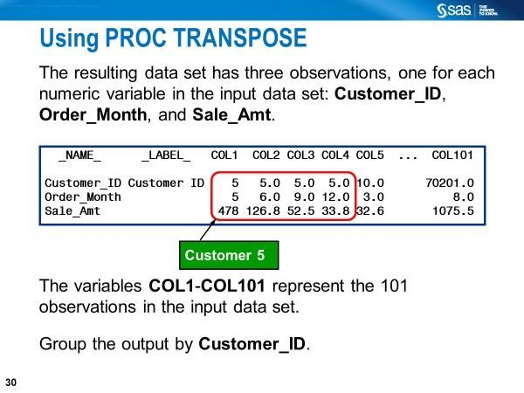
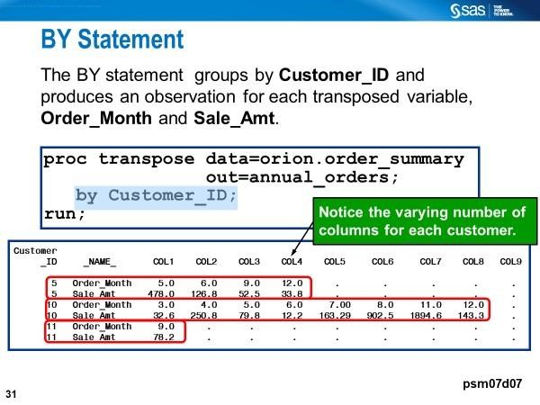

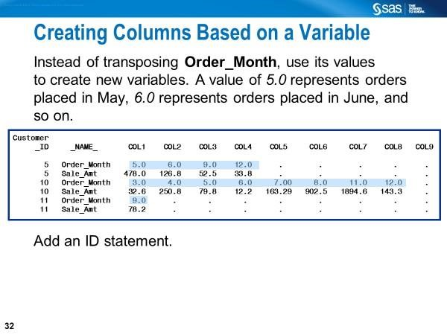
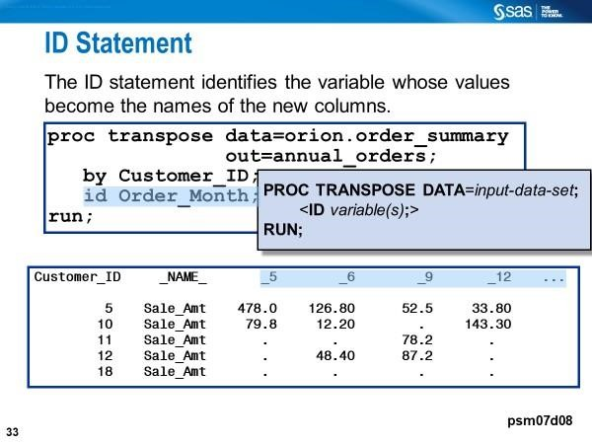
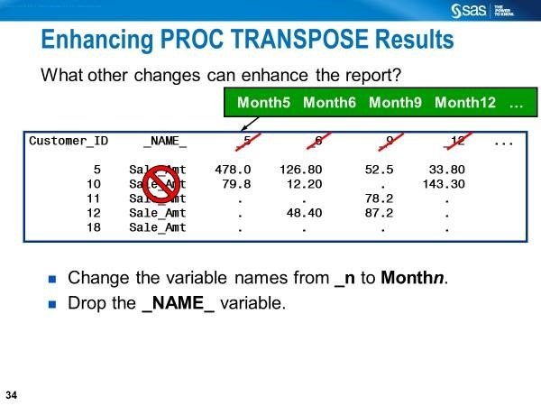
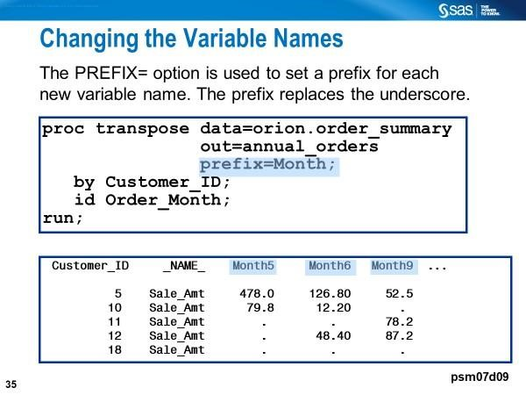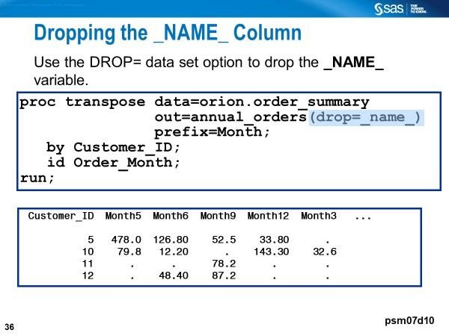

PROC DATASETS
The DATASETS procedure can be used to do the following among many tasks:
- list data sets in the memory in the existing SAS session
- manage SAS data sets (e.g., copying, updating, deleting indexes, catalogs)
- rename variables in a SAS data set
- add/change formats and labels, etc., to a SAS data set
- remove formats from a SAS data set

How to delete SAS data sets

Posted 02-20-2021 04:32 PM | by ChrisHemedinger (28916 views)
proc delete data=work.data1; run;
proc delete data=work.a1 work.a2 ; run; proc delete library=work data=DATA1-DATA5; run;

proc datasets nolist lib=work; delete a1 a2 a3 ; quit; proc datasets nolist lib=work; delete a: ; /* all data sets that begin with "A" */ delete a1-a3; /* or data sets in this range */ quit;
/* delete all data files from WORK */ proc datasets nolist lib=work kill; quit;

Because the WORK library often contains data related to work-in-progress, sometimes I will create a library in a temp location specifically for transient data, which I can then "kill" when that part of the program completes.
/* create a subfolder in WORK for my data */ options dlcreatedir;
libname scratch "%sysfunc(getoption(WORK))/scratch";

/* just adding some data for example purpose */ data scratch.a1 scratch.a2 scratch.a3; set sashelp.class; run;

/* more operations with scratch data */

/* now clear it when ready */ proc datasets lib=scratch kill nolist; quit;

Delete within PROC SQL using DROP TABLE
proc sql; drop
table work.a1; drop table work.a2; drop table work.a3; quit;

Use the %DELTABLE autocall macro
%deltable (tables=scratch.a1 scratch.a2 scratch.a3)

SAS Transport Files
According to the SAS Institute, SAS transport files are the "best overall format" for interfacing with other systems because they are consistent across all host environments. SAS transport files can be converted into a variety of system files (e.g., SAS, Stata, and R). https://meps.ahrq.gov/data_stats/download_data_files.jsp
Many SAS transport files (public-use files) are available for download from the MEPS (The Medical Expenditure Panel Survey) website.
“The Medical Expenditure Panel Survey, which began in 1996, is a set of large-scale surveys of families and individuals, their medical providers (doctors, hospitals, pharmacies, etc.), and employers across the United States. MEPS collects data on the specific health services that Americans use, how frequently they use them, the cost of these services, and how they are paid for, as well as data on the cost, scope, and breadth of health insurance held by and available to U.S. workers.”
Ex11_download_unzip_create.sas
- can be used to download/unzip a single SAS transport file from the above website and convert it into a SAS data set
-
Ex12_download_unzip_create_macro.sas can be used to:

- download multiple SAS transport files from the MEPS website - unzip those files
- convert the SAS transport files into SAS data sets

