The George Washington University
Department of Statistics

STAT 4197/6197

Week 6: Aggregating Data and Combining SAS Data Sets
Topics:
- PROC SQL Basics
- Aggregating/Summarizing data - DATA step vs. PROC SQL
- Combining SAS data sets - DATA step vs. PROC SQL
- Obtaining information from DICTIONARY tables Using PROC SQL
- Getting information from SASHELP Views – DATA step vs. PROC
SQL

Readings:

- Delwiche, Lora D., and Susan J. Slaughter. 2019. The Little SAS® Book: A Primer, Sixth Edition. Cary, NC: SAS Institute Inc.

- Ottesen RA, Delwiche LD, and Slaughter SJ. 2020. Exercises and Projects for The Little SAS Book, Sixth Edition. Cary, NC: SAS Institute Inc.

- SET Statement and By-Group Processing SET Statement

- Telanus, E.W. (2008). SET, MERGE and beyond. SAS Global Forum.

- Jepson, Brett. (2019). Sometimes SQL Really Is Better: A Beginner's Guide to SQL Coding for DATA Step Users. SAS Global Forum, 2019.

- Lund, Pete. An Introduction to SQL in SAS®. SUGI 30.

- Williams, Christianna. (2015). PROC SQL for PROC SUMMARY Stalwarts. SESUG.

- Varney, Brian. (2019). Data Step versus Everybody: Approaching Problems as a Beginning Coder. SESUG.

- DiIorio, F and J. Abolafia. Dictionary Tables and Views: Essential Tools for Serious Applications. SUGI 29.

- DiIorio. Frank C. (2019). Discovering the Power of SAS® Metadata: An Introduction to Dictionary Tables and Views. SESUG.

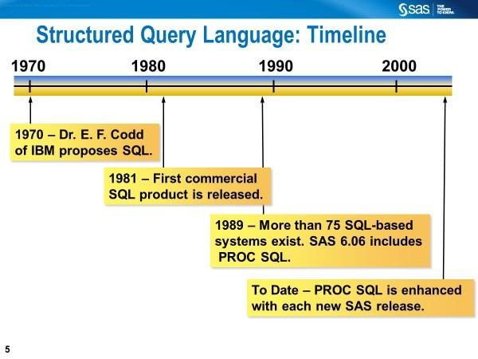

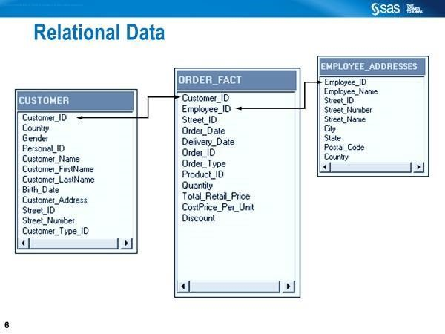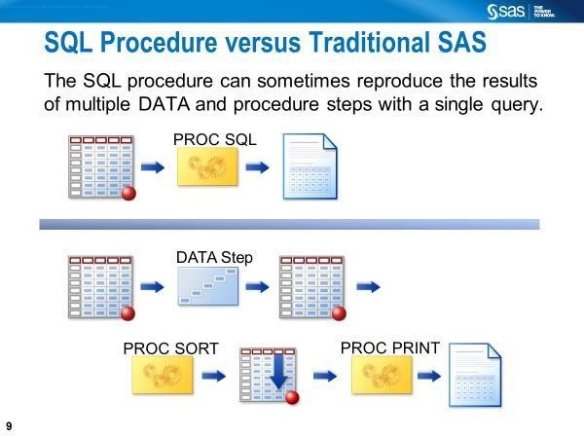

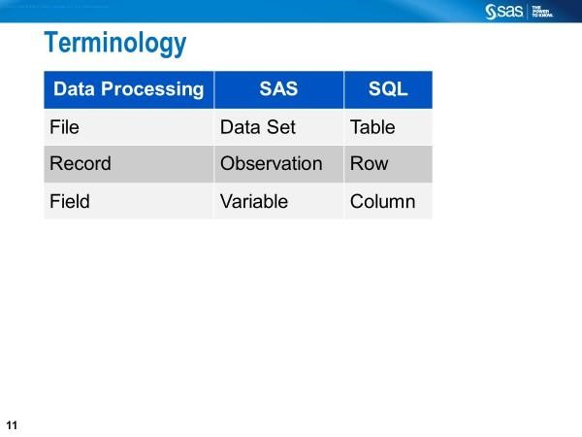
Uses for SQL: Read data from tables; add/modify/drop columns in tables, sort/filter rows, create tables/views, join tables/views, and create reports.

The Order of Clauses of the SELECT Statement within PROC SQL
- SELECT (So)
- FROM (Few)
- WHERE (Workers)
- GROUP BY (Go)
- HAVING (Home)
- Order BY (On-time)

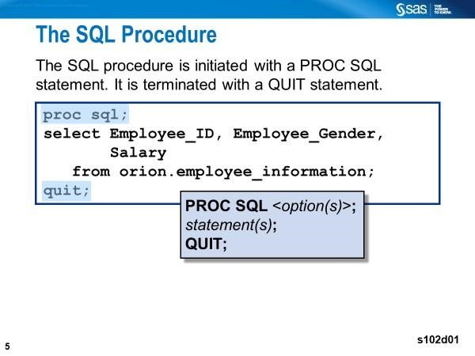
  - The SELECT statement has multiple clauses (e.g., SELECT, FROM,
WHERE); PROC SQL, SELECT, QUIT statements are required
  - The SELECT statement retrieves and displays data
  - The SELECT clause specifies the columns and column order.
  - The FROM clause specifies the data sources.
  - You can query from 1 to 256 tables.
  - Multiple statements can be included in a PROC SQL step.
  - Each statement defines a process and is executed immediately.

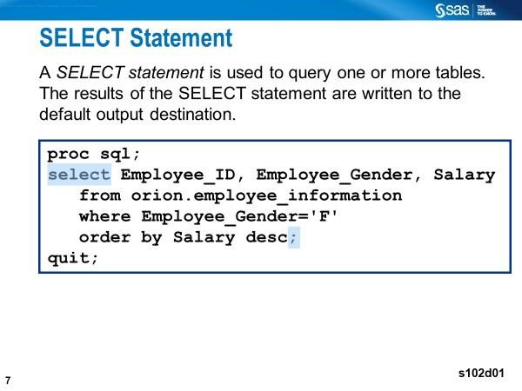

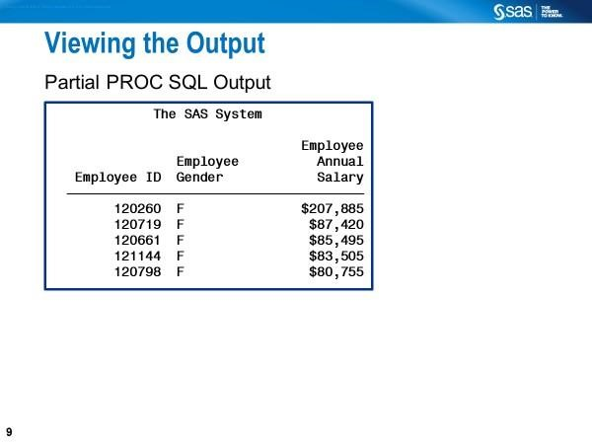

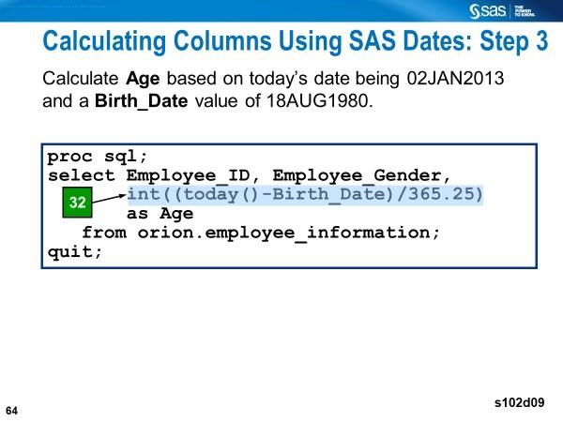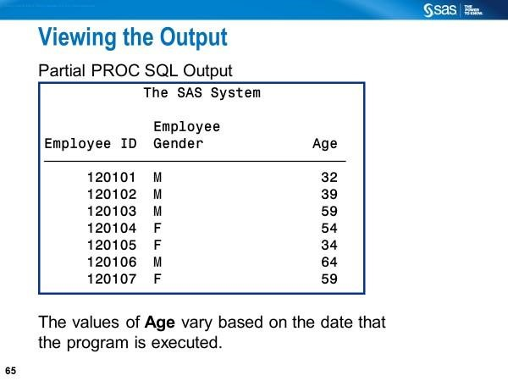
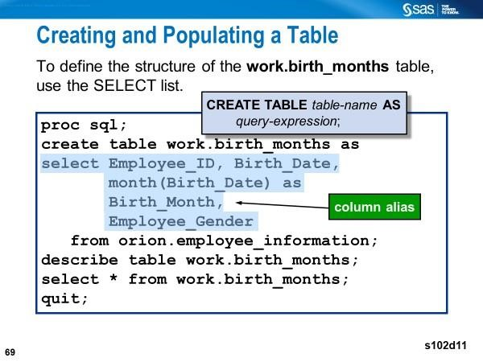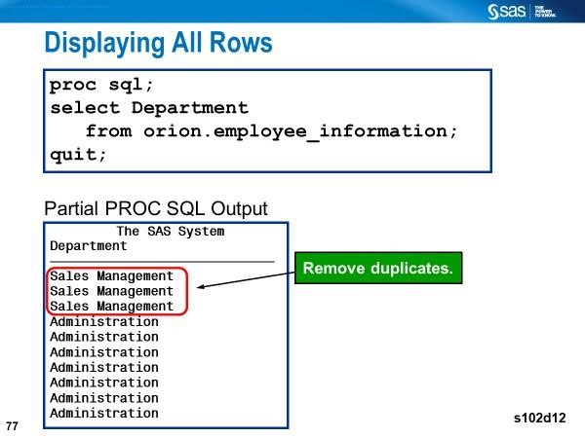
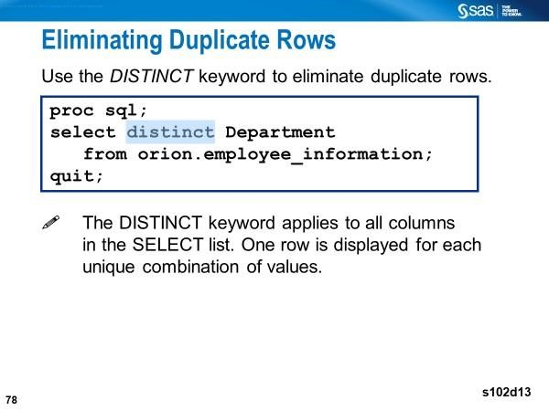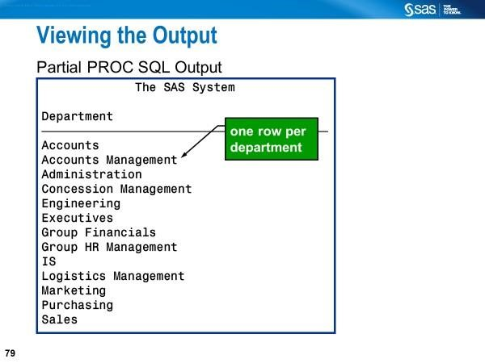

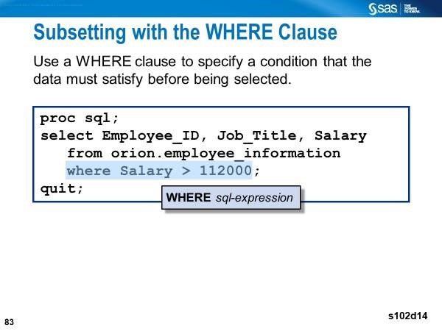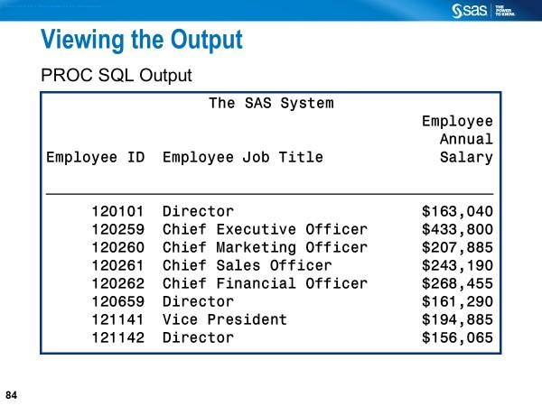
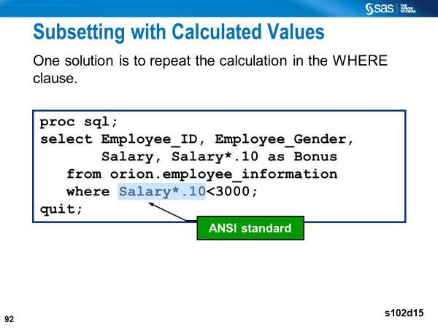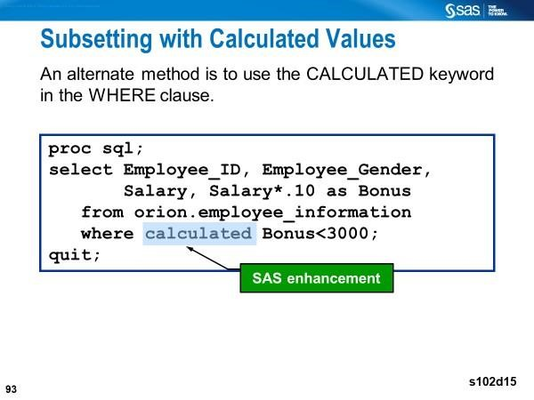
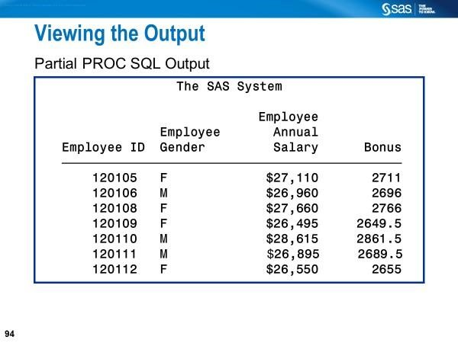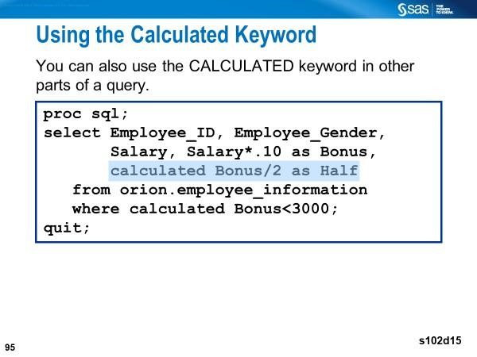
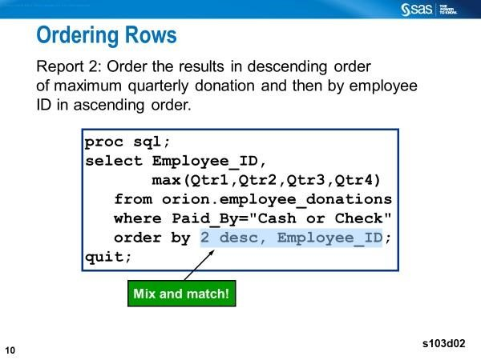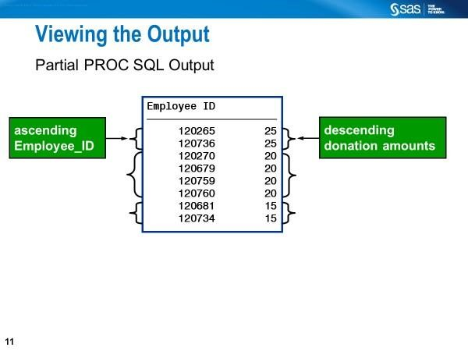
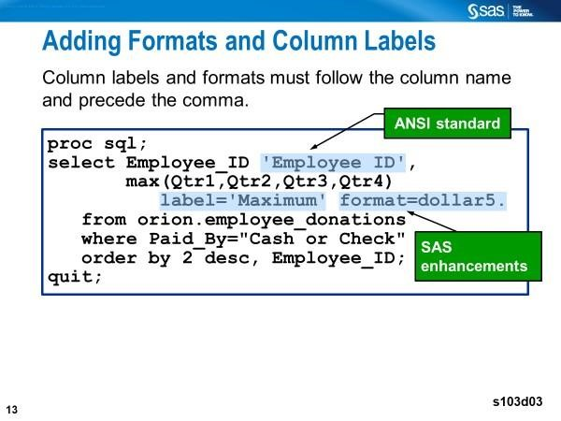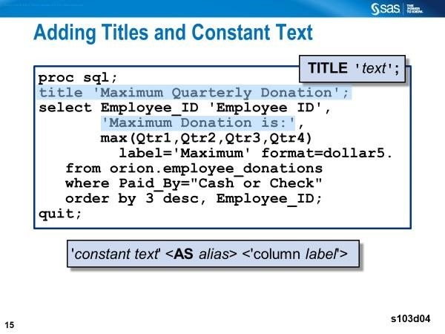
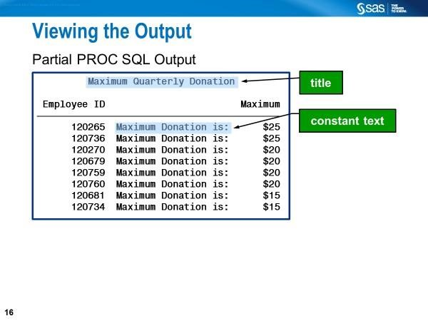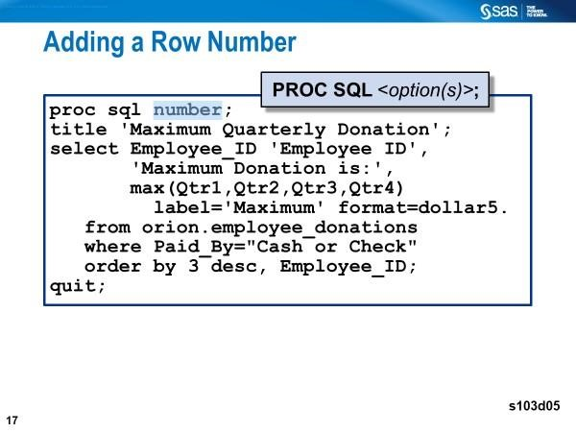
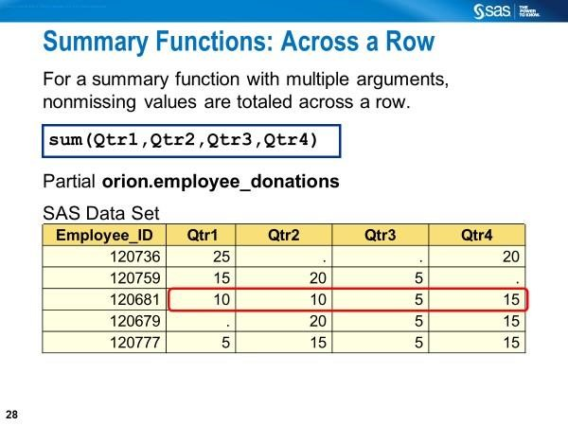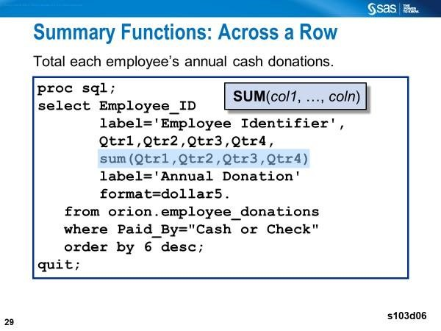
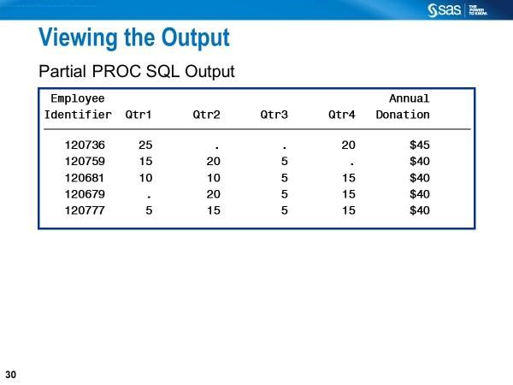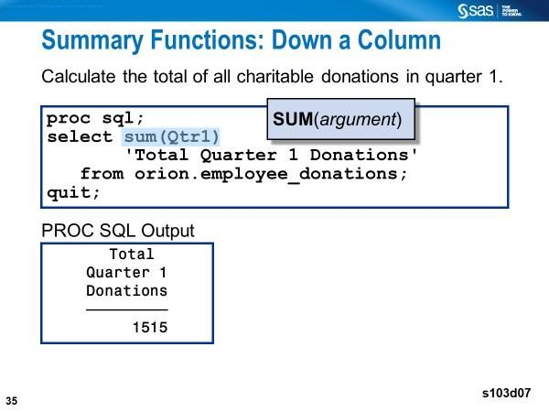
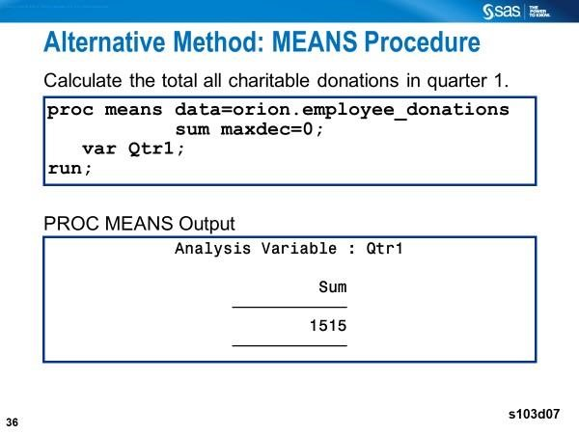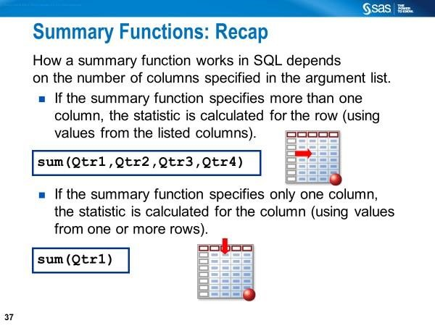
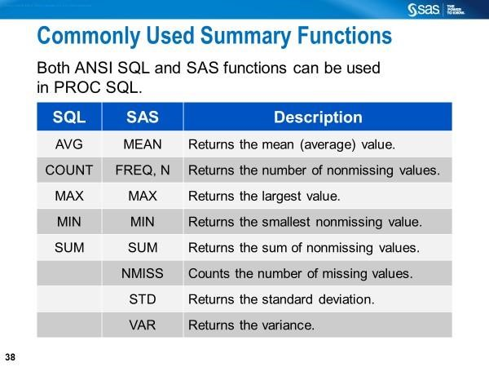
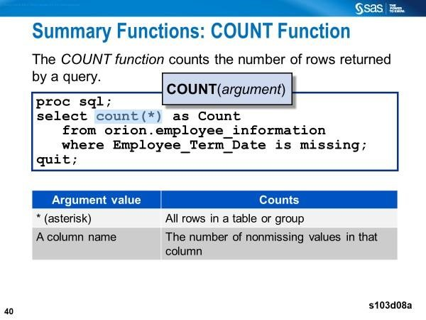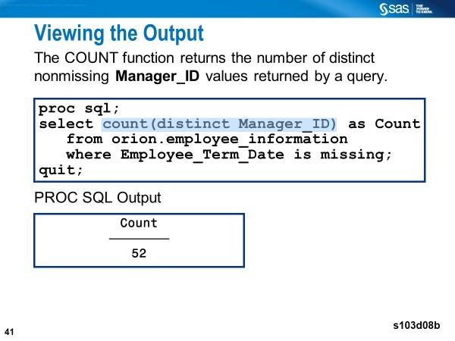

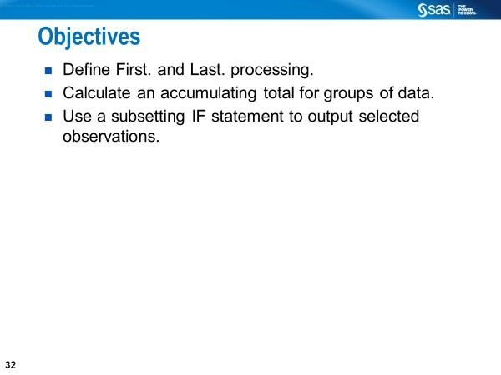

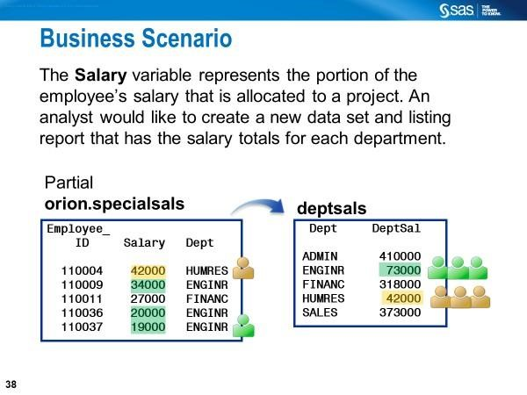

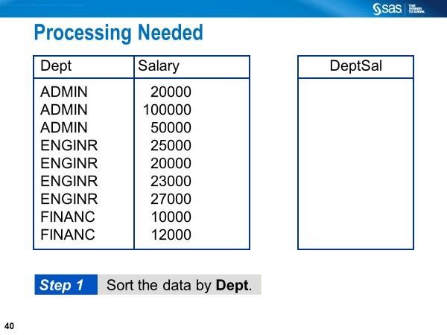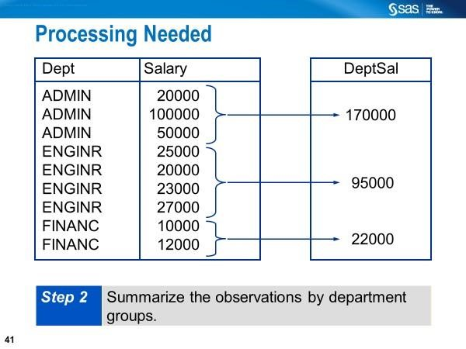
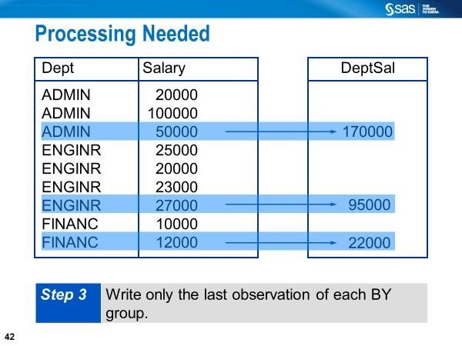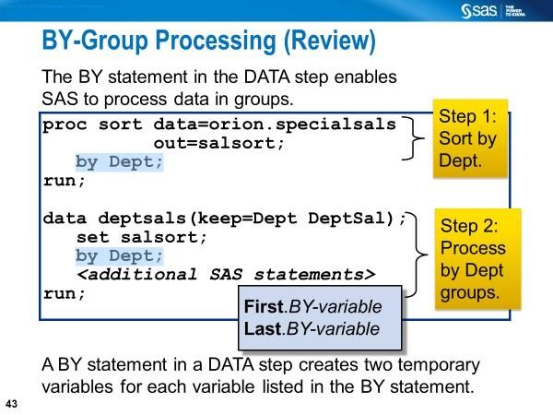
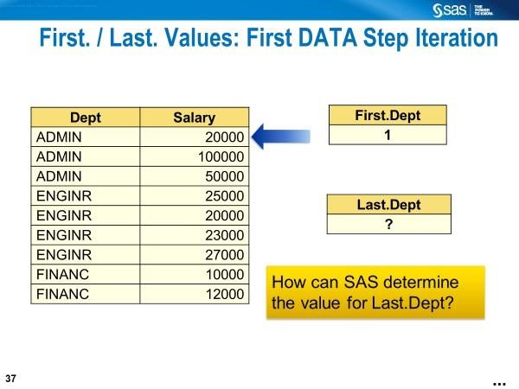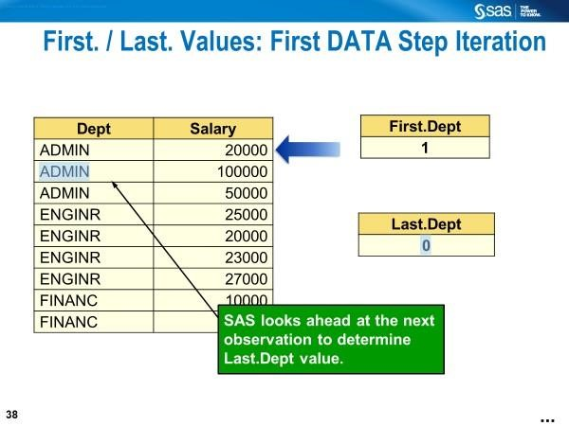

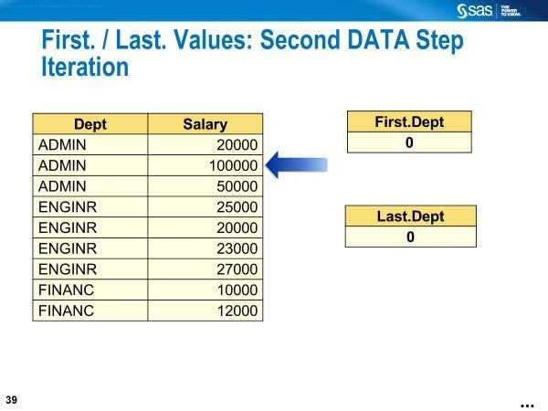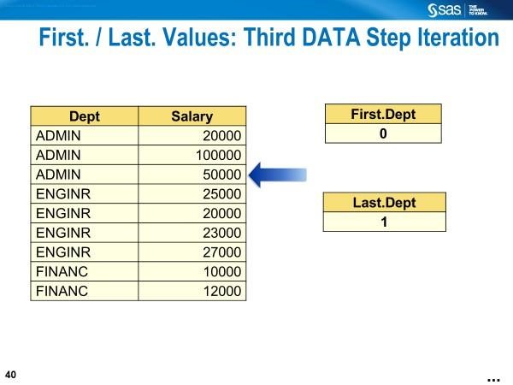
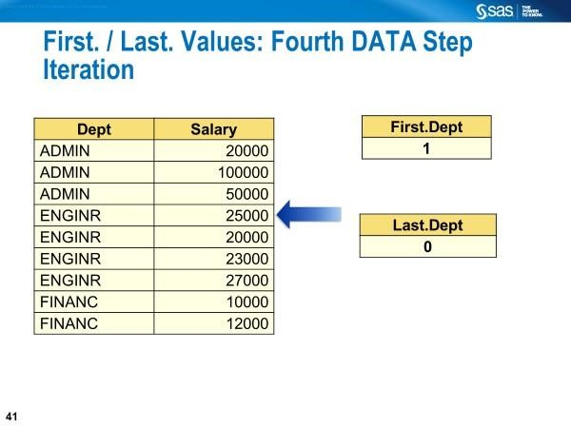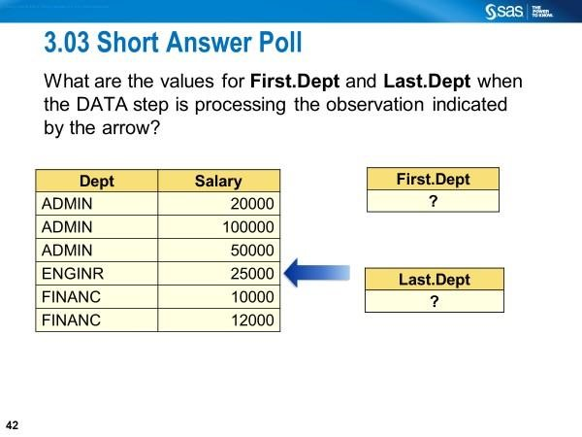
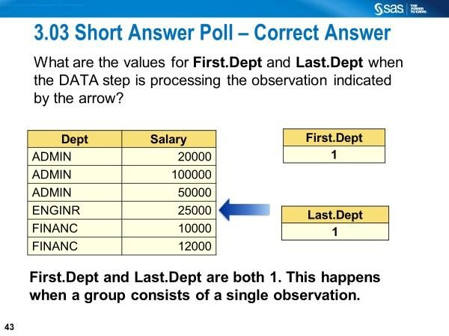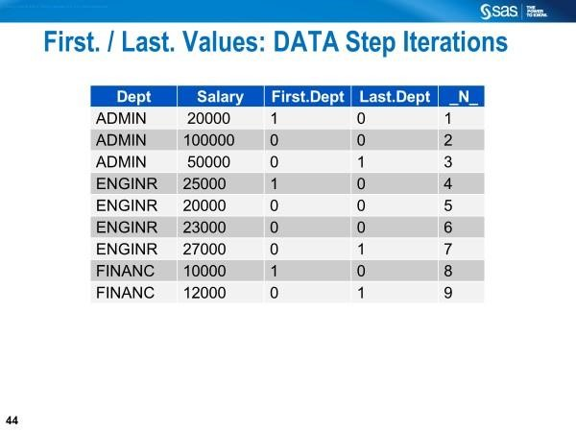
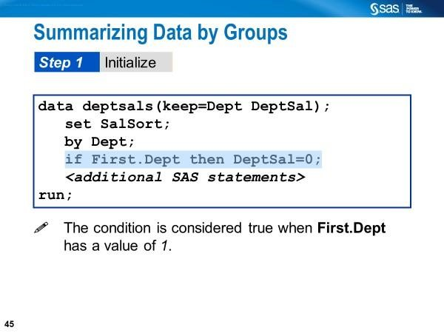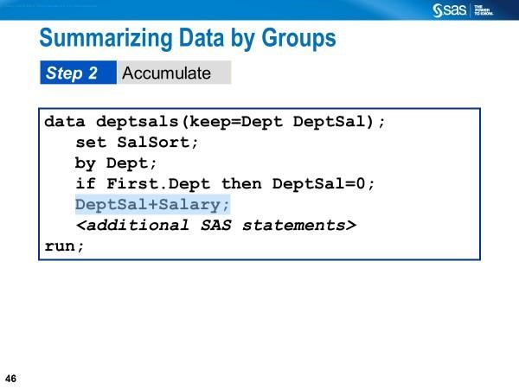
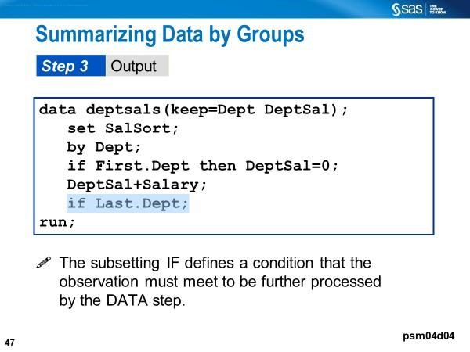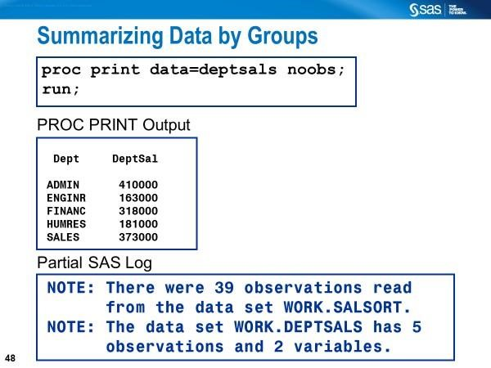
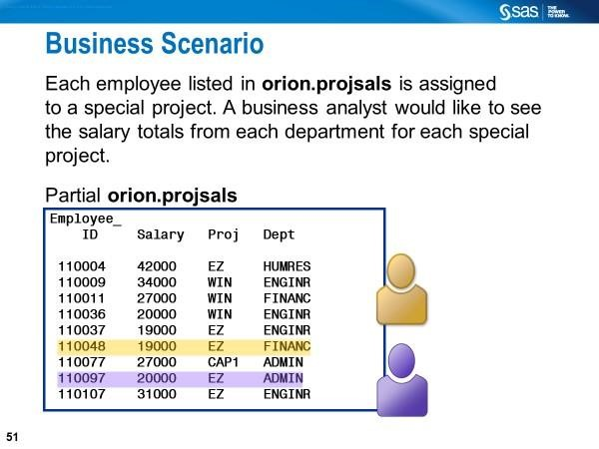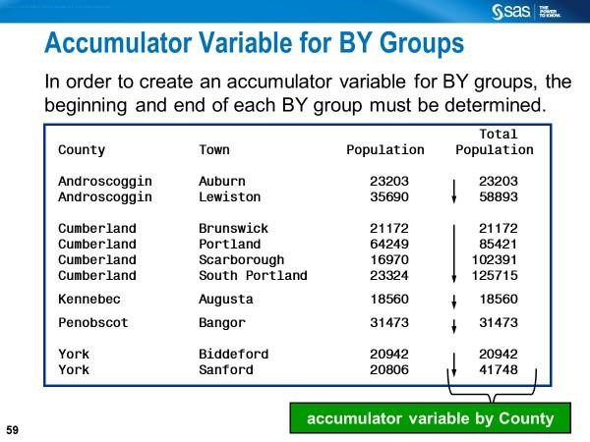

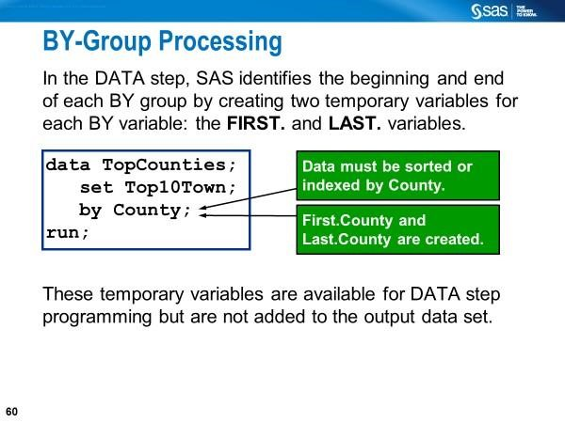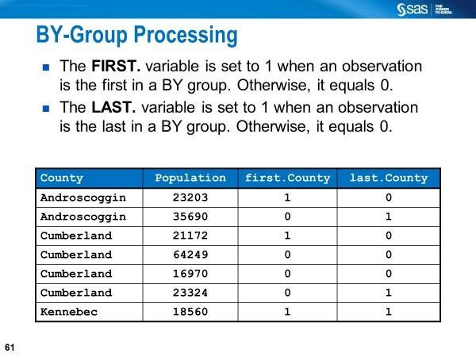
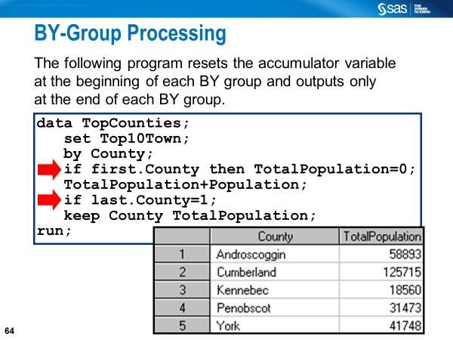

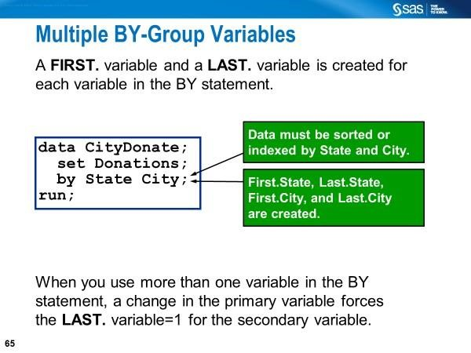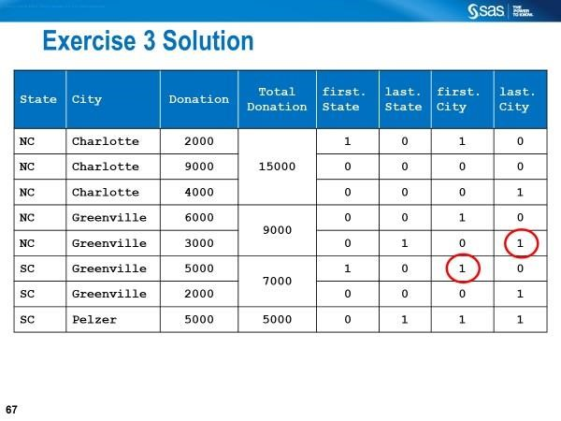
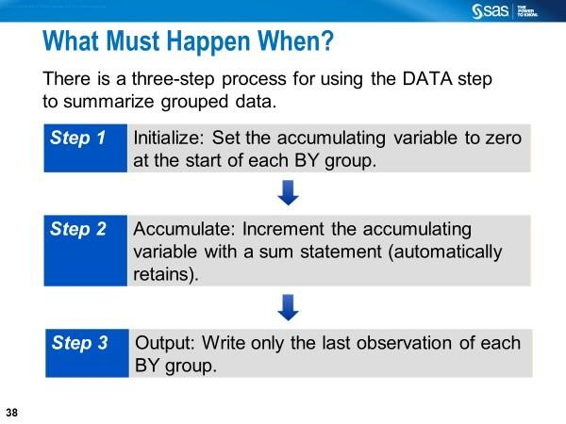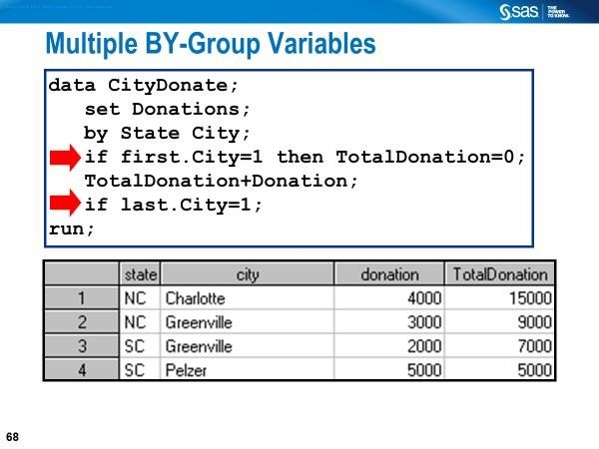

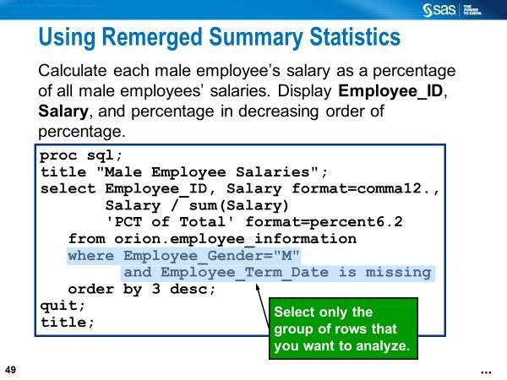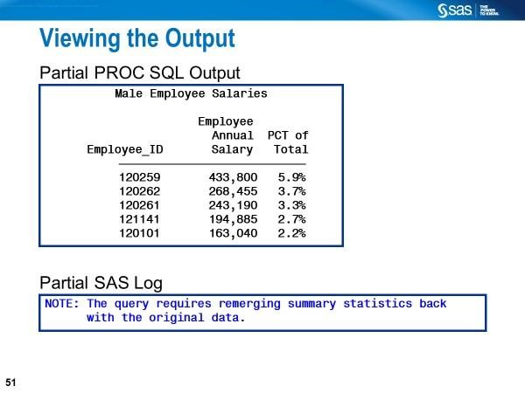
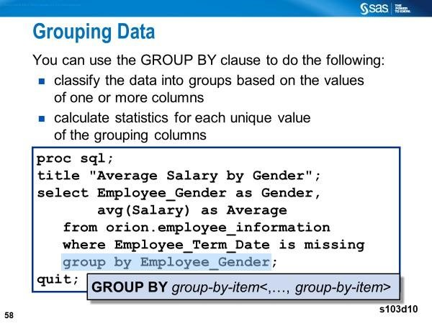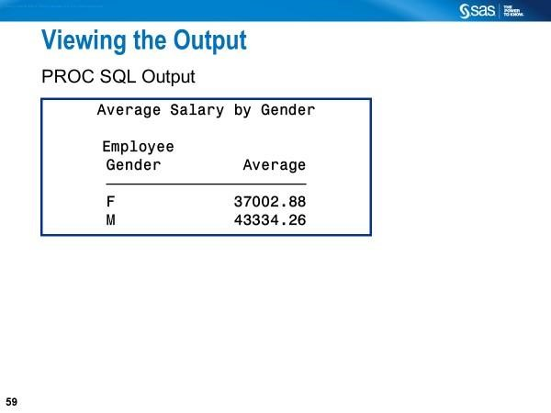
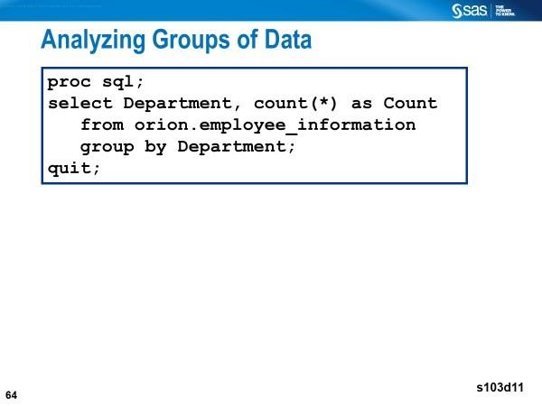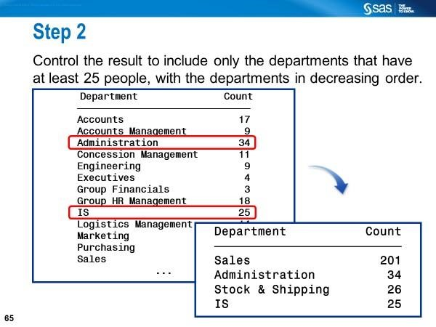
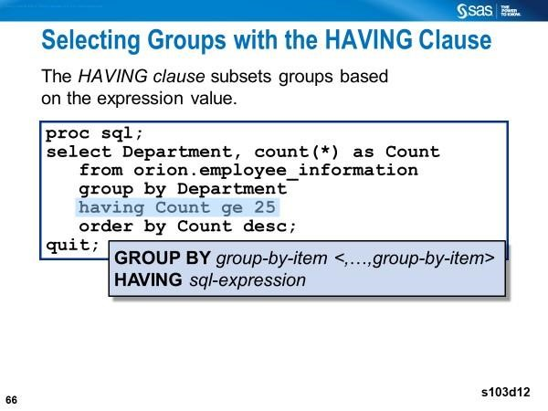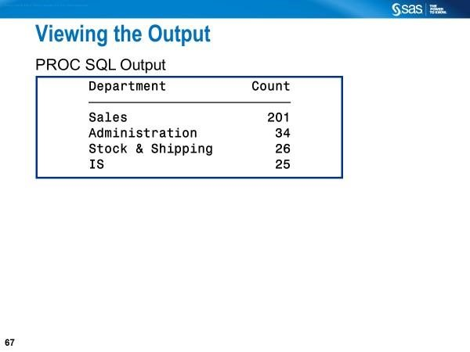
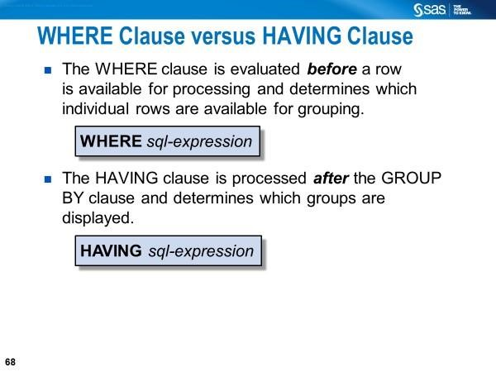
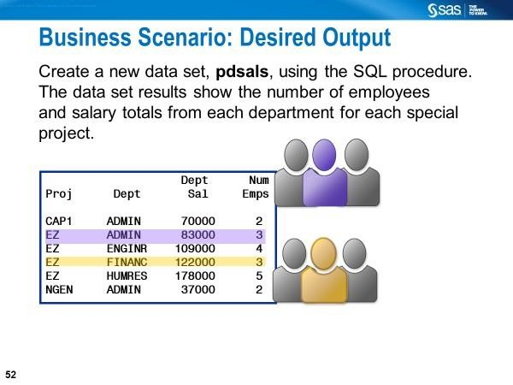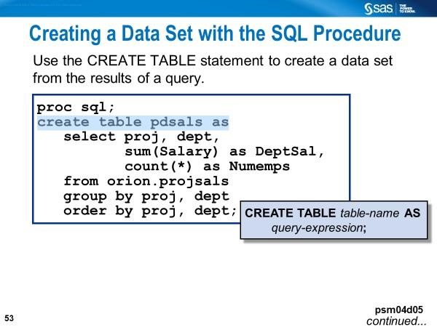
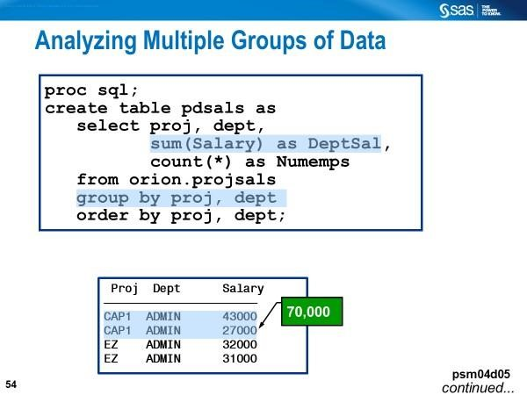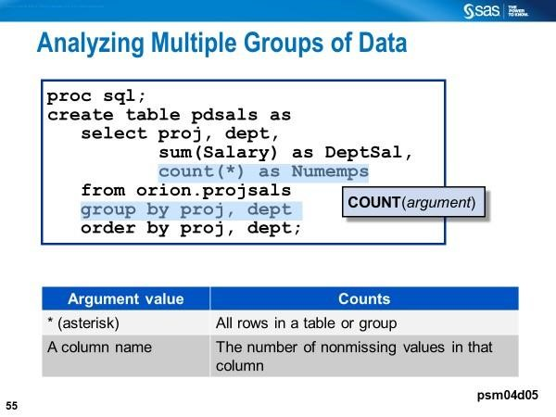
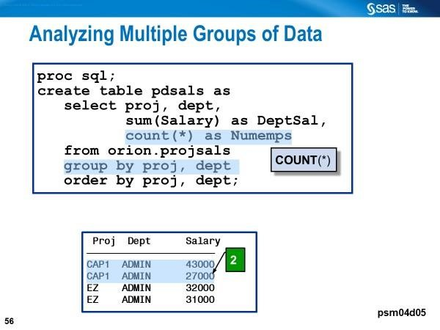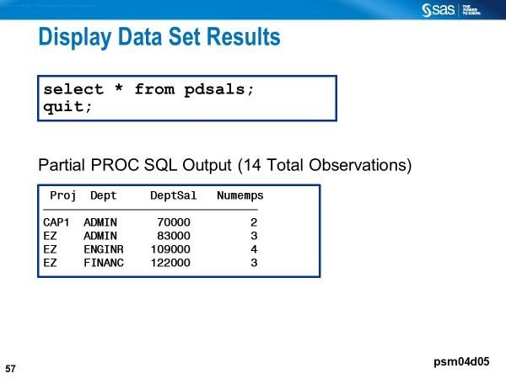

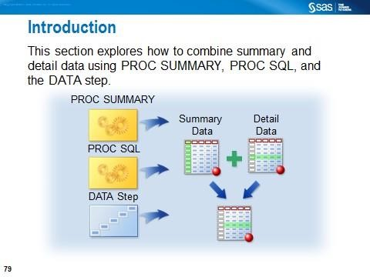

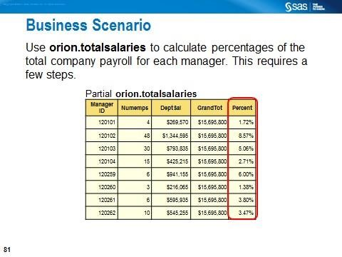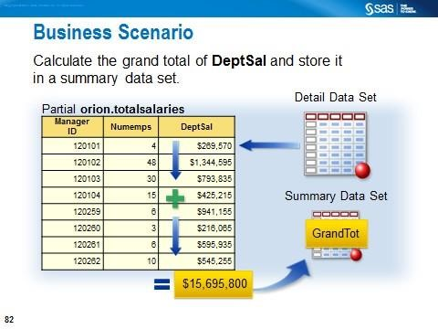
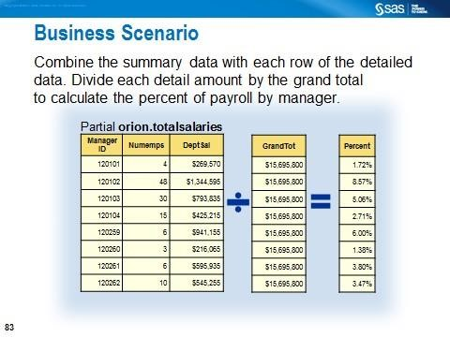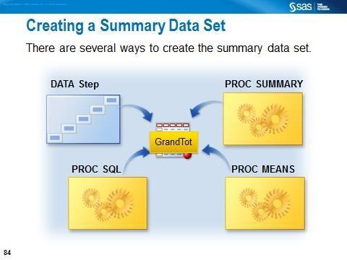
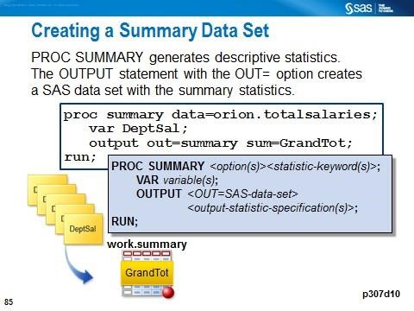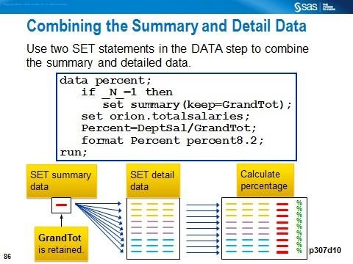

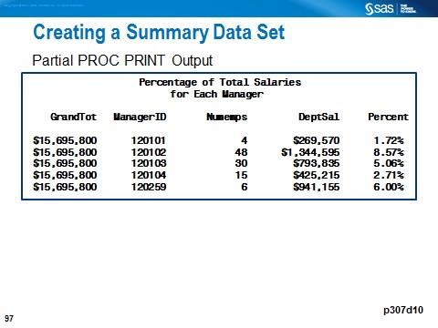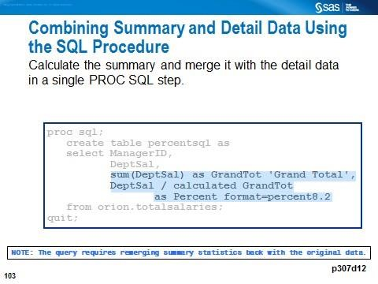
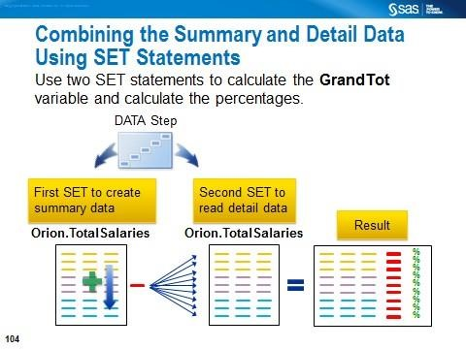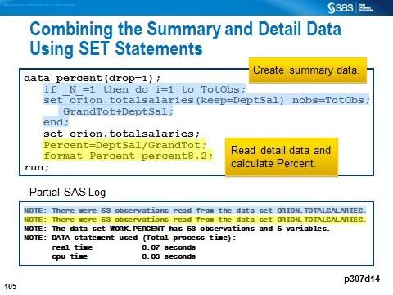

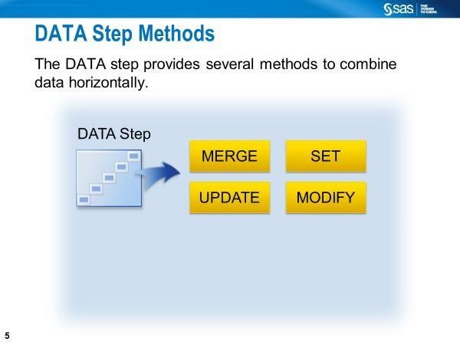
You can read observations sequentially using the SET, MERGE, UPDATE, or MODIFY statements.

Combining Data Using the SET Statement (Concatenation)
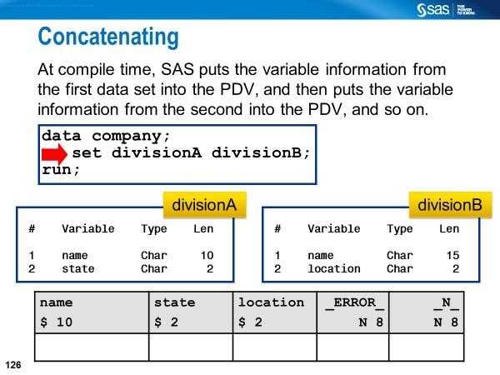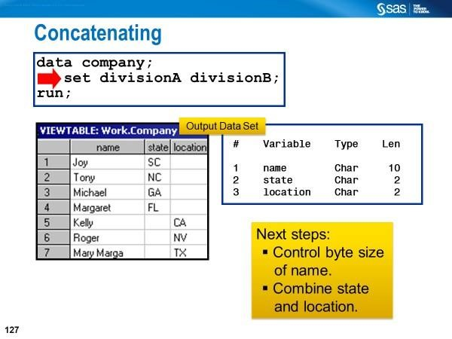
The length of the variables in the first input data set will determine the length of the variables in the output data set.
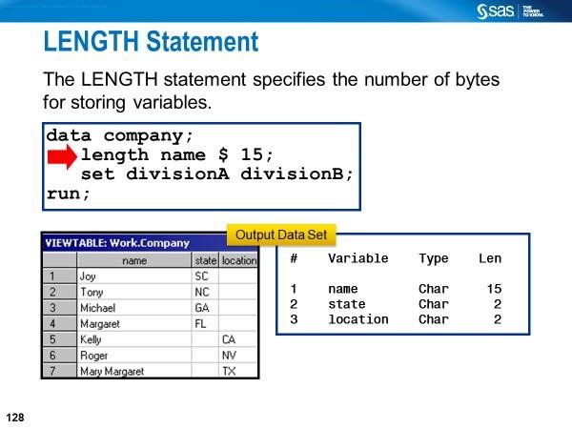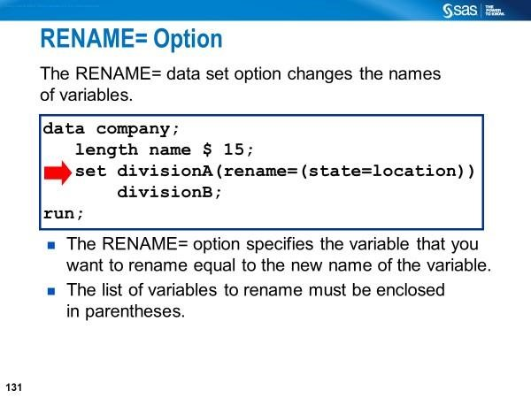
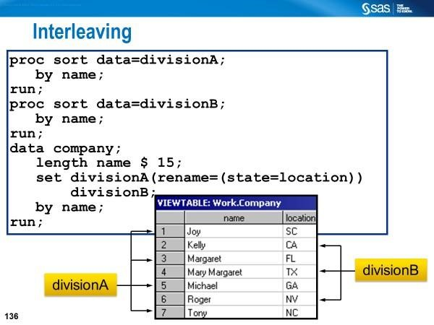
The observations in the new data set are arranged by the values of the BY variable or variables. Then, within each BY group, they are arranged by the order of the data sets in which they occur. In another words, when two or more data sets are concatenated using a SET statement followed by a BY statement, as shown below, files are interleaved.

Combining Data Using the MERGE Statement
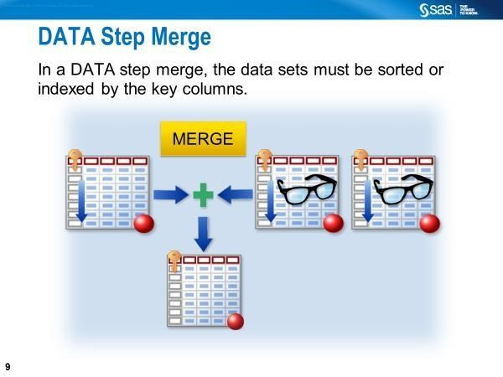

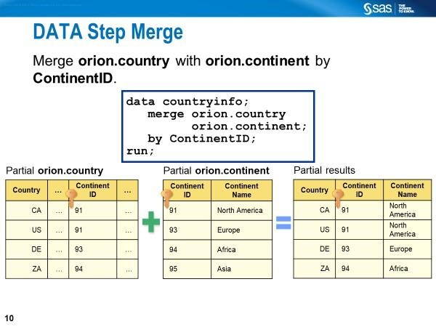
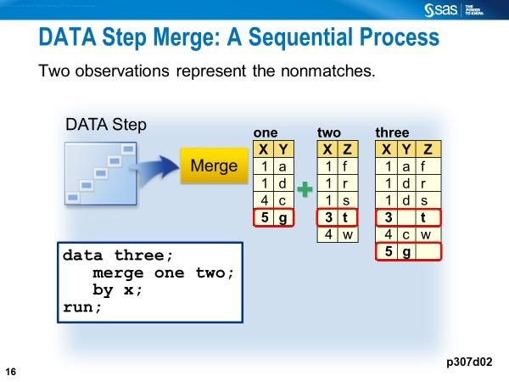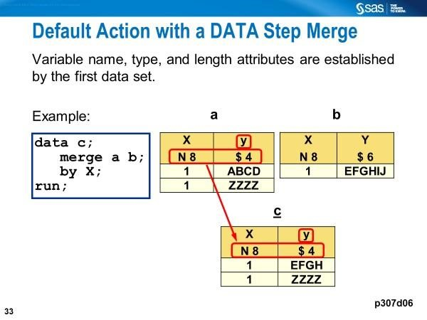
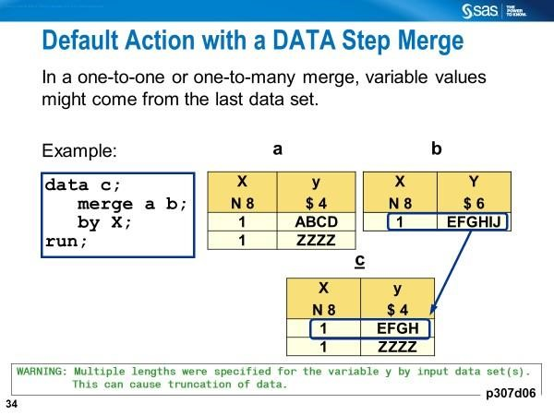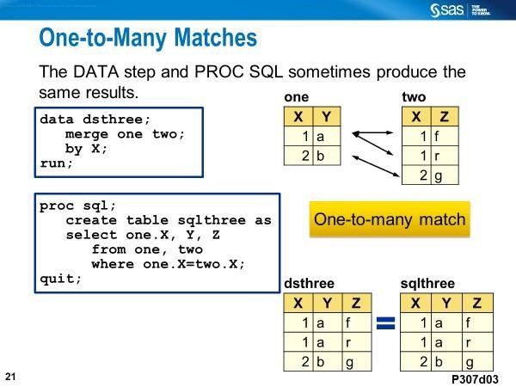
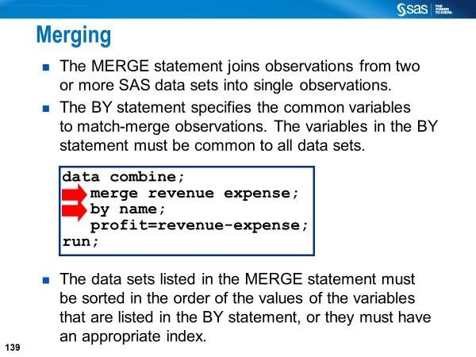

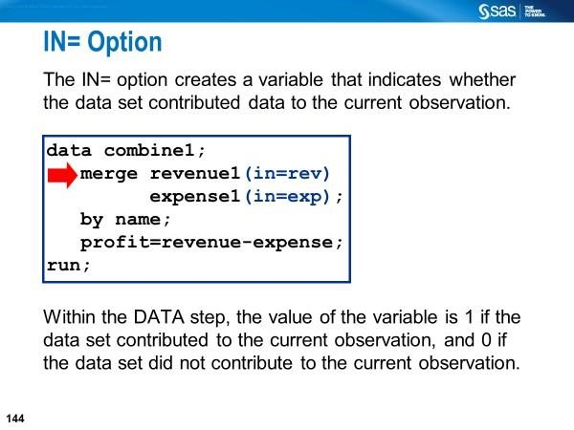

When you combine two data sets, you can use IN= data set options to track which of the original data sets contributes to each observation in the new data set.

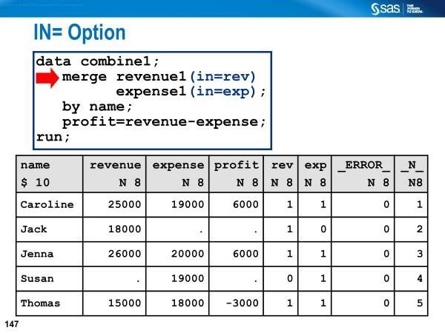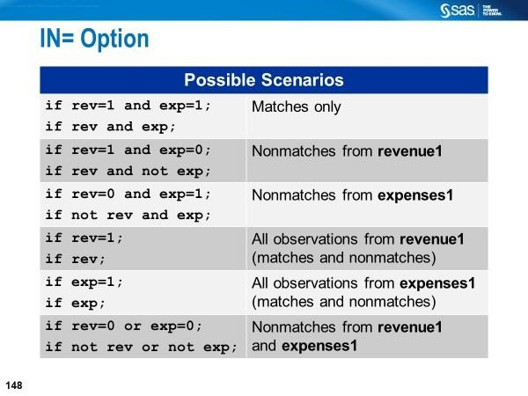
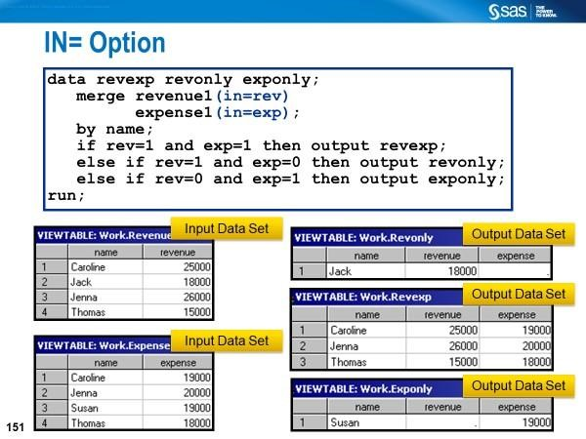

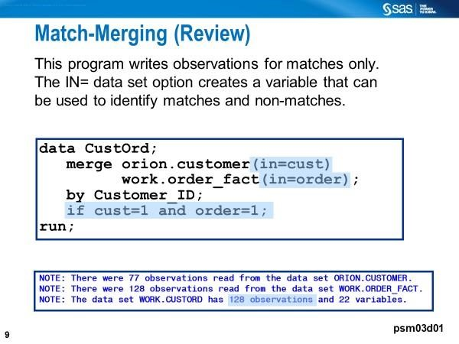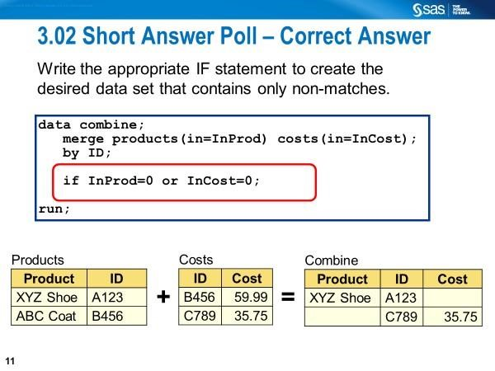

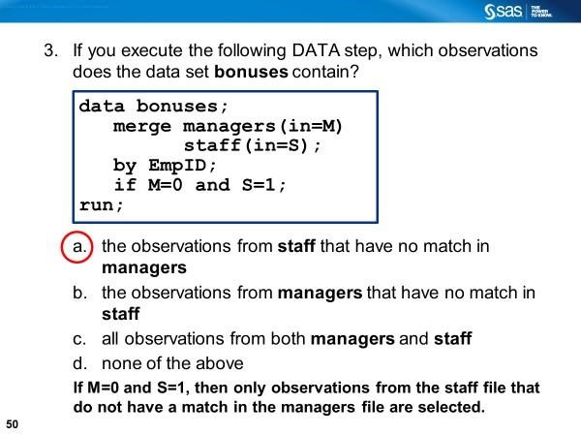

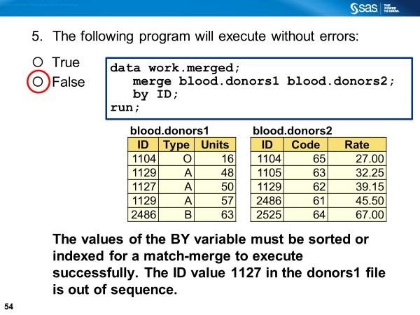
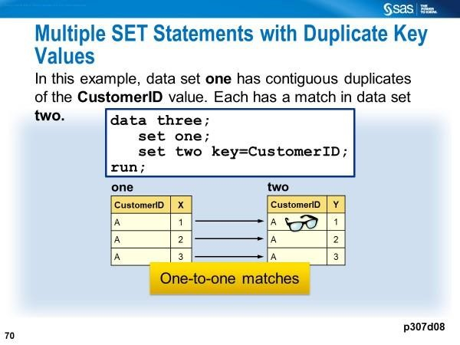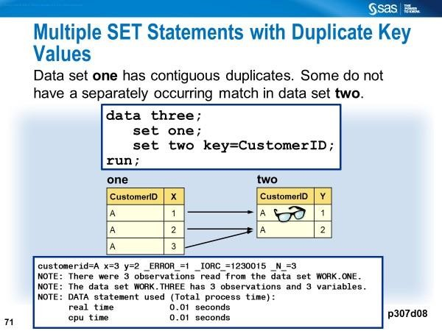
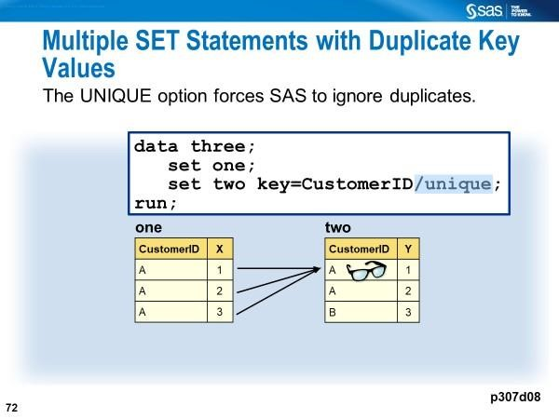

Combining Data using the UPDATE Statement
You can update selected values of certain variables in a master file (e.g., MASTER) using a transaction file (e.g., TRANSECT below).
*Ex15_update_modify.sas;
Master | Transact
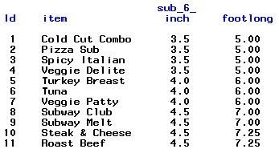 | 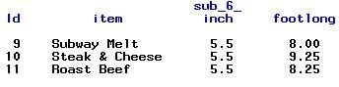

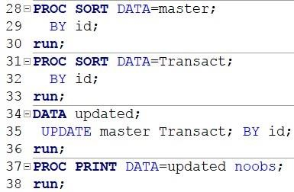 | 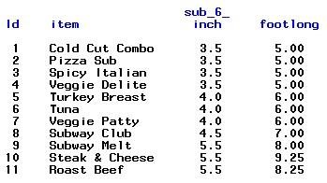

Combining Data using the MODIFY Statement
You can modify selected values of certain variables in a master file (e.g., MASTER) using a transaction file (e.g., TRANSECT below).
*Ex15_update_modify.sas;
Master | Transact
 | 

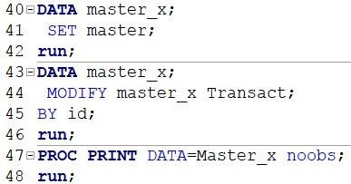 | 

UPDATE replaces an existing file with a new file, allowing you to add, delete, or rename columns. MODIFY performs an update in place by rewriting only those records that have changed, or by appending new records to the end of the file.

Processing Missing Values with UPDATE and MERGE Statements *Ex4_merge_update_missing.sas;
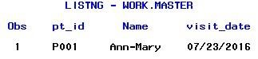 | 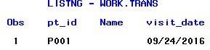
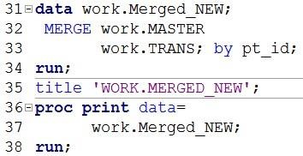 | 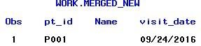
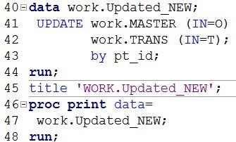 | 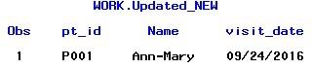

Lines 31-34: When merging, SAS overwrites in the PDV with values from the rightmost data file specified in the statement.

Lines 40:44: During an update, SAS uses the value for the NAME variable from the MASTER data set to replace the missing value for the same variable in the TRANS data set when it writes the observation in data set work.UPDATED_NEW.

Note that by default, UPDATE and MODIFY do not replace nonmissing values in a master data set with missing values from a transaction data set.

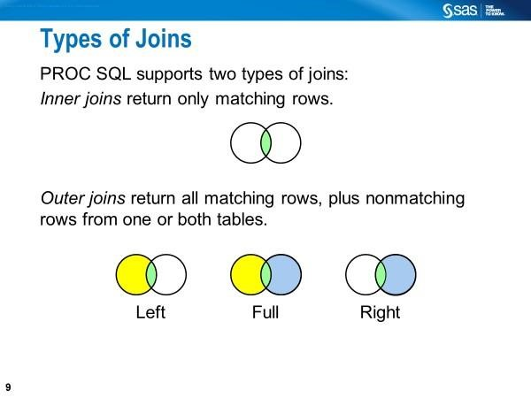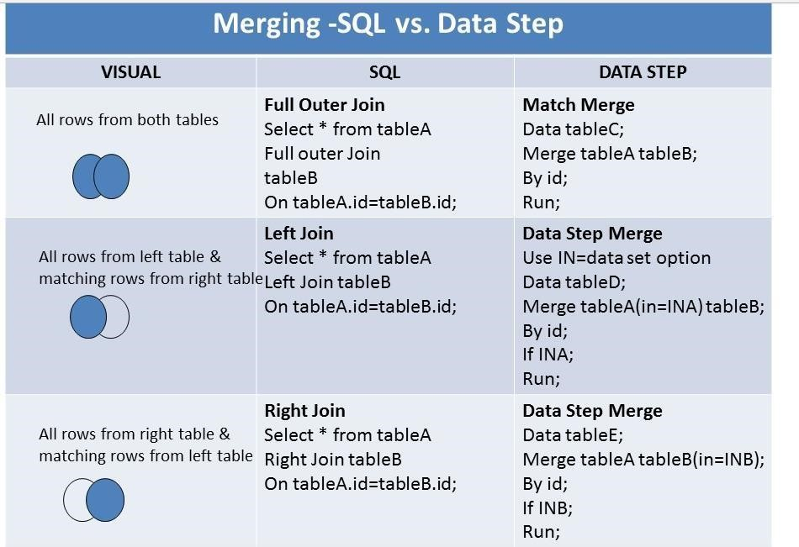

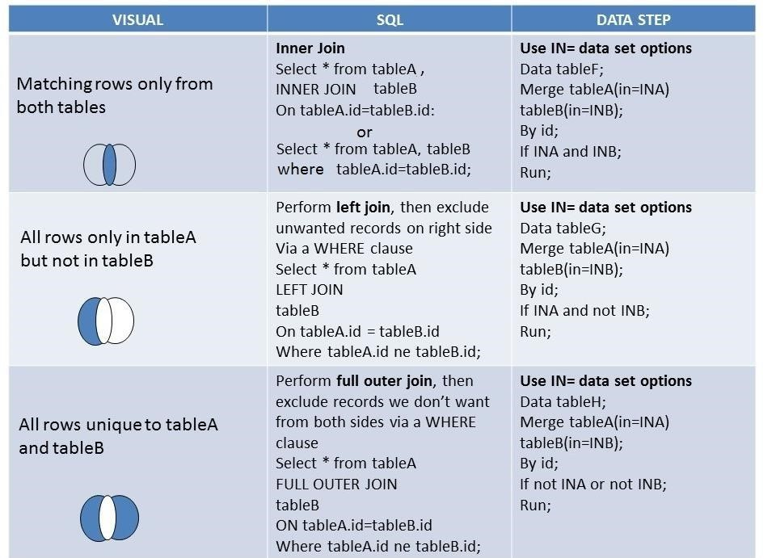

Source: https://blogs.sas.com/content/sastraining/2015/05/27/life-saver-tipforcomparing-proc-sql-join-with-sas-data-step-merge/
Blog written by Charu Shankar, 2015

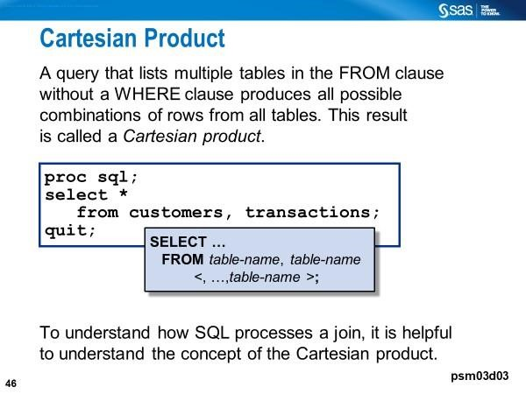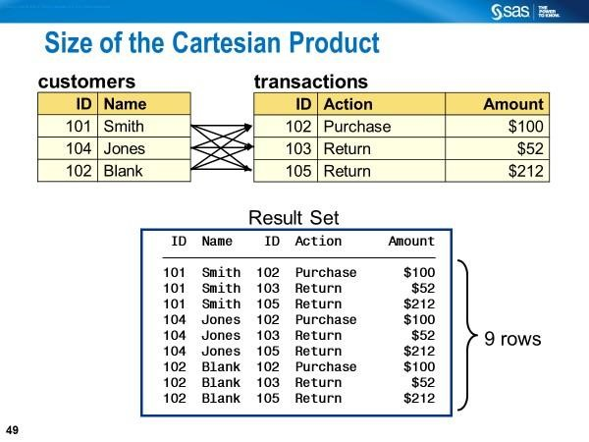
If you join tables that have multiple records per matching ids, your output table may be a Cartesian product. For example, with PROC SQL, 2 rows joining 5 rows of the same id variable will produce 10 rows. The DATA Step MERGE will create only 5 observations.
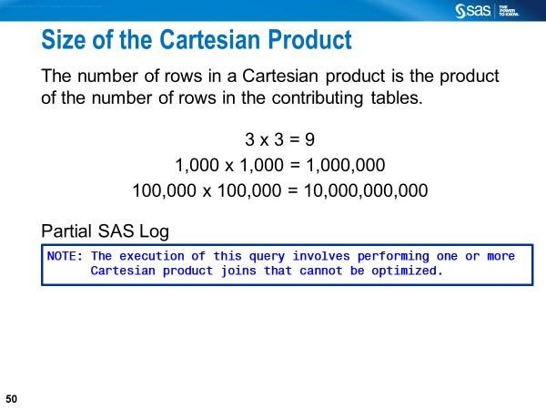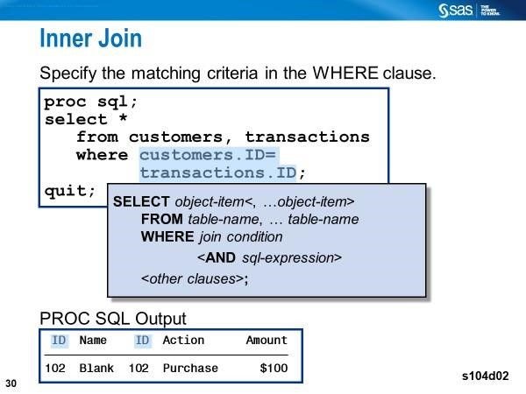

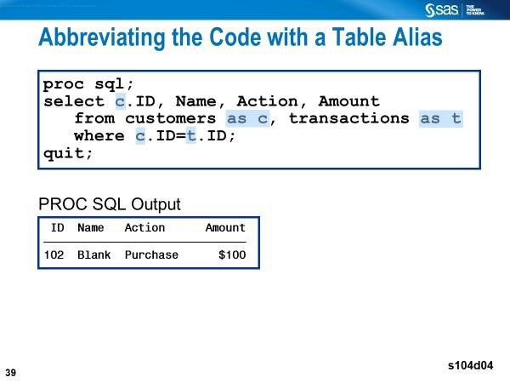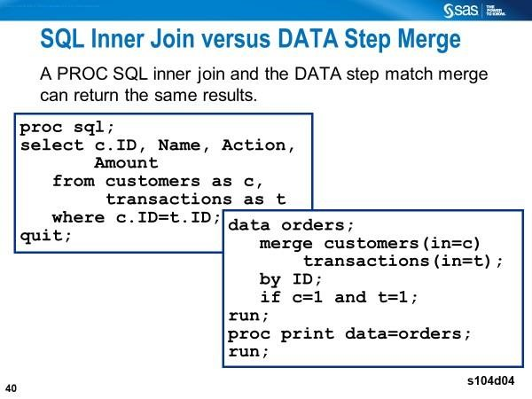
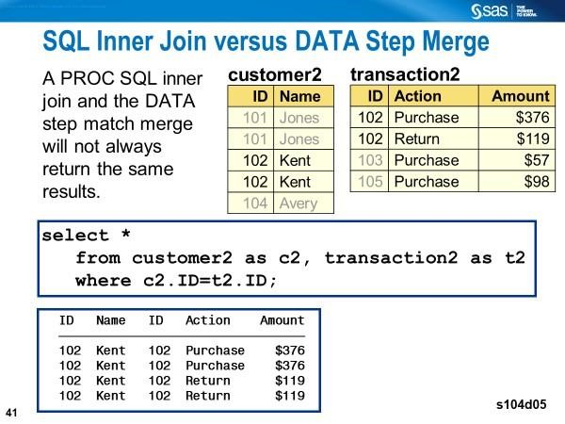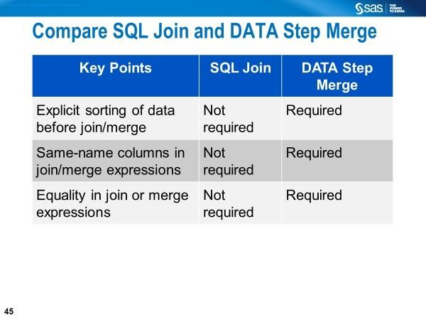
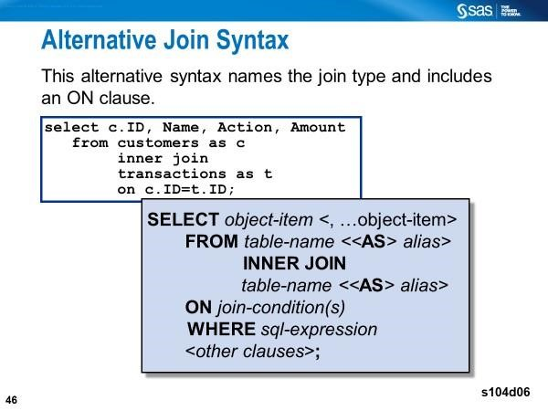

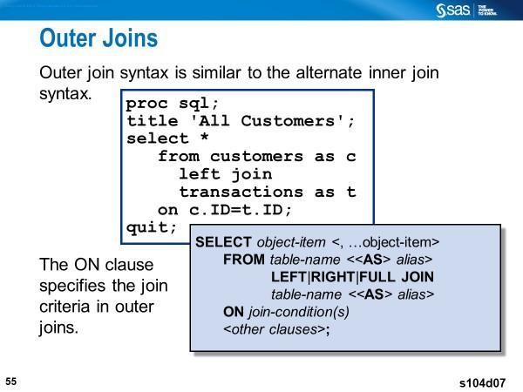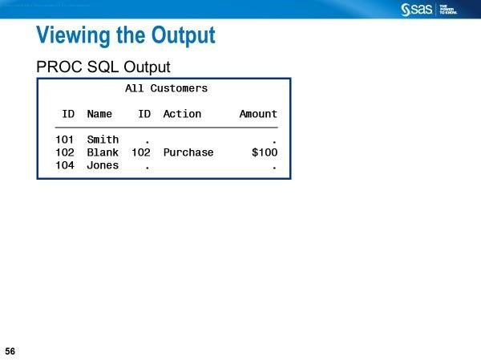
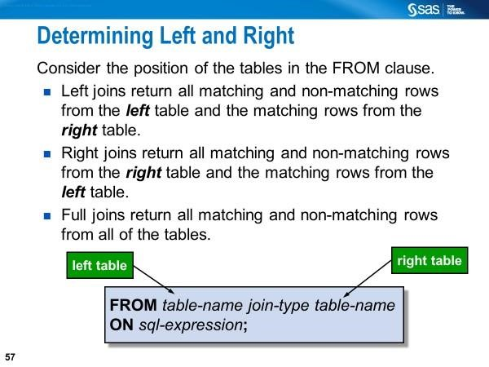

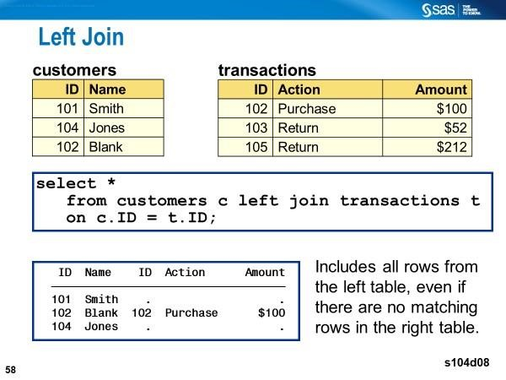
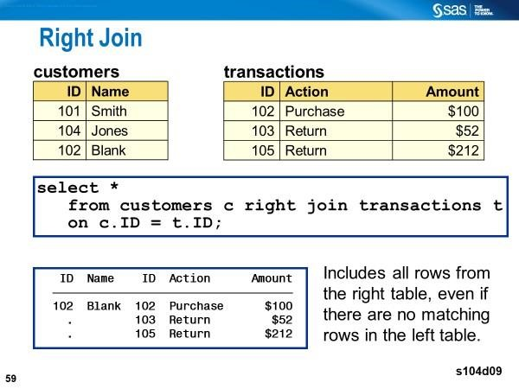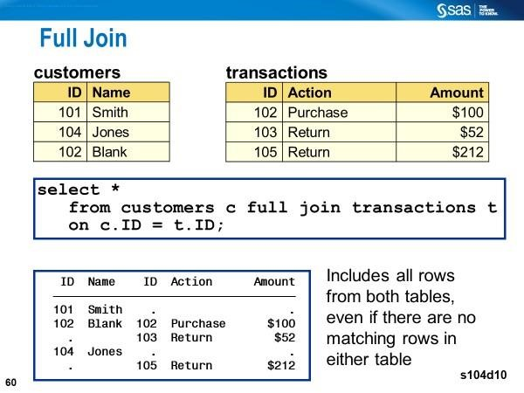

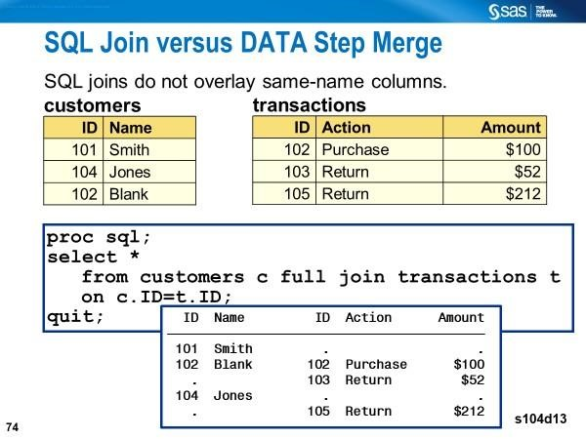

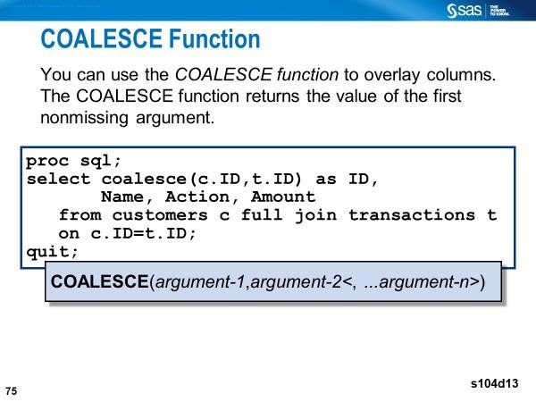
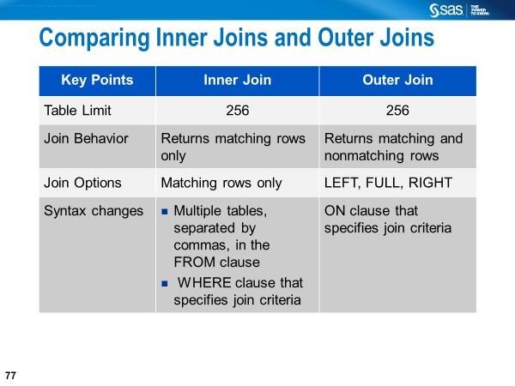
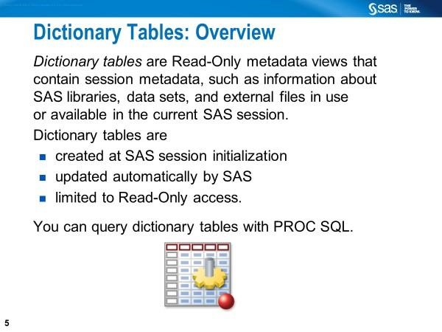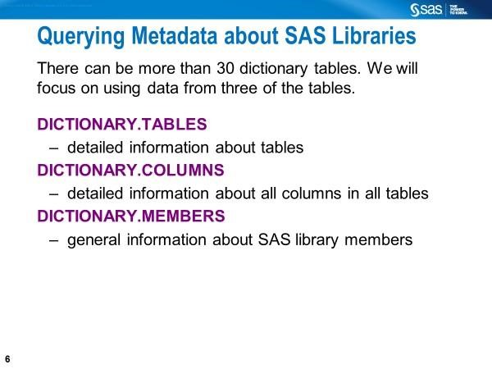

At initialization, SAS creates special Read-Only dictionary tables and views that contain data or metadata about each SAS session or batch job. You can access the tables using PROC SQL or you can use traditional SAS programming to access the view.
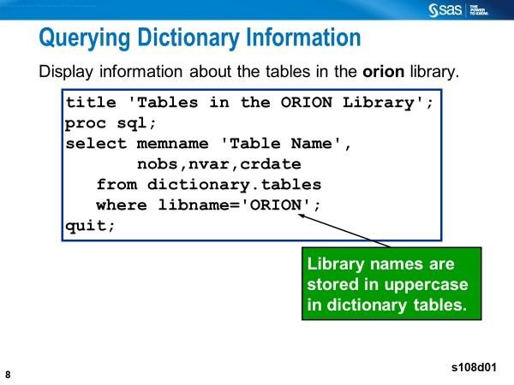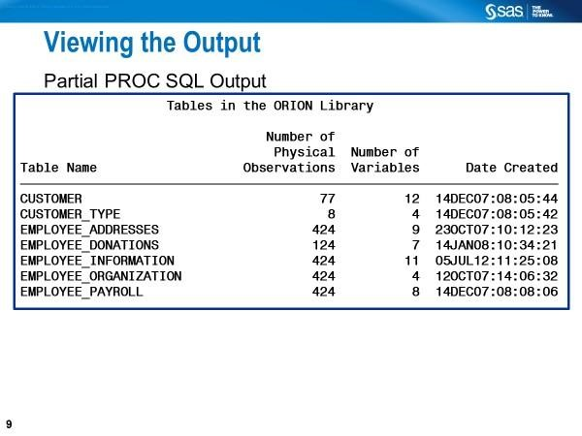
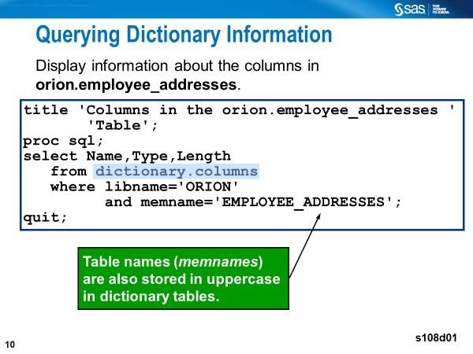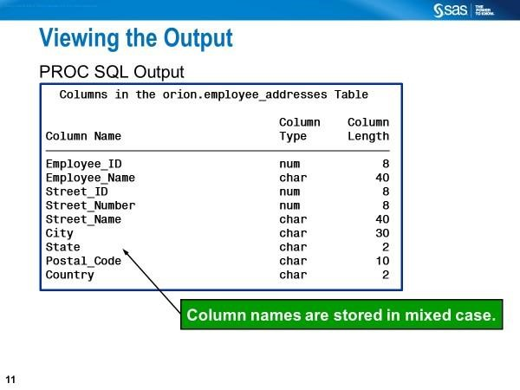
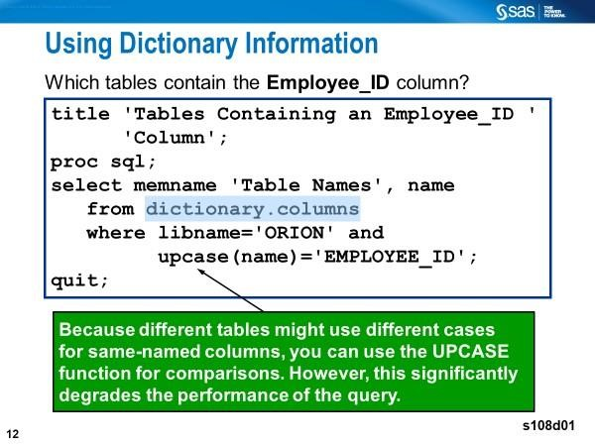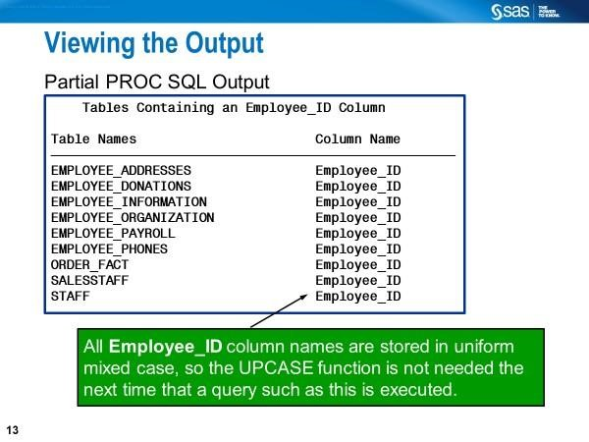
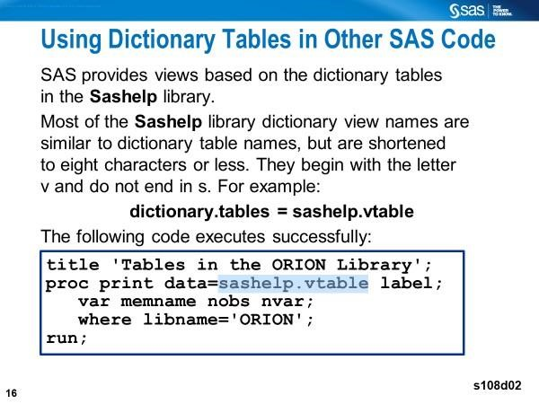

Review Questions
- Suppose you have listed a variable named ID in the BY statement along with the SET statement in a DATA step, what variables are created?
- What is the purpose of using the IN= option in the MERGE statement in a DATA step?
- You have merged two SAS data sets. From which data set (left or right), common non-BY variable values will be kept in the output data set?
- You have concatenated two SAS data sets. From which data set (left or right), common non-BY variable values will be kept in the output data set?
- Imagine that you are merging two data sets based on a selected variable. Which SQL join will produce the same results as “match-merging” when only some of the values of that variable match?
- How would you eliminate the rows containing duplicate values in PROC SQL?
- Explain the significance of the following operators in PROC SQL.
    - CONTAINS
    - IN
    - BETWEEN-AND
    - IS MISSING
    - IS NULL
    - Wild card operator underscore (_) with LIKE operator
    - Wild card operator percent (%) with LIKE operator
    - SOUNDS-LIKE operator
- In PROC SQL, how is the calculation performed when the summary function (e.g., AVG or COUNT) with one argument is used?
- In PROC SQL, how is the calculation performed when the summary function (e.g., SUM) with multiple arguments is used?
- Write PRCO SQL codes to calculate the
  - Total number of rows in a data table or group
  - Number of non-missing values for a specific column
  - Number of unique values for a specific column
- Use SASHELP.CLASS and write a single-value subquery (i.e., inner query) in PROC SQL such that the outer query lists students by SEX whose weights are greater than the average weight of all students.

