The George Washington University
Department of Statistics

STAT 4197/6197
Week 9: Macro Facility and Macro Variable Basics

- Macro Facility
- Creating Macro Variables
- Automatic Macro Variables versus User-Defined Macro Variables
- Referencing and Displaying Macro Variables
- Combining Macro Variables with text
- Global Symbol Table versus Local Symbol Table
- Converting Macro Variables into Data Step Variables
- Indirectly Referencing Macro Variables
- Using Macro Variables for Table Look-up
- Deleting Macro Variables

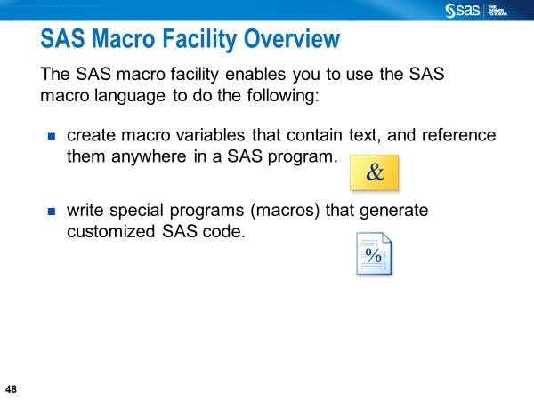
More specifically, the macro facility does the following:
- Displaying system information
- Symbolic substitution within the SAS code
- Automated production of SAS code (automation for repetitive tasks)
- Conditional construction of SAS code
- Dynamic generation of SAS code (data-driven applications)

SAS Macro Facility = Macro Processor + Macro Language
Macro Processor: The Part of Base SAS that performs the macro activity. Macro Language: The syntax that interacts with the macro processor

Levels of Learning of Macro Language
- Code Substitutions
- Macro Statement and Functions
- Dynamic Programming (See Carpenter, A. 2016. Carpenter’s Complete Guide to the SAS Macro Language. Third Edition)

Why Use a Macro Language?
- To avoid the same pieces of code repeatedly
- To minimize typing when writing the SAS program
- To the same piece of code (text), such as
  - data set name
  - data value
  - variable name
  - SAS statement
  - part of the SAS statement at different parts of your SAS program multiple times without you having to type the exact code/text over and over again provided you assign that text to a macro variable [%LET DS=CLASS;] once and then reference it [&DS] repeatedly.

With the SAS macro language, you can
- Reuse the same code multiple times after defining it once in your SAS program
- Change the code once in a single place in your SAS program and reflect it in multiple parts of your SAS program
- Make your program data-driven by letting SAS decide what code to generate based on the data values.
You can create multiple macro variables that contain text and then reference them anywhere in a SAS program.

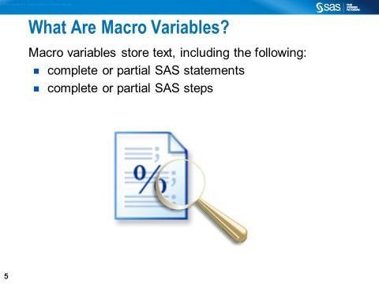

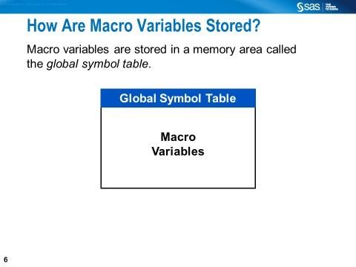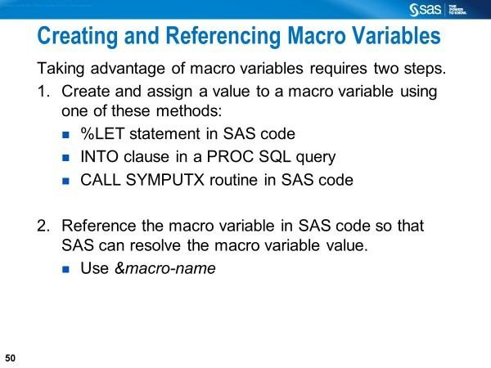

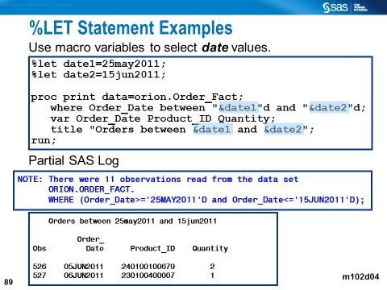
The %LET statement is used to manually create two macro variables (date1 and date2) and assign a value to each (25may2011 and 15jun2011, respectively) in open code. Macro variable references begin with an & followed by a macro variable name (e.g., &date1 and &date2). Double quotes surrounding the macro variable references are required for the macro processor to resolve them into macro variable values.

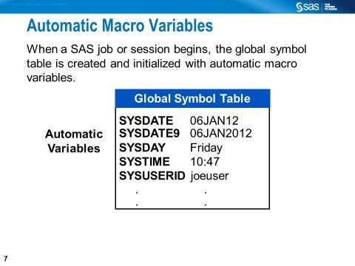

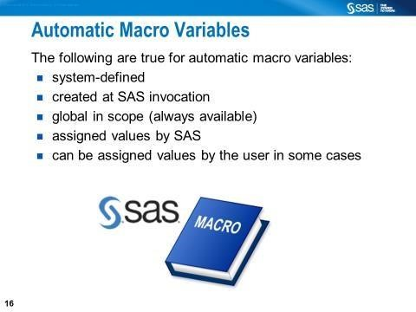
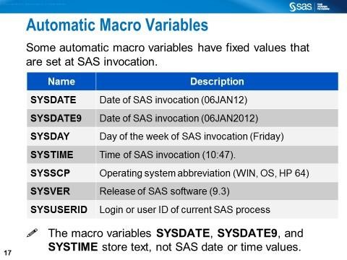

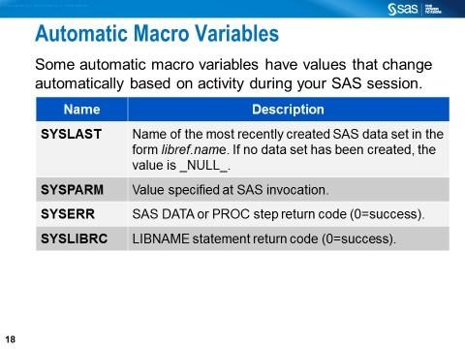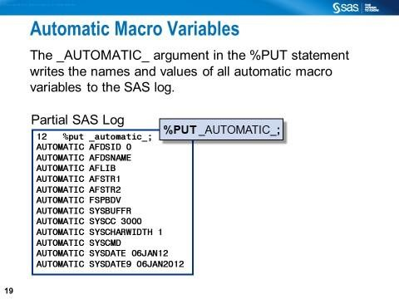
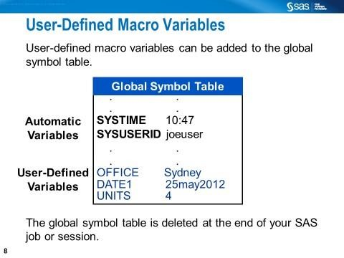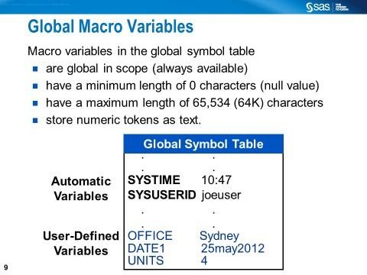
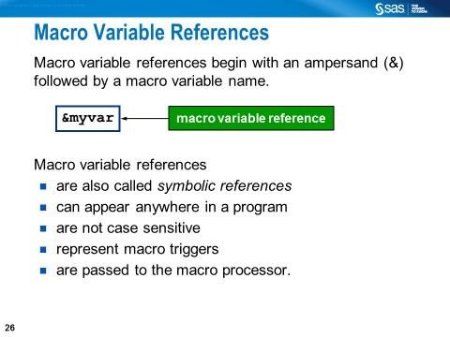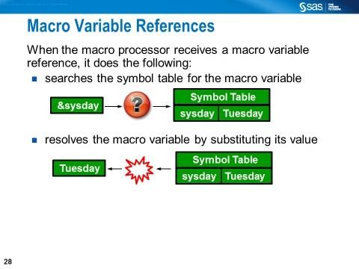
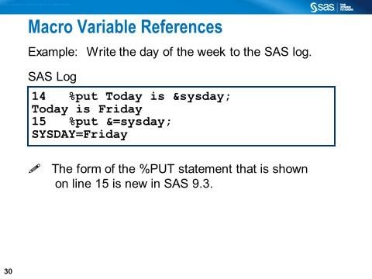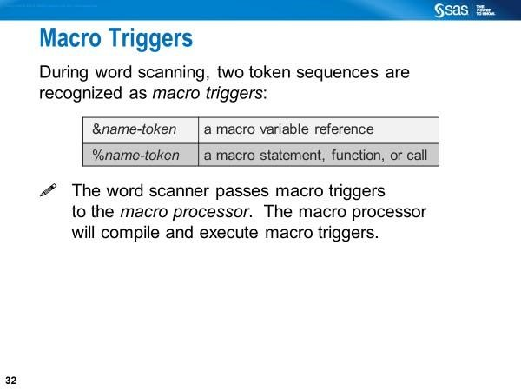
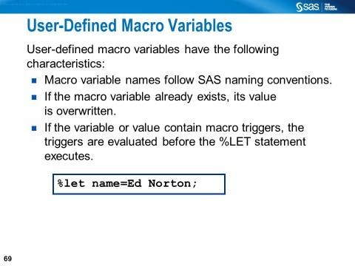
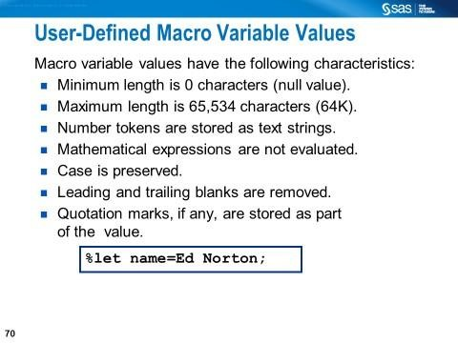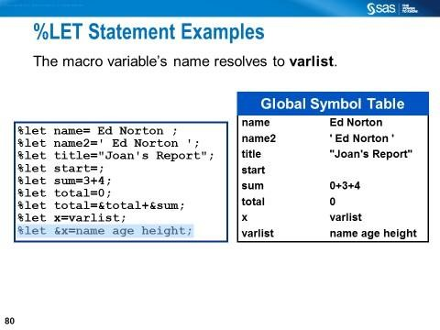
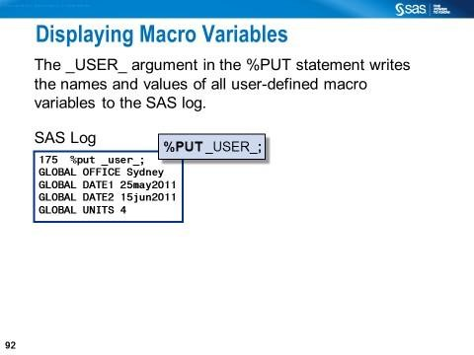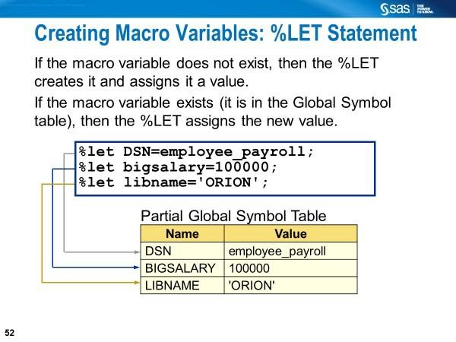

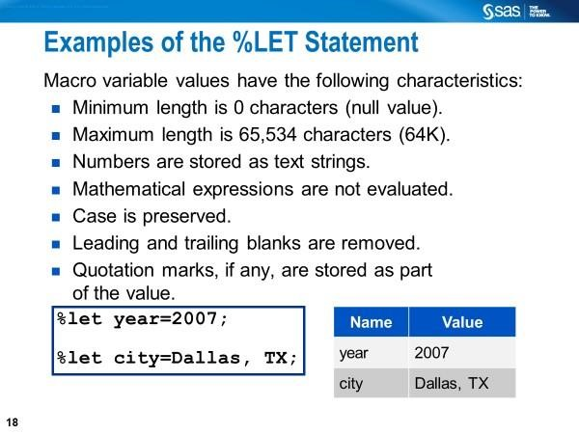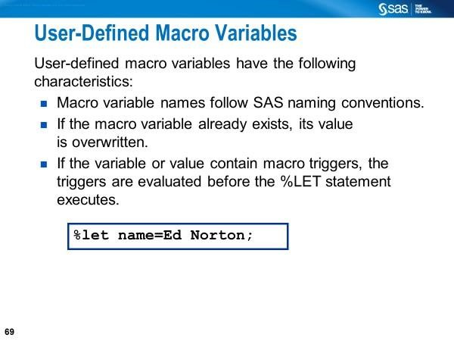
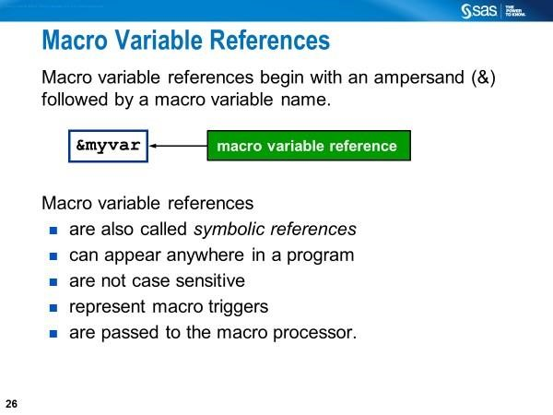
&mavar.
A macro variable can also be referenced with an ampersand, the macro variable name, and a period.
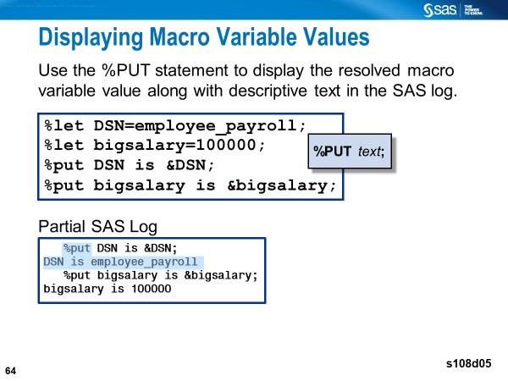
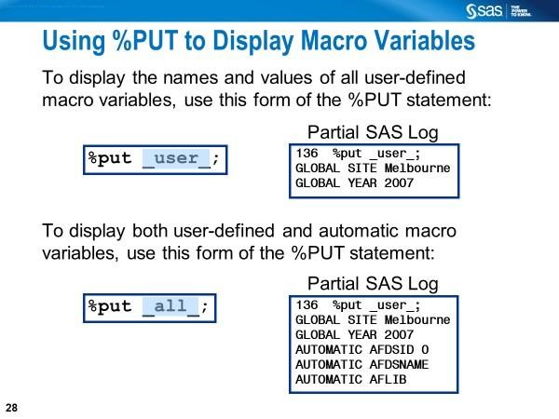

Points to remember: The %PUT statement is valid in open code. It writes to column one of the next line in the SAS log. It writes a blank line if no text is specified.

PUTLOG (or PUT) vs. %PUT

PUTLOG or PUT can write the following to the SAS log
- text strings inside quotation marks
- values of the variables found in the DATA step

- Use the PUTLOG statement to write informational message (includding the debugging message) to the SAS log.

- Use the PUT statement to write to an external file that isspecified in the FILE statement.

The %PUT statement

- writes text strings and values of the macro variables to the SAS log, starting in column one
- writes a blank line if text is not specified
- does not require quotation marks around text
- is valid in open code
- can appear o before the DATA step o after the DATA step o in the middle of the DATA step

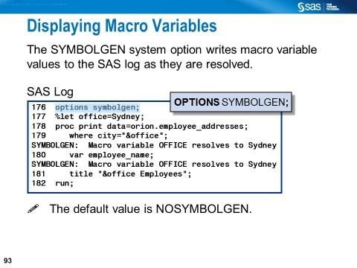

Points to remember: The %PUT statement is valid in open code. It writes to column one of the next line in the SAS log. It writes a blank line if no text is specified.

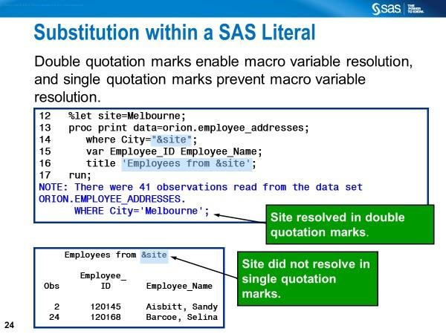

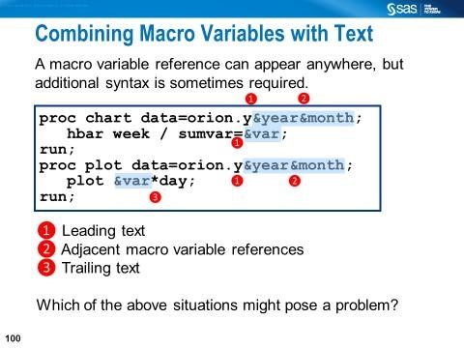
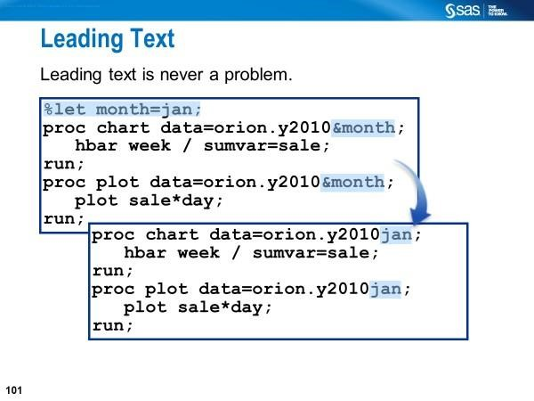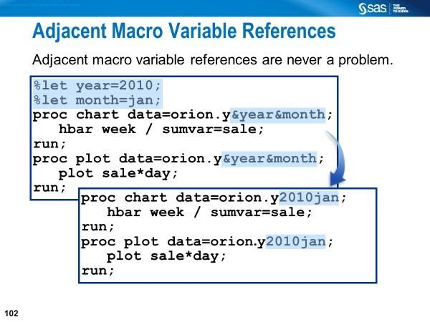
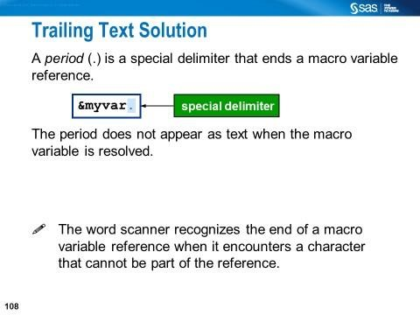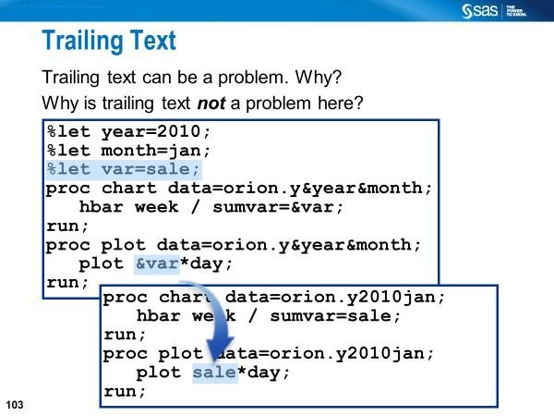
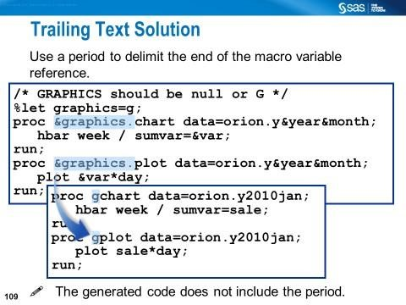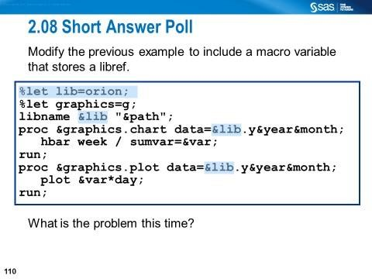
Trailing text can be a problem if a dot is not added after the macro variable.

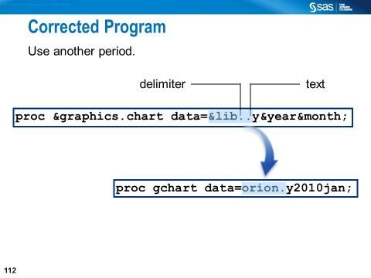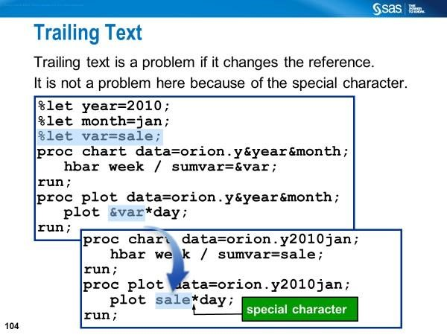

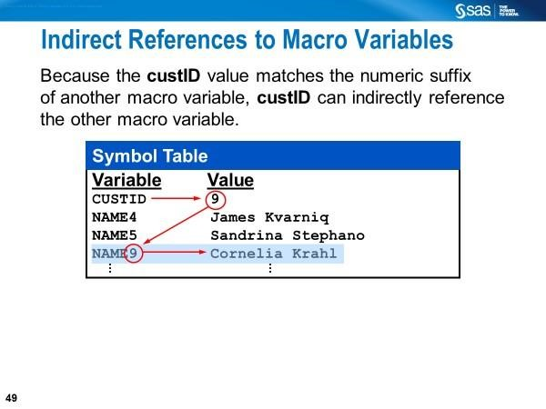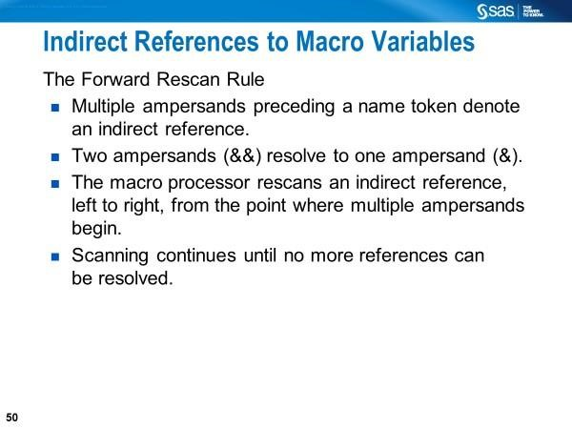

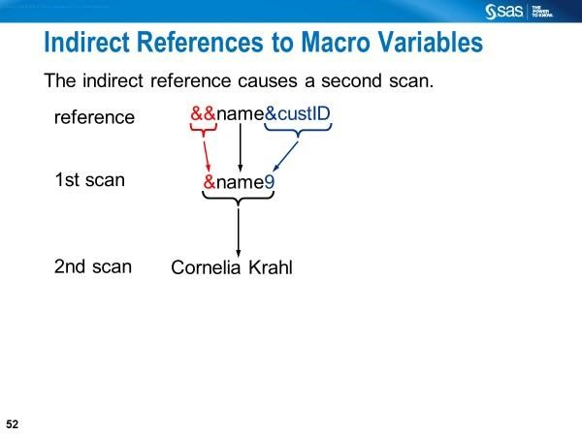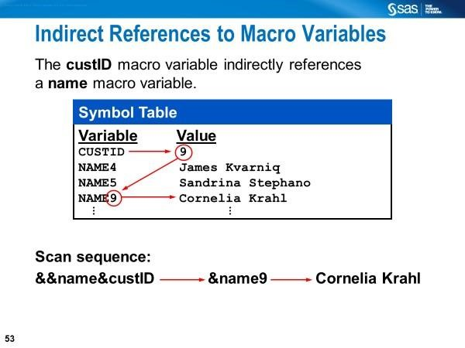

Example: Referencing Macro Variables Indirectly Using a Macro The double ampersands always resolve into a single ampersand.
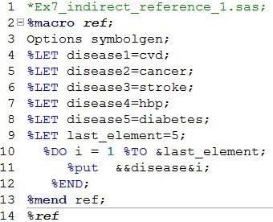
The above code imply macro arrays, which are not explicit arrays like those defined in the DATA step.
Line 4-8: Five macro variables (disease1-disease5) are created.
Line 11: The two ampersands (&&) in front of the macro variable name force the macro processor to scan the macro variable twice.
When the macro %REF is executed, SAS:
- (1st iteration) resolves &&disease&i to &disease1 in the first scan &disease1 to cvd in the second scan.
- (2nd iteration) resolves &&diseasei to &disease2 in the first scan  &disease2 to cancer in the second scan.
…
- (5th iteration) resolves &&disease&i to &disease5 in the first scan
- &disease5 diabetes in the second scan.

Why do we use macro variables?
One reason for using macro variables is to circumvent the problem that the variable stored in a SAS data set cannot be retrieved in a DATA step without using it as an input data set.
Problem:
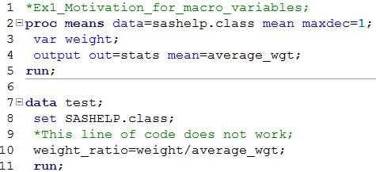
The variable average_wgt stored in data set STATS cannot be used in the DATA step (lines 7-11) above.

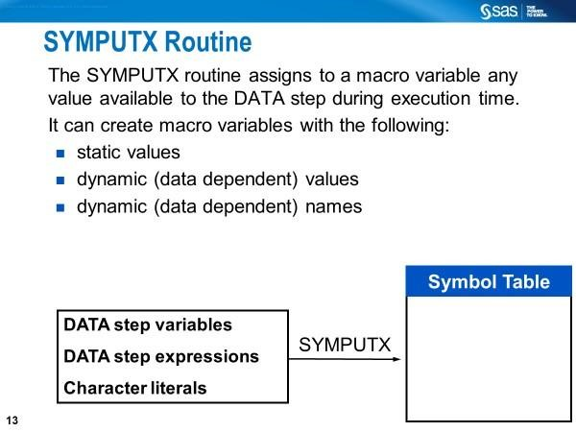

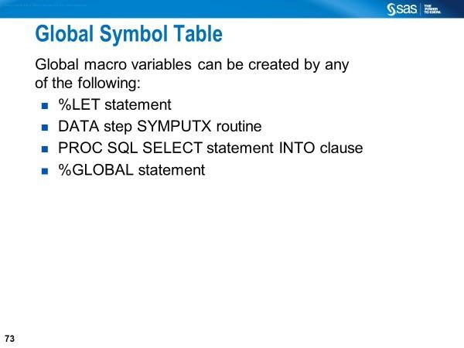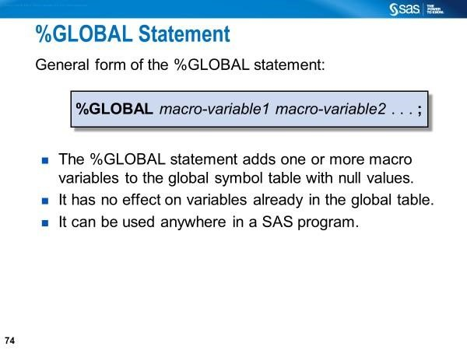

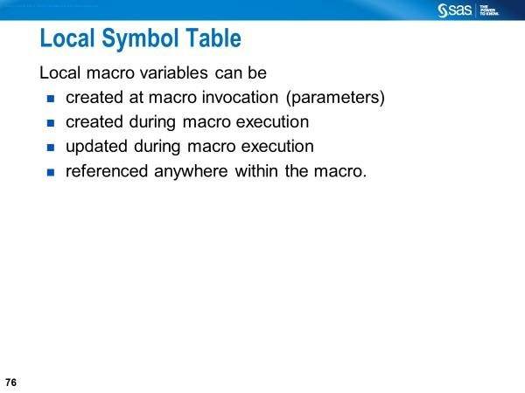
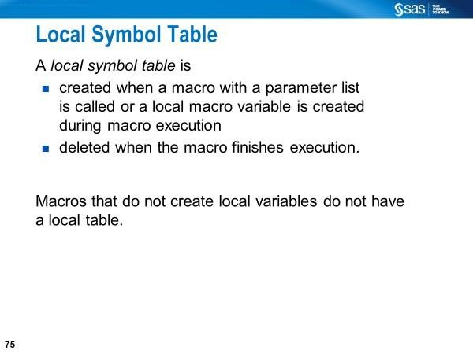

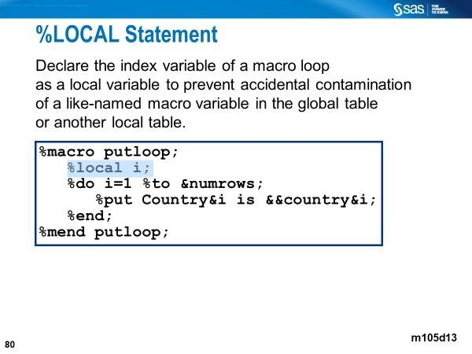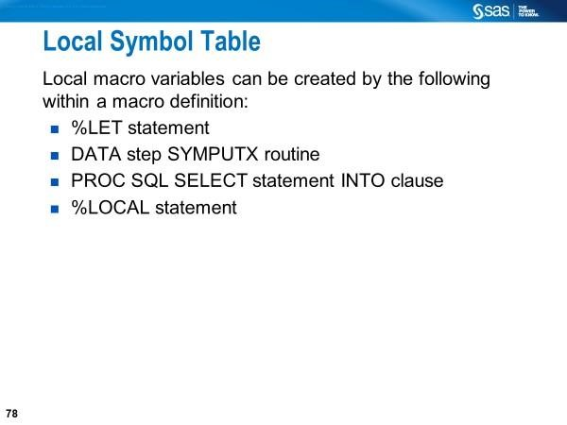
Macro variables are global when they are defined outside of a macro; and local to a macro when they are defined inside of a macro when the %GLOBAL statement is not used.
CALL SYMPUTX vs. PROC SQL INTO:
The following code is obtained from Simon (2017).
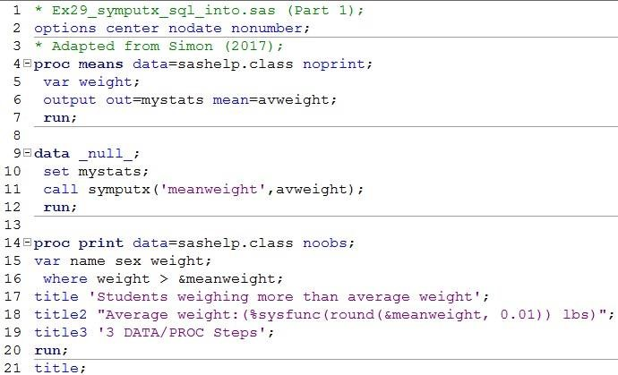
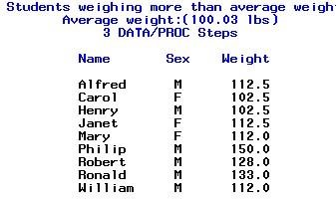

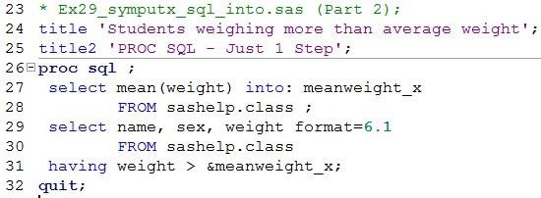

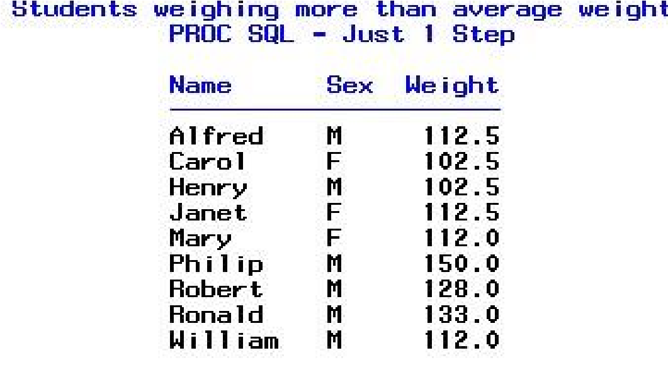

Creating and Using Macro Variables for Table Look-Up

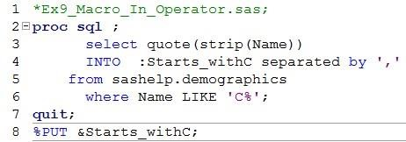
(Partial SAS Log)
"CANADA","COSTA RICA","CUBA","CHILE","COLOMBIA","CZECH
REPUBLIC","CROATIA","CAMEROON","CAPE
VERDE","CENTRAL AFRICAN
REP.","CHAD","COMOROS","CONGO","CAMBODIA","CHINA","CYPRUS","COOK
ISLANDS","CORAL SEA ISLANDS"

Using a Macro Variable Reference to Select a List of Character Values in the PROC PRINT Step without a Macro

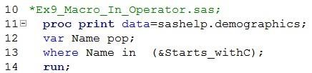

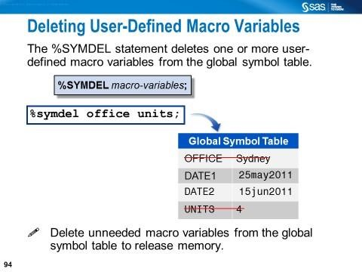

The macro statements can delete user-defined macro variables.

The SYMDEL routine can also be used to remove user-defined macro variables from the global symbol table.

Review Questions

- Describe the ways one could create macro variables.
- What is the purpose of creating macro variables in SAS?
- Which points need to be considered when creating macro variables using a %LET statement?
- What is the maximum length of a macro variable?
- What is an automatic macro variable?
- Name some common automatic macro variables and state their usage.
- Where are the macro variables stored?
- Where can you reference a macro variables?
- What rule has to be followed when referencing a macro variable in the TITLE or FOOTNOTE statement?
- Describe the purpose of using the %PUT statement?
- What is the difference between the %PUT statement and the SYMBOLGEN option?
- What macro functions would enable you to do arithmetic on the macro variables whose values are numeric?
- Describe when you use the CALL SYMPUTX routine to create macro variables?
- How do you create a single macro variable which can hold all the distinct values of DATA step variable?
- How do you create a series of macro variables, each containing a distinct value of a DATA step variable?
- How would you define a macro and then call it for execution?
- What is the purpose of using a macro?
- What is the difference between %LOCAL and %GLOBAL statements?
- When would you indirectly reference macro variables?
- How do you convert macro variables to DATA step variables?
- Show code examples how to:
  - Add text before a macro variable reference
  - Add text after a macro variable reference
  - Add two macro variable references one after another
  - Reference a permanent SAS data set ( a two-level SAS name) where the libref part is in the form of a macro variable reference
- Explain the global symbol table.
- How would you delete macro variables from a global symbol table?
- How is a local symbol table created?

