Spring AOP

In Spring AOP, 4 type of advices are supported:
- Before advice – Run before the method execution
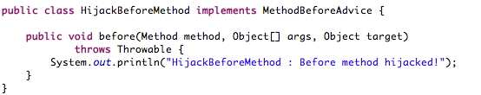
- After returning advice – Run after the method returns a result
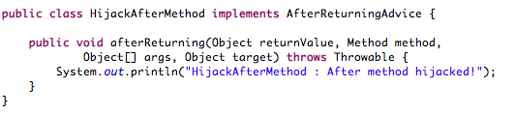
- After throwing advice – Run after the method throws an exception
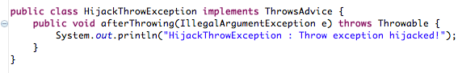
- Around advice – Run around the method execution, combine all three advices above. - implements MethodInterceptor

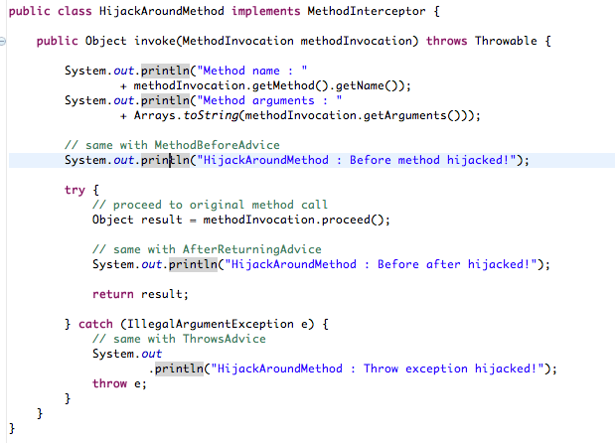
Bean definition

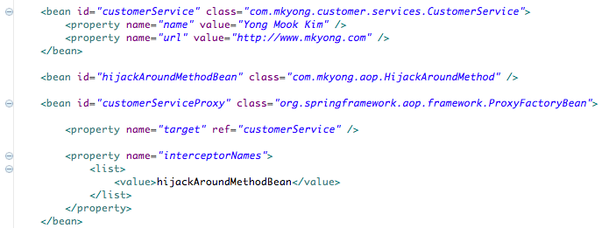

A complete application context

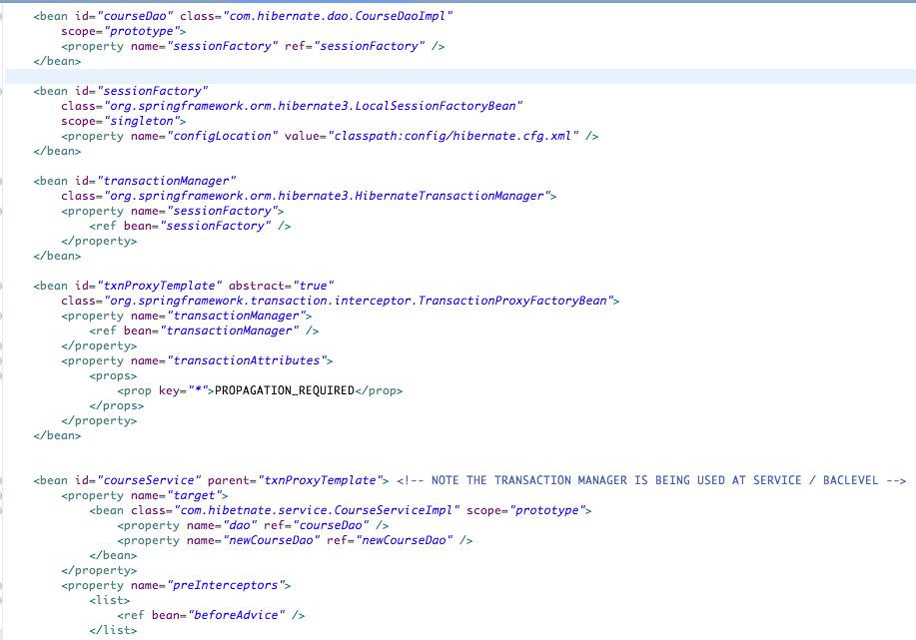

- Aspect: a modularization of a concern that cuts across multiple classes. Transaction management is a good example of a crosscutting concern in J2EE applications. In Spring AOP, aspects are implemented using regular classes (the schema-based approach) or regular classes annotated with the @Aspect annotation (the @AspectJ style).
- Join point: a point during the execution of a program, such as the execution of a method or the handling of an exception. In Spring AOP, a join point alwaysrepresents a method execution.
- Advice: action taken by an aspect at a particular join point. Different types of advice include "around," "before" and "after" advice. (Advice types are discussed below.) Many AOP frameworks, including Spring, model an advice as an interceptor, maintaining a chain of interceptors around the join point.
- Pointcut: a predicate that matches join points. Advice is associated with a pointcut expression and runs at any join point matched by the pointcut (for example, the execution of a method with a certain name). The concept of join points as matched by pointcut expressions is central to AOP, and Spring uses the AspectJ pointcut expression language by default.
- Introduction: declaring additional methods or fields on behalf of a type. Spring AOP allows you to introduce new interfaces (and a corresponding implementation) to any advised object. For example, you could use an introduction to make a bean implement an IsModified interface, to simplify caching. (An introduction is known as an inter-type declaration in the AspectJ community.)
- Target object: object being advised by one or more aspects. Also referred to as the advised object. Since Spring AOP is implemented using runtime proxies, this object will always be a proxied object.
- AOP proxy: an object created by the AOP framework in order to implement the aspect contracts (advise method executions and so on). In the Spring Framework, an AOP proxy will be a JDK dynamic proxy or a CGLIB proxy.
- Weaving: linking aspects with other application types or objects to create an advised object. This can be done at compile time (using the AspectJ compiler, for example), load time, or at runtime. Spring AOP, like other pure Java AOP frameworks, performs weaving at runtime.

