- 报站订阅线路后，返回实时报站数据
1、Request request = new Request.Builder()
.url("ws://47.119.154.255:9090/api/push/websocket/" + token)
.build();
2、JSONObject cmdJson = new JSONObject();
JSONObject paramJson = new JSONObject();
try {
paramJson.put("lineId",list.get(i));
cmdJson.put("param",paramJson);
cmdJson.put("cmd","openDiagramLine");
} catch (JSONException e) {
e.printStackTrace();
}
webSocket.send(cmdJson.toString());
3、第一次订阅线路下所有的车辆：
{"vehicleStatusList":[{"vehicleName":"45676","operateStatus":"2","planStatus":"0","dispatchStatus":"0","stationState":"0","speed":"0","deviceStatus":"3","lineStatus":"0","licensePlate":"粤B45676","serviceStatus":"0","trips":"0","serverType":"jt808","shifts":"0","driverName":"","id":"2da9bf43b1301bb633c72c74531193df","gpsValue":"114.08932,22.706217","stationIndex":"17"},{"vehicleName":"45678","operateStatus":"2","planStatus":"0","dispatchStatus":"0","stationState":"1","speed":"0","deviceStatus":"0","lineStatus":"0","licensePlate":"粤B45678","serviceStatus":"0","trips":"0","serverType":"jt808","shifts":"0","driverName":"","id":"62cb4a4a0254248246dea32610051216","gpsValue":"114.089377,22.706238","stationIndex":"1"}]}
后面是单个车有更新就上报：
{"vehicleStatusList":[{"vehicleName":"B5677","stationState":"0","speed":"0","deviceStatus":"0","lineStatus":"1","licensePlate":"粤B5677","serviceStatus":"2","id":"ecf03c22b6c5c0dd2c680621c441d523","gpsValue":"114.08929,22.706202","stationIndex":"1"}]}
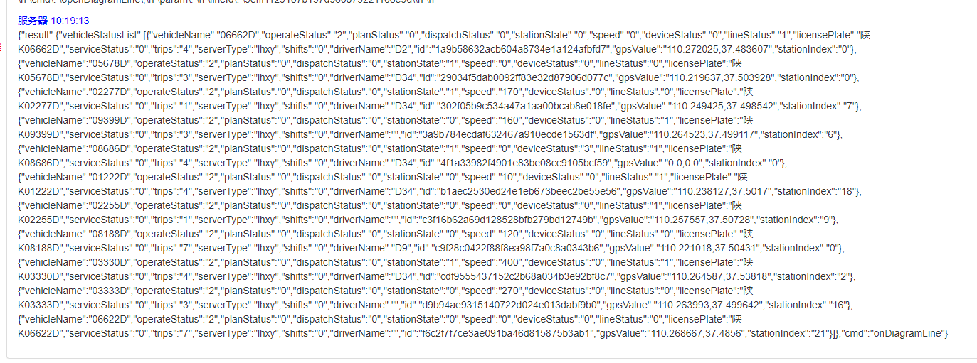
deviceStatus：车辆状态 （0：在线，3：离线）
lineStatus：上下行（0：上行，1：下行）
stationState：是否进站（0：进站，1：站外）
gpsValue：实时gps坐标（WGS84坐标） 百度坐标系
stationIndex：站点排序
licensePlate：车牌
lineStatus:上下行(0:上行，1:下行， 2：上行起始站， 3：下行起始站)
二、发送订阅车辆位置消息-实时GPS
openVehicleLocation
{
"cmd": "openVehicleLocation",
"param": "{}"
}
说明：1、请求所有车辆的实时位置；
- 第一次回应，全部位置；后续就是设备发那个，推送那个，单个；
- 单个数据：、
{"result":{"vehicleLocationList":[{"deviceSerial":"00000000000006010026","altitude":0,"licensePlate":"赣B08871D","latitude":24.737487,"angle":50,"id":"aa4177bf9ab3a784322754ca0fb80638","deviceTime":"2025-03-14 15:09:36","speed":2,"longitude":115.040165,"mileage":0,"deviceStatus":"0"}],"full":false},"cmd":"onVehicleLocation"}
全部数据：
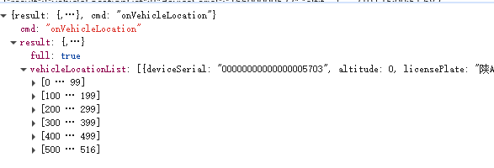
vehicleName 车辆名称
lineStatus 线路状态
stationIndex 站点编号
deviceStatus 设备状态
operateStatus 运营状态
dispatchStatus 调度状态
serviceStatus 服务状态
gpsValue 定位数据
planStatus 排班状态
stationState 站点状态
shifts 班次
trips 趟次
serverType 服务器类型

/**
* 运营状态常量
*/
public static final String VEHICLE_STATUS_VO_OPERATE_STATUS_INIT = "-1";
public static final String VEHICLE_STATUS_VO_OPERATE_STATUS_NO = "1";
public static final String VEHICLE_STATUS_VO_OPERATE_STATUS_YES = "2";
public static final String VEHICLE_STATUS_VO_OPERATE_STATUS_STOP = "3";

/**
* 调度状态常量
*/
public static final String VEHICLE_STATUS_VO_DISPATCH_STATUS_NORMAL = "0";
public static final String VEHICLE_STATUS_VO_DISPATCH_STATUS_SUPPORT = "1";
public static final String VEHICLE_STATUS_VO_DISPATCH_STATUS_REPLACE = "2";

/**
* 调度状态常量
*/
/** 正常 */
public static final String VEHICLE_STATUS_VO_SERVICE_STATUS_NORMAL = "0";
/** 气/电 */
public static final String VEHICLE_STATUS_VO_SERVICE_STATUS_GASELECTRIC = "3";
/** 包车 */
public static final String VEHICLE_STATUS_VO_SERVICE_STATUS_CHARTEREDBUS = "7";
/** 维修 */
public static final String VEHICLE_STATUS_VO_SERVICE_STATUS_MAINTENANCE = "8";
/** 回场 */
public static final String VEHICLE_STATUS_VO_SERVICE_STATUS_PULLIN = "9";
/** 故障 */
public static final String VEHICLE_STATUS_VO_SERVICE_STATUS_MALFUNCTION = "10";
/** 吃饭 */
public static final String VEHICLE_STATUS_VO_SERVICE_STATUS_DINING = "11";
/** 回程 */
public static final String VEHICLE_STATUS_VO_SERVICE_STATUS_RETURNTRIP = "32";
/** 一保 */
public static final String VEHICLE_STATUS_VO_SERVICE_STATUS_PROTECTED1 = "12";
/** 二保 */
public static final String VEHICLE_STATUS_VO_SERVICE_STATUS_PROTECTED2 = "13";
/** 事故 */
public static final String VEHICLE_STATUS_VO_SERVICE_STATUS_ACCIDENT = "14";
/** 三保 */
public static final String VEHICLE_STATUS_VO_SERVICE_STATUS_PROTECTED3 = "15";
/** 年审 */
public static final String VEHICLE_STATUS_VO_SERVICE_STATUS_YEARCHECK = "16";
/** 洗车 */
public static final String VEHICLE_STATUS_VO_SERVICE_STATUS_CARWASH = "17";
/** 收箱 */
public static final String VEHICLE_STATUS_VO_SERVICE_STATUS_CLOSEDBOX = "18";
/** 报警 */
public static final String VEHICLE_STATUS_VO_SERVICE_STATUS_CALLPOLICE = "19";
/** 绕行 */
public static final String VEHICLE_STATUS_VO_SERVICE_STATUS_ROUNDROAD = "20";
/** 乘客不适 */
public static final String VEHICLE_STATUS_VO_SERVICE_STATUS_PASSENGERDISCOMFORT = "21";
/** 司机不适 */
public static final String VEHICLE_STATUS_VO_SERVICE_STATUS_DRIVERDISCOMFORT = "22";
/** 超载 */
public static final String VEHICLE_STATUS_VO_SERVICE_STATUS_OVERLOAD = "23";
/** 堵车 */
public static final String VEHICLE_STATUS_VO_SERVICE_STATUS_TRAFFICJAM = "24";
/** 纠纷 */
public static final String VEHICLE_STATUS_VO_SERVICE_STATUS_DISPUTE = "25";
/** 专线 */
public static final String VEHICLE_STATUS_VO_SERVICE_STATUS_DEDICAT

/**
* 排班状态常量
*/
public static final String VEHICLE_STATUS_VO_PLAN_STATUS_STOP = "0";
public static final String VEHICLE_STATUS_VO_PLAN_STATUS_START = "1";

/**
* 站内
*/
public static final String VEHICLE_STATUS_VO_STATION_STATE_IN = "0";
/**
* 站外
*/
public static final String VEHICLE_STATUS_VO_STATION_STATE_OUT = "1";

/**
* 线路状态常量
*/
public static final String VEHICLE_STATUS_VO_LINE_STATUS_UP = "0";
public static final String VEHICLE_STATUS_VO_LINE_STATUS_DOWN = "1";
public static final String VEHICLE_STATUS_VO_LINE_STATUS_LEFT = "2";
public static final String VEHICLE_STATUS_VO_LINE_STATUS_RIGHT = "3";
public static final String VEHICLE_STATUS_VO_LINE_STATUS_PARK = "4";

/**
* 设备状态常量
*/
public static final String VEHICLE_STATUS_VO_DEVICE_STATUS_INIT = "-1";
public static final String VEHICLE_STATUS_VO_DEVICE_STATUS_ONLINE = "0";
public static final String VEHICLE_STATUS_VO_DEVICE_STATUS_OFFLINE = "3";

