**Screenshot of the Ansible exercises:**

List of playbooks for the exercise:

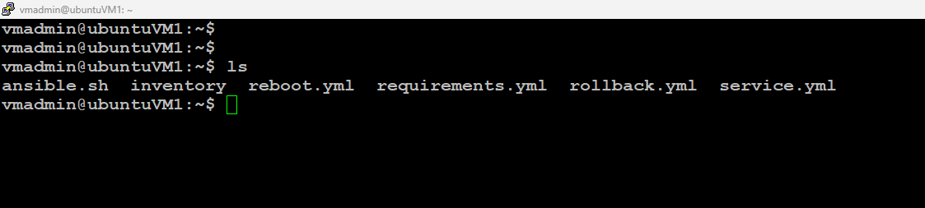

Inventory file:

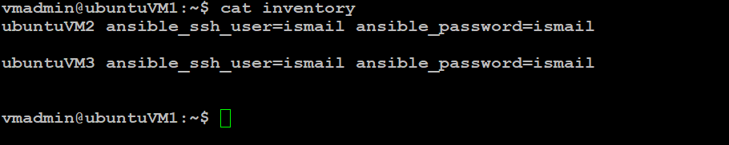

1. Ansible for Weekly System Reboots

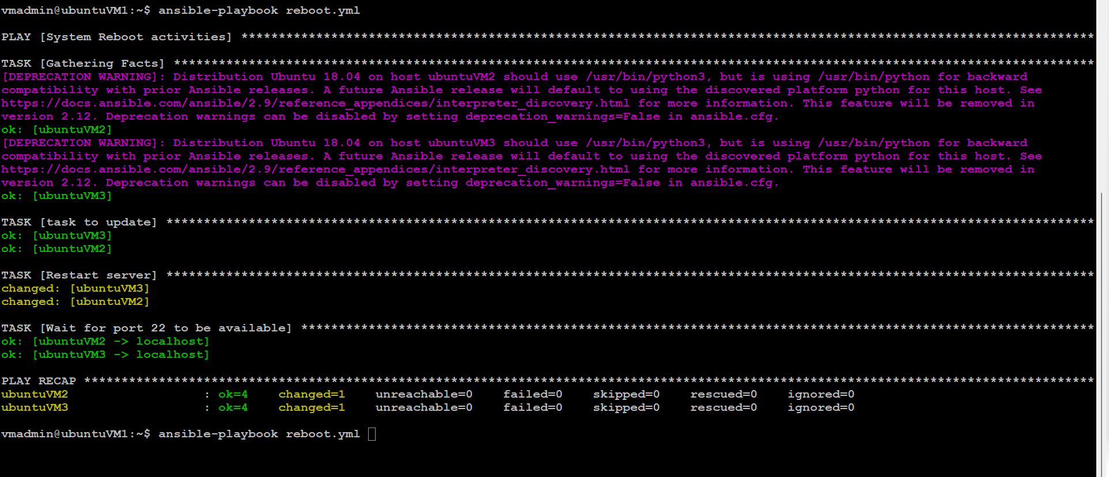

Reboot.yml

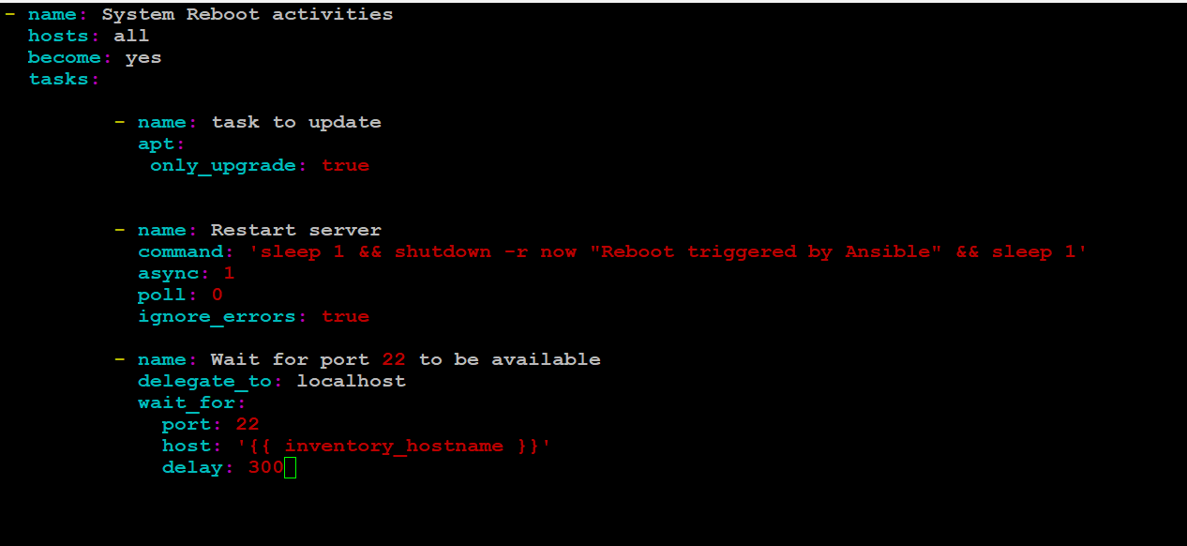

1. Security Guidelines for Server in Ansible

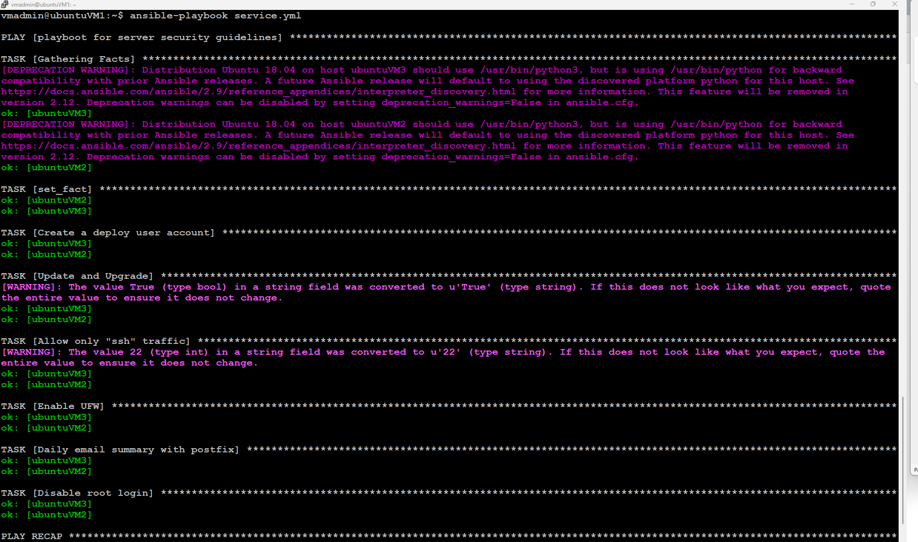

Service.yml

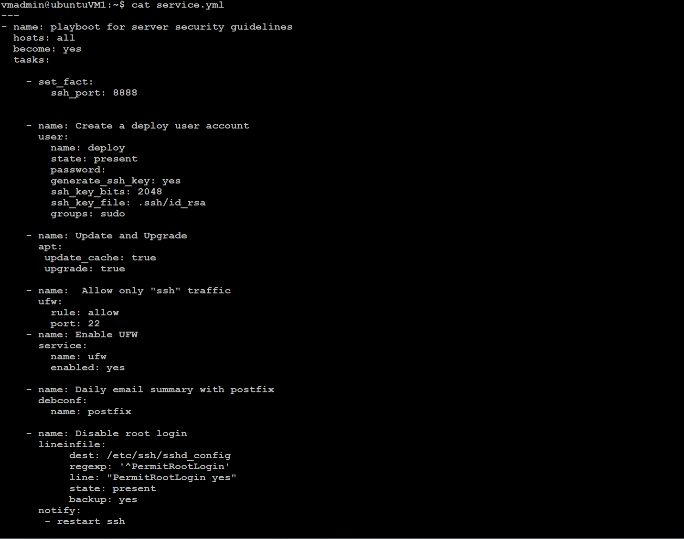

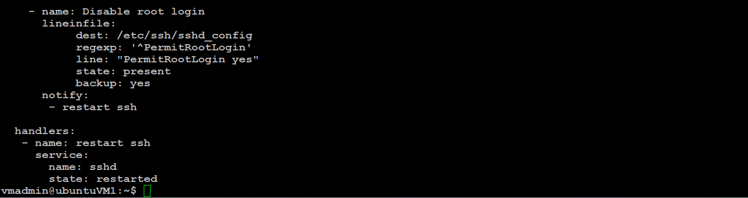

1. Ansible Rollback

Installing ansistrano.rollback role using requirements.yml

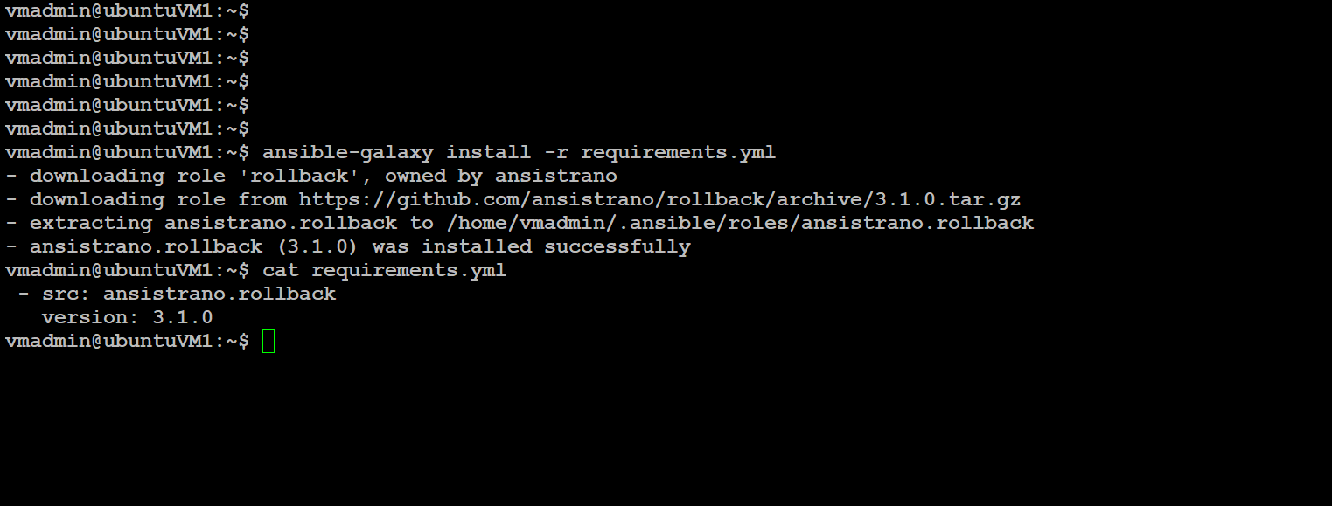

Rollback.yml

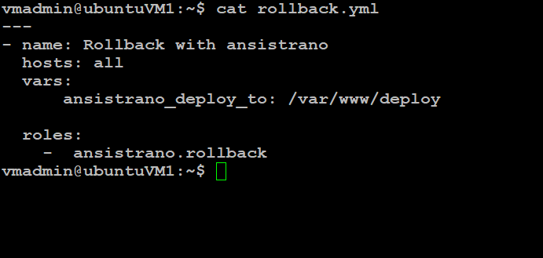

Ansistrano rollback playbook output:

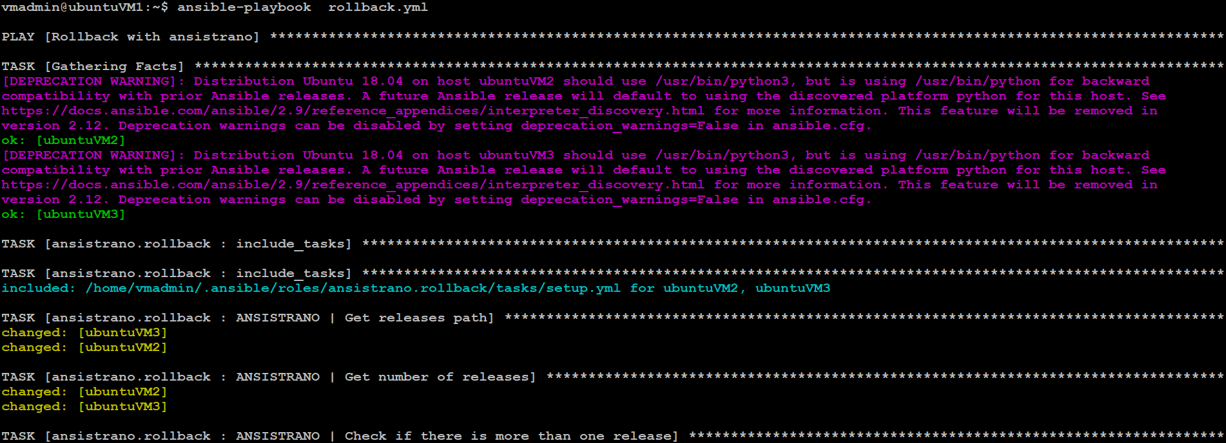

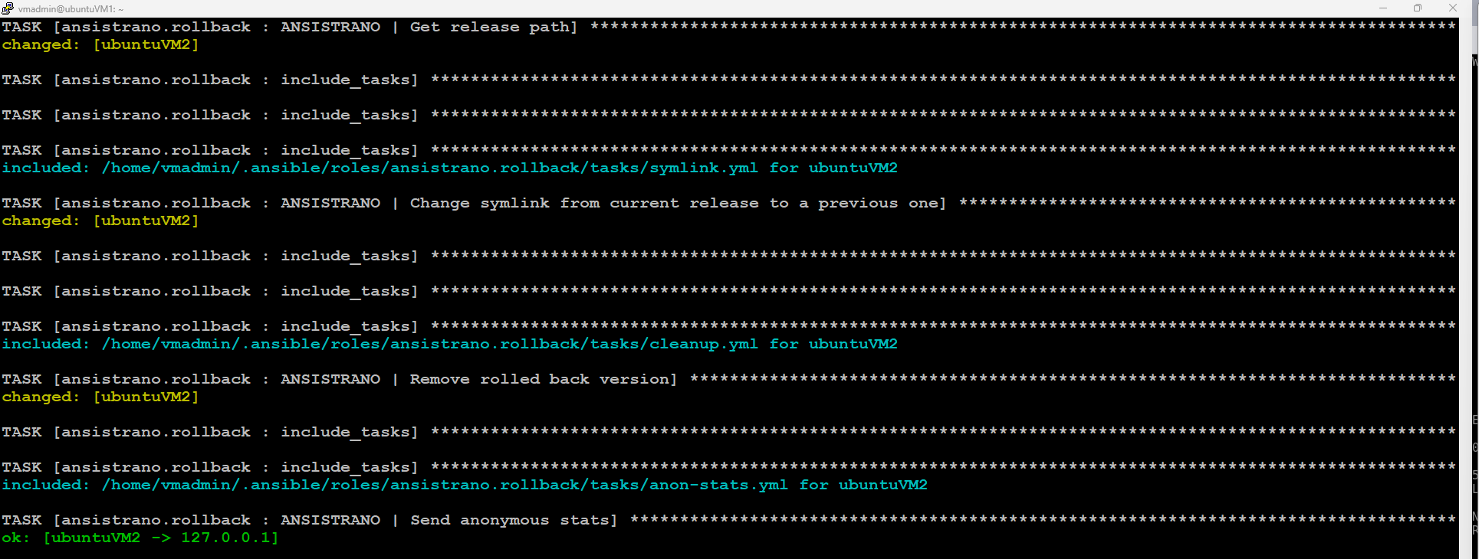

Creating nginx Role using ansible-galaxy

