Project Readme Template
Version 1 9/11/24
A single copy of this template should be filled out and submitted with each project submission, regardless of the number of students on the team. It should have the name readme_”teamname”
Also change the title of this template to “Project x Readme Team xxx”
1 | Team Name: Yohannes Mariam
2 | Team members names and netids: ymariam
3 | Overall project attempted, with sub-projects: Binpacking – the Knapsack problem - Backtracking
4 | Overall success of the project: It works
5 | Approximately total time (in hours) to complete: ~5 hours
6 | Link to github repository: https://github.com/ymariam1/Project1-TOC
7 | List of included files (if you have many files of a certain type, such as test files of different sizes, list just the folder): (Add more rows as necessary). Add more rows as necessary.  File/folder Name File Contents and Use  Code Files  Bin_packing_helper_LANK.py Timing_LANK.py This is where the logic for the backtracking and solving algorithm exists timing_lank.py is where the logic for timing the different experiments and generating the plots.  Test Files  Module_tests/tests.py This is where the testing logic exists, pulls from the dataset test_data_lank.txt  Output Files  All exist in results directory This is where we have the results of running all the tests and their outputs and the timing plots generated  Plots (as needed)  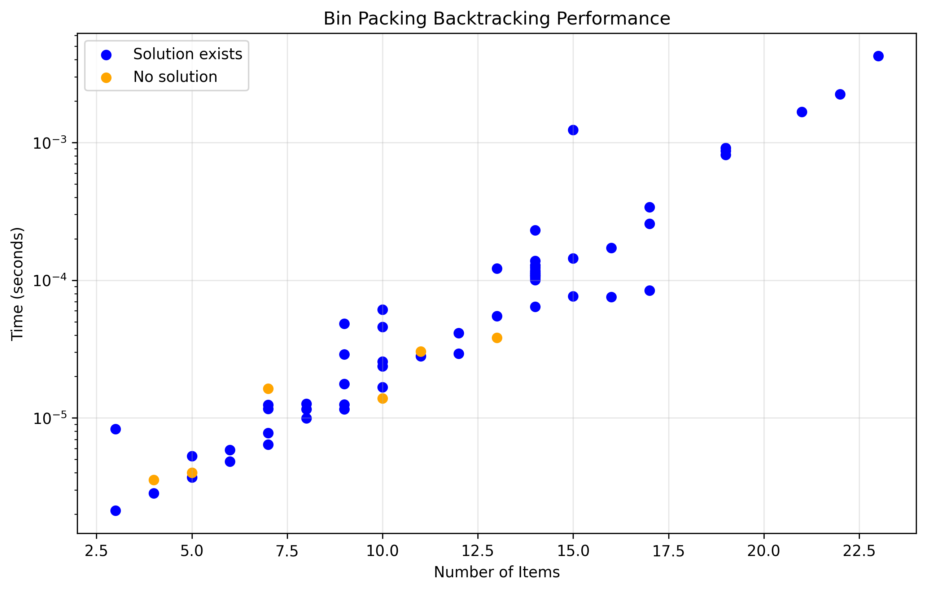
8 | Programming languages used, and associated libraries: Python
9 | Key data structures (for each sub-project): Backtracking:  - List as a stack: Used in the backtracking recursion to manage the current bin being filled. Items are appended during exploration and popped during backtracking.  - List of Lists: Used to store all valid solutions, where each inner list represents a valid bin configuration that sums exactly to the bin capacity.
10 | General operation of code (for each subproject): Backtracking at a high-level explores the solution space by building potential solutions one item at a time and abandoning them as soon as it determines they cannot lead to valid solutions. The time complexity of this was O(2^n) and space complexity was O(n)  More specifically this is a recursive solution that has the following steps  1) Extract the bin capacity and the list of items, then create an empty results list to store all valid solutions. Also create an empty temp list to build combinations. Then start with sum = 0 and start index = 0.  2) At each recursive step, check the current sum:  If sum equals bin capacity: Save a copy of the temp list to results, then return (we found a solution)  If sum is greater than capacity: Return immediately (this path is invalid)  If sum is less than capacity: Continue exploring (try adding more items)  3) Try adding each remaining item by first looping through items from the start index to the end. Before adding an item, check if it would make the sum exceed capacity. If the number is valid: append the item to temp list, then recursively call with the next index and updated sum After the recursive call returns: pop the item from temp list (backtrack to try other options)  4) Repeat step 2-3 for all possible combinations  5) Return the results list containing all valid bin combination
11 | What test cases you used/added, why you used them, what did they tell you about the correctness of your code.  At first, I implemented very simple test cases with fixed answers. I found the testcases for these from leetcode from the problem subset sum ii. Then once I had the logic down and returning the correct answers, I started to expand the items we could support within the algorithm with one test case having 23 items. I used these larger testcases to see how the code would perform when there was a larger n.
12 | How you managed the code development:  I sat down and built this in one sitting. First I explored the codebase to make sure I understood how the different files/classes interacted, and once I decided where my logic should go I wrote out the pseudocode on paper and then implemented it. After this I built the logic for testing, and then I created the code for generating the timings.
13 | Detailed discussion of results:  So far as the results go, with the different sized training the results are as expected. When there are not very many items we get near instantaneous results, and as we begin to increase the number of items up to 23 the average time increases, and as can be seen in the timing graph (which has a logarithmic y) we get exponential growth, and I predict that if we continue to increase the amount of items the timing will continue to grow in this pattern.
14 | How team was organized: n/a
15 | What you might do differently if you did the project again: I think I would’ve had a team, It wouldve been interesting to see how the different algorithms would have had different timings for the same data, and to be able to visualize the different time complexities would have been cool.
16 | Any additional material:

