你好，詹姆斯，我是博菲特出口贸易公司的阿米莉亚。

Hello James, this is Amelia from Beaufort Export Trading.

你是Technogym市场部经理詹姆斯吗？

Are you James, the marketing manager of Technogym?

詹姆斯是Technogym市场部的经理，也是我们公司的合作伙伴。

James is the manager of Technogym's marketing department and a partner of our company.

我的天，我想应该是我输入了错误的号码，打扰到你了，请原谅。

Sorry, I should have entered the wrong number. I'm sorry to disturb you. please forgive

相遇就是缘分，你来自哪里?  
Meeting is destiny, where are you from?

一个非常美丽的地方，有机会我会去旅行。

Your place is a very beautiful country. I have been there a few years ago, but I just don’t know how much has changed now?

我来自香港,你来过这里吗?

I am from Shenzhen, have you been here?

如果有机会，欢迎您来香港，这里的美食非常好，有很多值得一游的地方。

If you have the opportunity, you are welcome to come to China, the food here is very good, there are many places worth visiting

我的英文名字叫阿米莉亚，你叫什么名字？

My English name is Amelia, what is your name?

很高兴认识你。我喜欢旅行。并且结交世界各地的朋友。当我来到你国家旅行的时候。能有一个朋友可以接待我。并且介绍当地的文化和美食。如果你来中国旅行。我同样会接待你

Nice to meet you. I like to travel. And make friends from all over the world. When I come to travel in your country. There can be a friend who can receive me. And introduce the local culture and cuisine. If you travel to China. I'll do the same for you

COVID-19非常严重，否则我已经环游世界了，我去过非洲探险，挪威，加拿大，迪拜，新加坡，泰国，您的爱好是什么

Global COVID-19 is very serious. Otherwise I have traveled around the world, I have been to Africa, Norway, Canada, Dubai, Singapore, Thailand, etc. What are your hobbies

顺便问下。我在中国经营一家贸易公司。主要从事健身器材进出口业务。你从事什么行业？

by the way. I run a trading company in Shenzhen. Mainly engaged in the import and export business of fitness equipment. What industry are you in?

COVID-19对你的工作有影响吗？

Does COVID-19 affect your work?

那挺好的工作。 我希望上帝保佑。 COVID-19将尽快结束。 你的事业越来越好（自选）

That's good work. I hope God bless. COVID-19 will end as soon as possible. Your career is getting better

我希望上帝保佑。COVID-19尽快结束，让大家生活恢复正常（自选）

I hope God bless. COVID-19 will end as soon as possible and let everyone's life return to normal

我们可以相互交换照片，我怕你是机器人，希望你不要介意

We can exchange photos with each other and I hope you don't mind if I worry that you're a robot.

------------------------------------------------------------------------------------------------------------------------------------------------------------------------------------------------------------------------------------------------------------------- 发照片或者视频

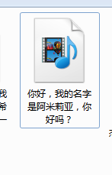

很高兴我们可以成为远方的朋友 ，明年3月份我会前往比利时进行健身器材销售项目启动！到时候我们面对面一起喝咖啡（根据客户的地方说地点）I

I'm glad we can be friends from afar, I'm going to Belgium this December for the launch of my fitness equipment sales project! We'll meet face to face for coffee!

等待几分钟，我将检查我的心电图（发加密货币走势图）

Wait a few minutes. I went to check my electrocardiogram

我的心率看起来不错。你能理解它是什么吗？

My heart rate looks good. Can you understand what it is?

抱歉。这是我第二个项目，加密货币投资，而不是心电图。我喜欢这样称呼它。希望我说心电图。它不会吓到你。 （自选）

Sorry. This is my second project, foreign exchange investment, not an electrocardiogram. I like to call it that way. Hope I said ECG. It will not scare you.😅

哈哈。你真聪明，这是我第二个项目，加密货币投资，而不是心电图。我喜欢这样称呼它。希望我说心电图。它不会吓到你。 （自选）

Haha. You are so smart, this is my second project, foreign exchange investment, not an electrocardiogram. I like to call it that way. Hope I said ECG. It will not scare you.😜

俗话说生活来源取决于工资。财富取决于投资，在这个时代有一些保值投资。可以保持稳定的收益，你在投资什么行业？

As the saying goes, the source of livelihood depends on wages. Wealth depends on investment, and there are some value-preserving investments in this era. Can maintain stable income, what industry are you investing in?

我喜欢旅游，健身，书法等，当然加密货币交易也是我的爱好之一

I like traveling, fitness, calligraphy, etc. Of course, foreign exchange trading is also one of my hobbies

客户聊投资，你就接着聊一些就是，问问客户的投资回报率之类的！

例如房地产投资或医疗投资以及金融投资，都是良好的投资项目。（选择性发送，也可以不发送）

For example, real estate investment or medical investment and financial investment are all good investment projects.

**（转私人号）我认为你是个有趣的人。也许我们可以成为无话不谈朋友。你可以加上我的私人WhatsApp。我通常用这个号码只联系我的朋友+852**

**I think you're an interesting person. Maybe we can be friends who talk about everything. You can add my private WhatsApp, I usually use this number to contact only my friends +852**

**在你添加我的私人号码以后，在Whatsapp给我发送一条信息，我会在第一时间保存你的姓名。**

**After you add my private number, send me a message on Whatsapp, and I will save your name as soon as possible.**

**转到私人号：**

很高兴再次见到你。这是我私人whatsAPP。在这里我们可以更好的沟通

Really happy to see you again. This is my private whatsAPP. Here we can communicate better

香港的生活节奏总是那么快，现在我要去研究美容院项目，如果合适我将进行投资



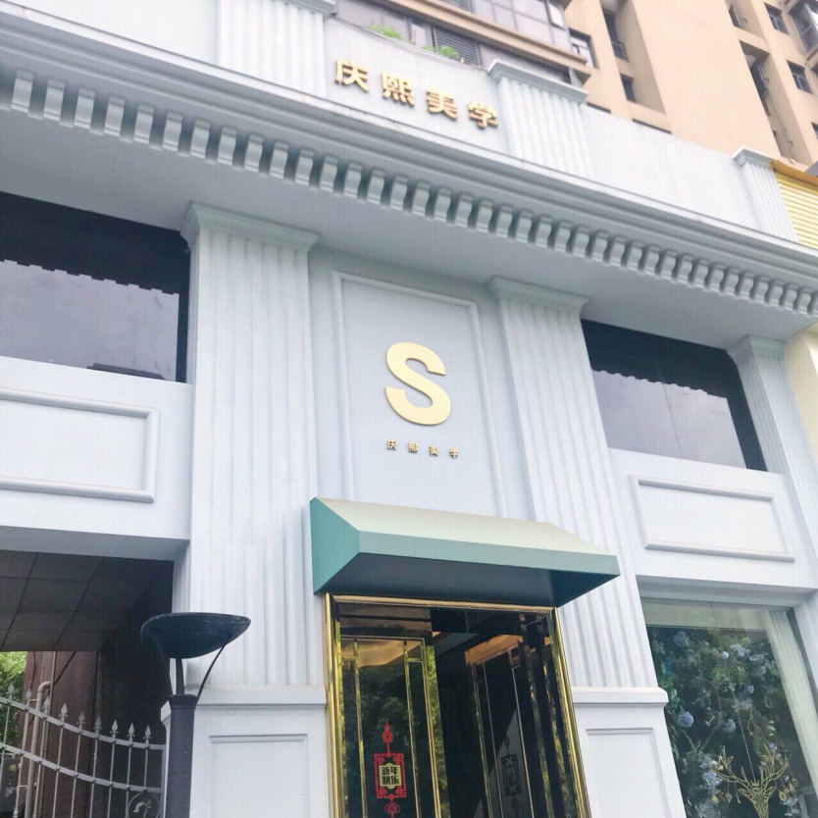

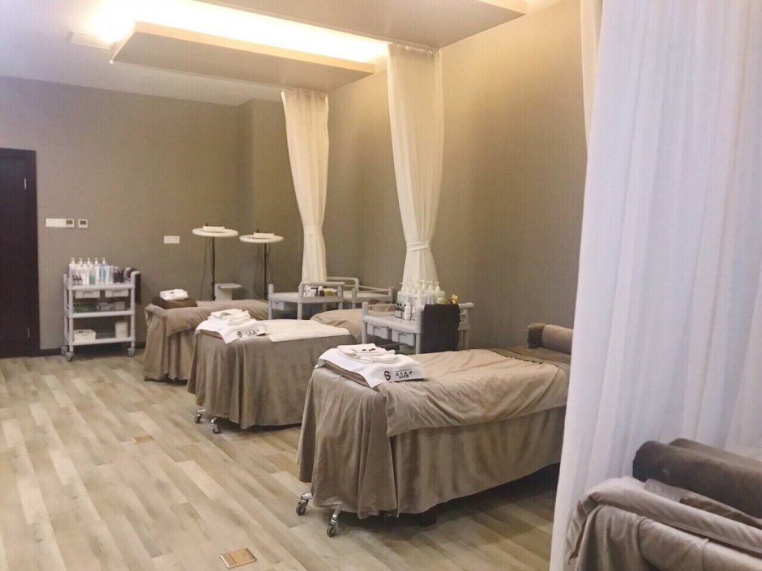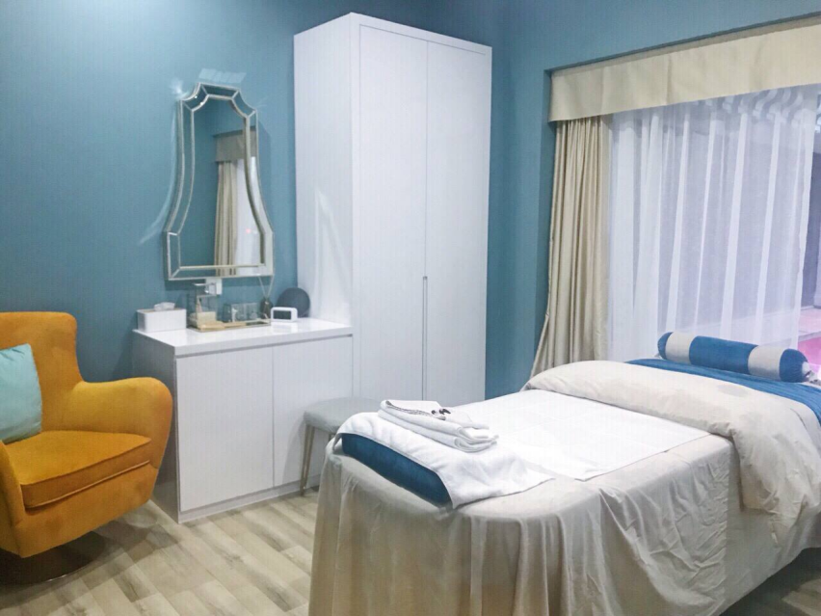

我们到了。 您如何看待这里的环境？  
We have arrived. What do you think of the environment here?

这家美容院的主题是创造家的温暖，让顾客体验到家的温暖，因此它看起来像一个公寓  
The theme of this beauty salon is to create the warmth of home so that customers can experience the warmth of home, so it looks like an apartment

这家美容院是我的好姐妹因为疫情大流行的影响，不得不出售一些公司股份，以缓解公司资金的压力，我刚好过来了解一下是否可以投资

This beauty salon is a good friend of mine. Because of the pandemic, I had to sell some company shares to relieve the pressure on the company’s funds. I just came over to find out if I can invest.

(接下来可以延伸和客户聊一些投资的话题）

睡前说：明天是我公司三周年纪念日，这是一个有意义的日子，我要早点休息，明天我们会组织员工一起去希望小学献爱心，为这个社会留下一些属于我们公司的贡献！