Guide to setup Raspberry Pi Plant Automation

- Connect arduino with your PC and Flash arduino code provide to you
https://www.youtube.com/watch?v=5OtMqr5hGjE
- Wire as per:
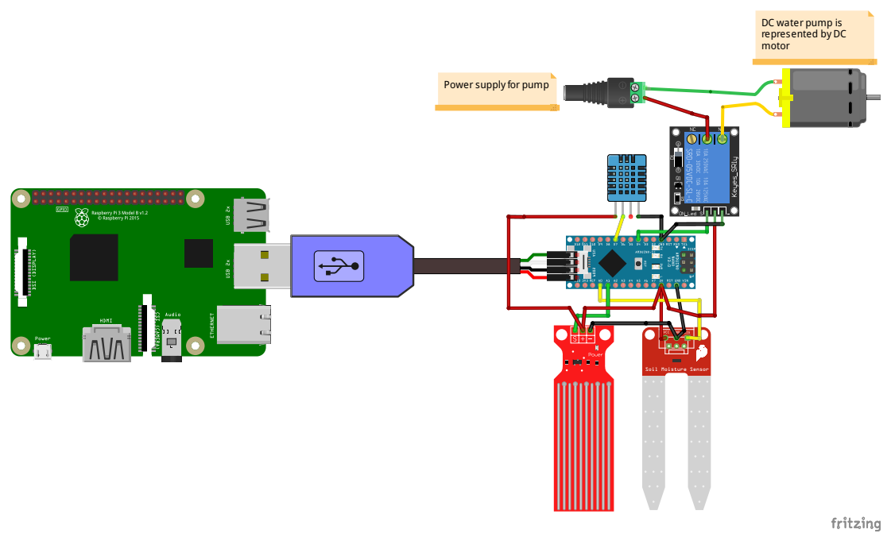
Overview of python code:

from serial import Serial
import sys
import urllib2
from time import sleep

# Enter Your API key here
myAPI = '1YJZRBLZ5BV9A4CM'
# URL where we will send the data, Don't change it
baseURL = 'https://api.thingspeak.com/update?api_key=%s' % myAPI
#serial object to read from arduino serial port. Run this command to check your serial port “dmesg | grep tty”
ser = Serial(port='/dev/ttyACM1',baudrate = 9600)

while 1:
try:
if ser.is_open:
if ser.in_waiting>0:
x=ser.readline()
y=x.split(",")
temp=y[1]
humidity=y[0]
soil_moisture=y[2]
water_level=y[3]
print humidity,temp,soil_moisture,water_level
# Sending the data to thingspeak
conn = urllib2.urlopen(baseURL + '&field1=%s&field2=%s&field3=%s&field4=%s' % (water_level, soil_moisture,temp,humidity))
print conn.read()
# Closing the connection
conn.close()
sleep(10)
except:
print("Error")

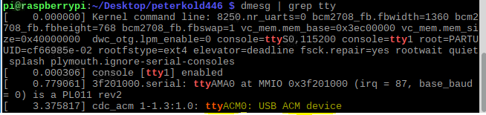
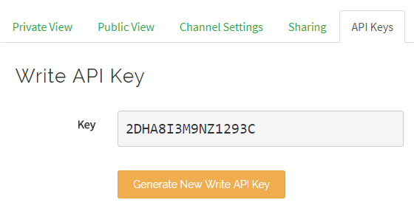

This is the api key you need to replace in the code.
g

