**MicroTUTOR with Pterm**

# **A Brief User Guide**

By Dale Sinder

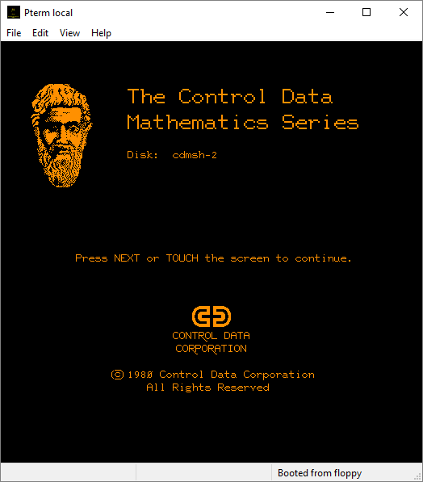

Pterm version 5.1 has been updated to provide support for the MicroTUTOR language, which runs lessons and parts of lessons inside the Pterm emulator. This document is a brief guide to using those new features. It is suggested that you familiarize yourself with MicroTUTOR by pressing Q on the Author Mode page and then typing μtutor and pressing NEXT. The μ symbol is typed by pressing F4 and then m.

# Running a prepared floppy disk image

We will first discuss how to run a pre-existing floppy such as those available at <http://www.controlfreaks.org/twiki/bin/view/Main/MicroPlato> or <http://drs.ddns.net/index/mtutor/ToTom.zip>

To run a floppy first create a new Profile:

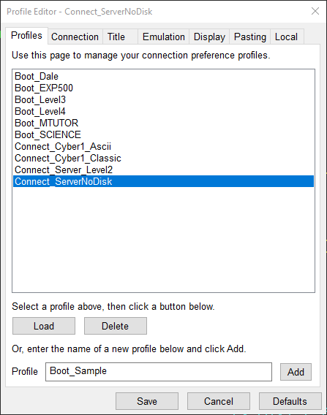

Click Add to add the profile.

PTerm has new items on the Preferences -> Local Tab. Go to it next.

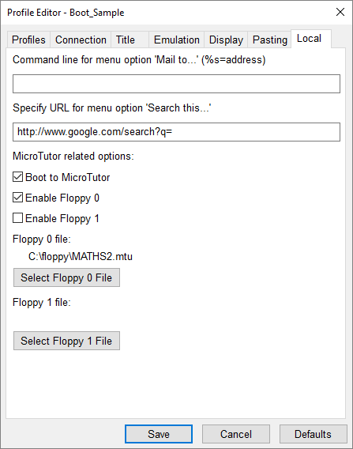

Find the MATHS2.mtu file by using the Select Floppy 0 File button. Select it. Select Enable floppy 0 and Boot to Micro Tutor. Return then return the Preferences tab and Save. Then use the Menu File -> New Terminal Window…

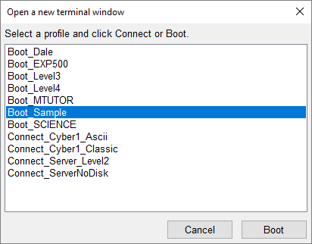

Double click on the new profile and you should see:



Then just use the lessons.

# Creating a new disk

To create a new Floppy image follow these steps:

* Create a new text file with a few characters in it.
* Rename the file diskx.mtu where diskx it the name you choose for the disk.
* Attach the new disk as shown below (I’m using Dale4.mtu) and do not select Boot to MicroTutor:

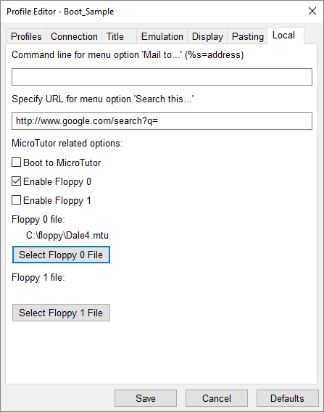

* Save this profile and open it. Log in to PLATO/Cybis as an author.
* Use lesson floppy:

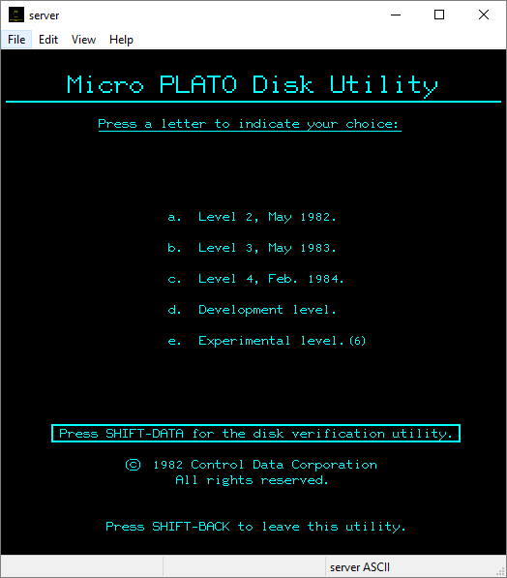

* Choose option c for Level 4.
* Follow the directions to initialize a new disk.
* Press SHIFT-DATA to load the utility to your disk.

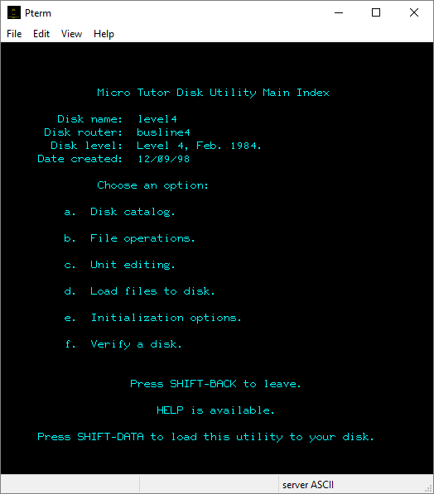

* You can then proceed to load files (lessons and charsets) to your disk.

# Running MicroTUTOR units from PLATO/Cybis.

This is an advanced topic. Press Q on the Author Mode page and then type μtutor and press NEXT to learn about this topic.