## ECE 555 Spring 2022



## Pavel Koprov

# HW1



**System Pose Graph**

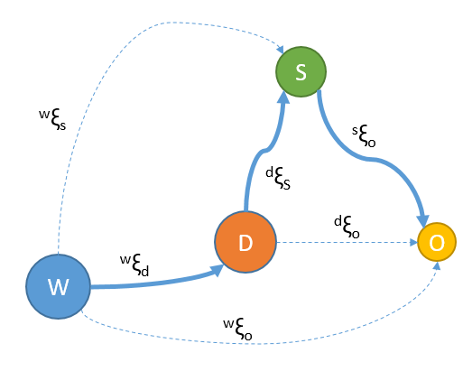

**Pose of the drone (black), camera (red) and object (green) w.r.t. world.**

