## ISE 589 Spring 2023



## Pavel Koprov

# HW1



### **Problem 1.**

|  |  |  |  |  |  |
| --- | --- | --- | --- | --- | --- |
| A | B | C | $$\overline{A}$$ | $$\overline{A}+\overline{B}$$ | Y |
| 0 | 0 | 0 | 1 | 1 | 0 |
| 0 | 0 | 1 | 1 | 1 | 1 |
| 0 | 1 | 0 | 1 | 1 | 0 |
| 0 | 1 | 1 | 1 | 1 | 1 |
| 1 | 0 | 0 | 0 | 1 | 0 |
| 1 | 1 | 0 | 0 | 0 | 0 |
| 1 | 1 | 1 | 0 | 0 | 0 |

### **Problem 2.**

1. 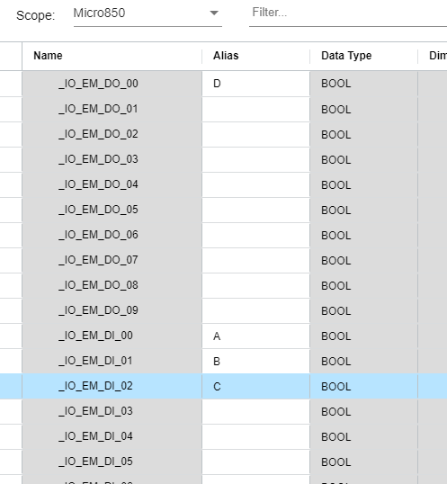
2. 
3. 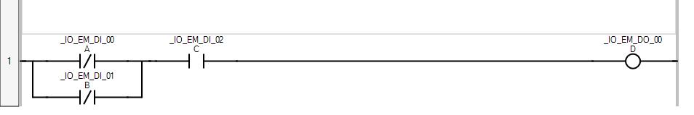
4. 