MOESI Protocol

1. INTRODUCTION

In this task, we implement a version of the MOESI protocol and verify its performance. The results are obtained by testing on a simulator with different numbers of processors (1 to 8 processors) using different standard trace files for each case.

1. MOESI PROTOCOL AND IMPLEMENTATION

In this protocol caches can be in five states, M (Modified), O (Owned), E (Exclusive), S (Shared) and I (Invalid). We ran the simulation with 3 different trace files, which are random, debug, and FFT with 1-8 processors. The results are as presented below.

Below are the results for the debug algorithm:

|  |  |  |  |  |  |  |  |  |  |
| --- | --- | --- | --- | --- | --- | --- | --- | --- | --- |
| **Algorithm** | **Cache Information** | | | | | | | | |
| ***CPU*** | ***Reads*** | ***Read Hit*** | ***Read Miss*** | ***Write*** | ***Write Hit*** | ***Write Miss*** | ***Hit Rate*** | ***Run Time*** |
| dbg_p1.trf | 0 | 40 | 19 | 21 | 60 | 26 | 34 | 45.00% |  |
| Total |  | 40 | 19 | 21 | 60 | 26 | 34 | 45.00% | 5602ns |
| Average |  | 40 | 19 | 21 | 60 | 26 | 34 | 45.00% |  |

Total number of read/write operations: 100

Main memory access rates

Bus had 21 reads, 34 reads_ex, 0 writes and 0 upgrades.

A total of 55 accesses.

Average time for bus acquisition

There were 0 waits for the bus.

Average waiting time per access: 0.000000 cycles.

Valid Snoop Stats::0 read 0 read_ex 0 upgrade 0 Total: 0 Shared counter: 0

The Average Memory Access Time is: 56

|  |  |  |  |  |  |  |  |  |  |
| --- | --- | --- | --- | --- | --- | --- | --- | --- | --- |
| **Algorithm** | **Cache Information** | | | | | | | | |
| ***CPU*** | ***Reads*** | ***Read Hit*** | ***Read Miss*** | ***Write*** | ***Write Hit*** | ***Write Miss*** | ***Hit Rate*** | ***Run Time*** |
| dbg_p2.trf | 0 | 30 | 0 | 30 | 25 | 1 | 24 | 1.82% |  |
|  | 1 | 32 | 0 | 32 | 35 | 1 | 34 | 1.49% |  |
| Total |  | 62 | 0 | 62 | 60 | 2 | 58 | 1.64% | 6602ns |
| Average |  | 31 | 0 | 31 | 30 | 1 | 24 | 1.64% |  |

Total number of read/write operations: 122

Main memory access rates

Bus had 62 reads, 58 reads_ex, 0 writes and 0 upgrades.

A total of 120 accesses.

Average time for bus acquisition

There were 0 waits for the bus.

Average waiting time per access: 0.000000 cycles.

Valid Snoop Stats::0 read 0 read_ex 0 upgrade 0 Total:: 0 Shared counter: 0

Valid Snoop Stats::1 read 0 read_ex 0 upgrade 0 Total:: 0 Shared counter: 0

The Average Memory Access Time is: 99.36

|  |  |  |  |  |  |  |  |  |  |
| --- | --- | --- | --- | --- | --- | --- | --- | --- | --- |
| **Algorithm** | **Cache Information** | | | | | | | | |
| ***CPU*** | ***Reads*** | ***Read Hit*** | ***Read Miss*** | ***Write*** | ***Write Hit*** | ***Write Miss*** | ***Hit Rate*** | ***Run Time*** |
| dbg_p4.trf | 0 | 8 | 0 | 8 | 8 | 1 | 7 | 6.25% |  |
|  | 1 | 27 | 0 | 27 | 32 | 0 | 32 | 0.00% |  |
|  | 2 | 43 | 1 | 42 | 38 | 2 | 36 | 3.70% |  |
|  | 3 | 45 | 0 | 45 | 42 | 0 | 42 | 0.00% |  |
| Total |  | 123 | 1 | 122 | 120 | 3 | 117 | 1.65% | 8706ns |
| Average |  | 30.75 | 0.25 | 30.5 | 30 | 0.75 | 29.25 | 1.65% |  |

Total number of read/write operations: 242

Main memory access rates

Bus had 122 reads, 117 reads_ex, 0 writes and 0 upgrades.

A total of 239 accesses.

Average time for bus acquisition

There were 4 waits for the bus.

Average waiting time per access: 0.032787 cycles.

Valid Snoop Stats::0 read 0 read_ex 0 upgrade 0 Total:: 0 Shared counter: 0

Valid Snoop Stats::1 read 0 read_ex 0 upgrade 0 Total:: 0 Shared counter: 0

Valid Snoop Stats::2 read 0 read_ex 0 upgrade 0 Total:: 0 Shared counter: 1

Valid Snoop Stats::3 read 0 read_ex 1 upgrade 0 Total:: 1 Shared counter: 0

The Average Memory Access Time is: 99.35

|  |  |  |  |  |  |  |  |  |  |
| --- | --- | --- | --- | --- | --- | --- | --- | --- | --- |
| **Algorithm** | **Cache Information** | | | | | | | | |
| ***CPU*** | ***Reads*** | ***Read Hit*** | ***Read Miss*** | ***Write*** | ***Write Hit*** | ***Write Miss*** | ***Hit Rate*** | ***Run Time*** |
| dbg_p8.trf | 0 | 6 | 0 | 6 | 4 | 0 | 4 | 0.00% |  |
|  | 1 | 34 | 0 | 34 | 22 | 0 | 22 | 0.00% |  |
|  | 2 | 35 | 0 | 35 | 43 | 0 | 43 | 0.00% |  |
|  | 3 | 39 | 2 | 37 | 46 | 2 | 44 | 4.71% |  |
|  | 4 | 36 | 0 | 36 | 55 | 0 | 55 | 0.00% |  |
|  | 5 | 52 | 0 | 52 | 46 | 0 | 46 | 0.00% |  |
|  | 6 | 48 | 3 | 45 | 51 | 2 | 49 | 5.05% |  |
|  | 7 | 42 | 1 | 41 | 55 | 5 | 50 | 6.19% |  |
| Total |  | 292 | 6 | 286 | 322 | 8 | 313 | 2.28% | 9920ns |
| Average |  | 36.5 | 0.75 | 35.75 | 40.25 | 1 | 39.125 | 2.28% |  |

Total number of read/write operations: 614

Main memory access rates

Bus had 286 reads, 313 reads_ex, 0 writes and 1 upgrades.

A total of 600 accesses.

Average time for bus acquisition

There were 70 waits for the bus.

Average waiting time per access: 0.244755 cycles.

Valid Snoop Stats::0 read 0 read_ex 0 upgrade 0 Total:: 0 Shared counter: 0

Valid Snoop Stats::1 read 0 read_ex 0 upgrade 0 Total:: 0 Shared counter: 0

Valid Snoop Stats::2 read 0 read_ex 0 upgrade 0 Total:: 0 Shared counter: 0

Valid Snoop Stats::3 read 0 read_ex 0 upgrade 0 Total:: 0 Shared counter: 1

Valid Snoop Stats::4 read 1 read_ex 0 upgrade 0 Total:: 1 Shared counter: 0

Valid Snoop Stats::5 read 0 read_ex 0 upgrade 0 Total:: 0 Shared counter: 0

Valid Snoop Stats::6 read 1 read_ex 0 upgrade 1 Total:: 2 Shared counter: 3

Valid Snoop Stats::7 read 0 read_ex 3 upgrade 0 Total:: 3 Shared counter: 1

The Average Memory Access Time is: 98.72

Below are the results for the FFT algorithm:

|  |  |  |  |  |  |  |  |  |  |
| --- | --- | --- | --- | --- | --- | --- | --- | --- | --- |
| **Algorithm** | **Cache Information** | | | | | | | | |
| ***CPU*** | ***Reads*** | ***Read Hit*** | ***Read Miss*** | ***Write*** | ***Write Hit*** | ***Write Miss*** | ***Hit Rate*** | ***Run Time*** |
| fft_16_p1.trf | 0 | 86298 | 7264 | 79034 | 43195 | 10974 | 32221 | 14.08% |  |
| Total |  | 86298 | 7264 | 79034 | 43195 | 10974 | 32221 | 14.08% | 11292628ns |
| Average |  | 86298 | 7264 | 79034 | 43195 | 10974 | 32221 | 14.08% |  |

Total number of read/write operations: 129493

Main memory access rates

Bus had 79034 reads, 32221 reads_ex, 37633 writes and 0 upgrades.

A total of 148888 accesses.

Average time for bus acquisition

There were 0 waits for the bus.

Average waiting time per access: 0.000000 cycles.

Valid Snoop Stats::0 read 0 read_ex 0 upgrade 0 Total:: 0 Shared counter: 0

The Average Memory Access Time is: 86.92

|  |  |  |  |  |  |  |  |  |  |
| --- | --- | --- | --- | --- | --- | --- | --- | --- | --- |
| **Algorithm** | **Cache Information** | | | | | | | | |
| ***CPU*** | ***Reads*** | ***Read Hit*** | ***Read Miss*** | ***Write*** | ***Write Hit*** | ***Write Miss*** | ***Hit Rate*** | ***Run Time*** |
| fft_16_p2.trf | 0 | 29312 | 3497 | 25815 | 15417 | 2209 | 13208 | 12.76% |  |
|  | 1 | 29262 | 3408 | 25854 | 14801 | 2046 | 12755 | 12.38% |  |
| Total |  | 58574 | 6905 | 51669 | 30218 | 4255 | 25963 | 12.57% | 3967502ns |
| Average |  | 29287 | 3452.5 | 25834.5 | 15109 | 2127.5 | 12981.5 | 12.57% |  |

Total number of read/write operations: 88792

Main memory access rates

Bus had 51669 reads, 25963 reads_ex, 28285 writes and 3 upgrades.

A total of 105920 accesses.

Average time for bus acquisition

There were 718 waits for the bus.

Average waiting time per access: 0.008980 cycles.

Valid Snoop Stats::0 read 249 read_ex 9 upgrade 2 Total:: 260 Shared counter: 264

Valid Snoop Stats::1 read 258 read_ex 10 upgrade 1 Total:: 269 Shared counter: 247

The Average Memory Access Time is: 88.43

|  |  |  |  |  |  |  |  |  |  |
| --- | --- | --- | --- | --- | --- | --- | --- | --- | --- |
| **Algorithm** | **Cache Information** | | | | | | | | |
| ***CPU*** | ***Reads*** | ***Read Hit*** | ***Read Miss*** | ***Write*** | ***Write Hit*** | ***Write Miss*** | ***Hit Rate*** | ***Run Time*** |
| fft_16_p4.trf | 0 | 11274 | 1690 | 9584 | 6552 | 966 | 5586 | 14.90% |  |
|  | 1 | 9417 | 1407 | 8010 | 6083 | 746 | 5337 | 13.89% |  |
|  | 2 | 9834 | 1457 | 8377 | 5523 | 591 | 4932 | 13.34% |  |
|  | 3 | 9881 | 1465 | 8416 | 5972 | 693 | 5279 | 13.61% |  |
| Total |  | 40406 | 6019 | 34387 | 24130 | 2996 | 21134 | 13.97% | 1532682ns |
| Average |  | 10101.5 | 1508.25 | 8593.25 | 6032.5 | 751 | 5281.5 | 13.97% |  |

Total number of read/write operations: 64536

Main memory access rates

Bus had 34387 reads, 21134 reads_ex, 21728 writes and 16 upgrades.

A total of 77265 accesses.

Average time for bus acquisition

There were 1822 waits for the bus.

Average waiting time per access: 0.032469 cycles.

Valid Snoop Stats::0 read 322 read_ex 46 upgrade 5 Total:: 373 Shared counter: 291

Valid Snoop Stats::1 read 383 read_ex 39 upgrade 3 Total:: 425 Shared counter: 304

Valid Snoop Stats::2 read 363 read_ex 40 upgrade 1 Total:: 404 Shared counter: 344

Valid Snoop Stats::3 read 421 read_ex 39 upgrade 4 Total:: 464 Shared counter: 333

The Average Memory Access Time is: 87.03

|  |  |  |  |  |  |  |  |  |  |
| --- | --- | --- | --- | --- | --- | --- | --- | --- | --- |
| **Algorithm** | **Cache Information** | | | | | | | | |
| ***CPU*** | ***Reads*** | ***Read Hit*** | ***Read Miss*** | ***Write*** | ***Write Hit*** | ***Write Miss*** | ***Hit Rate*** | ***Run Time*** |
| fft_16_p8.trf | 0 | 4956 | 1022 | 3934 | 3153 | 716 | 2437 | 21.43% |  |
|  | 1 | 3983 | 793 | 3190 | 2890 | 541 | 2349 | 19.41% |  |
|  | 2 | 3997 | 807 | 3190 | 2703 | 474 | 2229 | 19.12% |  |
|  | 3 | 4043 | 813 | 3230 | 2695 | 464 | 2231 | 18.95% |  |
|  | 4 | 4055 | 788 | 3267 | 2662 | 463 | 2199 | 18.62% |  |
|  | 5 | 4055 | 797 | 3258 | 2733 | 490 | 2243 | 18.96% |  |
|  | 6 | 4074 | 768 | 3306 | 2710 | 422 | 2288 | 17.54% |  |
|  | 7 | 4124 | 808 | 3316 | 2705 | 443 | 2262 | 18.32% |  |
| Total |  | 33287 | 6792 | 26495 | 22251 | 4204 | 18047 | 7.57% | 631463ns |
| Average |  | 4160.875 | 849 | 3311.875 | 2781.375 | 525.5 | 2255.875 | 7.57% |  |

Total number of read/write operations: 55538

Main memory access rates

Bus had 26691 reads, 18238 reads_ex, 17032 writes and 50 upgrades.

A total of 62011 accesses.

Average time for bus acquisition

There were 4176 waits for the bus.

Average waiting time per access: 0.095510 cycles.

Valid Snoop Stats::0 read 342 read_ex 82 upgrade 3 Total:: 427 Shared counter: 278

Valid Snoop Stats::1 read 369 read_ex 60 upgrade 5 Total:: 434 Shared counter: 280

Valid Snoop Stats::2 read 392 read_ex 73 upgrade 6 Total:: 471 Shared counter: 357

Valid Snoop Stats::3 read 410 read_ex 86 upgrade 7 Total:: 503 Shared counter: 352

Valid Snoop Stats::4 read 422 read_ex 77 upgrade 4 Total:: 503 Shared counter: 346

Valid Snoop Stats::5 read 417 read_ex 80 upgrade 2 Total:: 499 Shared counter: 298

Valid Snoop Stats::6 read 397 read_ex 94 upgrade 3 Total:: 494 Shared counter: 319

Valid Snoop Stats::7 read 415 read_ex 74 upgrade 5 Total:: 494 Shared counter: 367

The Average Memory Access Time is: 93.43

Below are the results for the random algorithm:

|  |  |  |  |  |  |  |  |  |  |
| --- | --- | --- | --- | --- | --- | --- | --- | --- | --- |
| **Algorithm** | **Cache Information** | | | | | | | | |
| ***CPU*** | ***Reads*** | ***Read Hit*** | ***Read Miss*** | ***Write*** | ***Write Hit*** | ***Write Miss*** | ***Hit Rate*** | ***Run Time*** |
| rnd_p1.trf | 0 | 33031 | 18659 | 14372 | 32505 | 18306 | 14199 | 56.40% |  |
| Total |  | 33031 | 18659 | 14372 | 32505 | 18306 | 14199 | 56.40% | 2942692ns |
| Average |  | 33031 | 18659 | 14372 | 32505 | 18306 | 14199 | 56.40% |  |

Total number of read/write operations: 65536

Main memory access rates

Bus had 14372 reads, 14199 reads_ex, 20054 writes and 0 upgrades.

A total of 48625 accesses.

Average time for bus acquisition

There were 0 waits for the bus.

Average waiting time per access: 0.000000 cycles.

Valid Snoop Stats::0 read 0 read_ex 0 upgrade 0 Total:: 0 Shared counter: 0

The Average Memory Access Time is: 44.60

|  |  |  |  |  |  |  |  |  |  |
| --- | --- | --- | --- | --- | --- | --- | --- | --- | --- |
| **Algorithm** | **Cache Information** | | | | | | | | |
| ***CPU*** | ***Reads*** | ***Read Hit*** | ***Read Miss*** | ***Write*** | ***Write Hit*** | ***Write Miss*** | ***Hit Rate*** | ***Run Time*** |
| rnd_p2.trf | 0 | 16496 | 385 | 16111 | 16402 | 393 | 16009 | 2.36% |  |
|  | 1 | 24556 | 865 | 23691 | 24804 | 877 | 23927 | 3.53% |  |
| Total |  | 41052 | 1250 | 39802 | 41206 | 1270 | 39936 | 1.54% | 4851678ns |
| Average |  | 20526 | 625 | 19901 | 20603 | 635 | 19968 | 1.54% |  |

Total number of read/write operations: 82258

Main memory access rates

Bus had 39802 reads, 39936 reads_ex, 39515 writes and 0 upgrades.

A total of 119253 accesses.

Average time for bus acquisition

There were 811 waits for the bus.

Average waiting time per access: 0.010225 cycles.

Valid Snoop Stats::0 read 0 read_ex 0 upgrade 0 Total:: 0 Shared counter: 0

Valid Snoop Stats::1 read 0 read_ex 0 upgrade 0 Total:: 0 Shared counter: 0

The Average Memory Access Time is: 99.46

|  |  |  |  |  |  |  |  |  |  |
| --- | --- | --- | --- | --- | --- | --- | --- | --- | --- |
| **Algorithm** | **Cache Information** | | | | | | | | |
| ***CPU*** | ***Reads*** | ***Read Hit*** | ***Read Miss*** | ***Write*** | ***Write Hit*** | ***Write Miss*** | ***Hit Rate*** | ***Run Time*** |
| rnd_p4.trf | 0 | 8039 | 85 | 7954 | 8251 | 89 | 8162 | 1.07% |  |
|  | 1 | 20450 | 0 | 20450 | 20221 | 0 | 20221 | 0.00% |  |
|  | 2 | 26553 | 982 | 25571 | 26498 | 1056 | 25442 | 3.84% |  |
|  | 3 | 29600 | 0 | 29600 | 29695 | 3 | 29692 | 0.01% |  |
| Total |  | 84642 | 1067 | 83575 | 84665 | 1148 | 83517 | 0.68% | 6023634ns |
| Average |  | 21160.5 | 266.75 | 20893.75 | 21166.25 | 287 | 20879.25 | 0.68% |  |

Total number of read/write operations: 169307

Main memory access rates

Bus had 83575 reads, 83517 reads_ex, 82072 writes and 1 upgrades.

A total of 249165 accesses.

Average time for bus acquisition

There were 5266 waits for the bus.

Average waiting time per access: 0.031790 cycles.

Valid Snoop Stats::0 read 9 read_ex 2 upgrade 0 Total:: 11 Shared counter: 29

Valid Snoop Stats::1 read 26 read_ex 21 upgrade 1 Total:: 48 Shared counter: 16

Valid Snoop Stats::2 read 2 read_ex 5 upgrade 0 Total:: 7 Shared counter: 42

Valid Snoop Stats::3 read 20 read_ex 17 upgrade 0 Total:: 37 Shared counter: 30

The Average Memory Access Time is: 100.32

|  |  |  |  |  |  |  |  |  |  |
| --- | --- | --- | --- | --- | --- | --- | --- | --- | --- |
| **Algorithm** | **Cache Information** | | | | | | | | |
| ***CPU*** | ***Reads*** | ***Read Hit*** | ***Read Miss*** | ***Write*** | ***Write Hit*** | ***Write Miss*** | ***Hit Rate*** | ***Run Time*** |
| rnd_p8.trf | 0 | 4113 | 22 | 4091 | 4030 | 35 | 3995 | 0.70% |  |
|  | 1 | 18318 | 0 | 18318 | 18440 | 0 | 18440 | 0.00% |  |
|  | 2 | 25834 | 22 | 25812 | 25470 | 33 | 25437 | 0.11% |  |
|  | 3 | 29549 | 1275 | 28274 | 28801 | 1180 | 27621 | 4.21% |  |
|  | 4 | 31366 | 2 | 31364 | 30548 | 1 | 30547 | 0.00% |  |
|  | 5 | 32015 | 11 | 32004 | 31781 | 21 | 31760 | 0.05% |  |
|  | 6 | 32327 | 1620 | 30707 | 32285 | 1642 | 30643 | 5.05% |  |
|  | 7 | 32536 | 1681 | 30855 | 32584 | 1764 | 30820 | 5.29% |  |
| Total |  | 206058 | 4633 | 201425 | 203939 | 4676 | 199263 | 2.27% | 6459680ns |
| Average |  | 25757.25 | 579.13 | 25178.13 | 25492.38 | 584.5 | 24907.88 | 2.27% |  |

Total number of read/write operations: 409997

Main memory access rates

Bus had 201425 reads, 199263 reads_ex, 197231 writes and 50 upgrades.

A total of 597969 accesses.

Average time for bus acquisition

There were 26322 waits for the bus.

Average waiting time per access: 0.066027 cycles.

Valid Snoop Stats::0 read 111 read_ex 94 upgrade 0 Total:: 205 Shared counter: 9

Valid Snoop Stats::1 read 52 read_ex 54 upgrade 0 Total:: 106 Shared counter: 207

Valid Snoop Stats::2 read 64 read_ex 55 upgrade 0 Total:: 119 Shared counter: 159

Valid Snoop Stats::3 read 18 read_ex 21 upgrade 0 Total:: 39 Shared counter: 61

Valid Snoop Stats::4 read 66 read_ex 67 upgrade 0 Total:: 133 Shared counter: 135

Valid Snoop Stats::5 read 59 read_ex 62 upgrade 2 Total:: 123 Shared counter: 195

Valid Snoop Stats::6 read 739 read_ex 733 upgrade 26 Total:: 1498 Shared counter: 1398

Valid Snoop Stats::7 read 584 read_ex 589 upgrade 22 Total:: 1195 Shared counter: 1738

The Average Memory Access Time is: 98.73

1. SIMULATION RESULTS

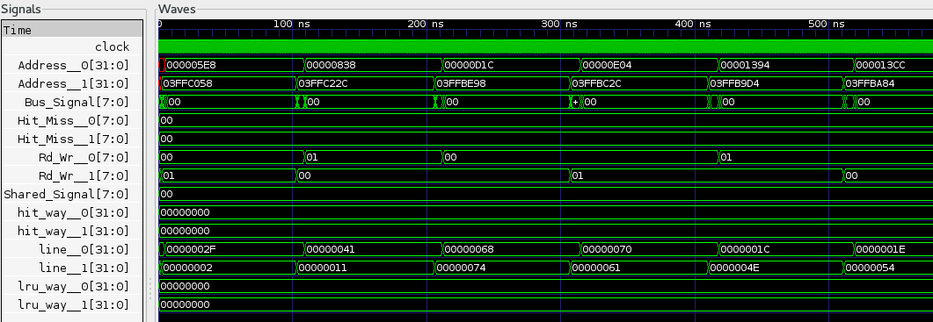

Fig. 1. The Simulation Result by Using dbg_p2 Algorithm.

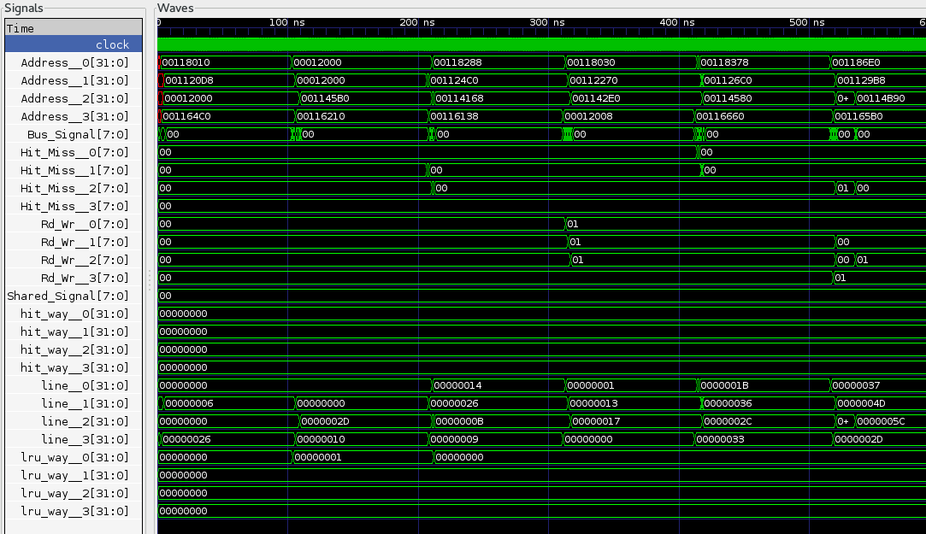

Fig. 2. The Simulation Result by Using fft_16_p4 Algorithm.

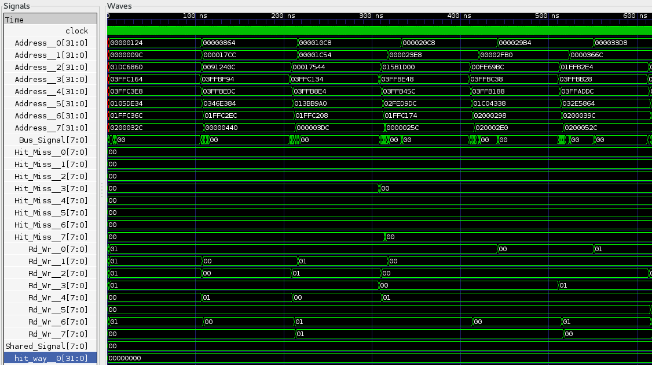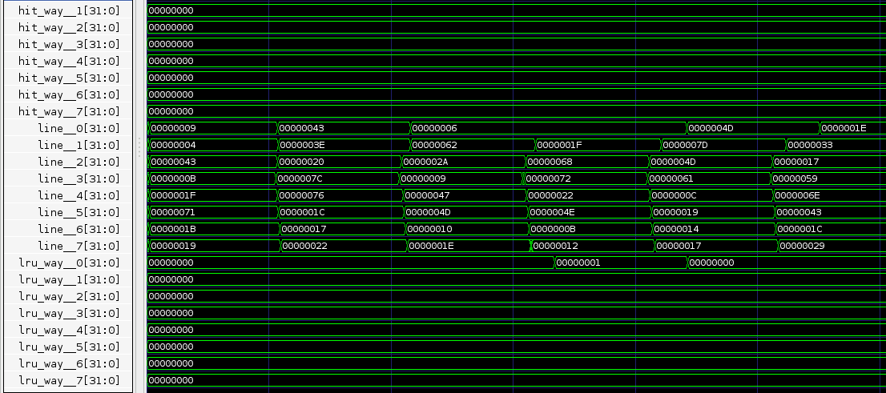

Fig. 3. The Simulation Result by Using rnd_p8 Algorithm.

Because we simulate 4 different cases for 3 algorithms, it will be 12 possible cases for the waveform graph, it will be too much to include in the report, so we choose one case for each algorithm to show our result is correct.