**Assignment 2**

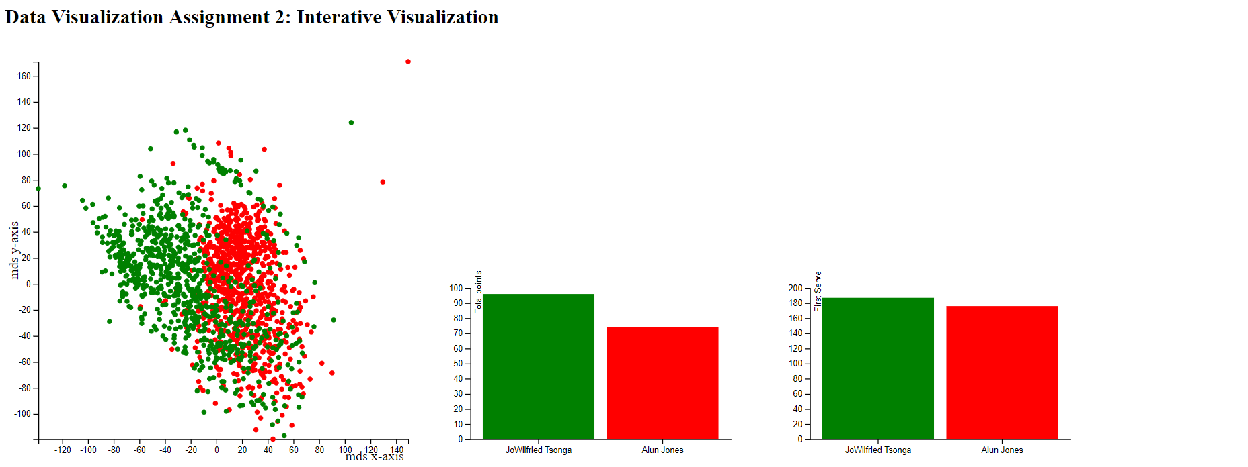

The scatter plot is the two dimensional representation of the high dimensional data provided. The 11 variables provided in the dataset are fed to a sklearn's multi-dimensional scaling algorithm and two dimensional points are generated. The red dots represent the runners and the green dot represents the winners.   
  
**Interactive Component:**   
When user clicks on a green dot and a red dot, two bar charts show up. First bar chart represents the total points gained by the players and second bar chart shows the average first serve points of the selected players.   
  
**Conclusions:**   
Scatter plots shows the data has patterns and is highly distinguishable for predicting a winner and a runner. User can select the players they specifically want to analyze and view the players two key metrics: Total points and average first Serve