**HGA**

**Agenda: Conflict in East Pakistan 1971**

**Timeline:**

4th December—Battle of Longewala begins

7th December—End of Battle of Longewala

Present Date—8th December

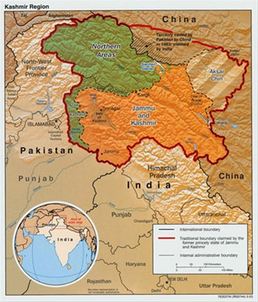

**Reasons for Bangladesh Liberation War**

· Language controversy

· Disparities

· Political differences

· Response to the 1970 cyclone

· Operation Searchlight

**Introduction:**

The Battle of Longewala that took place from the 4th of December to the 7th of December, this year between the Indian forces and Pakistani forces has caused the loss of around 200 lives. This conflict arose from tensions that began due to the liberation war that is taking place in East Pakistan. East and West Pakistan have been at war for the better part of the year with the casualty list ever increasing. With India now taking part in the struggle, the subcontinent region is on the verge of a war of great severity, and the situation will only deteriorate, unless this committee is able to bring the matter to a solution.

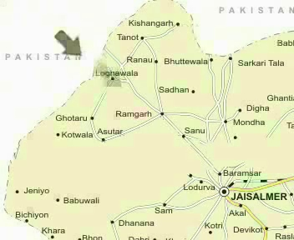

The liberation war is said to have started on the 26th of March, 1971, when Awami League leader Sheikh Mujibur Rehman declared East India’s independence as the state of Bangladesh. Pakistani President Agha Mohammed Yahya ordered the Pakistani military to restore the Pakistani government's authority, beginning the civil war.

One of the best ways to prevent another Indo-Pak war would be to solve the East Pakistan crisis.

**The East Pakistan Liberation War**

The liberation war began on the 26th of March after East Pakistan felt it was being economically exploited by West Pakistan, where all the political power lay. The people of East Pakistan also had a number of grievances. The fact that India lay right between the two parts of Pakistan did not help either. Administration in the two regions was also discontinuous and at times eccentric.

**Language Controversy**

In 1948, Governor General Mohammad Ali Jinnah declared that "Urdu, and only Urdu" would be the federal language of Pakistan. However, Urdu was historically prevalent only in the north, central, and western region of the subcontinent; whereas in East Bengal, the native language was Bengali, the most easterly branch of the Indo-European languages.The Bengali-speaking people of Pakistan constituted over 50% of the country's population. The government stand was widely viewed as an attempt to suppress the culture of the eastern wing. The people of East Bengal demanded that their language be given federal status alongside Urdu and English.

The Bengali Language Movement began in 1948, as civil society protested the removal of the Bengali script from currency and stamps, which were in place since the British Raj. The movement reached its climax in 1952, when on 21 February, the police fired on protesting students and civilians, causing several deaths.

Although the question of official languages was settled by 1956, the military regime of Ayub Khan promoted the interests of [West Pakistan](https://en.wikipedia.org/wiki/West_Pakistan) at the expense of East Pakistan. Despite forming the majority of the national population, the East Pakistani population continued to be under-represented in the civil and military services, and received a minority of state funding and other government help. This was mainly due to lack of [representative government](https://en.wikipedia.org/wiki/Democracy) in the fledgling state. Mainly due to regional economic imbalances sectional divisions grew, and support for the Bengali ethnic nationalist Awami League,which invoked the [6-point movement](https://en.wikipedia.org/wiki/Six_point_movement) for greater provincial autonomy. One demand was that [East Pakistan](https://en.wikipedia.org/wiki/East_Pakistan) be called *Bangladesh* (Land/Country of Bengal), which subsequently led to the Bangladesh Liberation War.

**Political Differences**

Although East Pakistan accounted for a slight majority of the country's population, political power remained in the hands of West Pakistanis. Since a straightforward system of representation based on population would have concentrated political power in East Pakistan, the West Pakistani establishment came up with the "[One Unit](https://en.wikipedia.org/wiki/One_Unit)" scheme, where all of West Pakistan was considered one province. This was solely to counterbalance the East wing's votes.

The East Pakistanis observed that the West Pakistani establishment would swiftly depose any East Pakistanis elected Prime Minister of Pakistan, such as [Khawaja Nazimuddin](https://en.wikipedia.org/wiki/Khawaja_Nazimuddin), [Muhammad Ali Bogra](https://en.wikipedia.org/wiki/Muhammad_Ali_Bogra), or [Huseyn Shaheed Suhrawardy](https://en.wikipedia.org/wiki/Huseyn_Shaheed_Suhrawardy). Their suspicions were further influenced by the military dictatorships of [Ayub Khan](https://en.wikipedia.org/wiki/Ayub_Khan_(Field_Marshal)) (27 October 1958 – 25 March 1969) and [Yahya Khan](https://en.wikipedia.org/wiki/Yahya_Khan) (25 March 1969 – 20 December 1971), both West Pakistanis. The situation reached a climax in 1970, when the [Awami League](https://en.wikipedia.org/wiki/Awami_League), the largest East Pakistani political party, led by [Sheikh Mujibur Rahman](https://en.wikipedia.org/wiki/Sheikh_Mujibur_Rahman), won a landslide victory in the national elections. However, [Zulfikar Ali Bhutto](https://en.wikipedia.org/wiki/Zulfikar_Ali_Bhutto) (a former Foreign Minister), the leader of the [Pakistan Peoples Party](https://en.wikipedia.org/wiki/Pakistan_Peoples_Party), refused to allow Rahman to become the Prime Minister of Pakistan.[[32]](https://en.wikipedia.org/wiki/Bangladesh_Liberation_War" \l "cite_note-Hassan_2000_p._393-33) Instead, he proposed the idea of having two Prime Ministers, one for each wing. The proposal elicited outrage in the east wing, already chafing under the other constitutional innovation, the "One Unit scheme".

Between 10 and 13 March, [Pakistan International Airlines](https://en.wikipedia.org/wiki/Pakistan_International_Airlines) cancelled all their international routes to urgently fly "government passengers" to Dacca. These "government passengers" were almost all Pakistani soldiers in civilian dress. MV *Swat*, a ship of the Pakistan Navy carrying ammunition and soldiers, was harboured in [Chittagong](https://en.wikipedia.org/wiki/Chittagong) Port, but the Bengali workers and sailors at the port refused to unload the ship. A unit of [East Pakistan Rifles](https://en.wikipedia.org/wiki/East_Pakistan_Rifles) refused to obey commands to fire on the Bengali demonstrators, beginning a mutiny among the Bengali soldiers.

**The 1970 Cyclone**

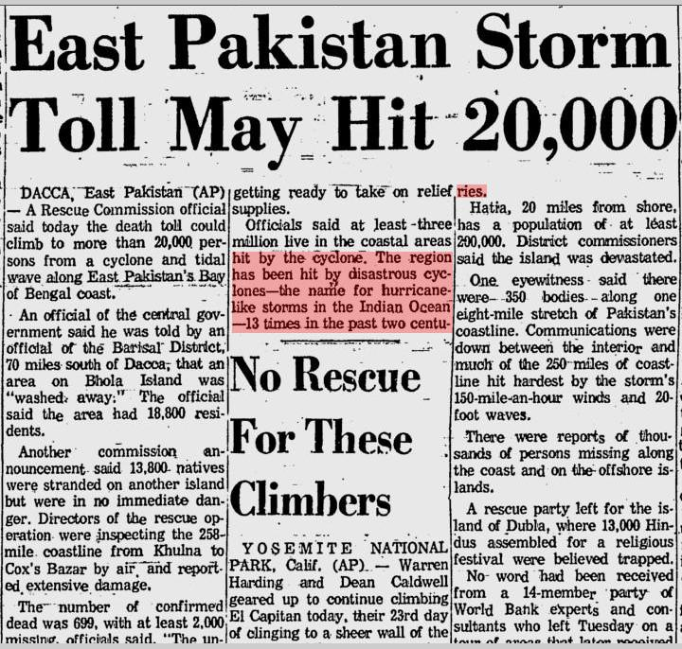

Political leaders in East Pakistan were deeply critical of the central government's initial response to the disaster. A statement released by eleven political leaders in [East Pakistan](https://en.wikipedia.org/wiki/East_Pakistan) ten days after the cyclone hit charged the government with 'gross neglect, callous indifference and utter indifference'. The Pakistani government only deployed a single helicopter to relief operations, with [Yahya Khan](https://en.wikipedia.org/wiki/Yahya_Khan) later stating that there was no point deploying any helicopters from West Pakistan as they were unable to carry supplies.

[India](https://en.wikipedia.org/wiki/India) became one of the first nations to offer aid to Pakistan, despite the generally poor [relations](https://en.wikipedia.org/wiki/Indo-Pakistani_relations) between the two countries, and by the end of November had pledged $1.3 million (1970 [USD](https://en.wikipedia.org/wiki/USD)) of assistance for the relief efforts. The Pakistani government refused to allow the Indians to send supplies into East Pakistan by air, forcing them to be transported slowly by road instead. The Indian government also said that the Pakistanis refused an offer of military aircraft, helicopters and boats from [West Bengal](https://en.wikipedia.org/wiki/West_Bengal) to assist in the relief operation.

[US President](https://en.wikipedia.org/wiki/US_President) [Richard Nixon](https://en.wikipedia.org/wiki/Richard_Nixon) allocated a $10 million (1970 USD, $53 million 2007 USD) grant to provide food and other essential relief to the survivors of the storm, and the U.S. ambassador to Pakistan pledged that he would "assist the East Pakistan government in every way feasible."

The [Canadian](https://en.wikipedia.org/wiki/Canada) government pledged $2 million of assistance. [France](https://en.wikipedia.org/wiki/France) and [West Germany](https://en.wikipedia.org/wiki/West_Germany) both sent helicopters and various supplies worth $1.3 million.

**Operation Searchlight**

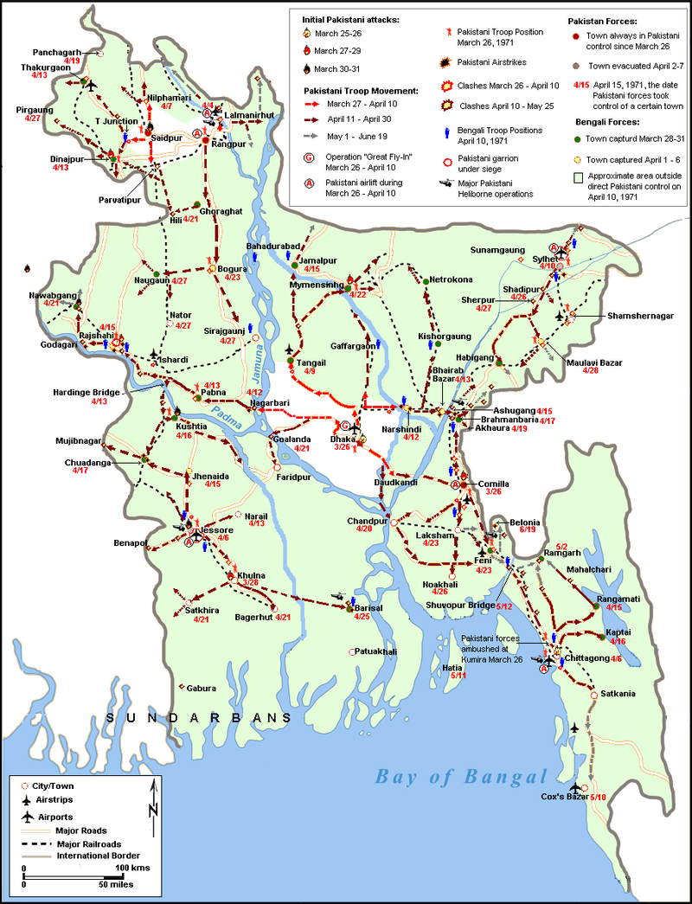

Ordered by the central government in West Pakistan, this was seen as the sequel to "[Operation Blitz](https://en.wikipedia.org/w/index.php?title=Operation_Blitz&action=edit&redlink=1)" which had been launched in November 1970. The original plan envisioned taking control of the major cities on March 26, and then eliminating all opposition, political or military. Bengali intelligentsia, academics and Hindus were targeted for the harshest treatment, with significant indiscriminate killing taking place.

West Pakistani military and civilian elite, who sought to create a cohesive polity unified by Islam and the Urdu language, viewed Bengali culture and language as closely linked to Hinduism and consequently, a threat to their conception of an Islamic nation. Local Islamist organizations in East Pakistan, such as Jamaat-e-Islami (JeI) and its student wing Islami Chhatra Shibir (ICS), similarly opposed the creation of a secular state and collaborated with the Pakistani military.

Not surprisingly, Hindus and the Bengali secular intelligentsia were the primary targets of the Pakistani onslaught, that resulted in an estimated three million deaths, more than ten million displaced, and the mass rape of 200,000 women and girls.

A number of professors from Dhaka University were killed during the first few days of the war.

The main phase of Operation Searchlight ended with the fall of the last major town in Bengali hands in mid May.

**The Jinjira Massacre**

The army started to amass forces around Keraniganj from the midnight of 1 April. They took control of the Mitford Hospital by the river. At around 5 AM they commenced the attack by throwing flares from the roof of the mosque adjacent to the hospital. The army moved into Jinjira and opened fire on people. The massacre continued for nearly nine hours. One of the largest such executions took place beside a pond near the Nandail Dak street where 60 people were lined up and shot. The soldiers also fired on the houses using gunpowder. More than a thousand people died in this brutal massacre.

**The Blood Telegram**

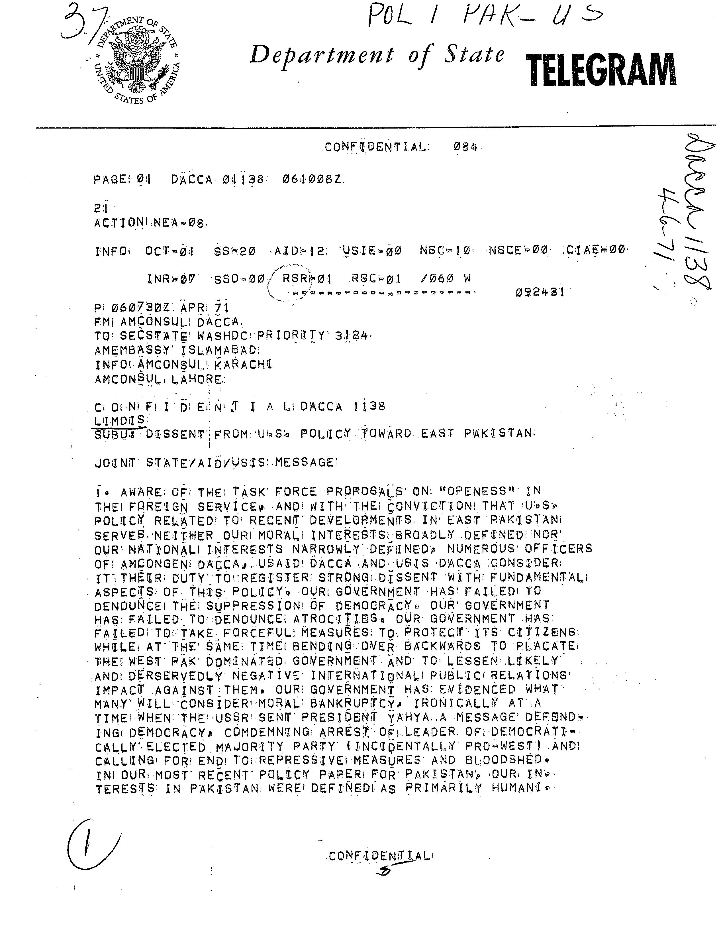

The Blood telegram (April 6, 1971) was seen as the most strongly worded expression of dissent in the history of the U.S. Foreign Service and was signed by 29 [American officials.](https://en.wikipedia.org/wiki/United_States_of_America) The telegram stated:

*“Our government has failed to denounce the suppression of democracy. Our government has failed to denounce atrocities. Our government has failed to take forceful measures to protect its citizens while at the same time bending over backwards to placate the West [Pakistan] dominated government and to lessen any deservedly negative international public relations impact against them. Our government has evidenced what many will consider* [*moral bankruptcy*](https://en.wikipedia.org/wiki/Moral_bankruptcy)*,(...) But we have chosen not to intervene, even morally, on the grounds that the Awami conflict, in which unfortunately the overworked term* [*genocide*](https://en.wikipedia.org/wiki/Genocide) *is applicable, is purely an internal matter of a sovereign state. Private Americans have expressed disgust. We, as professional civil servants, express our dissent with current policy and fervently hope that our true and lasting interests here can be defined and our policies redirected.”*

In an earlier telegram (March 27, 1971), Blood wrote about American observations at Dhaka under the subject heading "Selective genocide":

*1. Here in Decca we are mute and horrified witnesses to a reign of terror by the Pak[istani] Military. Evidence continues to mount that the MLA authorities have list of AWAMI League supporters whom they are systematically eliminating by seeking them out in their homes and shooting them down*

*2. Among those marked for extinction in addition to the A.L. hierarchy are student leaders and university faculty. In this second category we have reports that Fazlur Rahman head of the philosophy department and a Hindu, M. Abedin, head of the department of history, have been killed. Razzak of the political science department is rumored dead. Also on the list are the bulk of MNA's elect and number of* [*MPA*](https://en.wikipedia.org/wiki/Member_of_Provincial_Assembly)*'s.*

*3. Moreover, with the support of the Pak[istani] Military. non-Bengali Muslims are systematically attacking poor people's quarters and murdering Bengalis and Hindus.*

**The Mukti Bahini**

The Mukti Bahini is a popular Bengali term that refers to the guerrilla resistance movement formed by East Pakistani military, paramilitary and civilians. Following the start of Operation Searchlight by the Pakistan Army on 25 March 1971, Bengali military and paramilitary units revolted across East Pakistan. They were joined by thousands of Bengali civilians from a wide strata of society, including villages and elite urban areas. The Bangladeshi Declaration of Independence was proclaimed from Chittagong by members of the Mukti Bahini on behalf of Prime Minister-elect Sheikh Mujibur Rahman- who was detained by the military junta in West Pakistan.

Women were at the forefront of the Bangladesh liberation struggle. The Mukti Bahini trained several female battalions for guerrilla warfare.

The launch of **Operation Chengiz Khan** by West Pakistan on North India finally drew India into the Bangladesh conflict. A joint command was established between Bangladeshi and Indian Forces. The Indian Prime Minister Indira Gandhi authorized diplomatic, economic and military support to the Bangladesh Forces in April 1971.

**Indian Involvement**

Prime Minister Indira Gandhi on 27 March 1971 expressed full support of her government for the independence struggle of the people of East Pakistan. The Indian leadership under Prime Minister Gandhi quickly decided that it was more effective to end the genocide by taking armed action against Pakistan than to simply give refuge to those who made it across to refugee camps. Exiled East Pakistan army officers and members of the Indian Intelligence immediately started using these camps for recruitment and training of Mukti Bahini guerrillas.

**International Policies**

**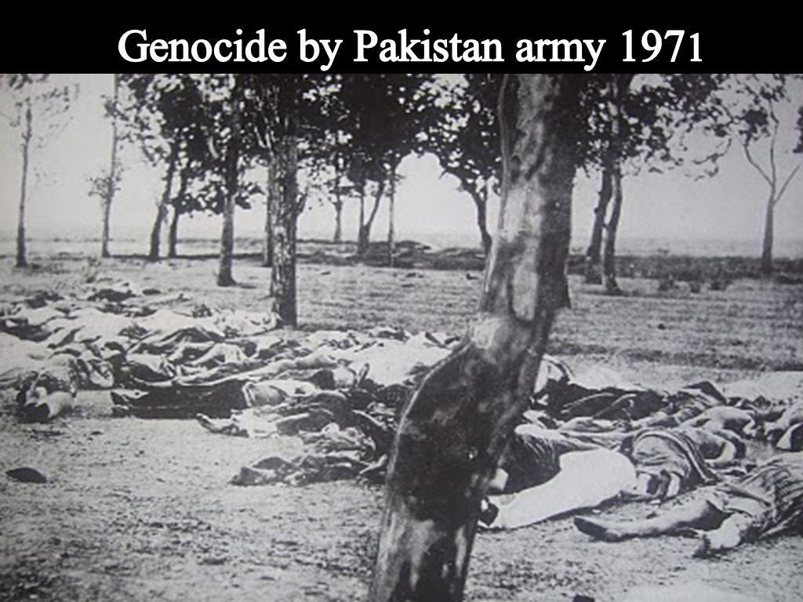**

The genocide by Pakistani forces caused widespread international outrage against West Pakistan. In the United States, Democratic senator Ted Kennedy castigated the Nixon administration for ignoring the genocide of Bengalis in East Pakistan.

The Nixon administration in the US enjoyed close ties with Pakistani military junta due to its policy of rapprochement with Communist China after the Sino-Soviet split.

French Minister of Cultural Affairs Andre Malraux vowed to fight on the battlefield alongside the Bangladesh Forces.

**References:**

1.Death by Government by R J Rummel

2. Against Our Will: Men,Women and Rape by Susan Brownmiller

3.The Rape of Bangla Desh by Anthony Mascarenhas.

4. Tormenting Seventy One by Shahriar Kabir