Studying Low-Energy Symmetry Properties of 1D Cuprates with Terahertz Spectroscopy

Eleanor Richard. Yuchen Han. David Hsieh.

Abstract

Cuprates are a class of materials that have generated interest for their strongly correlated degrees of freedom, including spin and charge. This strong correlation yields interesting quantum phenomena such as high-temperature superconductivity. A subset of these materials, called 1D cuprates, have the characteristic Cu-O chain in one direction and provide an important avenue in better understanding the electronic structure of these materials. We investigated the properties and dynamics of the 1D cuprate Sr₂CuO₃ in the low energy regime to search for nonequilibrium phases. To access this energy scale, we employed time-resolved time-domain terahertz spectroscopy. We observed polarization dependence in the material’s equilibrium state in the form of four-fold symmetry with increased absorption diagonal to the Cu-O chain direction, which we attribute to the birefringence of the material. We photoexcited the material with a laser pulse and saw various relaxation dynamics that may be attributed to several interesting quantum effects such as excitons.

Introduction

In the past decade, scientists have discovered novel properties and phases in materials at very low energies. This discovery has created a new area of study in condensed matter physics. Such low energy dynamics, accessed using ultrafast lasers, could be hiding quantum phenomena that have not yet been observed experimentally. A class of materials called cuprates has been of particular interest in these experiments. As mentioned above, these materials have strongly correlated degrees of freedom which yield high-temperature superconductivity and likely other interesting quantum features that we aim to discover in this experiment [1].

The low energy range in question is referred to as the terahertz (THz) frequency regime and spans from 1 to 200 meV [2]. Studying the THz regime requires the use of a femtosecond (10⁻¹² s) laser in a technique known as time-resolved time-domain THz spectroscopy [3]. The laser sends pulses of 35 fs in width every millisecond. The laser pulse photo-excites the material and interacts with the electron bands in the material to produce free electrons in a process called photo-doping [4]. This mechanism allows us to first photo-dope, or pump, the system with a pulse and then probe the system with another pulse at various time delays to measure how the material changes due to the photo-doping [2].

The Hsieh lab used THz spectroscopy to study the 1D cuprate Sr₂CuO₃ to search for nonequilibrium phases. 1D cuprates are materials with the CuO₂ structure that is characteristic of cuprates but in one direction [1] (Fig 1).

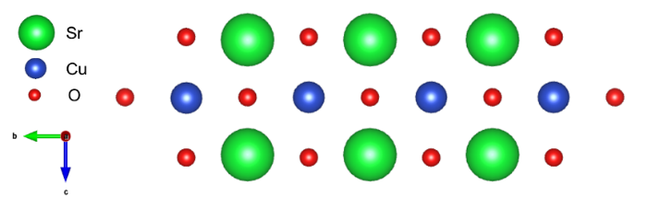

Figure 1: Crystal Structure of Sr₂CuO₃. Cu-O chain is represented by the alternating Cu and O atoms in the center row.

Sr₂CuO₃ has not yet been studied in the THz regime though we believe there is interesting physics at this level due to prior experiments by the Hsieh lab in the THz regime [5].

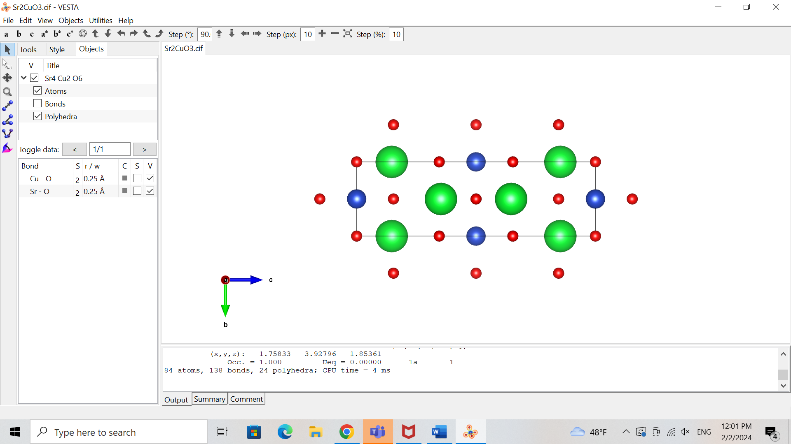

Sr

Cu

O

Methods and Results

To look for such quantum phenomena, we first measured the terahertz response of the Sr₂CuO₃ sample in static transmission, meaning that the material is not excited by an initial laser pulse. Hence, we are measuring the material in a steady state; there are no photo-induced effects.

Terahertz light cannot be produced directly by a laser so we must generate it through other mechanisms [3]. In the Hsieh lab, the terahertz light is generated through a nonlinear optical response of the original laser light with a ZnTe crystal. The signal can then be detected after passing through a second ZnTe crystal [3]. The interaction of the terahertz light and the material provides information on any absorptions in the materials at these energies [3]. These measurements are conducted to 1) explore the low energy properties intrinsic to the material and 2) distinguish the photo-induced effects from the material’s steady state when we later excite the material.

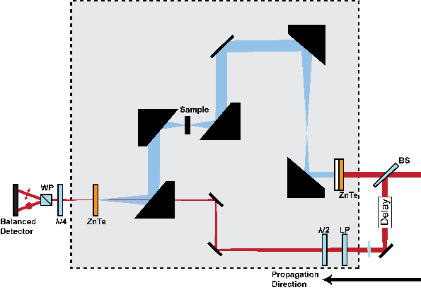

Figure 2: Static Transmission Layout [4]. The beam is separated into two paths by a beam splitter labeled BS. One beam reflects off several mirrors and is transmitted through the sample. The other beam detects the terahertz response of the material through the interaction of the two beams within the ZnTe crystal before the detector.

We measured our Sr₂CuO₃ samples in static transmission using a technique we developed called Rotational Anisotropy Terahertz (RA-THz) spectroscopy. We placed the sample in a rotation mount and measured the THz transmission at different sample orientations. This rotation allowed us to study the polarization dependence of phenomena in the sample. The changes in the polarization are significant because the axes of the matter have different properties, therefore light’s interaction along various axes in the material can yield unique effects. For example, the axes have different atoms (Fig 1), and hence different bond lengths and possibly electron interactions, which influence the axis’s response to light.

At the photodetector, we measure time traces of the signal to observe the material’s response to the terahertz light (Fig 3a).

Figure 3: a) Time domain THz transmission pulse at intervals of 15 deg from 0 to 345 deg.

After the static transmission measurements, we conducted pump probe reflectivity terahertz spectroscopy. In this configuration, we photo-excite the sample with an additional laser pulse and then study the light reflected off the sample with the same two beam set-up as for the transmission measurements.

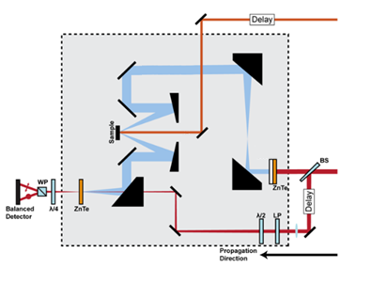

Figure 4: Pump-probe reflectivity set up [4]. There is an additional beam compared to the transmission set-up. This beam is at the top of the diagram and is directed onto the sample and excites the sample. Then, as in the transmission set-up, there are two beams, both coming from the beamsplitter, that interact in the second ZnTe crystal to give us information on the state of the material.

In this reflection geometry, we took two kinds of measurements. First, we measured the change in electric field of the reflected light as a function of time (Fig 5a). Second, we measured the terahertz pulse output at fixed time delays between the pump and the probe (Fig 5b). This second type of scan is similar to the measurements we took in the static transmission case, yet we measured at various delays after the pump pulse to understand how the material’s dynamics are changing with time due to the photo-doping. We can understand the principal exponential fit in Fig 5a as being a vertical slice of Fig 5b if Fig 5b was in the time domain and not yet Fourier transformed to the frequency domain.

b. 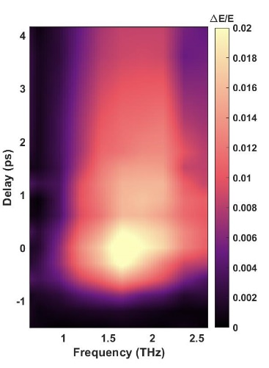

Figure 5: a) Exponential fitting of pump-probe scan along the Cu-O chain direction as a measure of the change in the electric field, hence the induced electric field. The main exponential fit is broken down into three parts to illustrate the different relaxation times: = 0.8 ps, = 7 ps, and a constant background C. b) Change in electric field as a function of time and frequency.

Discussion

We first want to look at the results of the static transmission measurements as this data tells us about the properties of the material because the material is not yet excited by an initial pulse. By Fourier transforming the time traces pulses from the static transmission measurements shown in Fig 3, we can analyze the data in the frequency space (Fig 6a). Dips in the frequency spectrum, as seen at 1.4 THz in Fig 6a, signify energy absorption, which in turn signals that something is happening in the material at that frequency as some process in the material is using energy. The challenge then becomes determining what phenomenon is causing the absorptions.

From our static transmission measurements of Sr₂CuO₃, we see a four-fold symmetry in the frequency spectrum (Fig 6). This four-fold symmetry persists throughout our frequency bandwidth. Additionally, around 1.4 THz, we see a dip in the signal 45 degrees from the Cu-O chain direction (Fig 6).

Figure 6: a) Fourier transform of THz transmission pulses. b) Slice of THz transmission at 1.4 THz as a function of sample orientation. 0 degrees represents the Cu-O chain direction of the material depicted in Fig 1.

We attribute part of the four-fold symmetry to birefringence. Birefringence is when the light’s path through the sample is delayed more in one direction than in the perpendicular direction. Therefore, the refractive indices of the material, which are a measure of this delay, are different. Our calculation of the refractive index along the chain and perpendicular to the chain supports this claim (Fig 7). We see that the refractive index along the Cu-O chain is in the 3-3.1 range whereas the refractive index perpendicular to the Cu-O chain is in the 2.65-2.9 range. Hence, light is more delayed in the Cu-O chain direction than in the perpendicular direction.

Figure 7: Real refractive index along the Cu-O chain direction (red) and perpendicular to the chain direction (green).

This birefringence, however, does not entirely explain the dip at 1.4 THz. To further understand this phenomenon, we plan to analyze the optical conductivity of the material at this frequency from the data we took to better understand the electronic behavior of the system. The optical conductivity is a measure of the electrical conductivity that is induced by an AC electric field, such as an ultrafast pulse of light [7]. In addition, we plan to ensure that the absorption is not simply an artifact of our terahertz spectroscopy set-up.

With the reflectivity data, we want to study the evolution of the system after the initial pulse that excites the material to understand how the material responds to this added energy. After the energy is added to the material, the material will relax, releasing this energy over time, and return to its initial state. The time length of this relaxation can signify what sort of response, and hence phenomena, has occurred due to the laser pulse. We can see in Fig 5a that the change in electric field decays very rapidly for a short amount of time and then decays much more slowly for the rest of the measurement. Therefore, we break down the total exponential decay into two exponentials, one with a fast decay time and the other with a slower decay time, 0.8 ps and 7 ps respectively. These two decay times are also portrayed in Fig 5b through the rate of change in intensity of the plotted change in electric field.

The two decay times we observe signal that there may be two phenomena occurring in the material when electrons are added to the system with the pump pulse. In some cases, the faster decay indicates an electronic response whereas the slower decay may be from the material cooling down after being heated from the laser pulse. The two decays could also be due to some recombination effects where the fast decay is the relaxation of the phenomena that are formed immediately after the pulse whereas the slow decay is from the same phenomena though they form and relax sometime after the pump due to the remaining excess energy in the system. One theory for the observed phenomena is that we are seeing Coulombic excitons, which are bound states between an electron and electron hole [6,8]. However, further measurements are required to investigate this theory.

We plan to conduct fluence dependence measurements, where we increase or decrease the power of the laser pump. If we are observing excitons, higher fluence should yield a greater response as more excitons are produced from the higher number of added electrons. In addition, we plan to cool down the sample to investigate whether we see additional absorptions and/or different time decays in the material. These low temperature measurements may be interesting because the optical conductivity of Sr₂CuO₃ increases at lower temperatures in the terahertz regime [7]. This increase means that more current is induced in the material due to the laser pulse, which could affect the response of the material and/or produce a stronger output signal.

Much of the phenomena we observed raises questions and requires more investigation. Nevertheless, the abundance of interesting physics in the terahertz regime is clear. Such experiments reveal the exciting aspects of strongly correlated systems. We hope to persuade scientists of the importance of low energy dynamics.

Acknowledgements

Thank you to David Hsieh for the incredible opportunity to work in his lab this summer. Thank you to Yuchen Han for being a great mentor and teaching me so much. Thank you to the entire Hsieh lab group for being so welcoming. Thank you to the Sankar lab and Suganya Murali at Academia Sinica, Taiwan for the samples. Thank you to the WAVE program and the Institute for Quantum Information and Matter (IQIM) for making it possible for me to be at Caltech this summer.

References

1. Fujisawa H., Yokoya T., Takahashi T. et al. “Angle-resolved photoemission study of Sr₂CuO₃” Phys. Rev. B 59, 7358 (1999).
2. Pala, N., Abbas, A.N. Terahertz Technology for Nano Applications. Encyclopedia of Nanotechnology. Springer, Dordrecht. (2012).
3. Jens Neu, Charles A. Schmuttenmaer; Tutorial: An introduction to terahertz time domain spectroscopy (THz-TDS). J. Appl. Phys. 21 December 2018; 124 (23): 231101.
4. Mehio, O., “Ultrafast dynamics of photo-doped Mott antiferromagnets” California Institute of Technology (2023).
5. Mehio, O., Li, X., Ning, H. *et al.* A Hubbard exciton fluid in a photo-doped antiferromagnetic Mott insulator. *Nat. Phys.* **19**, 1876–1882 (2023).
6. Kaindl, R., Carnahan, M., Hägele, D. *et al.* Ultrafast terahertz probes of transient conducting and insulating phases in an electron–hole gas. *Nature* **423**, 734–738 (2003).
7. Kim, K. W., Gu, G. D., Homes, C. C. *et al.* Bound Excitons in Sr₂CuO₃. Phys. Rev. Let. 101, 177404 (2008).
8. Zakharchenya, B.P., Permogorov, S.A. Excitons in Crystals, Encyclopedia of Condensed Matter Physics, Elsevier, 2005, Pages 171-179, ISBN 9780123694010.