Studying Low-Energy Symmetry Properties of 1D Cuprates with Terahertz Spectroscopy

Eleanor Richard. Yuchen Han. David Hsieh.

Abstract

Cuprates are a class of materials that have generated interest for their strongly correlated degrees of freedom, including spin and charge. This strong correlation yields interesting quantum phenomena such as high-temperature superconductivity. A subset of these materials, called 1D cuprates, (Fig. 1) and provide an important avenue in better understanding the electronic structure of these materials. We investigated the properties and dynamics of the 1D cuprate Sr₂CuO₃ in the low energy regime to search for nonequilibrium phases. To access this energy scale, we employed time-resolved time-domain terahertz spectroscopy. We observed polarization dependence in the material’s equilibrium state in the form of four-fold symmetry with increased absorption diagonal to the Cu-O chain direction, which we attribute to the birefringence of the material. We photoexcited the material with a laser pulse and saw various relaxation dynamics that may be attributed to interesting quantum effects such as excitons. Due to their high temperature superconductivity, cuprates may have applications in electronics for information processing and storage. Better understanding the physics of cuprates will allow us to create more efficient and powerful devices.

Introduction

In the past decade, scientists have discovered novel properties and phases in materials at very low energies. These low energies are from 1-200 meV and can be referred to as the terahertz (THz) regime [2]. The terahertz range, accessed using ultrafast lasers, could be hiding quantum phenomena that have not yet been observed experimentally. A class of materials called cuprates has been of particular interest in these experiments because these materials have strongly correlated degrees of freedom. Degrees of freedom in this context refer to the spin, charge, and orbital momentum of the electrons in the material. Depending on the values and the interactions of the degrees of freedom, the material exhibits different properties. In cuprates, interactions between the degrees of freedom yield high-temperature superconductivity and likely other interesting quantum features that we aim to discover in this experiment [1].

In this experiment, we studied the 1D cuprate Sr₂CuO₃ to search for nonequilibrium phases.

Figure 1: Crystal Structure of Sr₂CuO₃. This 1D cuprate that we were studying has the characteristic Cu-O chain in one direction, whichis represented by the alternating Cu and O atoms in the center row.

Before this experiment, Sr₂CuO₃ had not been studied in the THz regime though we believed that there is interesting physics due to prior experiments by the Hsieh lab in the THz regime [5].

To access the low energy physics, we employed a technique called time-resolved time-domain THz spectroscopy. Studying the THz regime requires the use of a femtosecond (10⁻¹² s) laser which sends pulses of 35 fs in width every millisecond. The laser pulse photo-excites the material and resonantly interacts with the electron bands in the material to produce free electrons in a process called photo-doping [4].

Figure 2: A laser pulse excites electrons from the valence band into the conduction band, producing free electrons.

This mechanism allows us to first photo-dope, or pump, the system with a laser pulse and then probe the system with another pulse at various time delays to measure how the material changes due to the photo-doping [2].

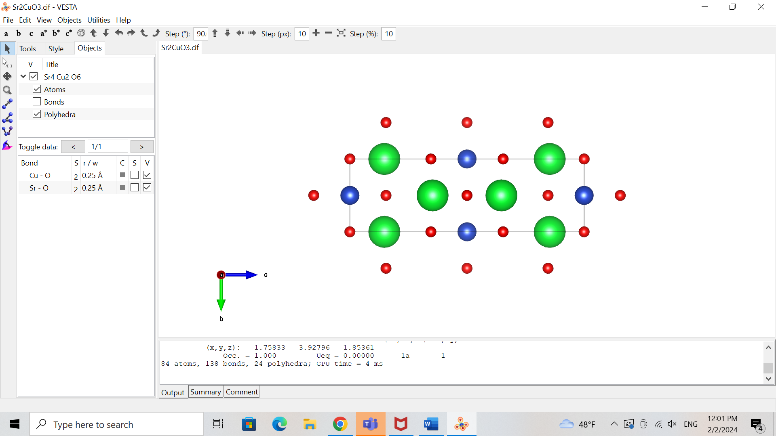

Sr

Cu

O

Methods and Results

To look for such quantum phenomena, we first measured the terahertz response of Sr₂CuO₃ in static transmission, meaning that the material is not excited by an initial laser pulse i.e. without the photo-doping process shown in Fig. 2.

Terahertz light cannot be produced directly by a laser, so we generated it through other mechanisms [3]. In the Hsieh lab, the terahertz light is generated through a nonlinear optical response of the original laser light with a ZnTe crystal. The terahertz light passes through the sample, the Sr₂CuO₃ material in this case, before going through a second ZnTe crystal. The interaction of the terahertz light and the second ZnTe crystal provides information on any absorptions that occurred in Sr₂CuO₃ in the terahertz regime [3]. These measurements are conducted to 1) explore the low energy properties intrinsic to the material and 2) distinguish the photo-induced effects from the material’s steady state for when we later photo-dope the material.

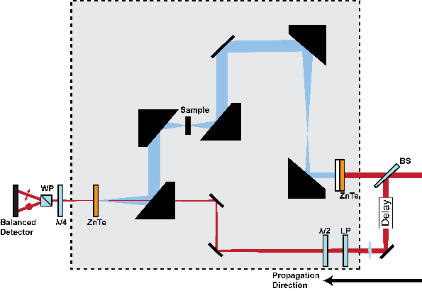

Figure 3: Static Transmission Layout [4]. The beam is separated into two paths by a beam splitter labeled BS. One beam reflects off several mirrors and is transmitted through the sample. The other beam detects the terahertz response of the material through its interaction of with the firstbeam within the ZnTe crystal before hitting the detector.

We measured our Sr₂CuO₃ samples in static transmission using a technique we developed called Rotational Anisotropy Terahertz (RA-THz) spectroscopy. We placed the sample in a rotation mount and measured the THz transmission at different sample orientations. This rotation allowed us to study the light polarization dependence of phenomena in the sample.. Light is a wave, and hence undergoes oscillations. The direction of these oscillations is the direction of the light’s polarization. The direction of the light’s polarization is significant because the axes of Sr₂CuO₃ have different properties, therefore light’s interaction along various directions in the material can yield unique effects. For example, the axes have different atoms (Fig 1), and hence different atomic bond lengths and electron interactions, which influence the axis’s response to light. By studying the material across many light polarizations as we do in Ra-THz spectroscopy, we get a more comprehensive understanding of the material’s properties.

From the photodetector, we measured the signal as a function of time and light polarization to observe the material’s response to the terahertz light (Fig 4).

Figure 4: Time domain THz transmission pulse at intervals of 15 deg from 0 to 345 deg. The degrees in different colors refer to various light polarizations.

After the static transmission measurements, we conducted pump probe reflectivity terahertz spectroscopy to measure how Sr₂CuO₃ responds to photo-doping. In this configuration, we photo-excite the sample with an additional laser pulse, labeled as the IR pump in Fig 5b, and then study the light reflected off the sample with the IR pump, juxtaposed with the transmission measurements. This same two- beam setup for the static transmission of Fig 3 is labeled as Sampling in Fig 5b.)

a) 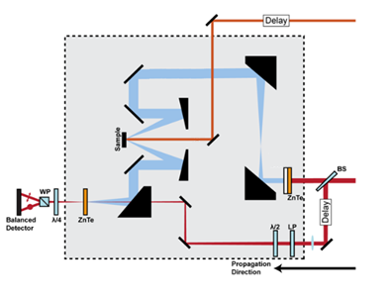 b) 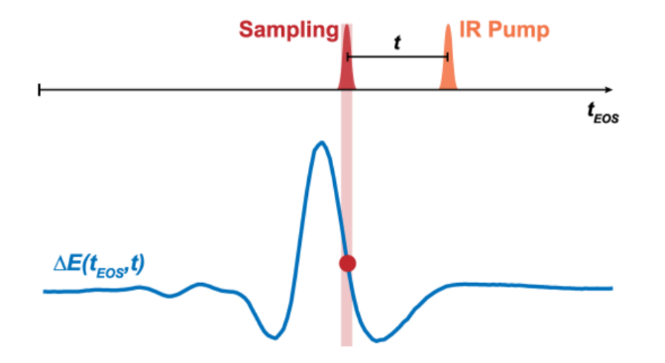

Figure 5: Pump-probe reflectivity set up. a) Optical set-up for reflectivity experiment [4]. The new photo-doping beam is at the top of the diagram and is directed onto the sample To excite it. Then, as in the transmission set-up we still have the two othero beams, both coming from the beamsplitter, that interact in the second ZnTe crystal to give us information on the state of the material. b) Diagram of pump-probe reflectivity measurement. By changing the time delay between the pump and the sampling pulse, we can measure the material’s response to the pump pulse.

In this new reflection setup, we took two kinds of measurements to study the response of Sr₂CuO₃ to the photo-doping from the pump pulse. First, we measured the change in electric field of the reflected light as a function of time (Fig 6a). Second, we measured the terahertz signal at fixed time delays between the pump and the probe (Fig 6b). This second type of scan is similar to the measurements we took in the static transmission case, yet we measured at various delays after the pump pulse to understand how the material’s dynamics are changing with time due to the photo-doping. We can understand the principal exponential fit in Fig 6a as being a vertical slice of Fig 6b if Fig 6b was in the time domain; not yet Fourier transformed from time to the frequency domain. As one can notice, Fig. 6b shows a peak in \frac{\Delta E}{E} at a delay of about 0.006 ps, with a slow exponential decay afterwards.

b. 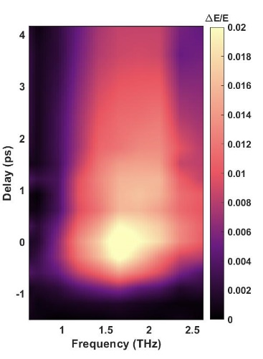

Figure 6: Pump probe THz spectroscopy results. a) Exponential fitting of pump-probe scan along the Cu-O chain direction as a measure of the change in the electric field, hence the induced electric field. The main exponential fit is broken down into three parts to illustrate the different relaxation times: = 0.8 ps, = 7 ps, and a constant background C. b) Change in electric field as a function of time and frequency.

Discussion

We first want to look at the results of the static transmission measurements as this data tells us about the properties of the material before we observe what happens to the material when we photo-dope it with a pump pulse. We Fourier transformed the time domain pulses from the static transmission measurements shown in Fig 4 to analyze the data in the frequency space (Fig 7a). Dips in the frequency spectrum, as seen at 1.4 THz in Fig 7a, signify energy absorption from some process in the materialat that frequency. The challenge then becomes determining what phenomenon caused the absorptions.

To our surprise, from our static transmission measurements of Sr₂CuO₃, we see a four-fold angular symmetry in the frequency spectrum (Fig 7). This four-fold symmetry interestingly persists throughout our frequency bandwidth. For example, in Fig 7b at 1.4 THz, we see a dip in the signal 45 degrees from the Cu-O chain direction, as is seen in Fig 7a.

Figure 7: Static Transmission Results. a) Fourier transform of THz transmission pulses. b) Vertical slice of Fig 7a at 1.4 THz as a function of sample orientation. 0 degrees represents the Cu-O chain direction of the material depicted in Fig 1.

We attribute part of the four-fold symmetry to birefringence. Birefringence is when the light’s path through the sample is delayed more in one direction than in the perpendicular direction. Therefore, the refractive indices of the material, which are a measure of this delay, are different. Our calculations of the refractive index along the chain and perpendicular to the chain support this claim (Fig 8). We see that the refractive index along the Cu-O chain is in the 3-3.1 range whereas the refractive index perpendicular to the Cu-O chain is in the 2.65-2.9 range. Hence, light is more delayed in the Cu-O chain direction than in the perpendicular direction.

Figure 8: Real refractive index along the Cu-O chain direction (red) and perpendicular to the chain direction (green).

This birefringence, however, does not entirely explain the dip at 1.4 THz. To further understand this phenomenon, we plan to calculate the optical conductivity of the material at this frequency from the data we took to better understand the electronic behavior of the system. The optical conductivity is a measure of the electrical conductivity that is induced by an AC electric field, such as an ultrafast pulse of light [7]. In addition, we plan to ensure that the absorption is not simply an artifact of our terahertz spectroscopy set-up.

We used the reflectivity data to study the evolution of the material after the pump pulse to understand how the material responds to this photo-doping. After the pump pulse interacts with the material, the material relaxes, releasing the energy from the pulse over time and returning to its initial state. The time length of this relaxation can signify what sort of response, and hence phenomena, has occurred due to the laser pulse. We can see in Fig 6a that the change in electric field decays very rapidly for a short amount of time and then much more slowly for the rest of the measurement. Therefore, we break down the total exponential decay into two exponentials, one with a fast decay time and the other with a slower decay time, 0.8 ps and 7 ps respectively. These two decay times are also portrayed in Fig 6b through the intial high rate of change in intensity of \frac{\Delta E}{E}, followed by a slower decay.

The two decay times we observe signal that there may be two phenomena occurring in the material when energy is added to the system with the pump pulse. In some cases, the faster decay indicates an electronic response whereas the slower decay may be from the material cooling down after being heated from the laser pulse [4].. One theory for the first phenomenon is that we are seeing Coulombic excitons (Fig 9), that are forming and quickly being relaxed after the pump pulse.

Figure 9: Formation of an exciton in a continuation of Fig 2. First, the electron is excited into the conduction band by a pulse of light. This transition leaves behind an electron hole in the valence band. The electron and the electron hole then attract through Coulomb’s force and produce a short-lived bound state that can be connected to the decay of \frac{\Delta E}{E} after the pulse.

Further measurements are required to investigate the existence of Coulombic excitons in Sr₂CuO₃. We plan to conduct fluence dependence measurements, where we increase or decrease the power of the pump pulse. higher fluence should yield more excitons produced from the higher energy (Fig 9). In addition, we plan to cool down the sample to investigate whether we see additional absorptions and/or different time decays in the material. These low temperature measurements may be interesting because the optical conductivity of Sr₂CuO₃ increases at lower temperatures in the terahertz regime [7]. This increase in the optical conductivity means that more current is induced in the material due to the laser pulse, which could affect the response of the material and/or produce a stronger output signal.

Much of the phenomena we observed raises questions and requires more investigation. Nevertheless, the abundance of interesting physics in the terahertz regime is clear. Such experiments reveal the exciting aspects of strongly correlated systems. We hope to persuade scientists of the importance of low energy dynamics.

Acknowledgements

Thank you to David Hsieh for the incredible opportunity to work in his lab this summer. Thank you to Yuchen Han for being a great mentor and teaching me so much. Thank you to the entire Hsieh lab group for being so welcoming. Thank you to the Sankar lab and Suganya Murali at Academia Sinica, Taiwan for the samples. Thank you to the WAVE program and the Institute for Quantum Information and Matter (IQIM) for making it possible for me to be at Caltech this summer.

References

1. Fujisawa H., Yokoya T., Takahashi T. et al. “Angle-resolved photoemission study of Sr₂CuO₃” Phys. Rev. B 59, 7358 (1999).
2. Pala, N., Abbas, A.N. Terahertz Technology for Nano Applications. Encyclopedia of Nanotechnology. Springer, Dordrecht. (2012).
3. Jens Neu, Charles A. Schmuttenmaer; Tutorial: An introduction to terahertz time domain spectroscopy (THz-TDS). J. Appl. Phys. 21 December 2018; 124 (23): 231101.
4. Mehio, O., “Ultrafast dynamics of photo-doped Mott antiferromagnets” California Institute of Technology (2023).
5. Mehio, O., Li, X., Ning, H. *et al.* A Hubbard exciton fluid in a photo-doped antiferromagnetic Mott insulator. *Nat. Phys.* **19**, 1876–1882 (2023).
6. Kaindl, R., Carnahan, M., Hägele, D. *et al.* Ultrafast terahertz probes of transient conducting and insulating phases in an electron–hole gas. *Nature* **423**, 734–738 (2003).
7. Kim, K. W., Gu, G. D., Homes, C. C. *et al.* Bound Excitons in Sr₂CuO₃. Phys. Rev. Let. 101, 177404 (2008).
8. Zakharchenya, B.P., Permogorov, S.A. Excitons in Crystals, Encyclopedia of Condensed Matter Physics, Elsevier, 2005, Pages 171-179, ISBN 9780123694010.