

**Semester Guidance**

**Name –** Pankaj Kumar

**Section –** KO138

**Roll Number –** 24

**Registration Number –** 11910254

**Course Name –** Product Development and Testing

**Teacher Name –** Sayantan Bhattacharya

**CA-2**

|  |  |  |
| --- | --- | --- |
| **S. No** | **Subject** | **Page No** |
| **1.)** | Introduction | 2 |
| **2.)** | Concept Generation | 2 |
| **3.)** | Concept Selection | 3 |
| **4.)** | Concept Testing | 3 |
| **5.)** | Product Architecture | 4 |
| **6.)** | Prototyping | 5 |
| **7.)** | Product Development Economics | 6 |
| **8.)** | Managing Project | 6 |
| **9.)** | References | 7 |

**Introduction**

Making an iOS app with the engineering curriculum for Computer Science and Engineering Hons, which includes each semester's syllabus, personal help, instructor guidance, etc., is the goal of this project. This app contains all of the things that are required. A user can excess all notes from any semester with only one click. able to view the app and guidance for placement preparation, as well as what is crucial this semester. It's necessary for you to install app. Without an internet connection, apps cannot operate. You may access all topic curriculums for each semester as well as instructor and personal guidance through these apps. The apps also provide placement-related information that will help you identify what is crucial for each semester. In addition, users have the option to modify the app to suit their needs. The user may additionally submit their personal experiences with the topic. The app also contains all the LPU faculty details like teacher ID, cabin number, mail ID, etc. In placement services, students can find all the free and paid study material sources. On-campus and off-campus companies list students with a single click.

**Concept Generation**

I'm a B. Tech. CSE Hons. student in my last year. I had a lot of academic problems in the first semester. When I asked many students for advice, they all had different ideas. There are more than seven subjects in the first semester. Which topic is significant or not? Which topic must you master in order to get placed? Electrical, mechanical, and other areas are addressed in our curriculum, just like in the first semester. Additionally, I am unsure of the best sites from which to learn about these topics. I believe that creating any app that instructs the student is something that is vital to perform in that semester. When I study iOS development in the seventh semester, then I think that making any app that guides the student is something that is necessary to do in that semester. For placement, which subject is more important and which is a good path to follow to get into good companies?

**Concept Selection**

There are numerous methods for answering these questions, which we can implement using the Python framework, the Java framework, JavaScript, or mobile development. If above things I implement in the form of web then for excessing the material we need every time internet without internet we not able excess the material. If more student wants to excess same time then website not working properly then we need to buy some server or rent the cloud to host our content. However, when we create an app, it is simple to use; we only need to download it once and then we can use it even without internet. That is why I chose app development.

**Concept Testing**

We finally decide we make the app for above all question. But another problem is their can make implement all above features in our app because for implementing all the syllabus of every branch in the form pdf or word.  Then our app takes more space and take for hardware to run the app then we think that we can implement int the form of compress image which take less space and there is no need to pdf reader and user can directly see the things in the form of image.  Students need to save their notes in the app, then they can easily save the notes. For communication between the student and teacher can done easily using this app. Another problem is that if we update our app, then how can we inform the users who used it? We think that to access the material, users have to be registered on the app. From there, we store that data for the user or simply create the website, whose link is provided in the app. The user can check for new app updates.

**Product Architecture**

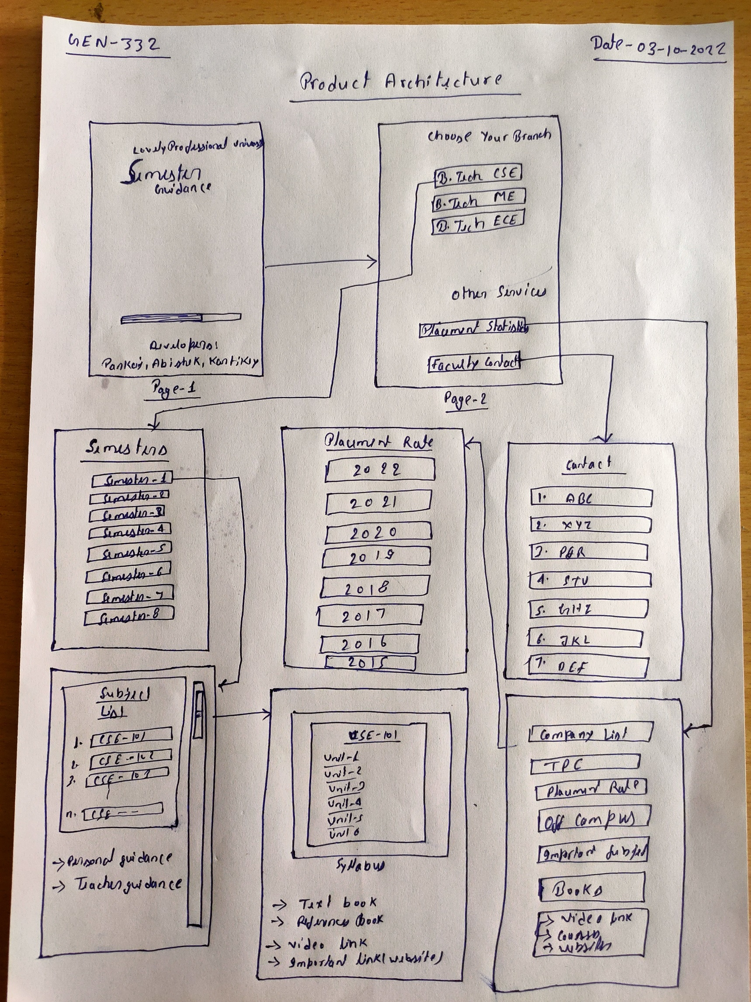

**Prototyping**

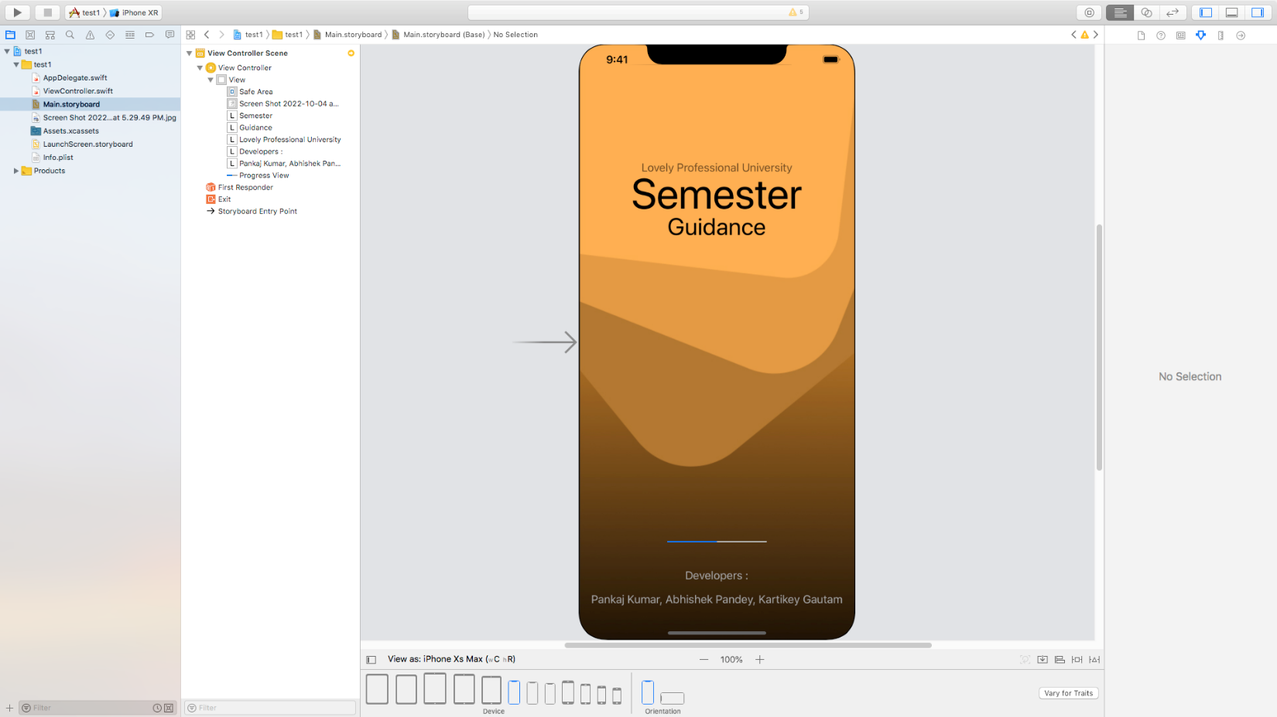

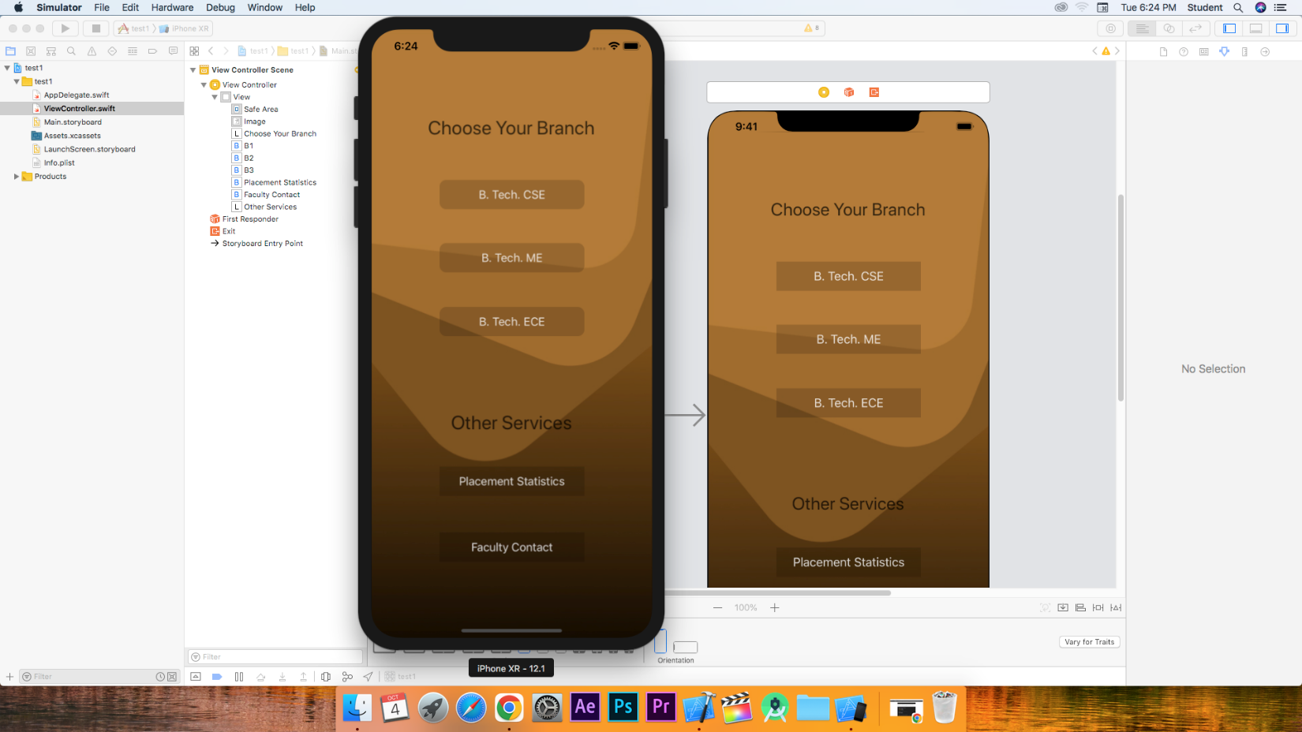

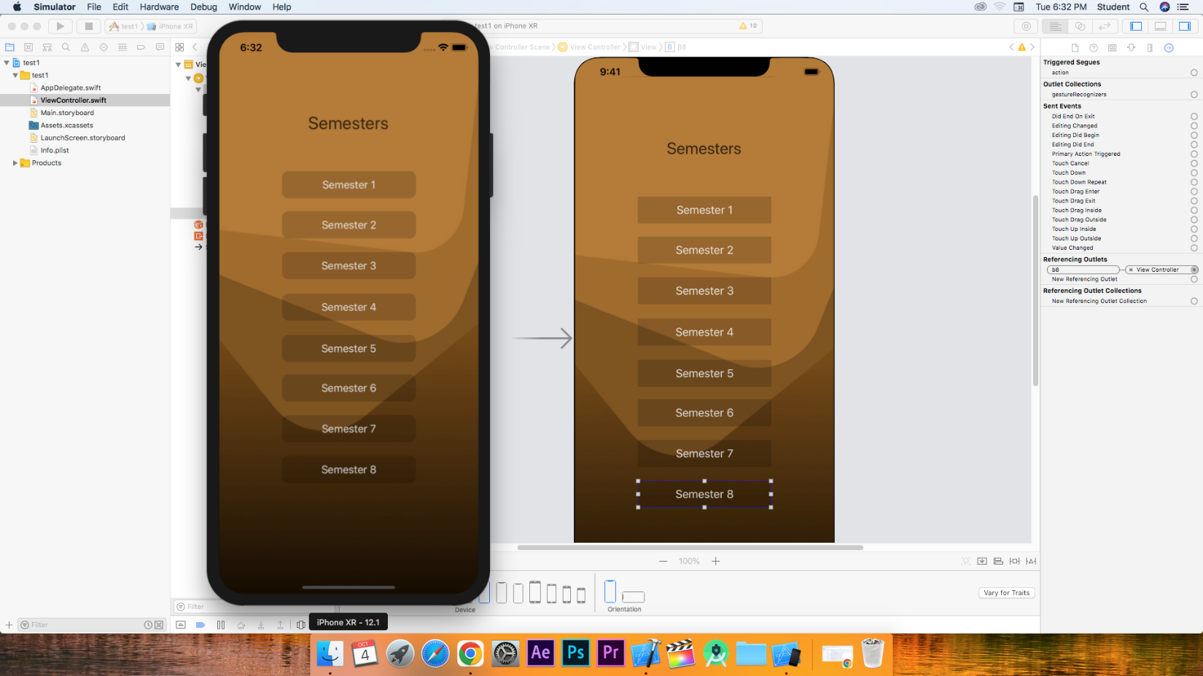

**Product Development Economics**

In order to construct the product, we broke it down into many parts, such as data collecting, architectural design, code implementation, and app testing on mobile devices. For collecting the data, we need approx. 20 days, and for architectural designing, we need at least 3 to 4 days, and for code implementation, we need 5 days, and for testing the app, we need 2 to 3 days.

**Managing Project**

For project management, we constantly update our app. To do so, we take a variety of approaches. For example, we manually update the app if there are changes to the university curriculum and notify users of the update. If a user recommends anything new and it is a good concept, we will integrate it into our software.

**References**

**1.)** <https://developer.apple.com/documentation/uikit>

**2.)** <https://docs.swift.org/swift-book/LanguageGuide/TheBasics.html>

**3.)** <https://www.hackingwithswift.com/>